+

TS/MME-MM
Section de Métallurgie et Métrologie/ Metallurgy and Metrology section
Domaine / Field:  LHC (Cold Mass) |  | Date: 27/03/2006 |  | N° EDMS / EDMS Nr.: 706247
Requérant / Customer:  F. Savary AT/MAS | Liste de distribution / Distribution list:  P. Fessia AT/MAS
Inclusion content of leaking collars

1. Résumé / Abstract:

Following leak testing of Cold Masses (CM), 10⁻⁵ mbar.l.s⁻¹ leaks have been found on bellow collars. 3 welded assemblies have been brought for metallurgical inspection see ATTACHMENT 1
Material certificate has been provided and showed inclusion rating within CERN specification n° 1000 Ed.3 08/1999.
This report contains the results of dye Penetrant Testing (PT) followed by micro-optical observations performed at the location of marked areas from previous tests at CMA (CM 2214) or issued from PT defect indications ( CM 2253 and CM 2264).

2. Données expérimentales / Experimental data:

3 leaking welded assemblies containing bellow collars extracted from:
CM 2214 (leaking area marked on the sample) CM 2253 and CM 2264 (no mark of leaking area)
PT: P. Deweulf TS/MME/MM
Micro-optical observations: QUANTIMET 600
Progressive polishing over 1 mm in the marked area for sample CM 2214 and polishing locally across the PT indications (see § 3) for samples CM 2253 and CM 2264

3. Résultats / Results:

PT performed at CERN showed:
No particular point has been detected for CM 2214 see ATTACHMENT 1
The presence of one particular point for CM 2253 and CM 2264. see ATTACHMENT 1

Micro-optical observations revealed the presence of one B type inclusion (aluminates) up to class 1 detected for sample CM 2253 and D type inclusion (oxides) up to class 1 for the three samples. Grain sizes (G = 4.5 for sample CM 2214 and G = 5.5 for samples CM 2253 and CM 2264) are below the maximum specified for 316LN see ATTACHMENT 2
Micro-optical observations of 1 mm further polishing performed across the identified area of sample CM 2214 did not show any visible leak path. The presence of inclusions of type D (oxides) up to class 1 is confirmed see ATTACHMENT 3

4. Discussion et conclusions / Discussion and conclusion:

In conclusion, micro-optical observations only revealed the presence of D type inclusions (oxides) up to class 1and B type inclusions (aluminates) up to class 1 for sample CM 2253, which is below maximum specified in CERN specification 1000 Ed. 3 (maximum quoted at 1 for A, B C and 1½ for D type inclusions). No visible leak paths could be identified for the three samples.

5. Annexes et références / Attachements and references:

-ATTACHMENT 1: Visual observations + PT
-ATTACHMENT 2: Micro-optical observations samples CM 2214, CM 2253 and CM 2264
-ATTACHMENT 3: Micro-optical observations samples CM 2214 (1 mm further polishing)

Redaction / Written by: A.Gerardin /TS/MME/MM |  |  | Approuvé par / Accepted by: S. Sgobba/TS/MME/MM
Expériences / Testing by:  A.Gerardin/ P. Deweulf /TS/MME/MM |  |  | Superviseur / Supervisor: S. Sgobba/TS/MME/MM
Rapport expérimental / Investigation report

ATTACHMENT 1:

Visual observations of the collars:
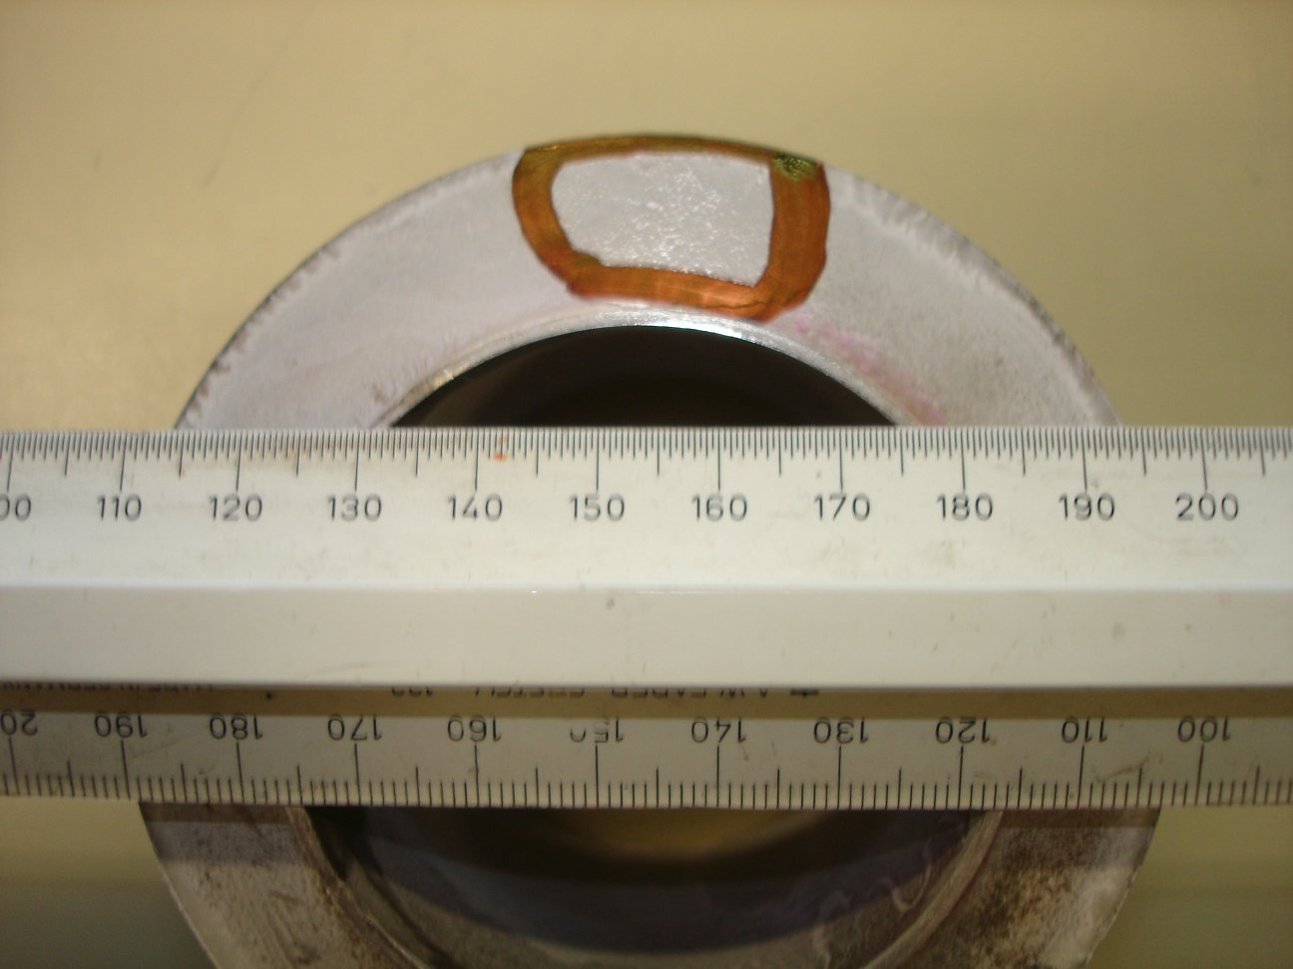
Area of detected leak
Polishing direction
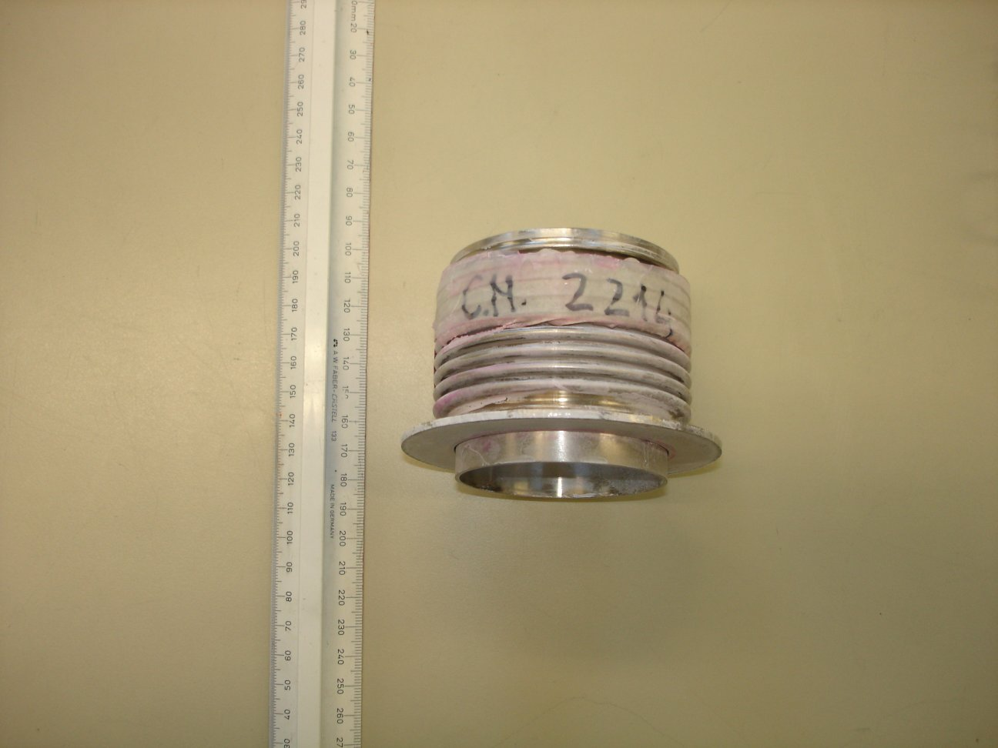
CM 2214

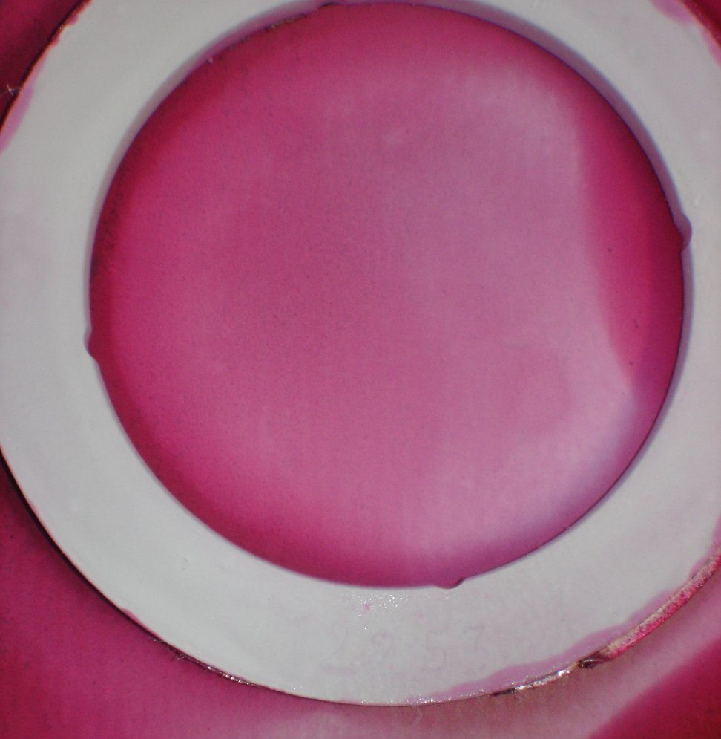
Penetrant testing:

Particular point

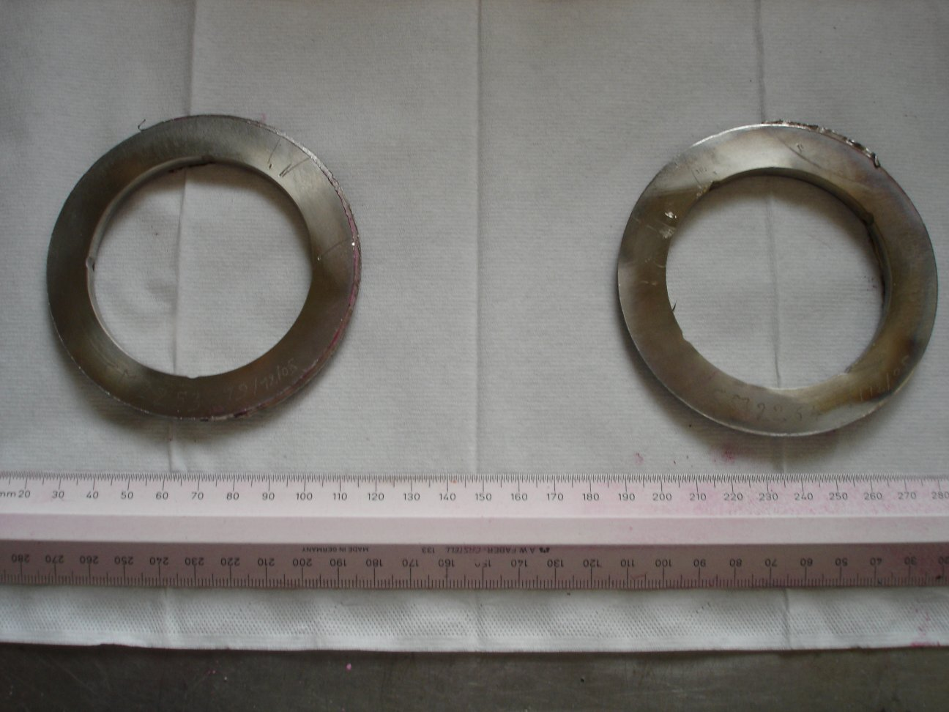
CM 2253
CM 2264

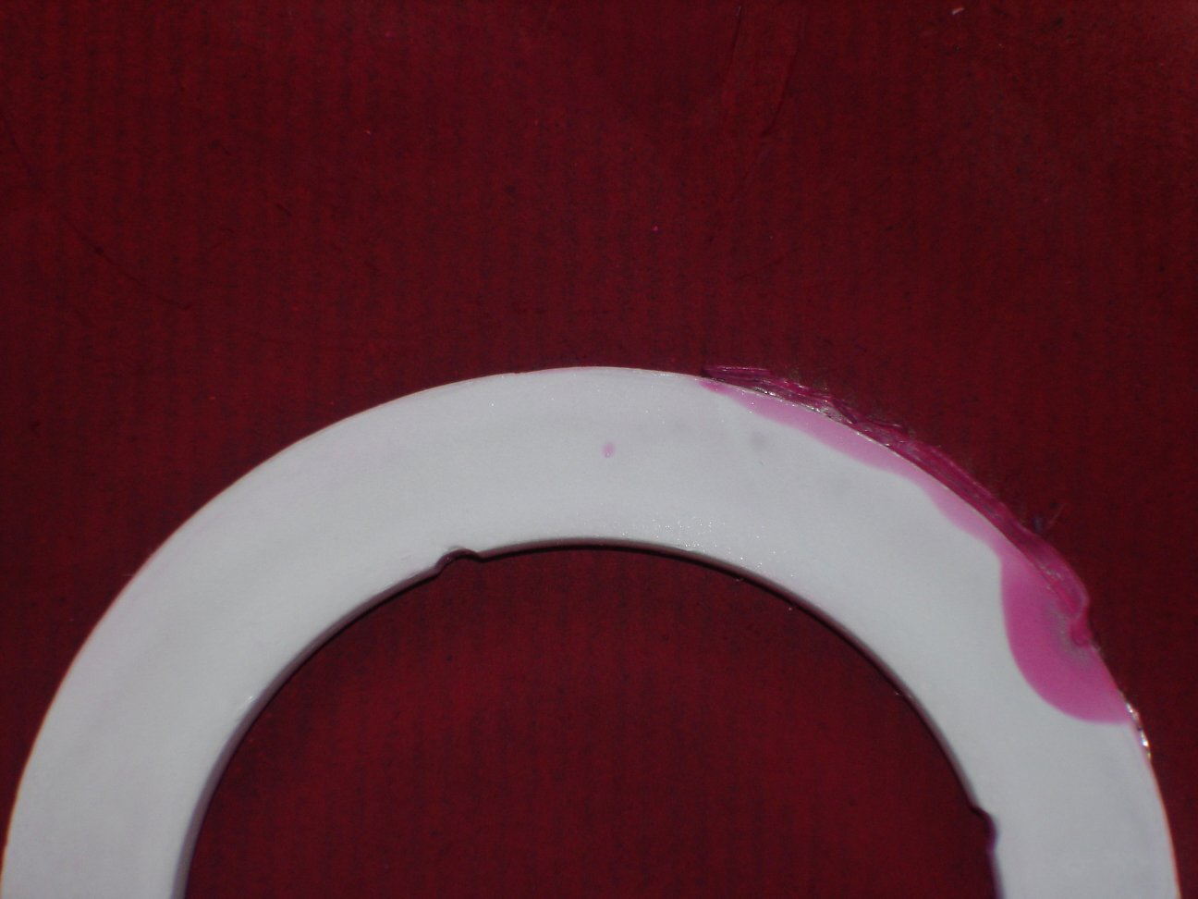
Particular point

ATTACHMENT 2:

Micro-optical observations, original magnification: 100 x:

Sample CM 2214:

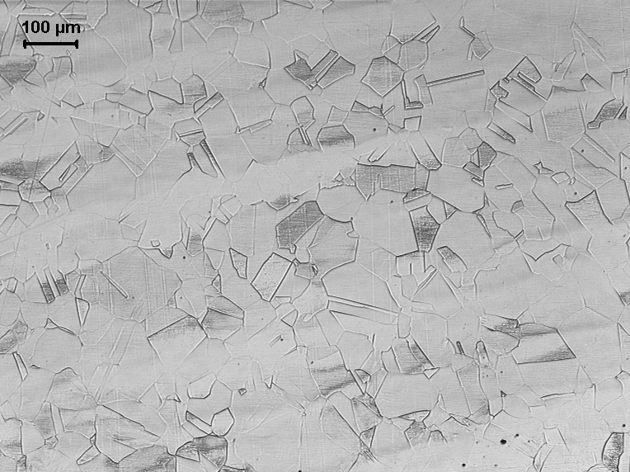

Average grain size number G = 4.5

Sample CM 2253:
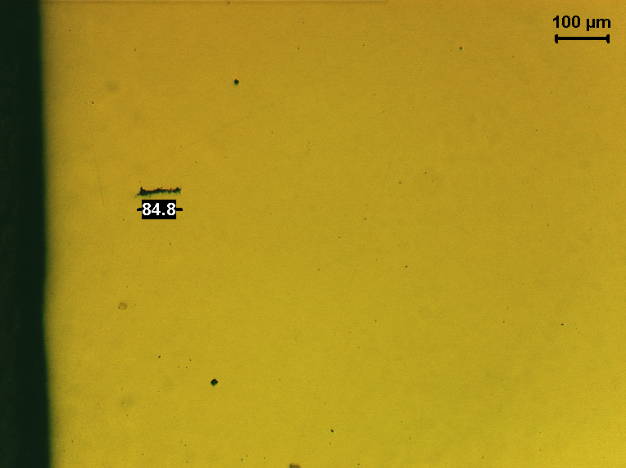
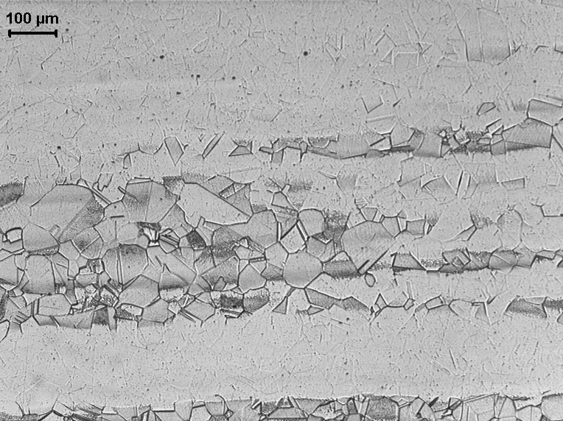

B type up to class 1

Average grain size number G = 5.5

Sample CM 2264:
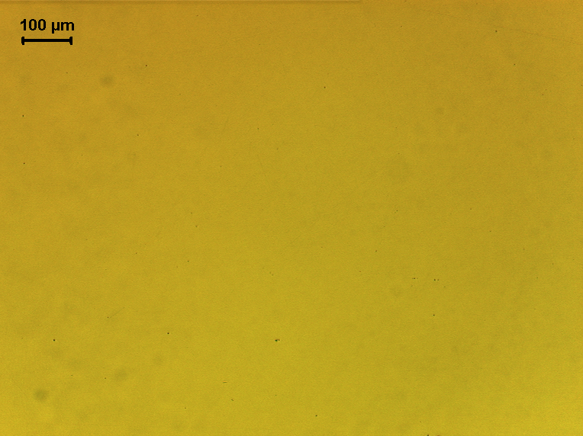
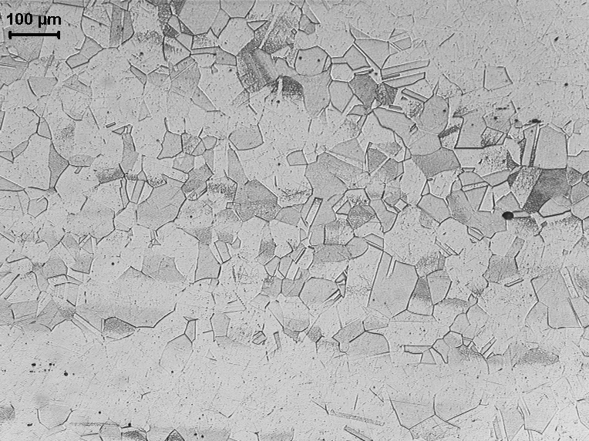

Average grain size number G = 5.5

ATTACHMENT 3:

Micro-optical observations of sample CM 2214, after polishing 1 mm further:
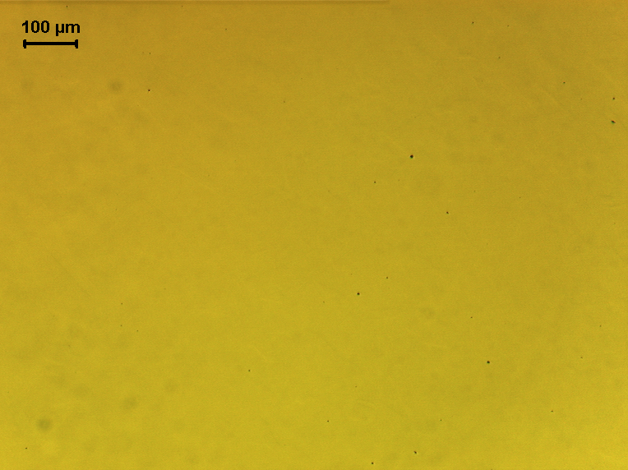

Original magnification: 100 x, D type inclusion up to class 1

