07.10.03

LHC: Collaring Press

- Introduction
Here below are reported the problems detected during the collaring of the last two magnets (CC2058 and CC2045); the events are reported in inverse chronological sequence.

- Collaring of CC2045 (06-10-03)

During the collaring operations for CC2045 started on 06-10-03 a lack of pressure on one circuit of the press (side A) was detected; this is clearly reported in the following graphs which refer at two different time steps (see Fig. 1 and 2). The values in the table refers to the position of the green bars at the time step reported in the middle of the time line.
The pressure decay over 2:46 minutes is about 30 bars on side A and 5 bars on side B.

To keep the pressure at the maximum values of 700 bars required for the collaring, was necessary to manually restore the pressure several time. In the following fig. 3 and 4

After a visual inspection of the press a leak on two jacks on side A was detected.

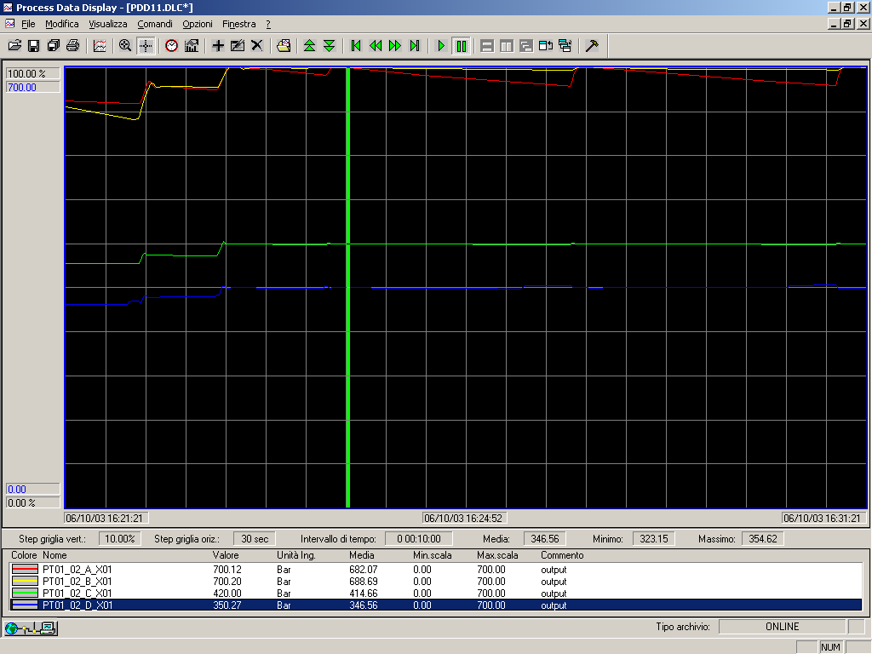
Fig. 1: Pressure profiles at 16:24:52

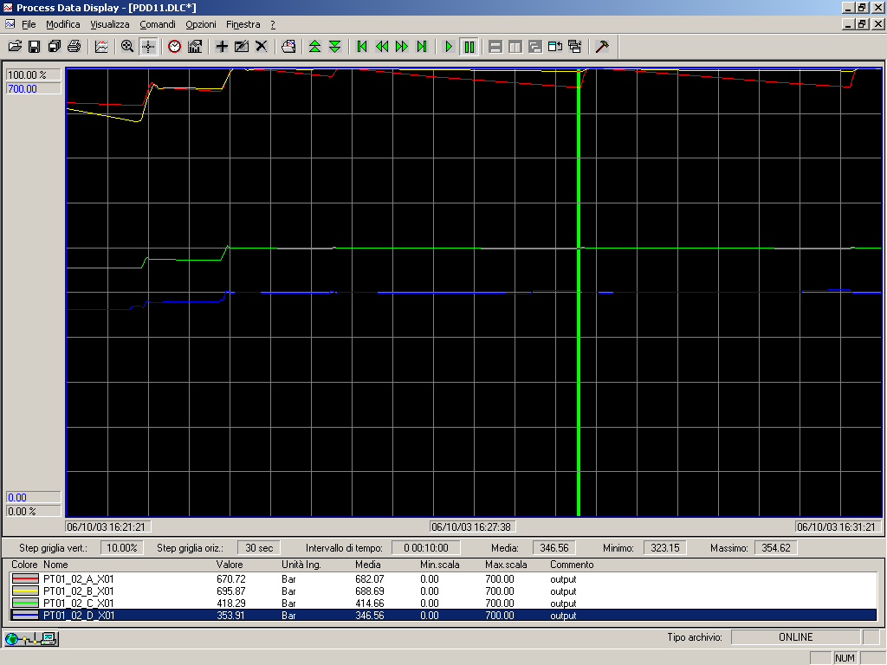
Fig. 2: Pressure profiles at 16:27:38

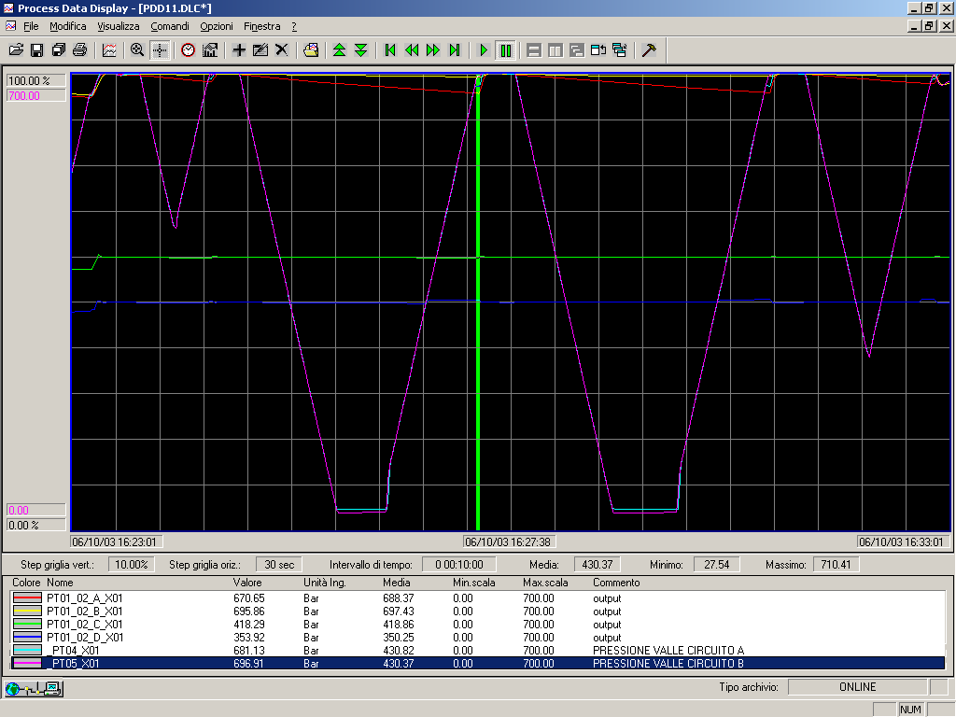
Fig. 3: Pressure profiles main and driving circuits during an automatic restore cycle

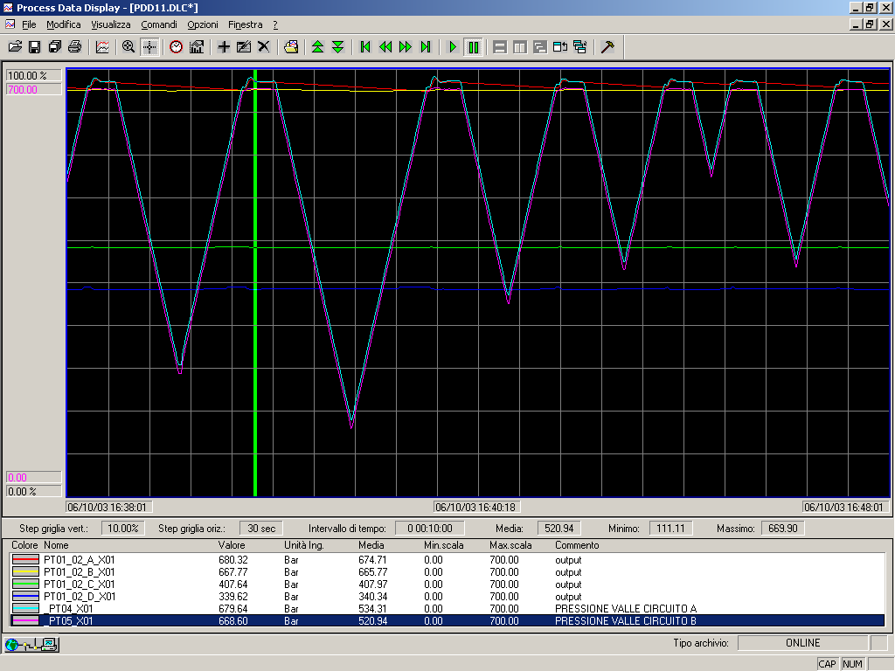
Fig. 4: Pressure profiles main and driving circuits during a manual restore cycle

- Collaring of CC2058 (29-09-03)

After the collaring of CC2045 a check on the pressure profiles of the collaring cycle of CC2058, which had similar but less critical problems, has been performed. The pressure profile in two different time steps are reported in the following fig. 5 and 6.
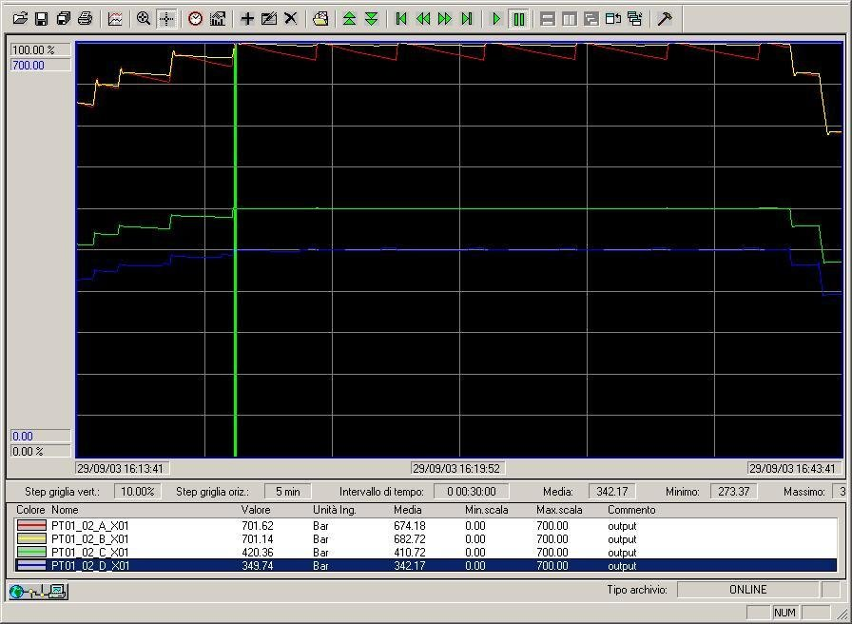
Fig. 5: Pressure profiles at 16:19:52

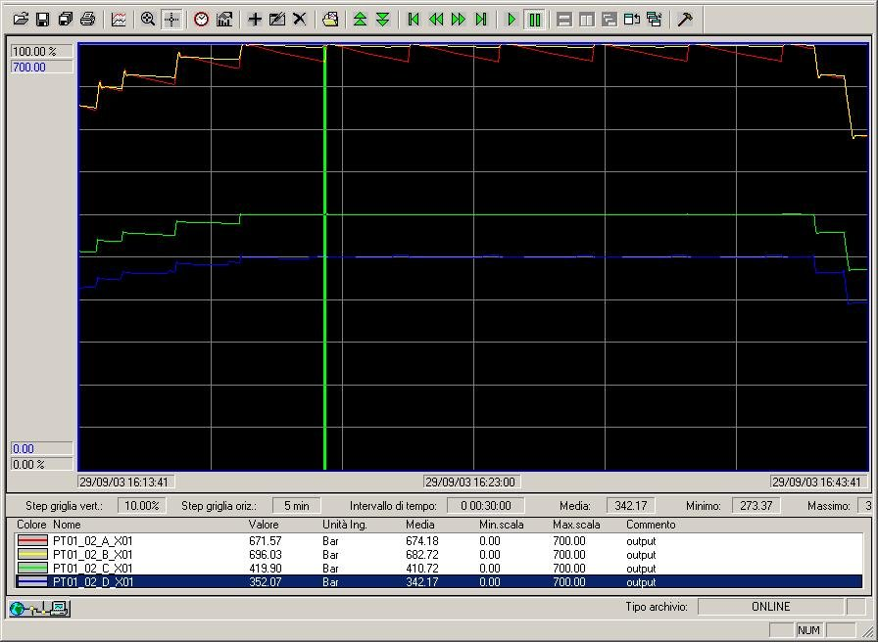
Fig. 6: Pressure profiles at 16:23:00

In this case the pressure decay over a time step of 3:08 min was 30 bars on side A, and 5 bars on side B.

- Conclusion

A cause of the pressure decay on the circuit A is for sure the leak on the two jacks, even if also smaller leak on the pipes and fittings can be present.
According ASG a check and an intervention on the complete hydraulic circuit is necessary in order to restore the complete potentiality of the press.
This is necessary also considering that with the introduction of the extra mid-plane shim the collaring pressure can be higher than usual.

