13.10.03

LHC: Collaring Press

- Introduction
Here below are reported the result of test at low pressure executed together with Biasetton on 13.10.03 in order to detect the cause of pressure drop on main cylinders.

- Ramp up at low pressure

Before the test, a check on the data of the last collaring has been done and it was found that the fill up of the two circuit are different; in Fig. 1 are reported the pressure profiles at time 07:09:03. At this step the pressure on side A reached 20 bar, with a pressure on the driving circuit of ~30 bars (PT04_X01) while side B is still at 0 bar, with a pressure on the driving circuit of ~20 bars (PT05_X01).
In Fig. 2 are reported the pressure profiles at time 07:14:38 when also side B reach the pressure of 20 bars.

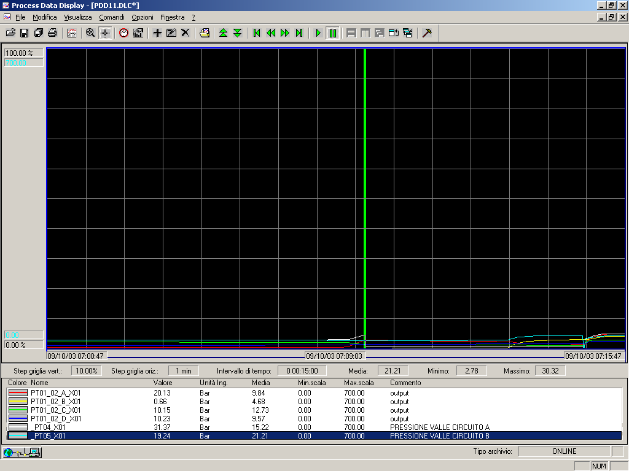

Fig. 1: Pressure profiles at 07:09:03

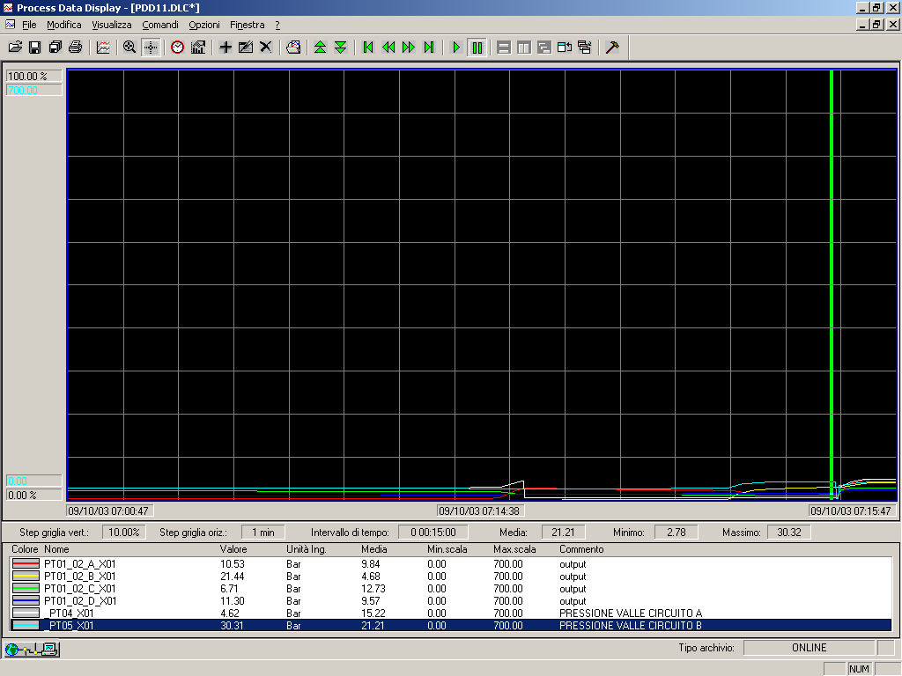

Fig. 2: Pressure profiles at 07:14:38

- Test at low pressure

A test at low pressure was done on 13-10-03 and a lack of pressure on both circuits of the press was detected; this is clearly reported in the following graphs (see Fig. 3 and 4) which refer at two different time steps. The values in the table refers to the position of the green bars at the time step reported in the middle of the time line.
At 12:37:47 the pressure is 200 bars on both the circuits; at 12:50:15 the pressure is 157 bars on side A and 173 bars on side B which means a pressure decay of 43 bars on side A and 27 bars on side B over ~13 minutes.

- Conclusion

The pressure decays on both circuits require a more detailed investigation at different section of the circuit in order to clearly identify the leak(s).
According ASG this investigation can be performed in week 43.

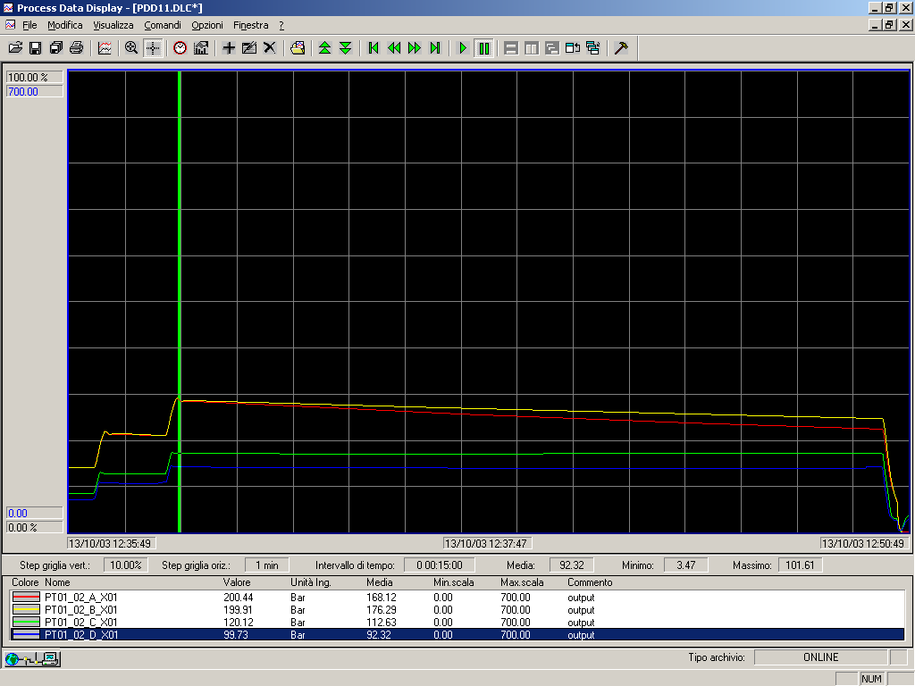

Fig. 3: Pressure profiles at 12:37:47

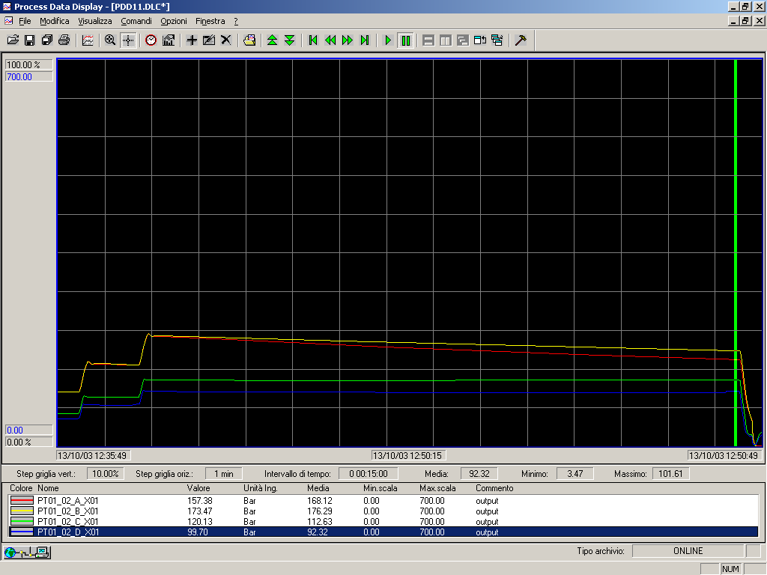
Fig. 4: Pressure profiles at 16:27:38

