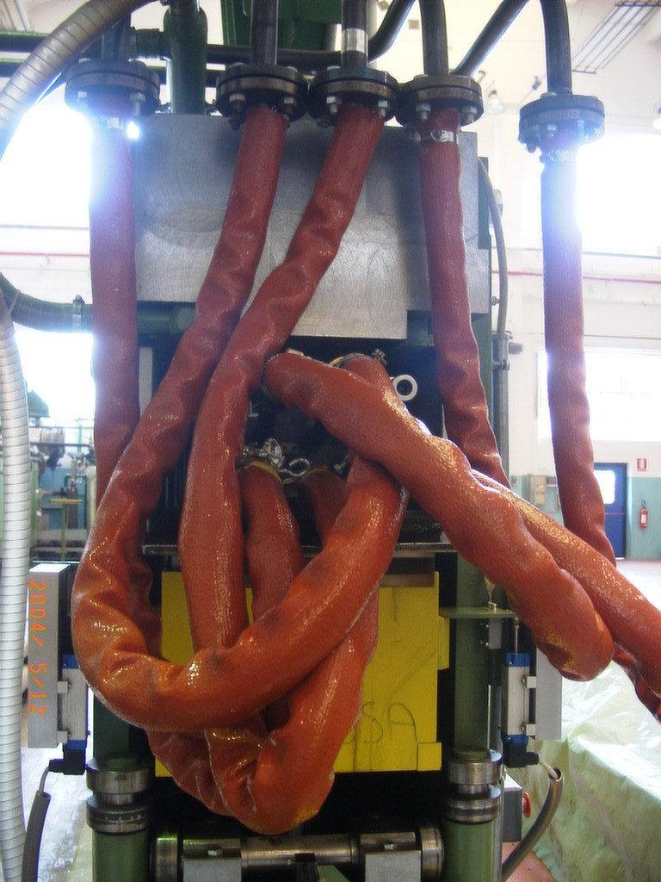
In

Out
Out Mandrel
Out
Out

