Instructions on the De-collaring of Collared Coil 2303

Ezio Todesco (Ezio.Todesco@cern.ch)
Christine Vollinger (Christine.Vollinger@cern.ch),
Accelerator Technology Division
02-February-06

Measurements of the Collared Coil
Magnetic measurements of collared coil 2303 have been carried out on 20th January 2006 by Ansaldo personnel. These measurements show an anomaly in measurement position 9 along the magnet axis in the 2nd aperture triggering yellow alarms on the multipole values b8 (6.1 σ) and b11 (4.2 σ), b12 (7.2 σ), a6 (4.9 σ), a9 (4.5 σ), a12 (5.2 σ), and a14 (4.4 σ) . On 23rd Jan 06, a second measurement with the short mole of 0.125 m coil length has been carried out, confirming the defect.

Analysis of the Measurements and Results
The results of the measurements for the multipoles showing larger anomalies, namely b8 and a6, are shown in the Figs. 1 and 2; the control limits at 4 σ (yellow alarm as dashed line) and at 8 σ (red alarm as continuous line) used in the analysis procedure are also plotted. The blue triangles are the measurement taken at the 20 positions with the standard mole, whereas the black curve shows the measurement taken in 115 positions with the short mole. As can be seen from the plots, there is a very good agreement between the two measurements.
The yellow alarm seen for b8 in position 9 (6.1 σ) with standard measurement is hiding a larger spike that is seen with the short mole (see Fig. 1). Such a spike, over a length of 0.125 m, is giving a field anomaly of 22.1 σ. The peak is sharp and located at 1.14 m from the centre of the collared coil towards connection side end. A very similar situation is found for a6, where the anomaly of 4.9 σ seen by using the standard mole is hiding a peak of 15.5 σ, in the same position as for b8. This is indicating an assembly defect considerably worse than expected from the standard measurement. The analysis of the inverse problem applied to the results of the short mole measurement shows that such a multipole pattern can be generated by an inward movement of block 6 of 1.1 mm in the 1st quadrant (see Figure 3). Indeed, this movement does not justify the measured anomaly in b14 and b15 and leaves some small anomalies in a13 and a14 of 4.6 to 6 σ.
Fig. 1: Comparison between the standard measurement with 20 positions and the measurement with the short mole for multipole b8 of collared coil 2303.
Fig. 2: Comparison between the standard measurement with 20 positions and the measurement with the short mole for multipole a6 of collared coil 2303.

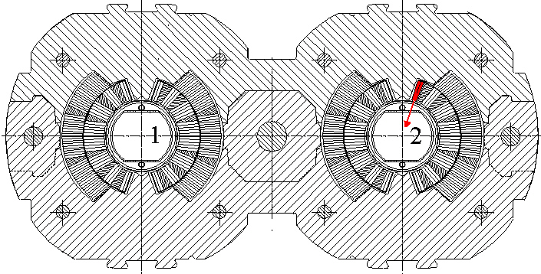
Fig. 3: Movement of the top block in the inner layer of the coil in aperture 2 could produce the observed multipole errors in the measurement position 9.

Instructions for the De-collaring
We recommend a complete de-collaring and a separation of the poles and a removal of the cold bore tube such that the collared coil can be inspected from the inside. Since the magnetic measurements also indicate an anomaly around 0.2 m from the center of the coil in direction of the non-connection end (see Fig.2), we recommend a careful visual inspection of this area of the coil as well.

