MACRO EXCEL

Collared Coil Production



REVISION 2.1

March 2003

Alberto Schiappapietra AT-MAS-MD

1. Introduction 3
2. Installation 3
3. Structure of the file 3
1. Collared Coil 3
2. Table Process 4
3. Time 4
4. Report 4
5. Time Table 4
6. Removed 4
7. Readme 4
4. Functions 4
1. NEW MAGNET 5
2. UPDATE MAGNET 6
3. REWORK MAGNET 6
4. HIDE MAGNET 8
5. INCOMPLETE MAGNETS 8
6. SEARCH PROCESSES 8
7. CHECK TIME 9
8. DELETE DATE 9
9. MAINTENANCE 9
5. Communication between CERN and CMA 11
1. OUTPUT 11
2. UPDATE DATA 11
6. Processes 12

Introduction
The goal of this MACRO is to supply help in following up the collared coil work process at CMAs. The idea was to make an easy and fast tool, able to update the information concerning time duration of the processes during the assembly and not just at the end. This file was created to be as user-friendly as possible. User has just to insert, in an apposite window, the date in which each process is realized. The MACRO will put the date in the right cell, avoiding in this way positioning errors.
The MACRO has to be updated once a week and the output file sent to CERN by email.

Installation
Create a new directory on your hard disk and then copy the file .xls from the floppy. In the same directory will be saved the output file as explained after.

Structure of the file
Seven different sheets compose the Excel file. Each sheet is a different tool to follow up the production. In the following paragraphs we illustrate the characteristics of each of them.

Collared Coil
“Collared Coil” is the first sheet of the file and it is the one dedicated to collect the input data inserted by the inspectors.
The structure of the sheet is shown in the figure below: the first two columns are dedicated to the name of the magnets whilst the first rows contain the processes.

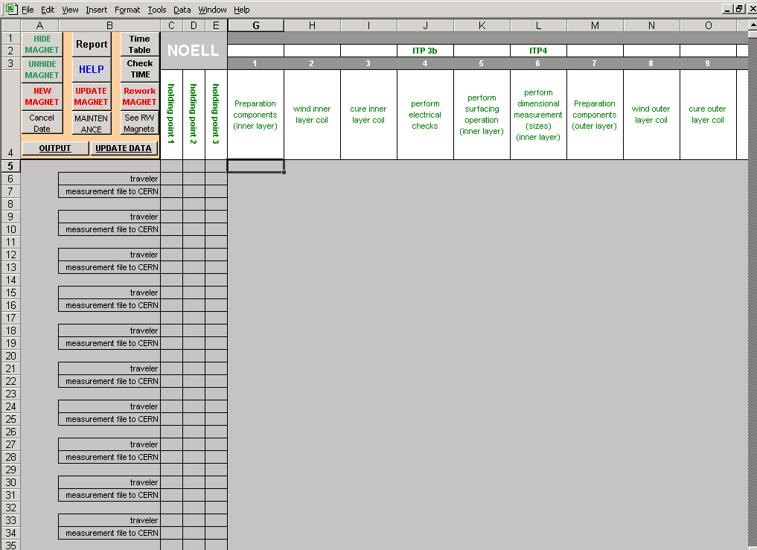
MAGNETS
PROCESSES
HOL D I NG

PO I N T
In the left-top corner there are all the buttons associated with different macros that will be illustrated later. Columns “C”, “D” and “E” contain cells that switch on when a particular process (called “Holding Point”) is done. When the three light are switched on the magnet is completed. The empty part of the sheet is the grid where the date will be inserted.

Table Process
In this sheet there is the list of the processes taken in account in this MACRO.

Time
This sheet allows visualizing the period of time spent to do a certain number of processes. In particular it considers the period between winding and pole assembly, between pole assembly and collaring, between collaring and warm magnetic measurements and the total time needed to do a collared coil.

Report
In this sheet is possible to read the list of all begun collared coils not yet finished. In the first column are listed the name of the magnets, in the second the last process done, in the third the date in which this process was done and in the last columns the date of the holding points if the processes related are done.

Time Table
This sheet shows all the processes done between two date given by the user as input. In this case are shown the date, the name of the magnet and the process done.

Removed
The MACRO has the possibility to modify the structure of the sheet “Collared Coil” changing the number of processes involved. One of the options is to delete a process. In this case the column related to this process is cut from this sheet and all the data are stored in the sheet “Removed” with the possibility to be recovered.

Readme
It explains the function of each button present in the file.

ATTENTION: just the first sheet has to be updated by the users; the program updates all the other sheets automatically!!!!!!

Functions
This MACRO is in reality the sum of various different macros developed in order to supply tools to check the trend of the production. In this chapter we will show the most important functions and how they could be used.

NEW MAGNET
This function allows inserting a new magnet in the grid. It asks in input the type of collared coil (type A or type B), the serial number of the collared coil, then the number of the process done and the date in which it has been done. If the process is related to an ITP (Inspection and Test Plan), the date in which the traveler was filled out and the date in which the measurement file was sent to CERN are also requested.

Example:

We want to introduce the date 01-Jan-02, in which was done the process “Perform Electrical checks” in the collared coil HCMBA__A001-03000001.

- Push the button NEW MAGNET in the left-top corner of the sheet.
- Insert the type of collared coil that you want to introduce, than click OK. (It is not case sensitive)

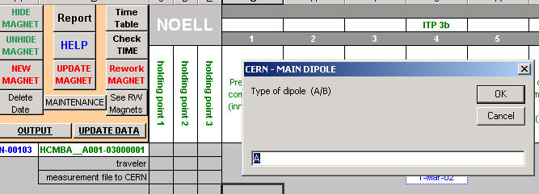
1
2

- Insert the last numbers of the name of the collared coil. In this case we have to insert the number “1” (do not insert 001 or 01!!!!!)
- Insert the number of the process. This number can be chosen from the table located in the sheet “Table Process” that automatically appears.
- Insert the date in which the process was done. It is possible to insert the date in two ways: day/month and day/month/year. In the first case the year is the current one and it is automatically set. So we insert “1/1” or “1/1/02” in the window and we click OK.
- If the process is related to an ITP the program asks now the date in which the traveler was filled out and the date in which the measurement file was sent to CERN. To do these operations follow the point 4.

This function can be used just one time for each magnet. If you want to insert the date of other processes in a magnet that you have already initialized you have to use the “Update Magnet” function.

UPDATE MAGNET
This function allows inserting a date related to a process in a magnet that was already inserted previously. The procedure is exactly the same illustrated before for the function “New Magnet”.
You have to use this option until you complete the collared coil. If you insert the date related to one of the holding point a colored cell will appear in the columns at the left side of the grid.

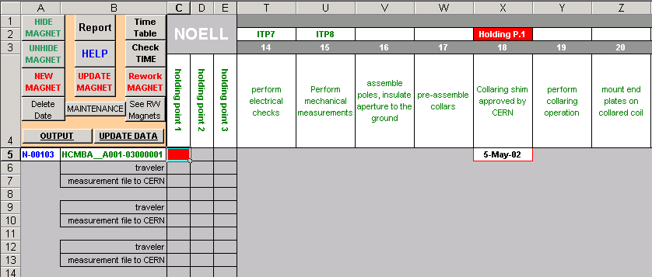
Holding Point 1 inserted

ATTENTION: to complete the Holding Point 3, all the cells related to travelers and measurement file sent to CERN has to be filled out!!!!

If you want to insert the date related to a TRAVEL you have to select the number of the process, than if you have already inserted the date of the process you have to push CANCEL in the window that ask you if you want to overwrite. Automatically you will have the possibility to fill the cells “Traveler” and “measurement file to CERN”.

REWORK MAGNET
This function allows to take in account the possibility to rework a magnet after an assembly error or a component breaking. Pushing the button Rework MAGNET you have to insert the type and the serial number of the magnet that you want to rework (see points 2 and 3 in ”NEW MAGNET”). Then you have to insert the number of the first process from which you want to rework the collared coil.

Example:
Suppose that we discover during dimensional measurements (process 6) that there has been a problem in process 2 ”wind inner layer coil”. We decide then to wind other inner layers to replace the broken ones. To do this we have to do:
- Push button Rework MAGNET.
- Insert the type and the number of the magnet to rework (see point 2 and 3 ”NEW MAGNET”).
- Insert the number of the process from which you want to start reworking the magnet, so the first process to be repeated. The program now cut all the processes done after the one chosen in order to let us fill again these cells.

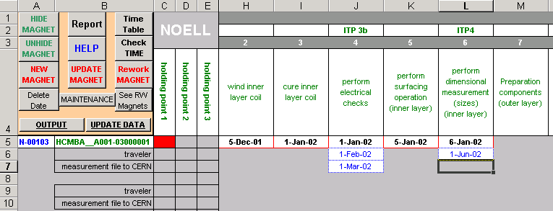
1
3

- Now all the cells are cleaned a red signal ”Bis” appears in the first column to indicate that the collared coil was reworked.

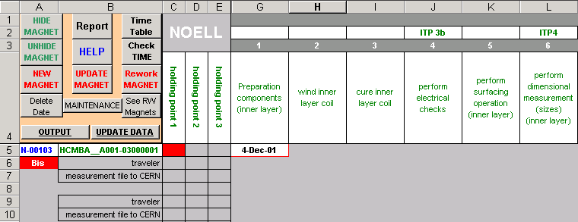
4
5

- The MACRO records the cutted cells in the lowest part of the sheet in order to save all the date inserted. To see this cells you have to push the botton See RW Magnets.

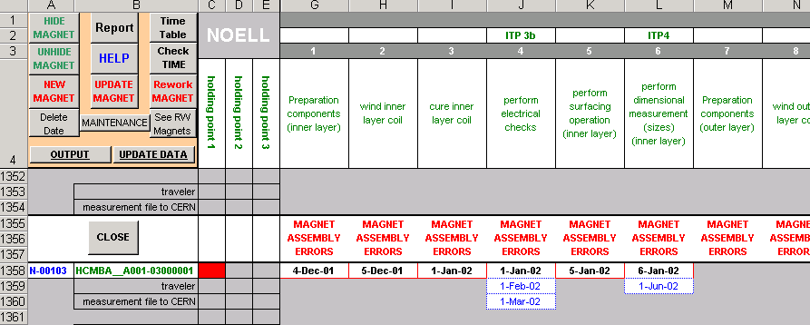
5

HIDE MAGNET
A magnet with all the three holding points done is considered completed. In order to take easy to read the sheet there is the possibility to hide all the completed collared coils, leaving in this way just the magnets still not finished.
To do this you have to push the button HIDE MAGNET. To show again all the collared coils you have to push UNHIDE MAGNET.

INCOMPLETE MAGNETS
This option visualizes in the sheet ”Report” all the magnet still not finished, their last processes done and the date relative to these processes and to the holding points done. To do this click Incomplete Magnets in the sheet ”Collared Coil”.

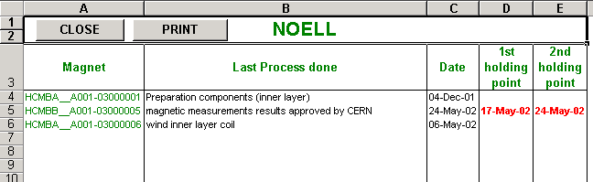

The layout of this page is studied in order to be printable in A4 form just pushing the button PRINT.

SEARCH PROCESSES
This option allows to show all the processes done in a certain period, between two date chosen by the user.
Pushing the button Search Processes a window appears and there you have to insert the first day of the period in which you want to look for the processes. Then you insert the last day of this period in a second window.
Automatically the sheet ”Time Table” is shown and you can see all the processes done during the period specify in the first row. Also the processes done and after repeated are taken in account.

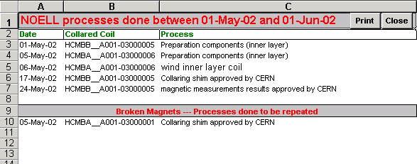
This sheet is printable in A4 format just clicking Print at the top of the sheet.

CHECK TIME
This function allows checking the time spent between winding and poles assembly, poles assembly and collaring, between collaring and the warm magnetic measurements and the total time spent to produce the collared coil.
To do this you have to click on Check TIME button in ”Collared Coil” sheet.
The sheet ”Time” automatically appears. The structure of the sheet is shown in the below figure. In the first row there is the average of the time for each interval evaluated for all the collared coils. In the second row the average is evaluated just for the last # coils, where # is a number that can be set by the user changing tha value of the cell [1]. It is also possible to note that there are red cells. This means that in those cases the values are higher than the average of the last magnets. It is possible to increase or decrease the sensitivity of this warning just changing the value in the cell [2]. The default value ”0.1” means that all the values that are higher then the average + 0.1 times the average are red.

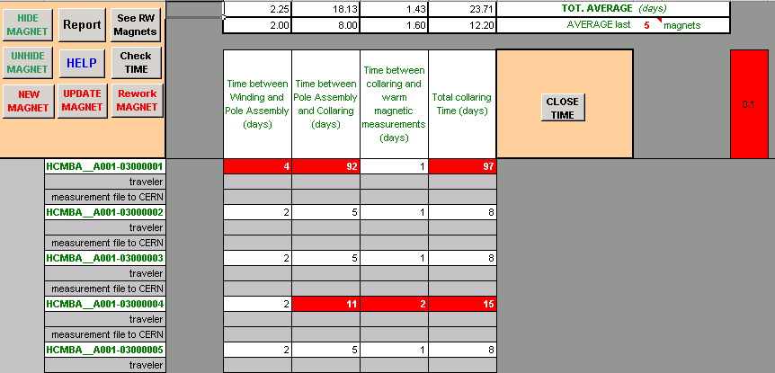
[1]
[2]

DELETE DATE
It allows to delete a date that was inserted erroneusly. Pushing the button Delete Date on the sheet ”Collared Coil”. The MACRO requests the number of the magnet and the number of the process related to the cell to clean. Clicking OK in the window the value of the cell is deleted.

MAINTENANCE
During the series production it could be important to monitor some processes not taken in account before or to neglige others that during the start up were critical.
To satisfay this necessity the MACRO is able to add or delete processes in the sheet ”Collared Coil”. Pushing on MAINTENANCE a new menu appears.

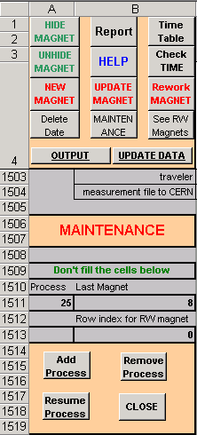
This new menu contains all the buttons corrispondent to functions the modify the strucure of the sheet ”Collared Coil”.

ADD PROCESS
This options allows to insert a new process, i.e. a new column in the sheet ”Collared Coil”.

- Click button Add Process.
- Insert the number that you want to associate to this process (the position of the coulmn in the sheet).
- Insert the name of the process.
- If the process is related to an ITP you have now to click OK and then insert the number of the ITP.

Automatically a new column appears with the name of the process. Also the sheet ”Table Process” is updated.

ATTENTION: This option used with the option ”UPDATE DATA” (see after) could generate an error. Excel infact has a limited number of columns that can be pasted on a sheet. If it happens you have just to close the file and to open it again.

REMOVE PROCESS
This option allows to remove a process, i.e. a column, from the sheet ”Collared Coil”.

- Click button Remove Process.
- Insert the number of the process that you want to remove

The removed column is stored in the sheet ”Removed” with all the date inserted. Also the sheet ”Table Process” is updated.

RESUME PROCESS
Removed processes are not lost, it is always possible to resume these processes and the data stored inside them.

- Click button Resume Process.
- The sheet ”Removed” appears.
- Insert the number of the column that you want to resume (the number is written in the first row of the sheet, above the ITP number).
- Insert the number that you want to assigne to the process, i.e. the position of the column in the sheet ”Collared Coil”.

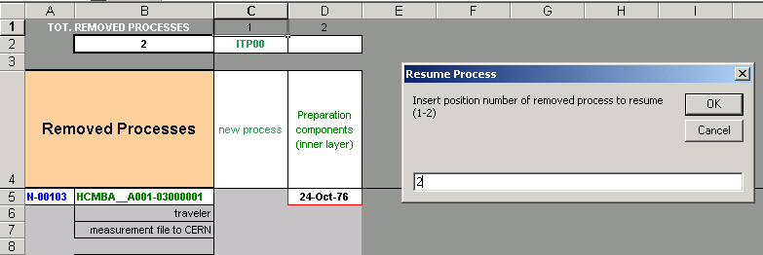

The program inserts the coumn in the sheet ”Collared Coil”, updates the numbering of the processes and updates the sheet ”Table Process”.

Communication between CERN and CMA
This MACRO is installed both at CMA and at CERN. The first has to update weekly the values, i.e. the date of the processes done during the week, while the second has to evaluate these data. To do this it is necessary that the MACRO installed in the two sites could communicate.

OUTPUT
It is possible to create an output text file just clicking on the button OUTPUT in the top-left corner of the sheet ”Collared Coil”. This small file can be easily sent by email to CERN.
- Click on OUTPUT.
- Insert the number of the week in which you have updated the MACRO.
- Insert the year.

The output file is created with the name CMA_collared_coil_week_# -200#.txt in the same directory where the MACRO is installed.

UPDATE DATA
It is possible to update the MACRO inserting the data stored in the output file.txt. This operation is usually done at CERN inserting the output file produced by the CMA.
ATTENTION: in order to update the file excel, the output file.txt must be saved in the same directory used to install the MACRO.
- Click on UPDATE DATA in the sheet ”Collared Coil”.
- Insert the number of the week that appears in the file.txt.
- Insert the year that appears in the file.txt.

Processes
The processes that appear in this MACRO are not exactly the same listed in the TECHNICAL SPECIFICATION. Same processes have been grouped and others neglected.

MACRO PROCESSES
Preparation Components | All the processes and tests related to the preparation of the superconducting cables (from cc-01 to cc-04, from ITP 1 to ITP 2)
Wind inner/outer layer coil | The cells related to this process have to be filled when all the 4 inner/outer layer of the collared coil have been winded.
Cure inner/outer layer coil | The cells related to this process have to be filled when all the 4 inner/outer layer of the collared coil have been cured.
Perform electrical checks ITP3b | The cells related to this process have to be filled when all the 4 inner/outer layer of the collared coil have been checked.
Perform surfacing operation | The cells related to this process have to be filled when all the 4 inner/outer layer of the collared coil have been surfaced.
Perform dimensional measurement ITP5 | The cells related to this process have to be filled when all the 4 inner/outer layer of the collared coil have been measured.
Assemble pole | The cells related to this process have to be filled when all the 4 pole of the collared coil have been assembled.
Pre-assemble collars | Processes from cc-17 to cc-20
Perform mechanical measurements on collared coil ITP10a | In the technical specification ITP10a does not exist. In the MACRO ITP10a means that you have to take in account just the part of the ITP concerning the cold bore tube and the total length.

for info mailto:Alberto.Schiappapietra@cern.ch

