MACRO EXCEL
Stock of the CERN delivered materials at the CMAs premises



REVISION 1

September 2002

Alberto Schiappapietra LHC-MMS-MD

1. Introduction 3
2. Installation 3
3. Structure of the file 3
Stock and Stock2 3
Components 4
Report 4
Readme 4
4. Philosophy of the MACRO 5
5. Functions 5
INSERT MAGNET 5
SUPPLIED COMPONENTS 6
ASSEMBLED COMPONENTS 8
BROKEN COMPONENTS 9
HIDE MAGNET 11
REPORT 11
DELETE DATE 12
6. Communication between CERN and CMA 12
OUTPUT 12
UPDATE DATA 13

Introduction
The goal of this MACRO is to control the flux of delivered materials by CERN to CMAs premises. This tool allows to check the quantity of components arrived at the manufacturer and the quantity used or lost during the assembly. In this way it will be possible to know how many components have been used in a certain period and in this way to organize future delivery taking in account the rate of production.

ATTENTION: in this MACRO we speak about batch and component; batch is the quantity of pieces used in 1 magnet (this number change for every component), component is the single piece part of a batch.

Installation
Create a new directory on your hard disk and then copy the file .xls from the floppy. In the same directory will be saved the output file as explained after.

Structure of the file
Five different sheets compose the Excel file. Each sheet is a different tool to follow up the production. In the following paragraphs we illustrate the characteristics of each of them.

Stock and Stock2
“Stock” and “Stock2” are the first sheets of the file and they are the ones dedicated to collect the input data inserted by the inspectors.
The structure of the sheets is shown in the figure below: the first two columns are dedicated to the name of the components whilst the first rows contain the name of the magnets.

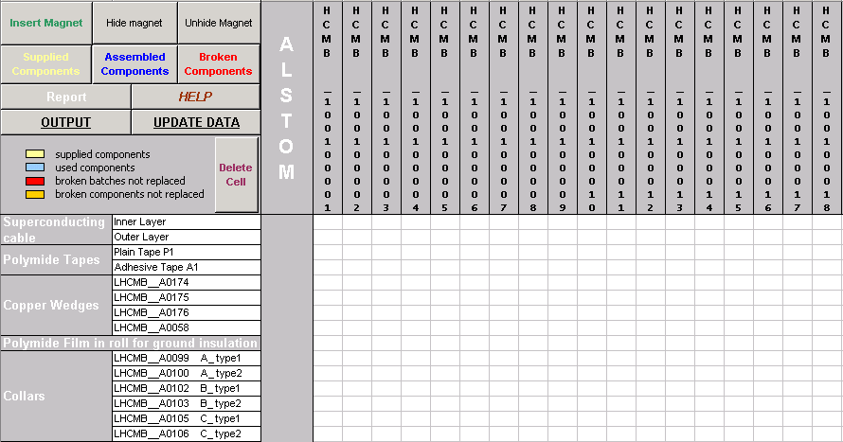
COMPONEN T S
MAGNETS

In the left-top corner there are all the buttons associated with different macros that will be illustrated later. The empty part of the sheet is the grid where the data will be inserted. In both sheets the last three columns on the right report, for each component, the number of supplied batches still available (not used or broken), the number of broken batches and the number of broken components.

Components
In this sheet there is the list of components delivered by CERN. Components with a red number are specific for a certain type of dipole.

Report
In this sheet it is possible to read the summary of the quantities of materials involved in the assembly. There are five columns: the first one is dedicated to the Total Supplied Batches, the second to the batches still available for the assembly, the third to the batches that have been assembled, the forth to the broken batches and the last to the broken components. In the second column (Batches still available for assembly) it is possible to set a warning (red cell) when the number of stocked available batches is less than a fixed quantity that the user can set in the additional column placed at the right side of the sheet.

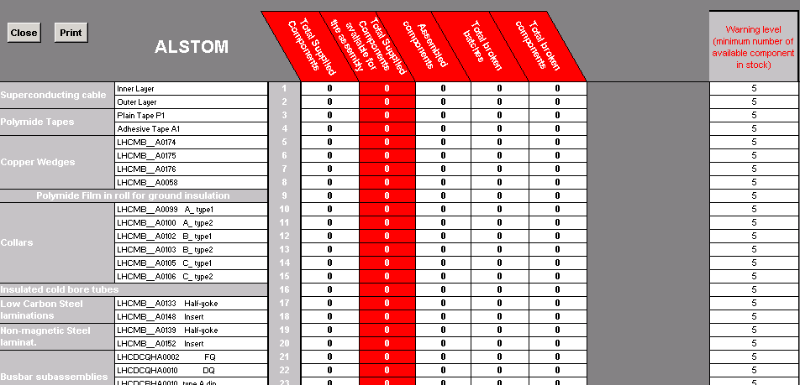

Broken
In this sheet are stored all the batches that have been broken during assembly. It is possible to read the component code and the number of the magnet in which it was broken.

Readme
It explains the function of each button present in the file.

ATTENTION: just the first two sheets have to be updated by the users; the program updates all the other sheets automatically!!!!!!

Philosophy of the MACRO
This MACRO is based on two different ideas. The first one is that it is not possible to know a priori in which magnet a batch will be used and the second is that it is important to know exactly in which magnet a certain component has been broken. To satisfy these two exigencies the program uses different methodologies: if we want to introduce a quantity of batches, supplied or assembled, we are not obliged to insert also the names of the magnets in which theses components are used but these batches will be assigned automatically to the first empty cells found on the grid. If we want to signal that a batch or a part of a batch has been broken during the assembly of a certain magnet we are obliged to insert previously the name of the magnet and in this way the program will fill the cell correspondent to that magnet and that component. This idea will be explained more in detail in the next chapter where all the functions will be presented.

Functions
This program is in reality the sum of various different macros; each macro acts on a cell changing its colour in correspondence to a different situation. In the following table we show all of these possible status in which the cell could stay.

Supplied batches available for the assembly

Batches assembled without problems

Batches broken during the assembly

Batches in which a certain number of components have been broken during the assembly. It is possible to replace the broken components and transform these batches in available batches for the assembly

Batches previously broken but now replaced

Batch partially delivered (not enough components to build a magnet)

Forbidden cell. This cell cannot be filled because it is related to a component not compatible with the type of dipole (A or B) that corresponds to that cell.

In the last part of the chapter we show the most important functions and how they can be used.

INSERT MAGNET
This function allows inserting the name of a magnet in the grid. It asks in input the serial number of the collared coil or the type of cold mass (type A or type B) and the serial number of the cold mass. Automatically the correspondent cells in the first rows change colour, yellow for the collared coil, green for a type A dipole and blue for a type B.
To insert the name of a magnet is not compulsory if you do not have to insert a broken magnet. Nevertheless, inserting the magnets, the program puts the “forbidden cells” in correspondence to the components that have not to be supplied to this type of dipole, recreating in this way a more realistic situation.
Example:

We want to introduce the cold mass HCMBA__A001-01000001.

- Push the button INSERT MAGNET in the left-top corner of the sheet “stock” or “stock2”.
- Insert the type of cold mass that you want to introduce, than click OK. (It is not case sensitive)
- Insert the last numbers of the name of the cold mass. In this case we have to insert the number “1” (do not insert 001 or 01!!!!!)
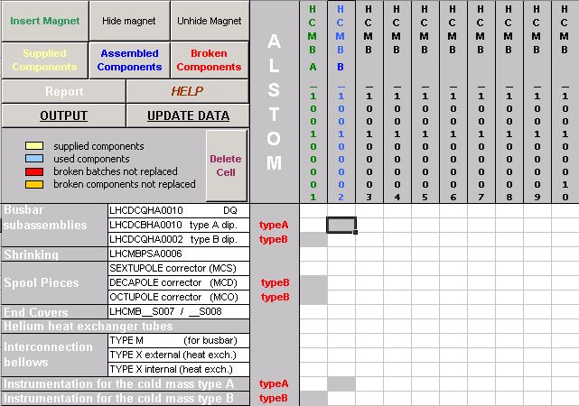
1
Forbidden cells

You can insert a magnet also if the “forbidden cells” related to that column are already filled by other colours. In this case the program will replace these cells with grey cells and it will shift contains in the nearest empty cells.

SUPPLIED COMPONENTS
This function allows inserting a defined quantity of batches of a certain component. Clicking on the button SUPPLIED COMPONETS you can choose between three options: [1] Supplied batches, [2] Supply components to partially broken batches, [3] Supply incomplete batch . Choosing the first option you have to insert the code related to the component and the quantity of batches that you want to insert. A corresponding number of yellow cells will appears on the grid. The second option can be chosen only if there are some orange cells (batches partially broken) in the row correspondent to the chosen component. In this case the procedure is the same that for option [1] but you cannot choose the quantity that is set to 1. The orange cell will become yellow.
The third option allows to insert a green cell that means that a batch was supplied but it was not complete or the were some components not conform. If you use this option for a component that already contains a green cell the program will ask if this incomplete batch is compatible with the one already present (if yes it sums the components of the new batch with the components of the other present, if no a new green cell appear) and if this supply is enough to create a complete batch ( if yes the green cell becomes yellow).
NEW

Example1:

Insert 10 supplied batches in component ”Polymide tapes – plain type P1”.
- Click on SUPPLIED COMPONETS in the top-left corner of the sheet ”stock”.
- Insert ”1” (supplied batches) in the window.
- Insert the code of the component, in this case ”3”, choosing from the table that appears.
- Insert the number of supplied batches

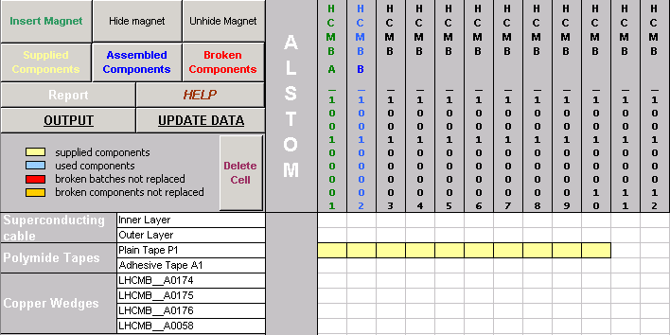
1

Example2:
Supply components to incomplete batch (orange cell) in order to get this batch available for the assembly.

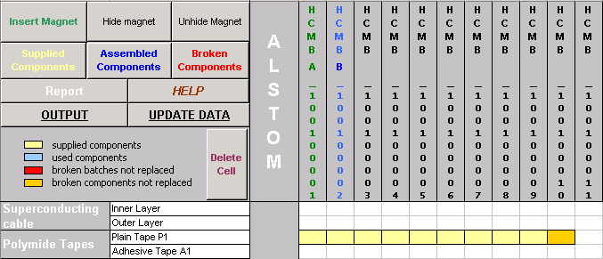

  - Click on SUPPLIED COMPONETS in the top-left corner of the sheet ”stock”.
  - Insert ”2” (Supply components to incomplete batches) in the window.
  - Insert the code of the component, in this case ”3”.
  - A window appears and ask if the supplied components are compatible with the others of the batch. Click YES and you will find the same configuration shown in the figure of the example1.

If a component has a red cell (broken batch) in its row, when you supply new batches the program will replace first of all the red cell with a yellow one and after it will fill the empty cells. Superconducting cables have a different procedure because of their peculiar nature. It is not always possible to replace a broken cable with another one available. For this reason when you supply new cables and there is a red cell the program does not replace automatically the cable but it asks before if the new cable is compatible with the old one.
.

ASSEMBLED COMPONENTS
This function allows inserting the number of batches used to assemble magnets. This batches are now no more available for other magnets. The program transform the yellow cells (supplied component still available) in blue cells (component used).
Example:
We start from the configuration shown in Example1, paragraph SUPPLIED COMPONENTS, with 10 supplied batches of ”Polymide tapes – plain type P1”. 5 of these batches have been used to produce 5 magnets.
- Click on ASSEMBLED COMPONETS in the top-left corner of the sheet ”stock”.
- Insert the code of the component in which you want to insert the assembled batches (in this case ”3”).
- Insert the number of batches the you want to assemble (in the window appears the maximum number of batches that you can insert that is equal to the number of supplied components still available), in this case ”5”.

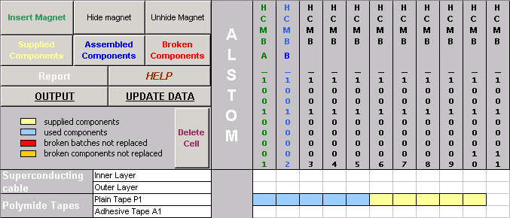

BROKEN COMPONENTS
This function allows to signal that a specific component in a determinate magnet has been broken during the assembly. In order to do this it is necessary to insert the name of the demaged magnet (see paragraph INSERT MAGNET). Once defined the cold mass you have to specify if it is just a broken component (option [2]) or a complete batch (option [1]) and you have to introduce the code of this component.
In case of option [2], batch partially broken, the program check if the selected cell correspond to a yellow cell (batch available). If it is so it will replace this cell with an orange one and it will ask if this cell is replaceble by other available batches. If the answer is YES the orange cell will be shifted at the end of the filled line and the selected one will become yellow again. If the answer is NO the cell is kept orange.
In case of option [1], batch complitely broken, the function check if the selected cell correspond to a yellow cell. If it is so the program will replace the yellow cell with another yellow cell available and so the number of yellow cells decrease of one unit. If there are not more yellow cells the program replace the broken batch with a red cell. Since the insertion of batches, supplied or assembled, is not linked to the number of the magnet, it could happen that the selected cell was a blue cell (batch assembled without problems).

In this situation the program looks for a yellow cell and exchange the place of this cell with the blue one.

Now the selected cell is again yellow and the program will follow the procedure described before.

NEW
During the assembly it could happen that a component was broken and this error causes the ropture of other components previously assembled (blue cells).
In order to take in account this eventuality, the MACRO asks if there are some assembled components broken by an assembly errors. Pushing YES the program asks if these batches have been broken completely (see option [1] in this paragraph) or partially (option [2]) then the code number of these components. At that moment the MACRO looks for a blue cell and deletes it replacing it with a yellow one (supplied component still not used).

Example1:
Initial situation: component 16 with 3 supplied component available. During the assembly of magnet 2 both cold bore tubes are broken.
- If it is not already done insert the magnet (see INSERT MAGNET).
- Click on BROKEN COMPONETS in the top-left corner of the sheet ”stock”.
- Choose option ”1” (broken batch).
- Insert the number of the magnet, in this case ”2”.
- Insert the code of the component, in this case ”16”.
The new configuration is: two available batches (yellow cells) for the component ”insulated cold bore tubes”.
If you repeat this example other two times, the last one you will find just one red cell because there are not more yellow cells to replace the broken one.
Example2:
Initial situation: component 16 with 3 supplied component available. During the assembly of magnet one of the cold bore tubes is broken.
- If it is not already done insert the magnet (see INSERT MAGNET).
- Click on BROKEN COMPONETS in the top-left corner of the sheet ”stock”.
- Choose option ”2” (batch partially broken).
- Insert the number of the magnet, in this case ”2”.
- Insert the code of the component, in this case ”16”.
The new configuration is: two available batches (yellow cells) for the component ”insulated cold bore tubes” and one partially broken batch (orange cell) at the end of the filled row.

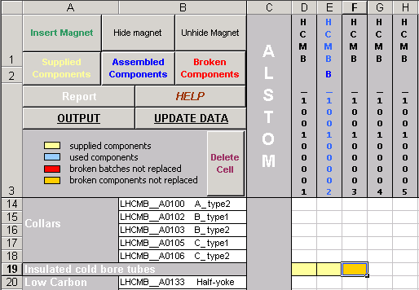

HIDE MAGNET
A magnet with all blue cells is considered completed. In order to ease the reading of the sheet there is the possibility to hide all the completed magnets, leaving in this way just the magnets still not finished.
To do this you have to push the button HIDE MAGNET. To show again all the columns you have to push UNHIDE MAGNET.

REPORT
Clicking the button REPORT in the sheet ”stock” the program shows the sheet ”Report” where it is possible to find the summary of the situation. For every component it is possible to read the quantity of supplied batches, how many of these batches are still available, how many have been used and how many have been broken, completely or partially.
The second column, available batches, is very important because it let us know if CERN have to supply other components or not. For this reason a warning has ben set, red colored cells [1], in order to point out the components with an ammount of pieces below a critic value. This value is different for each component and it can be set changing the value inside the column placed at the right side of the sheet [2].
ATTENTION: in the first column ”Total Supplied Batches”, it is possible to read two number, like for example ”50 –1”. It means that 50 complete batches have been supplied + 1 incomplete batch.

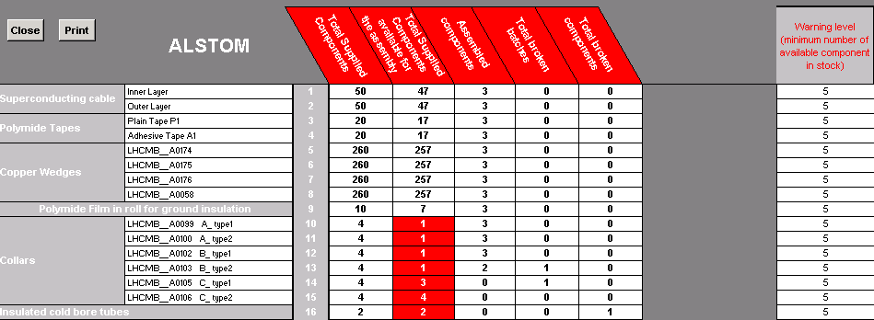
[2]
[1]

Clicking on the button PRINT is possible to have a printable version of this sheet in format A4.

REPORT BROKEN
Clicking on the button REPORT_BROKEN in the sheet ”stock” the program shows the sheet ”Broken” where it is possible to find the summary of all the broken batches and the magnets in which they were used.
Clicking on the button PRINT is possible to have a printable version of this sheet in format A4.

DELETE DATE
It allows to delete a cell that was inserted erroneusly. Pushing the button Delete Cell in the sheet ”stock”. The MACRO asks which kind of cell do you want to delete ([1] supplied (yellow), [2] assembled (blue), [3] broken batch (red), [4] broken components (orange), [5]batch partially supplied (green),[6] Magnet Name), the code of the component and the number of cells to clean.

Communication between CERN and CMA
This MACRO is installed both at CMA and at CERN. The first has to update weekly the values, i.e. the date of the processes done during the week, while the second has to evaluate these data. To do this it is necessary that the MACRO installed in the two sites could communicate.

OUTPUT
It is possible to create an output text file just clicking on the button OUTPUT in the top-left corner of the sheet ”stock”. This small file can be easily sent by email to CERN.
- Click on OUTPUT.
- Insert the number of the week in which you have updated the MACRO.
- Insert the year.

The output file is created with the name CMA_stock_week_# -200#.txt in the same directory where the MACRO is installed.

UPDATE DATA
It is possible to update the MACRO inserting the data stored in the output file.txt. This operation is usually done at CERN inserting the output file produced by the CMA.

ATTENTION: in order to update the file excel, the output file.txt must be saved in the same directory used to install the MACRO.
- Click on UPDATE DATA in the sheet ”stock”.
- Insert the number of the week that appears in the file.txt.
- Insert the year that appears in the file.txt.

FAQ
In this paragraph a series of particular situations will be illustrated and it will be explained how to solve these problems.

The break of one component cause the ropture of a component already assembled (blue cell)
Suppose the you have used a component (component A) and you transform its cell in blue. Than during the following production steps this component is broken due to an error in assembling another component (component B)

- Use ”Broken Component” for component number B.
- The macro will ask you if the ropture of component B has damaged some other components already assembled (so that you have already transformed in blue cell). You answer ”Yes”, than you choose if the batch has been complitelly broken (Yes) or just partially (No) and insert the code corrispondent to component B

Collared Coil/Cold Mass completed but send back for non conformity
Suppose that a cold mass (or a collared coil) has been completed and all the related cells are blue. During the following steps the magnet shows some problems and is sent back to be reworked and replace some components.

- In this case you should use the button ”Delete Cell”, choose the option [2] (delete blue cells), choose the code of the component that probably have to be replaced and insert the quantity ”1”. Then your blue cell becomes yellow.
- Now you can use the function ”Broken Component” as usual choosing the component that you have modified in point (1). When the macro asks you if there are other batches already assembled that have been broken you click on ”yes” and you repeat this point for all the components that have to be replaced.

Delivery of demaged components
A certain number of batches is delivered so that you insert a corrisponding number of yellow cells in you macro. After some time you discover that some batches contain broken components.

- In this case you should use the button ”Delete Cell”, choose the option [1] (delete yellow cells), choose the code of the demaged components, than insert the number of batches with broken components.
- Now you click on button ”Supply Batches”, choose option [3] (Supply incomplete batches) and insert the code of component. You have to repeat this step for all the batches with damaged components. During this step the macro will ask you if the incomplete batch that you are inserting is compatible with another already present: if you answer ”yes” the program will mix the components of the two incomplete batches to do a complete one. If you answer ”No” a new green cell will appear.

for info mailto:Alberto.Schiappapietra@cern.ch

