Summary on the Analysis of Warm Magnetic Measurement for CC 2549

Christine Vollinger (Christine.Vollinger@cern.ch)
Accelerator Technology Department
24-Feb-06

Analysis result: After re-collaring, CC 2549 shows a changed main field and various multipole anomalies in aperture 1, indicating block 6 movements. The source of the change in the main field is not explained. The CC should be repaired, if possible, and put on priority on cold test, including magnetic measurements at cold.

- Introduction

Warm magnetic measurements on CC 2049 and CM 2049 obtained an OK and assembly could continue. However, the magnet was rejected after quench heater failure during cold test at CERN and sent back to Ansaldo. The defect quench heaters were in ap. 1, upper poles. The magnet was stripped down to a CC, and was de-collared in order to exchange the quench heaters. Since then, the poles were stored in the company. The re-assembly was carried out only recently and with a different collar batch.
Fig. 1: Main field modulus (dB/B) in units along the axes of the two apertures. The dashed line indicates the too high main field.

After re-collaring, the standard measurement shows a main field too high by about 8-10 units in the straight part of both apertures (see Fig. 1) and multipole alarms in 11 positions (out of 18) in the straight part of ap. 1 are observed. A short mole measurement on ap. 1 has been carried out, confirming the too high main field (see Fig. 2).

In addition, aperture 2 shows two positions in the straight part with yellow alarms.

Fig. 2: Comparison of measurement of main field module (dB/B) in aperture 1 (triangles: standard measurement, continuous line: SMM). Also shown: alarm limits of 4 σ (dashed line) and 8 σ (continuous line).

- Analysis

Investigations on the source of the high field:
- B. Bellesia has compared the dimensions of the collars used for collaring of CC 2049 (where the main field was still OK) and CC 2549 (with the increased main field in the straight part). As can be seen in Fig. 3, no noticeable difference between the collar’s dimensions exist that could explain the change in main field. Fig. 4 shows the measurement positions of the collars.
- A. Musso has compared the outer dimensions measured on the two collared coils. In the plots, he also added the measurements of a production sample in order to put the values into context. Also here, no noticeable difference could be found (see Fig. 5). Figure 6 shows the measurement positions.

This way, the source of the change in the main field values is not found.

Fig. 3: Comparison of the measured points D30 to D73 of the two batches used for CC 2049 and CC 2549, versus measurement point of collars A1.

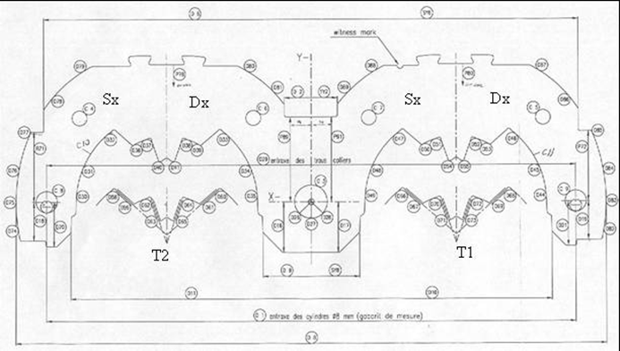
Fig. 4: Numbered measurement positions on collar A1.

Fig. 5: Comparison of outer dimensions of the collared coils 2049 and 2549 with a production sample. The measurement positions are shown in Fig. 6.

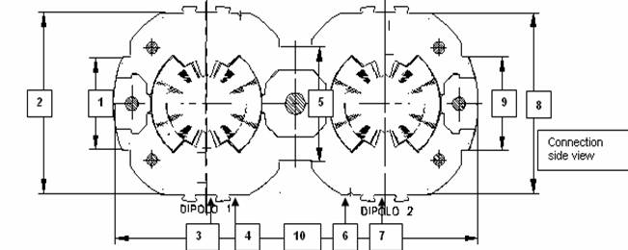
Fig. 6: Measurement positions of the outer coil dimensions on collared coils.

Analysis of the SMM:
The analysis of the short mole measurement in ap. 1 shows red and yellow alarms in 78 positions (out of 105) in the straight part of which I have carried out an inverse calculation of 19 positions. Most of these positions indicated a block 6 or a combined block5/block 6 movement radially inwards located in quadrants 1 and 2 (this is the pole which had the quench heater problem), see Fig. 7. Some positions do not give a clear solution. The results of the inverse calculation are shown in Table 1, and figures 8 and 9 show multipoles b3 and b7 in ap. 1 versus the magnet axis, measured with the standard mole and the short mole together with the alarm limits given at 4 σ (dashed line) and 8 σ (continuous line).

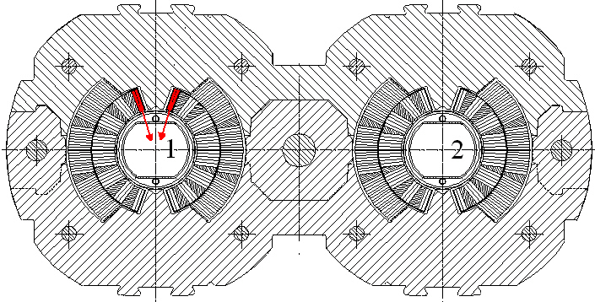
Fig. 7: Expected block 6 movements in quadrants 1 and 2 from inverse calculation.

Table 1: Expected defects on CC 2549 in aperture 1 from inverse calculation of individual positions.
Inverse Calculation on CC 2549
Quadrant | 1 | 1 | 1 | 1,2,3 | 1 | 1 | 2 | 2 | 2 | 2 | 1
Ampl (mm) | 0.35 | 0.35 | 0.35 | 0.40 | 0.30 | 0.55 | 0.10 | 0.25 | 0.35 | 0.20 | 0.25
Defect type | block 6 | block 6 | block 6 | block 6 | block 6 | block 6 | block 6 | block 6 | block 6 | block 6 | block 5-6
Position | 19 | 30 | 34 | 59 | 71 | 72 | 74 | 75 | 78 | 79 | 80
Aperture | 1 | 1 | 1 | 1 | 1 | 1 | 1 | 1 | 1 | 1 | 1
Quadrant | 1 | 1 | 1 | 2,3 |  |  | 3,4
Ampl (mm) | 0.20 | 0.30 | 0.25 | 0.20 | no clear  result | no clear  result | 0.20 | no clear  result | no clear  result
Defect type | block 5-6 | block 6 | block 6 | block 6 | no clear  result | no clear  result | block 6 | no clear  result | no clear  result
Position | 81 | 82 | 83 | 104 | 105 | 106 | 107 | 108 | 109
Aperture | 1 | 1 | 1 | 1 | 1 | 1 | 1 | 1 | 1

- Conclusion

The calculated movements of block 6 and block5/block 6 combinations in individual positions do not justify the request of a de-collaring and repair. However, the total number and the frequency of the defects indicate an overall bad quality of this collared coil. Since also the main field is too high in about 2/3 of the straight part, a re-opening and repair could be considered. Independent of whether a repair is carried out or not, this CC should be put on priority testing when send to CERN and I recommend to carry out a multipole measurement at cold.

