Assembly error of cold mass 2421 detected with warm magnetic measurements.

Fig. 1. the x section

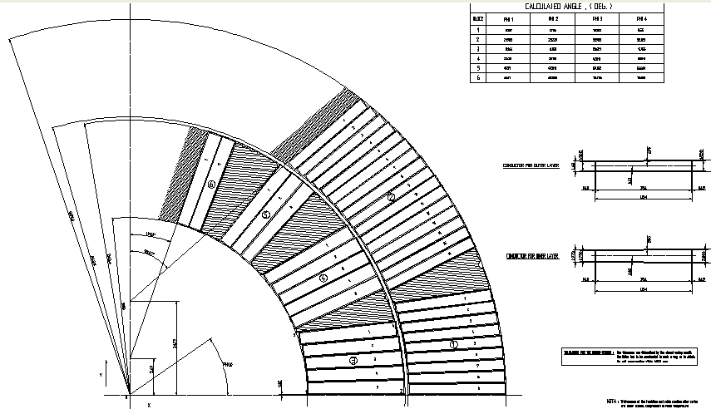

The position of the wrong Cu wedge in the inner layer

Figure 2. The correct Cu wedge  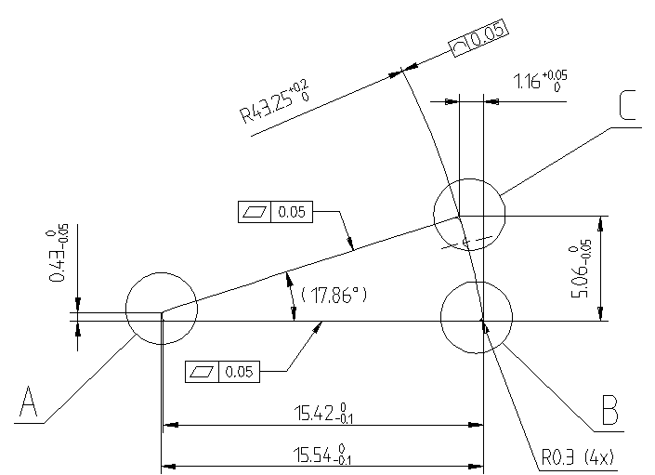 | Figure 3. The wrong Cu wedge  