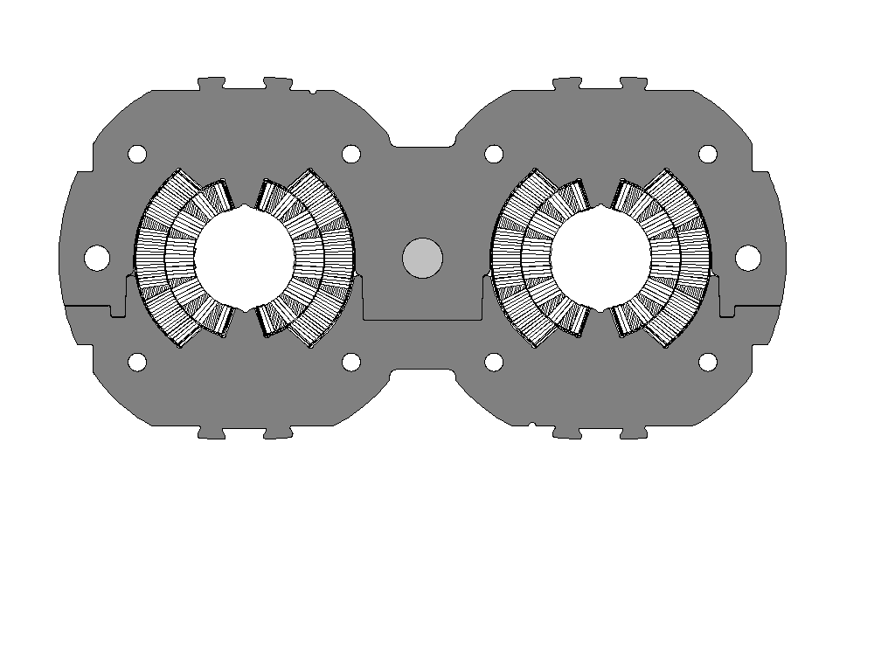
Collar-pack
2^{d}, 4th …collar witness mark
1st, 3, 5th…collar witness mark
Firm-2

