22/03/2004
EZIO SELVA S.R.L.
via Canova, 15
Corsico (MI)

CERN
attn. Mr. Savary

VISIT REPORT
Defects on outer layer cables

Place: EZIO SELVA S.R.L.
Date: 19/03/2004
Persons: EZIO SELVA: F. Chigorno (comm.. resp.), D. Gheoni (QA resp.)
CERN: J. Heer (Resident Inspector)
ASG: F. Terzi

Introduction
Scope of the visit was to check the quality of the outer layer cables delivered by CERN to Selva in the last weeks. In fact, during a visual inspection in ASG of OL cables of last deliveries, many cabling problems (strands out of position) were found.

Status of OL cables at SELVA
- SELVA has completed wrapping of OL cables nr.02B50501A & 02B50502A: a visual inspection of that cables, wounded on their rolls, didn't show any defects
- cable nr. 02B50501B was under wrapping process: we checked the strands before and after wrapping with Apical tape: no particular defect has been found
- cable nr. 02B50502B was wound on its original roll, without insulation, as received from CERN: no visible defect was detected. However, when it was unwound, straightened and connected to the end of the last wrapped cable to start wrapping, that cable clearly showed different strands out of position (see photo 1)
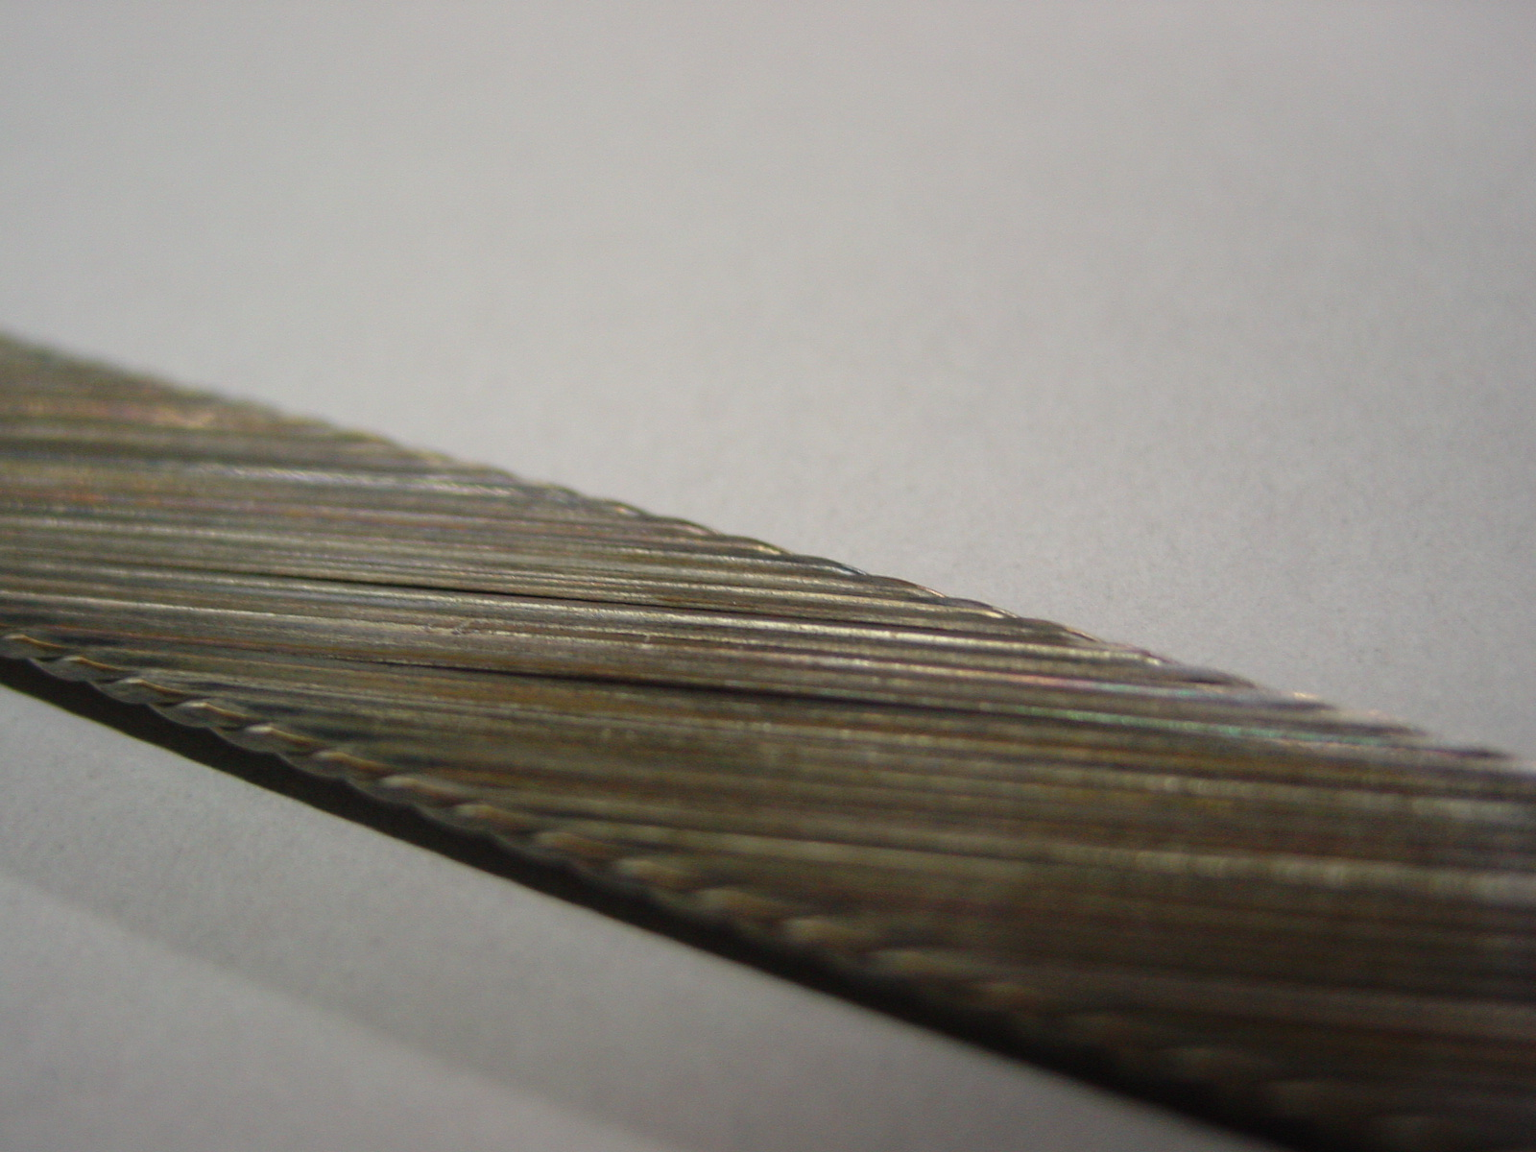
1 - Cable nr. 02B50502B just unwound, ready for wrapping

- then a more careful inspection of cable nr. 02B50501B after wrapping, showed the same cabling problem

Status of wrapping machine
- about the preparation of the cable and the set up of the wrapping machine, no changes were applied by SELVA since our last visit.
Each roll is installed on a support with a brake system: a dynamometer is connected to the brake in order to check and guarantee the tension of the cable at 185 N during wrapping. A calibration has been performed during the first set up of that system.
- all the installation of the wrapping machine (brake system, cleaning plant, wrapping device, electrical insulation check ystem) are working properly

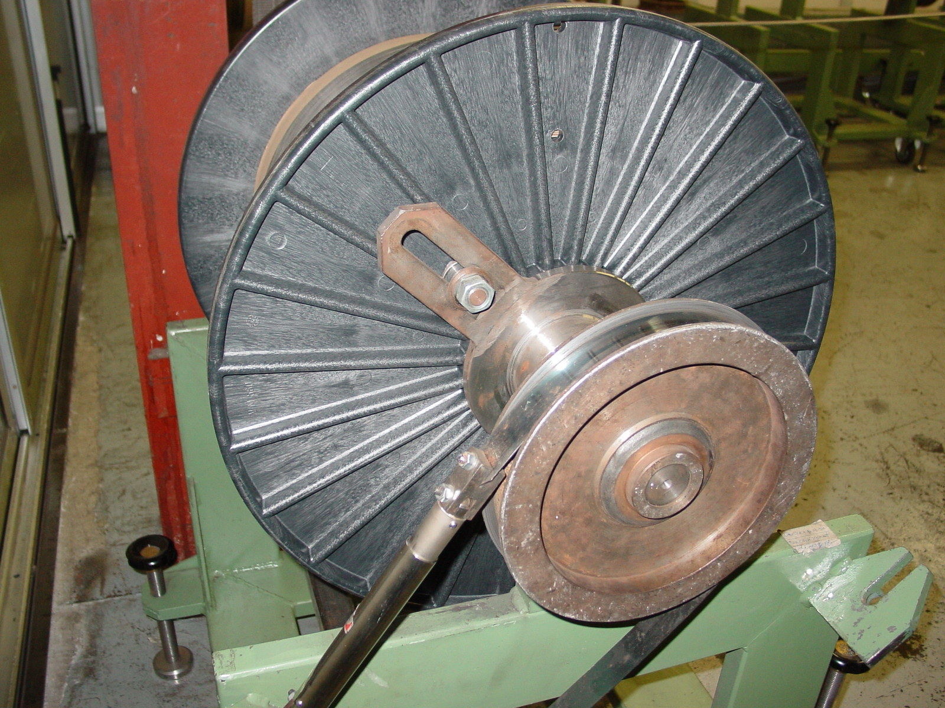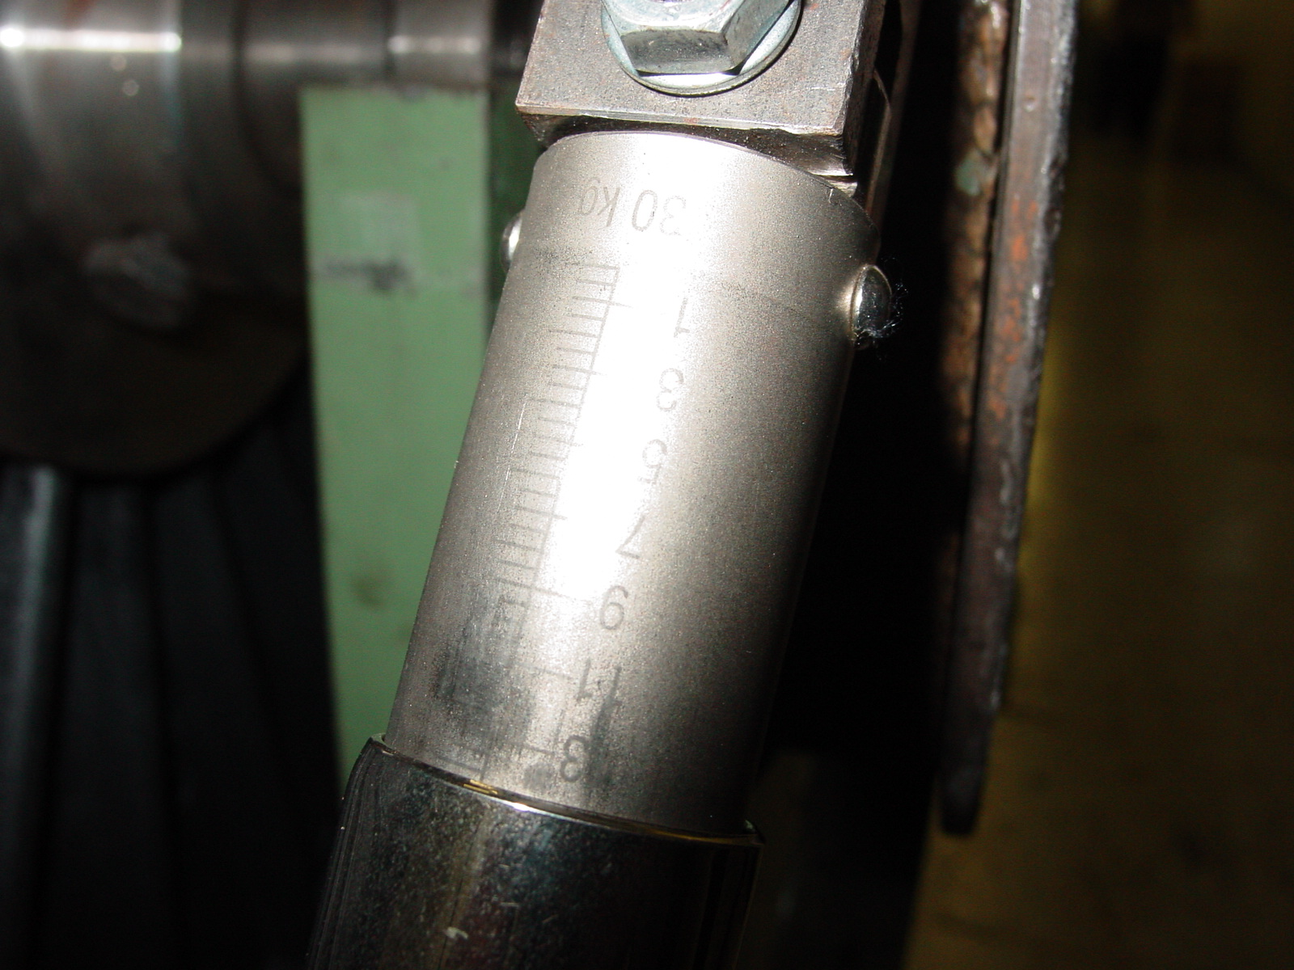
2 3

First conclusion
- cables under tension, wound on their original rolls or installed on the wrapping machine, doesn't show any visible defects
- cables free from any longitudinal tension show some strands out of position
- ASG decided not to start wrapping of OL nr. 02B50502B, waiting for CERN inspection. The same decision has been applied to the last 3 batches of OL cables, stored at SELVA in their original boxes
- a very soon visit by CERN personnel is necessary to avoid a possible stop or delay of production

Please note: SELVA pointed out that cables from last deliveries, showed more oxidation and so they had to change more frequently the alkaline solution for proper cleaning of the cables

F. Terzi

Remarks: please refer also to Mr. J. Heer visit report for further details and photos

