–

Non conformity Report
IDENTIFICATION
1. Originator’s Name: B.Caserza – F.Terzi | 5. Date: 10/09/2003
2. Contractor/Supplier: Ansaldo Superconduttori S.p.A. | 6. Part description: 02P00214
3. Contract No: F462/LHC/LHC | 7. Qty: 1
4. Project Engineer: F. Savary | 8. Dwg No: LHCMB__A0001/G (620RM08234/L)

9. Found during what activity:
□ Incoming inspection | □Final inspection
☑In-process inspection | □ Other:

10. Description of non conformity (use continuation page if necessary)
During collaring of CC 2054, at 300 bar of pressure, before inserting Ø13mm rods, HV electrical test at 2.6kV showed a discharge between QH YT121 (serial nr. ASGCICO-B0096) and 1st-2nd turns of outer layer 02E00217 of pole 02P00214.
We stopped collaring and verified that the discharge occurred at 4900mm from NCS.
Then we opened the collared coils along 2m aruond the region of the disharge and checked the problem: the QH metal strip cut the polyimide tape for about 10mm. See annexed photo for details.

11. Action taken to prevent misuse (use continuation page if necessary)

IMPORTANCE
12. | ☑ Non critical | □ Critical

DISPOSITION
13. | □ Use-as-is | ☑ Repair | □ Reject | □ Rework | □ Return to supplier
Description of proposed action (use continuation page if necessary)
The disposition is “repair” according to the proposal of Ansaldo formulated on the phone via Mr. G.Drago.
This disposition is implemented under the full responsibility of Ansaldo.
We (CERN) would like to point out the importance of such decision because the quench heaters are known to be a very critical item. It would have made sense to remove all collars and to inspect the damaged quench heater on its entire length and finally to replace it.

CORRECTIVE/PREVENTIVE ACTION
14. Description of proposed action (use continuation page if necessary)
This incident demonstrates clearly that there is a weak point somewhere in the quality assurance plan. Ansaldo must pay more attention when installing critical items like the quench heaters (what about incoming inspection at reception of the quench heaters at Ansaldo or visual check during their installation in a magnet?).
It must be clear that there cannot be room for taking any risk with critical items like the quench heaters. Ansaldo must take immediately measures to reinforce quality assurance in this respect.

APPROVAL OF NON CRITICAL NON CONFORMITIES
15 | Project Engineer: F.Savary | Date: September 15, 2003

APPROVAL OF CRITICAL NON CONFORMITIES
16 | Project Management: | Date:

CLOSURE OF THE NON CONFORMITY
Planned actions have been completed and corrective/preventive actions have been initiated
 | For non critical non conformities  Quality Manager or Project Engineer | For critical non conformities  Project Engineer
17 | Name: F. Terzi  Date: 16/09/2003 | Name:  Date:

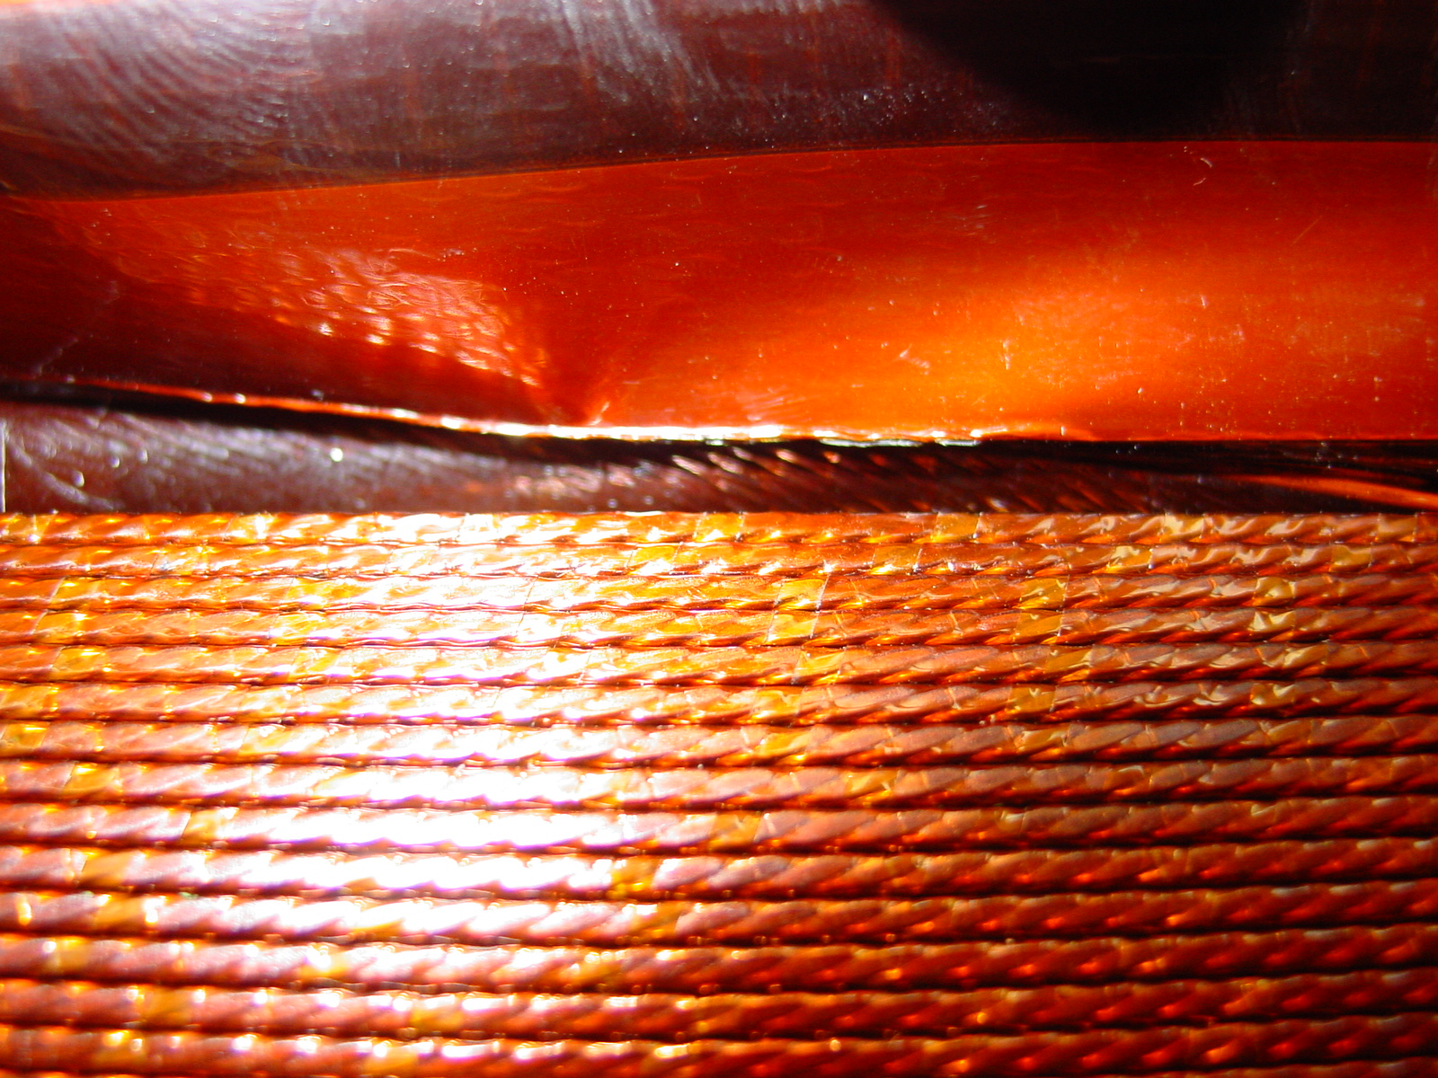
Quench Heater YT121 on CC 2054 (id. nr.ASGCICO-B0096)

