IDENTIFICATION
10. Description of non conformity (continuation page)
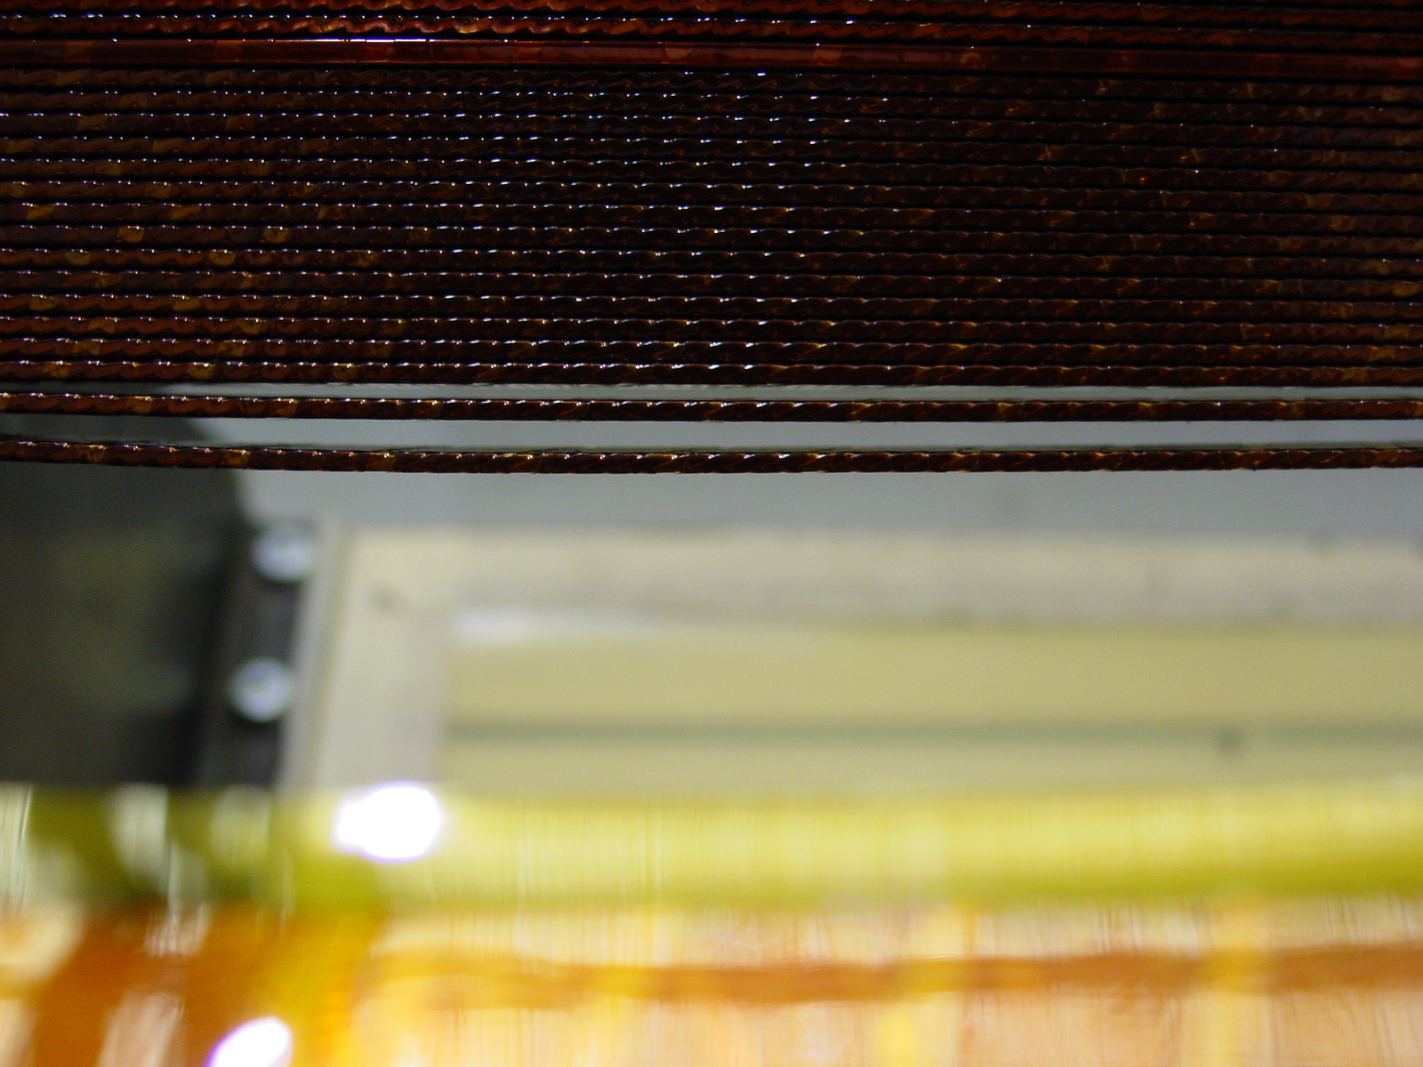02E00250 – NCS (1/2)

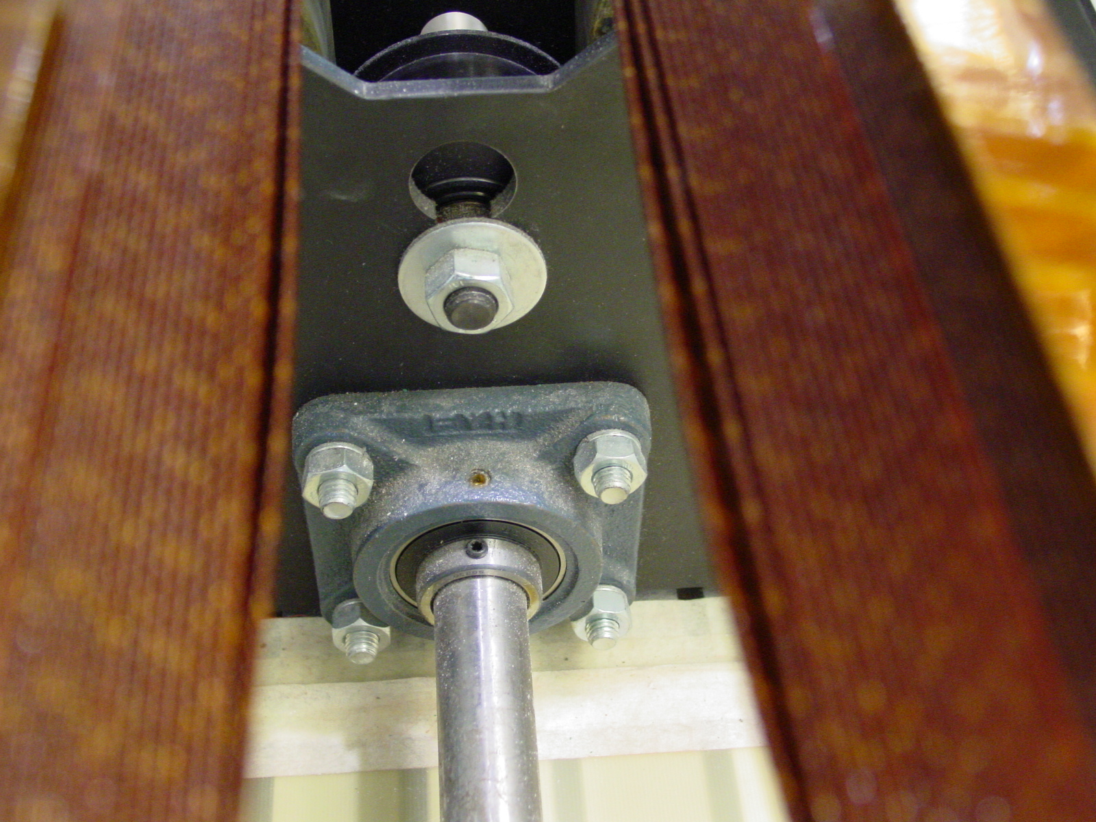02E00250 – NCS (2/2)

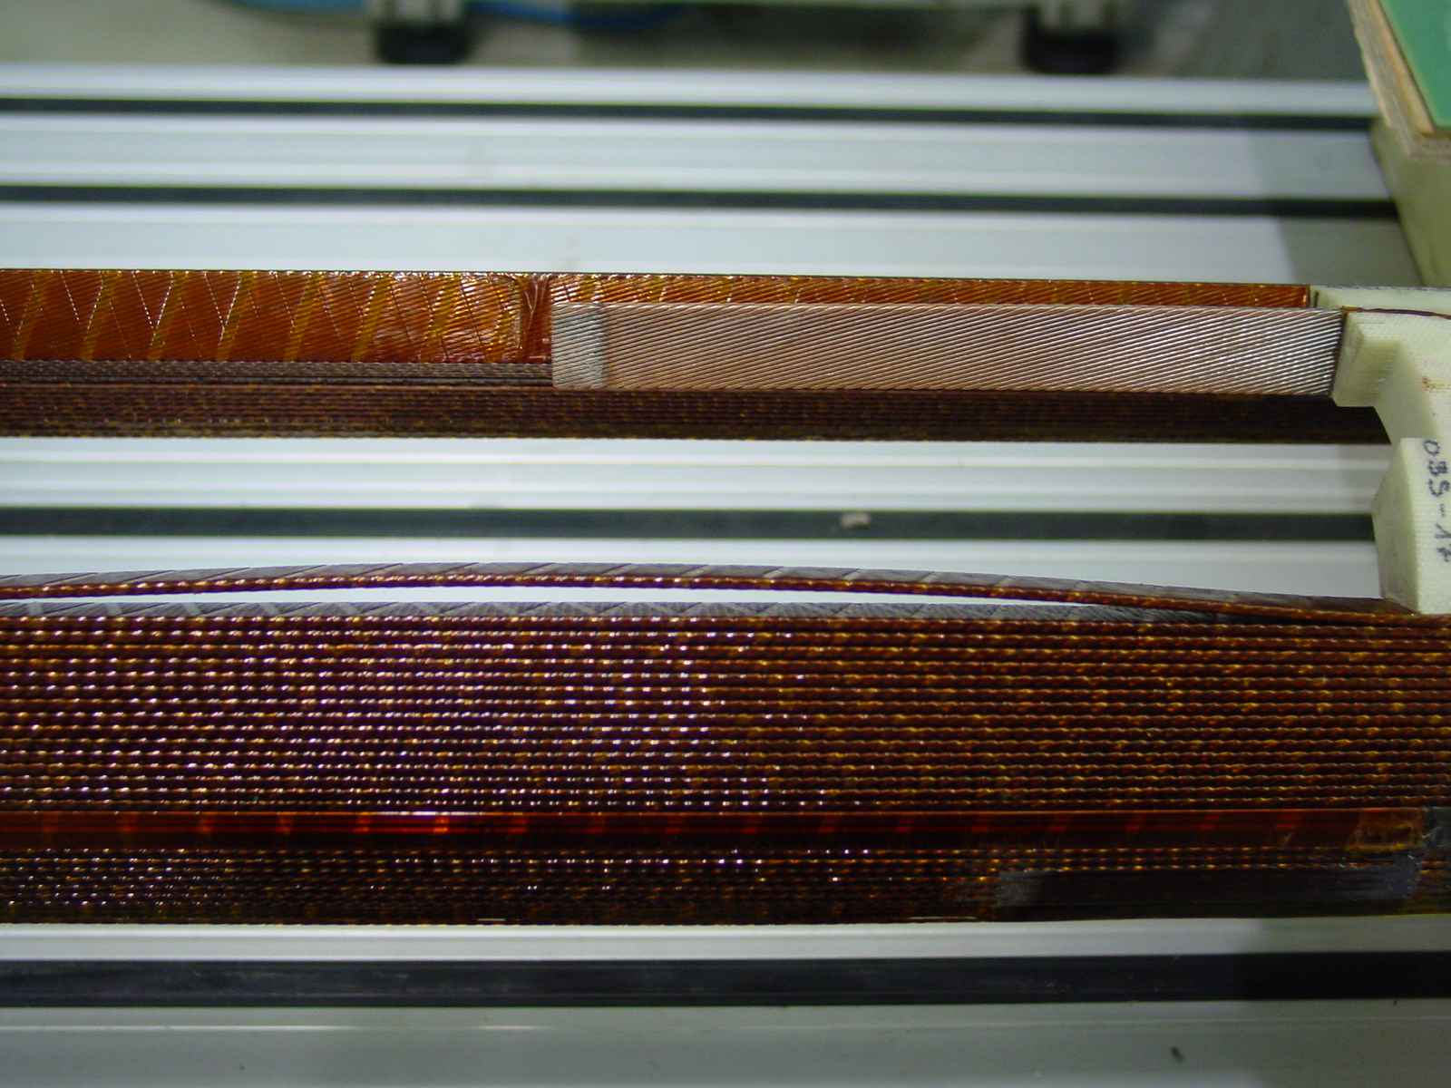02E00250 – CS (1/1)

