CLOSURE OF THE NON CONFORMITY
Here below are the photos about outer layer after repairing.

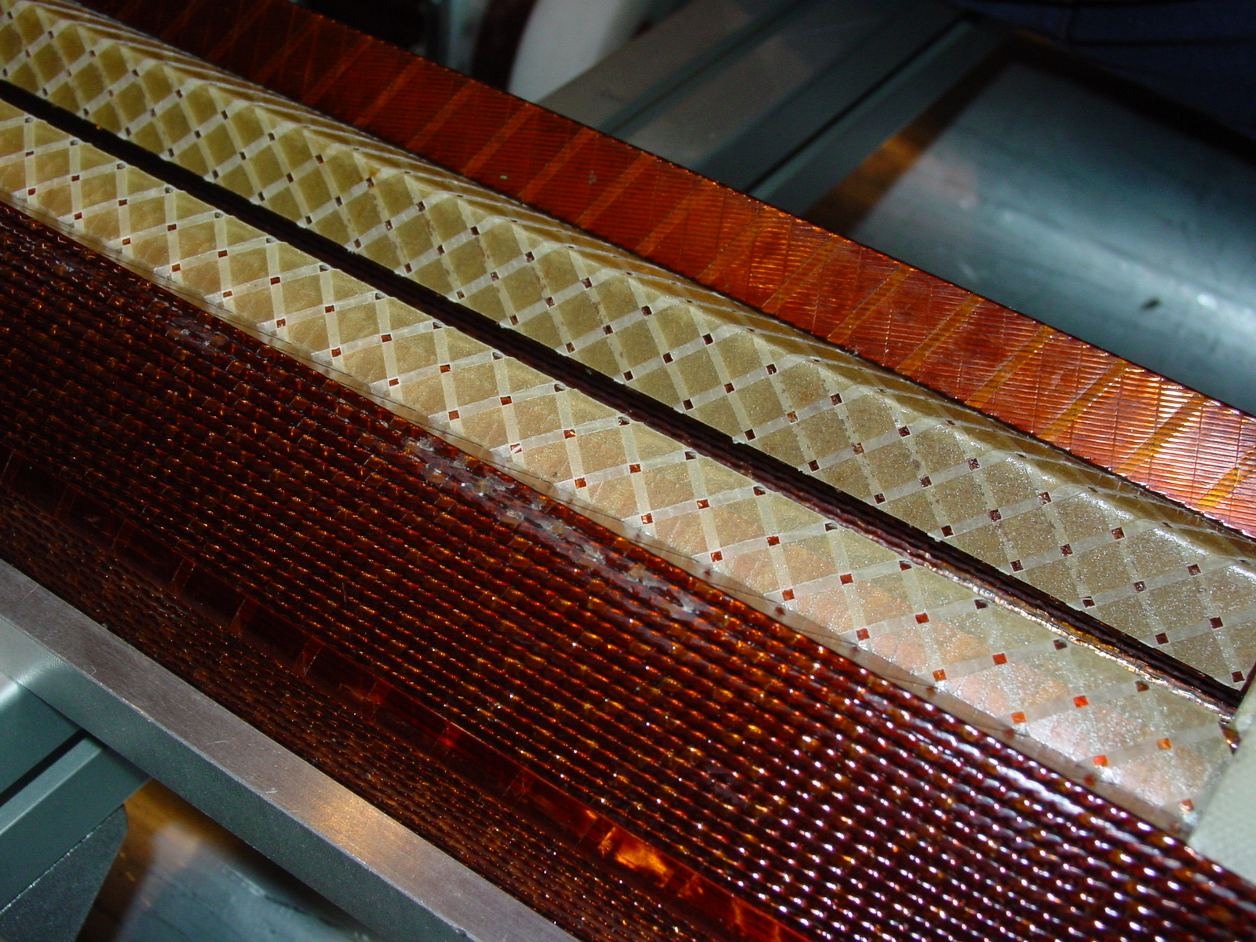02E00250 – NCS (1/2) – AFTER REPAIRING

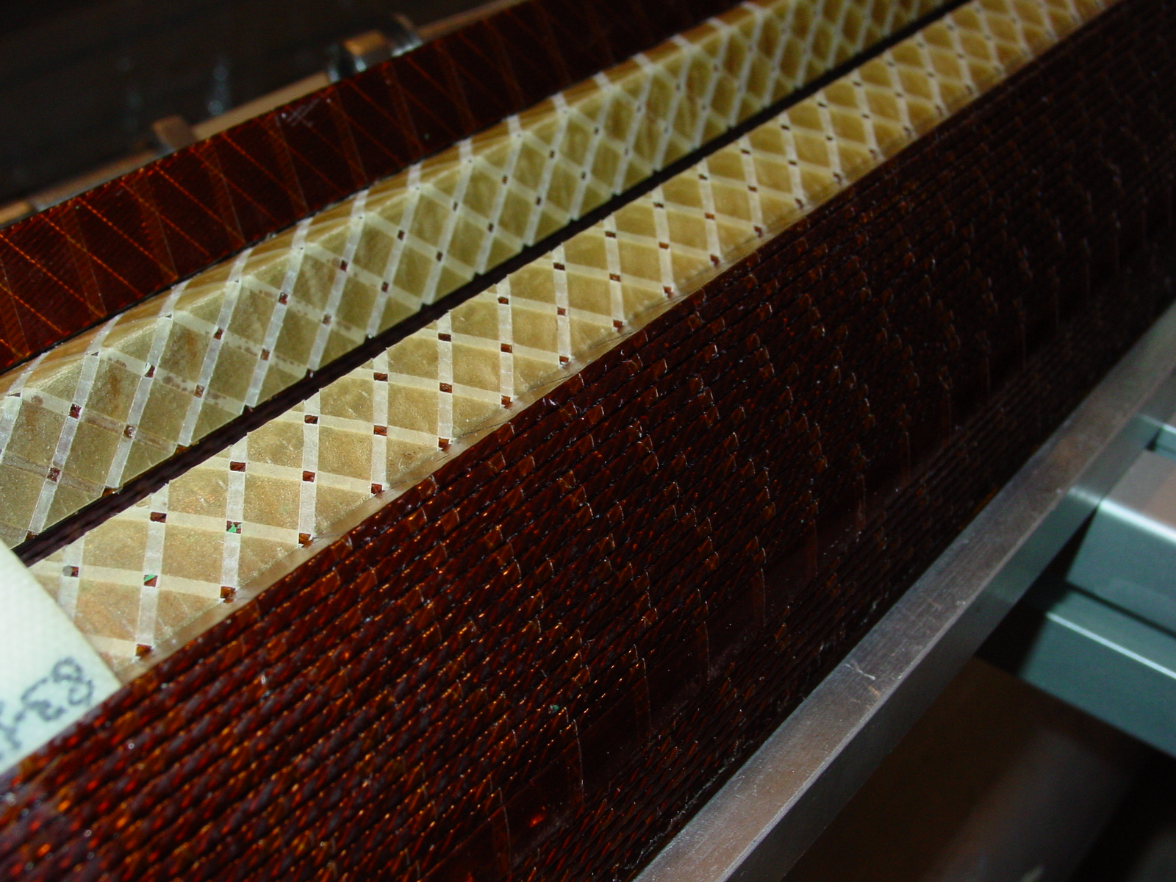02E00250 – NCS (2/2) – AFTER REPAIRING

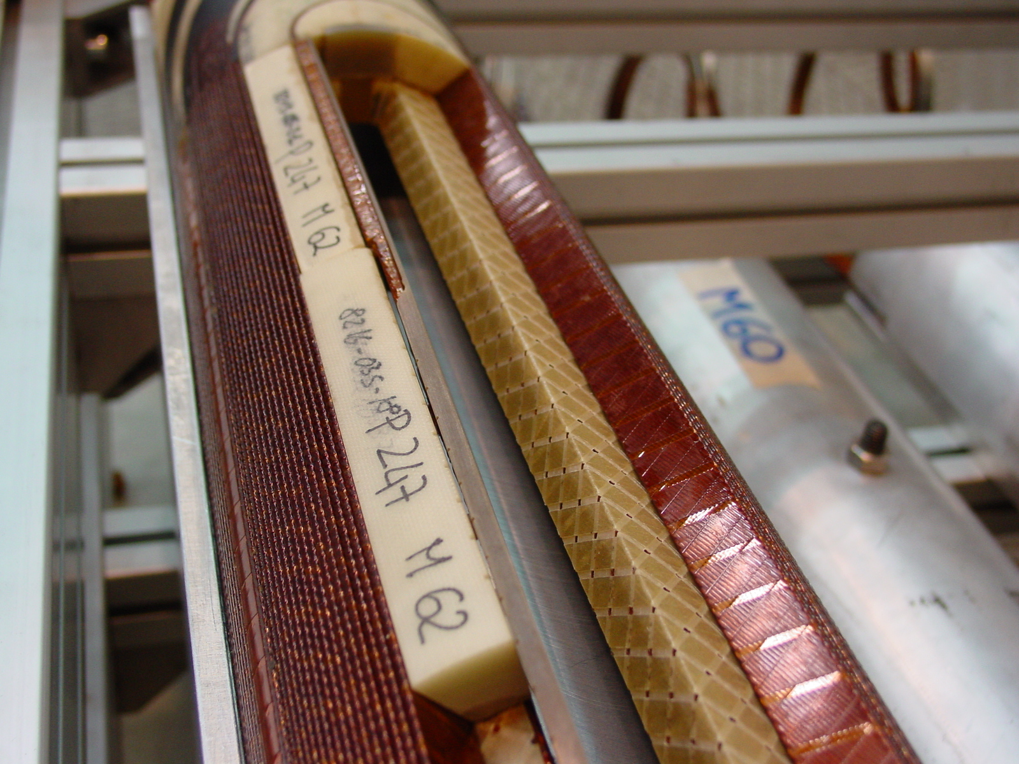02E00250 – CS (1/2) – AFTER REPAIRING

