–

Non conformity Report
IDENTIFICATION
1. Originator’s Name: F. Terzi | 5. Date: 02/10/2003
2. Contractor/Supplier: Ansaldo Superconduttori S.p.A. | 6. Part description: HCMBARA001-02000029
3. Contract No: F302/LHC/LHC | 7. Qty: 1
4. Project Engineer: F. Savary | 8. Dwg No: LHCMBB_A0002/F (683RM08451)

9. Found during what activity:
□ Incoming inspection | ☑ Final inspection
□ In-process inspection | □ Other:

10. Description of non conformity (use continuation page if necessary)
Final electrical measurements performed on CM 2029 showed a wrong value about corrector magnet MCO Apt1 – Bus 11/EE841.
Measured value=3293.69 mohm
Nominal value > 6500 mohm.
See next page for details.

11. Action taken to prevent misuse (use continuation page if necessary)

IMPORTANCE
12. |  □ Non critical | ☑ Critical

DISPOSITION
13. | ☑ Use-as-is | □ Repair | □ Reject | □ Rework | □ Return to supplier
Description of proposed action (use continuation page if necessary)
It is proposed to allow the manufacturer to deliver the magnet “as is”.
A first possibility is that the instrumentation wires added for the full test configuration in the manifold between M1 and M2 have not been connected correctly. In this case, the problem will be automatically solved during the stripping operation (these wires are removed at that stage).
A second possibility, which is more likely, is that the voltage tap EE841 has been connected on the wrong side of the corrector, as indicated in the enclosed sketch. In this case the voltage tap cannot serve in the machine. Should it be the case, we propose to use the magnet “as is”.

CORRECTIVE/PREVENTIVE ACTION
14. Description of proposed action (use continuation page if necessary)
Ansaldo to reinforce quality control to avoid this kind of mistake.
Ansaldo to indicate clearly in the traveller of 2029 the id number of the edms document related to the said non-conformity, insisting on the content of the non conformity. The document id number is 407043.

APPROVAL OF NON CRITICAL NON CONFORMITIES
15 | Project Engineer: | Date:

APPROVAL OF CRITICAL NON CONFORMITIES
16 | Project Management: F.Savary | Date: October 16th, 2003

CLOSURE OF THE NON CONFORMITY
Planned actions have been completed and corrective/preventive actions have been initiated
 | For non critical non conformities  Quality Manager or Project Engineer | For critical non conformities  Project Engineer
17 | Name:  Date: | Name: F.Savary  Date: October 16th, 2003

Final measurements at ITP 25c

R[dc] of the Spools |  |  | ITP 25c
I = | 1.00 | A | Apt 1 | [ext] |  | Apt 2 | [int]
 | Connection Side |  | [mΩ] |  |  | [mΩ]
 | MCO |  | 3293.69 | EE841/Aux.2 |  | 3283.80 | EE941/Aux.12
 |  | Nr. MC0 | MA-I-0210 |  |  | MA-I-0211 | #RIF!
 | MCD |  | -4317.86 | EE851/Aux.4 |  | -2110.00 | EE951/Aux.14
 |  | Nr. MCD | MA-I-0210 |  |  | MA-I-0211
 | Lyra Side
 | MCS |  | -2312.94 | EE831/Aux.10 |  | -104.96 | EE931/Aux.20
 |  | Nr. MCS | MA-I-0155 |  |  | MA-I-0243

First possible explanation (not likely): Instrumentation wires added in the manifold for the full test configuration have not been connected correctly (see following layouts).

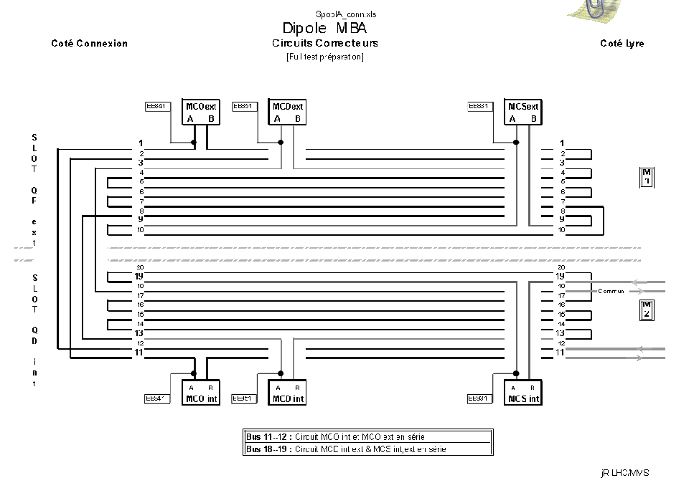
Right connection

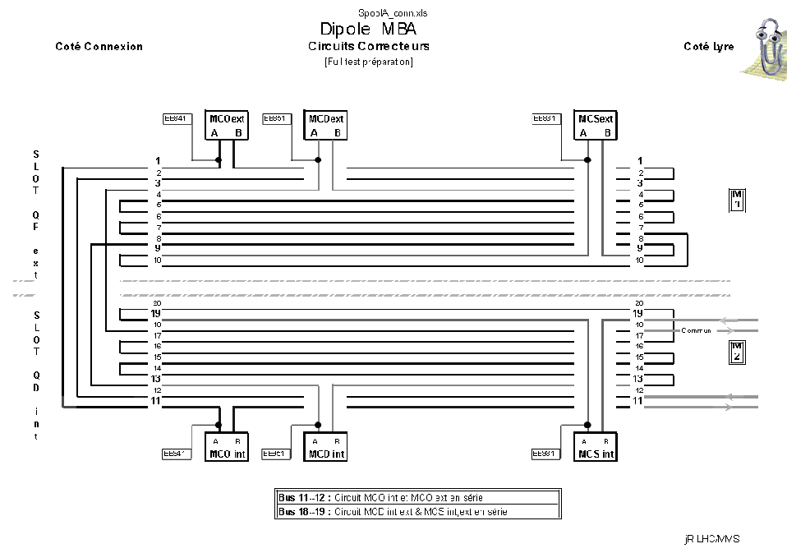
Wrong connection
Second possible explanation (likely): the voltage tap EE841 has been connected on the wrong side of the corrector

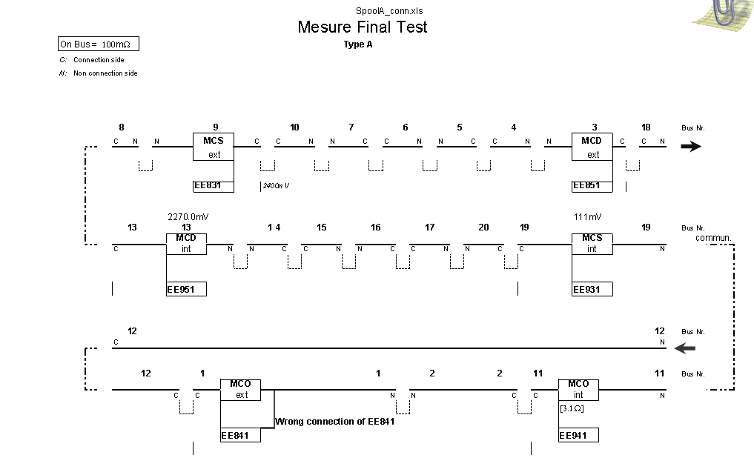
Additional measurements showed that the resistance of the circuit between terminals 11 and 12 is 6.692 Ω indicating that both correctors are sound.

