–

Non conformity Report
IDENTIFICATION
1. Originator’s Name: F.Terzi | 5. Date: 02/10/2003
2. Contractor/Supplier: Ansaldo Superconduttori S.p.A. | 6. Part description: 02E00274
3. Contract No: F462/LHC/LHC | 7. Qty: 1
4. Project Engineer: F. Savary | 8. Dwg No: LHCMB__A0012/E (620RM08202/F)

9. Found during what activity:
□ Incoming inspection | □ Final inspection
☑ In-process inspection | □ Other:

10. Description of non conformity (use continuation page if necessary)
After curing of outer layer 02E00274, first turn (from 190mm to 600mm from end) and Cu wedge (along 40mm) are not completely glued in the region near CS: see annexed photo on next page.
This problem has been already showed to Mr. A. Musso (CERN) during his visit in ASG on 02/10/2003.
The layer was made with the new winding machine. ASG propose to glue the detached turn and the Cu wedge by epoxy resin using the same tools we use for the re-conditioning of the layer jump region.

11. Action taken to prevent misuse (use continuation page if necessary)

IMPORTANCE
12. | ☑ Non critical | □ Critical

DISPOSITION
13. | □ Use-as-is | ☑ Repair | □ Reject | □ Rework | □ Return to supplier
Description of proposed action (use continuation page if necessary)
The repair can be done following the method proposed here above but this is to be done under full responsibility of Ansaldo Superconduttori.

CORRECTIVE/PREVENTIVE ACTION
14. Description of proposed action (use continuation page if necessary)
Measures have to be taken to trace back the cause of such adhesion failures. This may be due to mistakes during the curing cycle, lack of cleanliness of the components of the coils. Ansaldo Superconduttori should investigate seriously on the possible cause(s) of the problem because such detachments are for sure the cause of the problems observed on c.c.2032 and c.c.2035.

APPROVAL OF NON CRITICAL NON CONFORMITIES
15 | Project Engineer: F.Savary | Date: December 19th, 2003

APPROVAL OF CRITICAL NON CONFORMITIES
16 | Project Management: | Date:

CLOSURE OF THE NON CONFORMITY
Planned actions have been completed and corrective/preventive actions have been initiated
 | For non critical non conformities  Quality Manager or Project Engineer | For critical non conformities  Project Engineer
17 | Name: F. Terzi  Date: 22/12/2003 | Name:  Date:

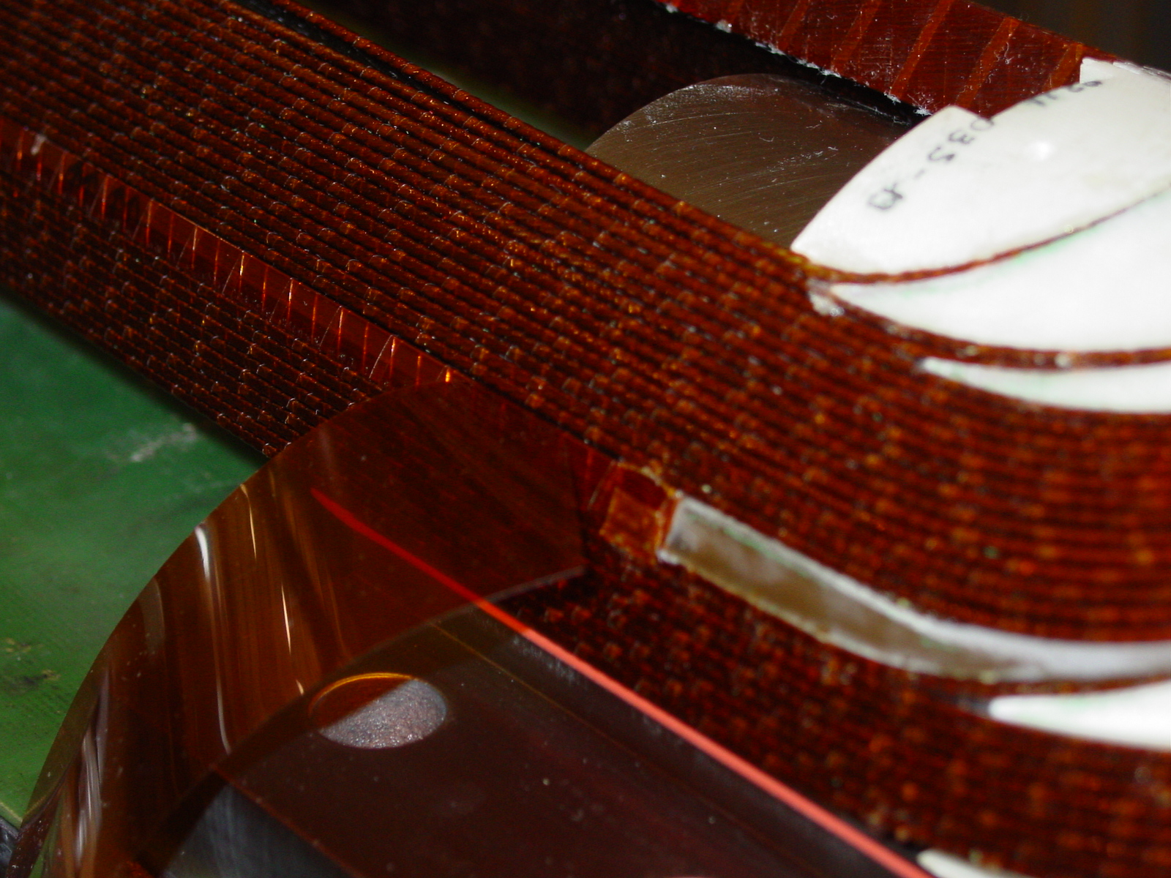
outer layer 02E00274 – connection side

