–

Non conformity Report
IDENTIFICATION
1. Originator’s Name: B.Caserza – F.Terzi | 5. Date: 15/10/2003
2. Contractor/Supplier: Ansaldo Superconduttori S.p.A. | 6. Part description: 02E00285
3. Contract No: F462/LHC/LHC | 7. Qty: 1
4. Project Engineer: F. Savary | 8. Dwg No: LHCMB__A0012/E (620RM08202/F)

9. Found during what activity:
□ Incoming inspection | □ Final inspection
☑ In-process inspection | □ Other:

10. Description of non conformity (use continuation page if necessary)
During winding of outer layer 02E00252 (sc cable nr. 02K18601D) a crash of the winding machine CSA1 occurred and the spool fell down to ground.
ASG checked the cable: nor the polyimide insulation, nor the cable has been damaged.
See annexed photos for details.

11. Action taken to prevent misuse (use continuation page if necessary)

IMPORTANCE
12. | ☑ Non critical | □ Critical

DISPOSITION
13. | ☑ Use-as-is | □ Repair | □ Reject | □ Rework | □ Return to supplier
Description of proposed action (use continuation page if necessary)
Because no damage was caused to the cable, it can be used as is.
Be aware that such disposition is to be taken under full responsibility of Ansaldo Superconduttori.

CORRECTIVE/PREVENTIVE ACTION
14. Description of proposed action (use continuation page if necessary)

APPROVAL OF NON CRITICAL NON CONFORMITIES
15 | Project Engineer: F.Savary | Date: December 19th, 2003

APPROVAL OF CRITICAL NON CONFORMITIES
16 | Project Management: | Date:

CLOSURE OF THE NON CONFORMITY
Planned actions have been completed and corrective/preventive actions have been initiated
 | For non critical non conformities  Quality Manager or Project Engineer | For critical non conformities  Project Engineer
17 | Name: F. Terzi  Date: 22/12/2203 | Name:  Date:

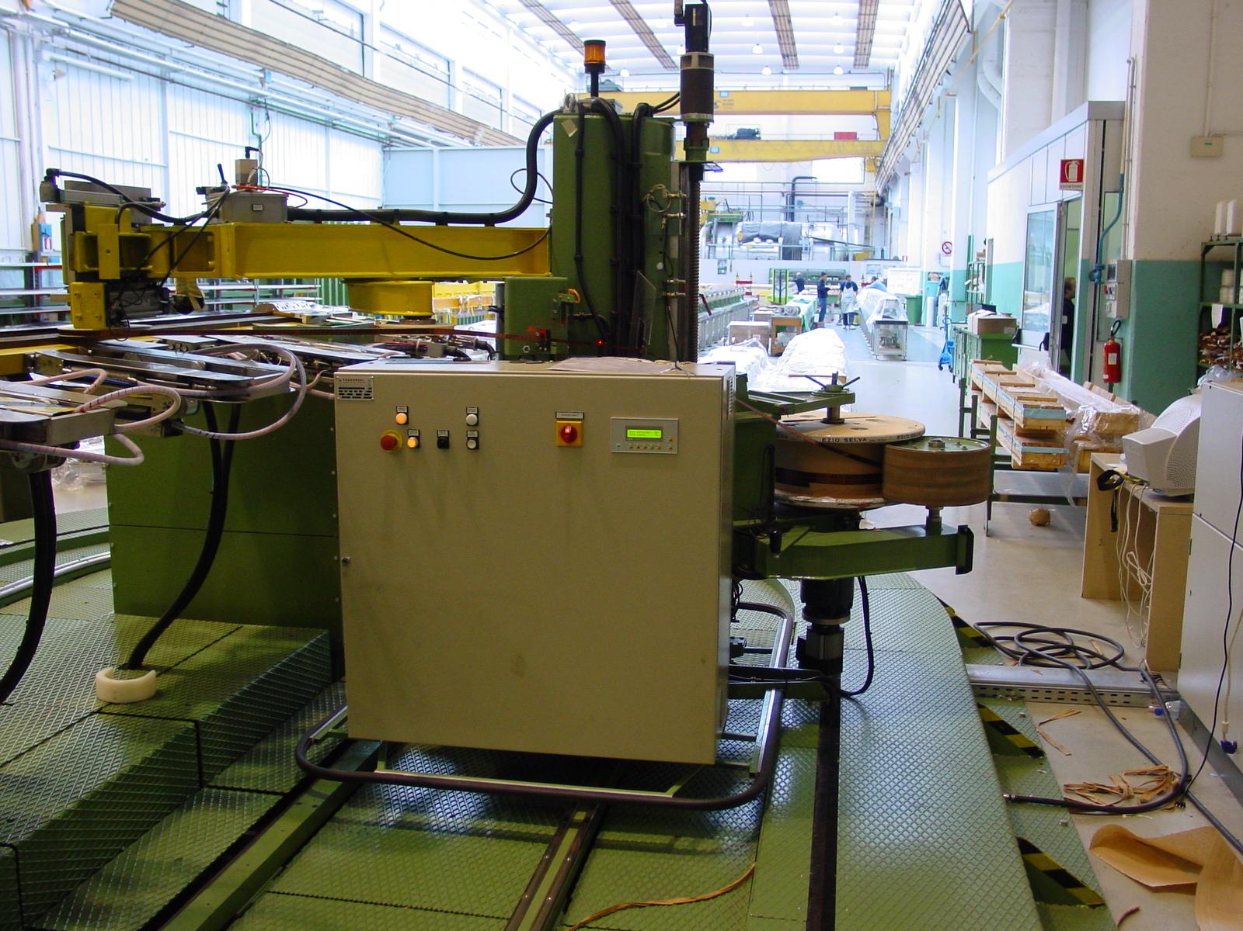
1/5
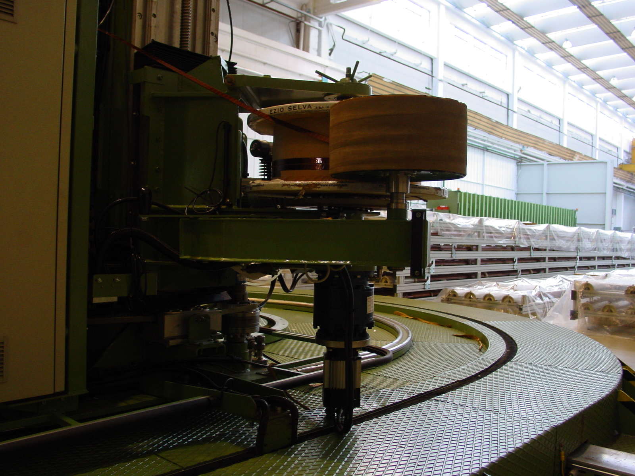
2/5
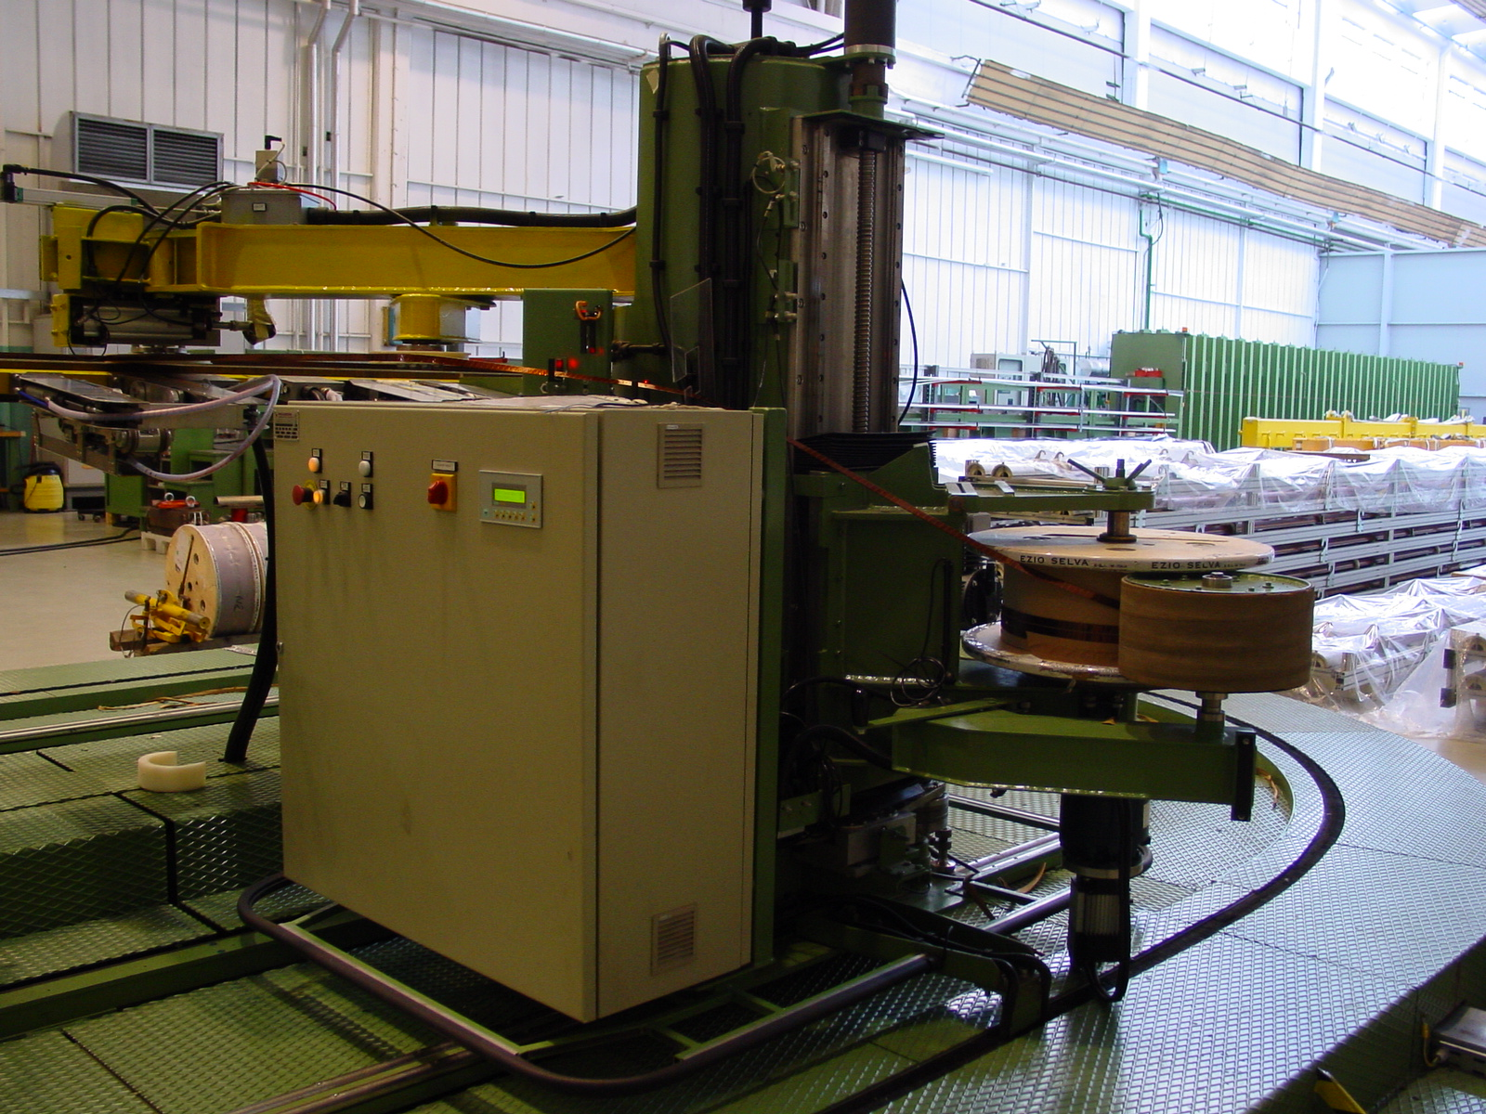
3/5
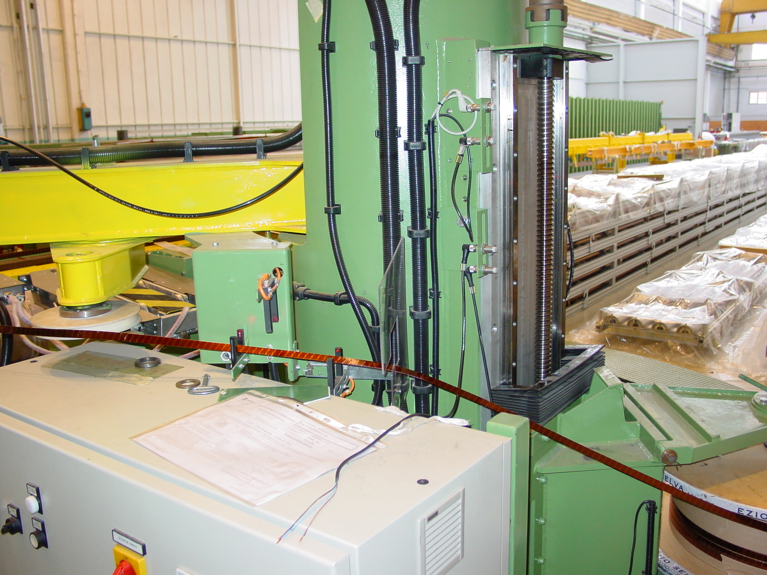
4/5
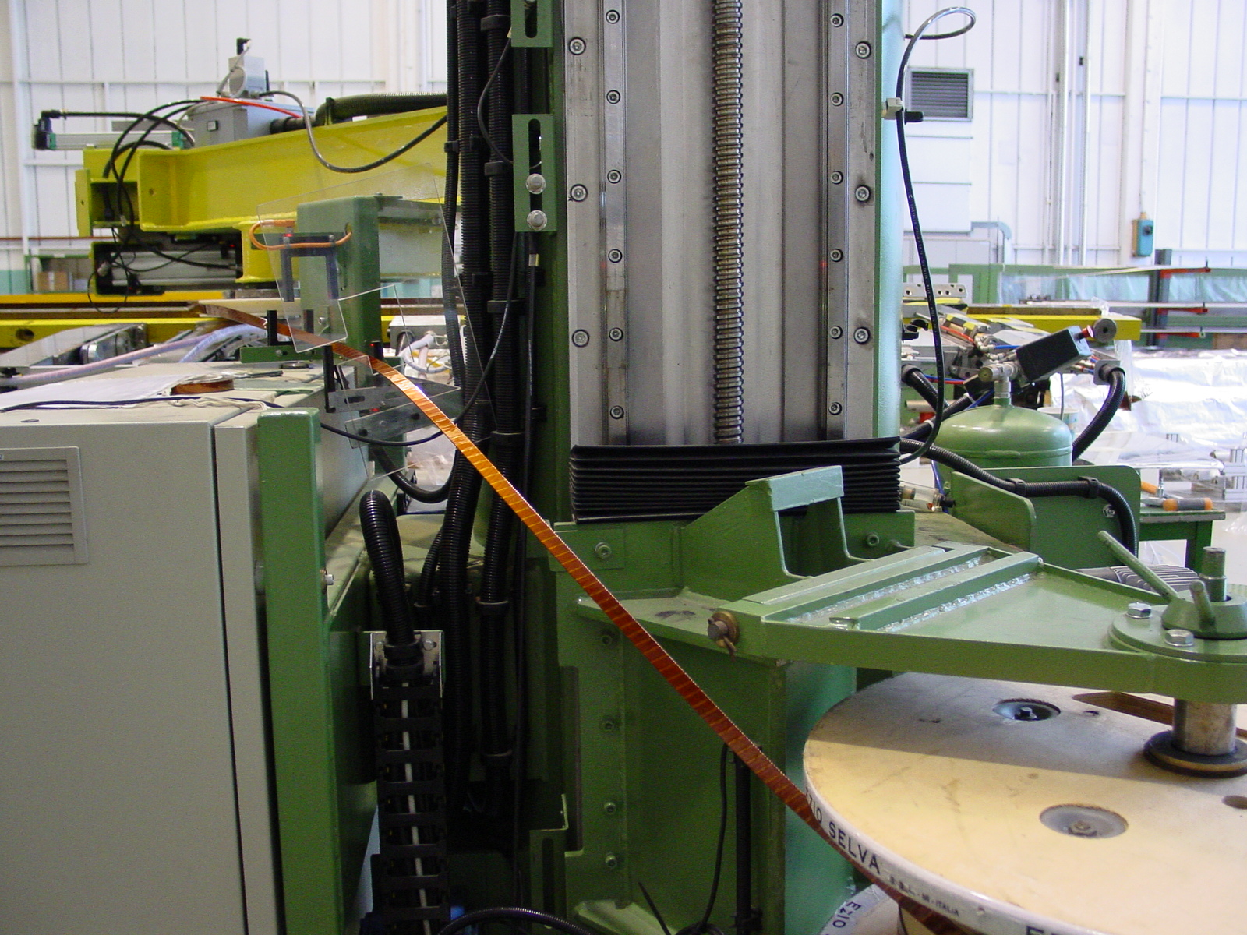
5/5

