–

Non conformity Report
IDENTIFICATION
1. Originator’s Name: B.Caserza – F. Terzi | 5. Date: 28/10/2003
2. Contractor/Supplier: Ansaldo Superconduttori S.p.A. | 6. Part description: Pole 02P00259
3. Contract No: F462/LHC/LHC | 7. Qty: 1
4. Project Engineer: F. Savary | 8. Dwg No: LHCMB__A0010/D (620RM08203/F)

9. Found during what activity:
□ Incoming inspection | □Final inspection
☑In-process inspection | □ Other:

10. Description of non conformity (use continuation page if necessary)
During electrical test, with end under load, on pole 02P00259 (cold mass 2065), an anomalous L value has been detected. Then resistance measurement and discharge test showed a short circuit on CS between 6th and 7th turn of inner layer 02I00262 (SC cable 01B10279A).
See annex photo for details.
Note: critical current of SC cable Ic=538A (min. required Ic=491A)
Pole is left pending, waiting for CERN inspection.

11. Action taken to prevent misuse (use continuation page if necessary)

IMPORTANCE
12. | ☑ Non critical | □ Critical

DISPOSITION
13. | □ Use-as-is | □ Repair | ☑ Reject | □ Rework | □ Return to supplier
Description of proposed action (use continuation page if necessary)
The layer cannot be used in these conditions. It is definitely rejected (after visual inspection in ASG premises).

CORRECTIVE/PREVENTIVE ACTION
14. Description of proposed action (use continuation page if necessary)

APPROVAL OF NON CRITICAL NON CONFORMITIES
15 | Project Engineer: F.Savary | Date: December 19th, 2003

APPROVAL OF CRITICAL NON CONFORMITIES
16 | Project Management: | Date:

CLOSURE OF THE NON CONFORMITY
Planned actions have been completed and corrective/preventive actions have been initiated
 | For non critical non conformities  Quality Manager or Project Engineer | For critical non conformities  Project Engineer
17 | Name: F. Terzi  Date: 22/12/2003 | Name:  Date:

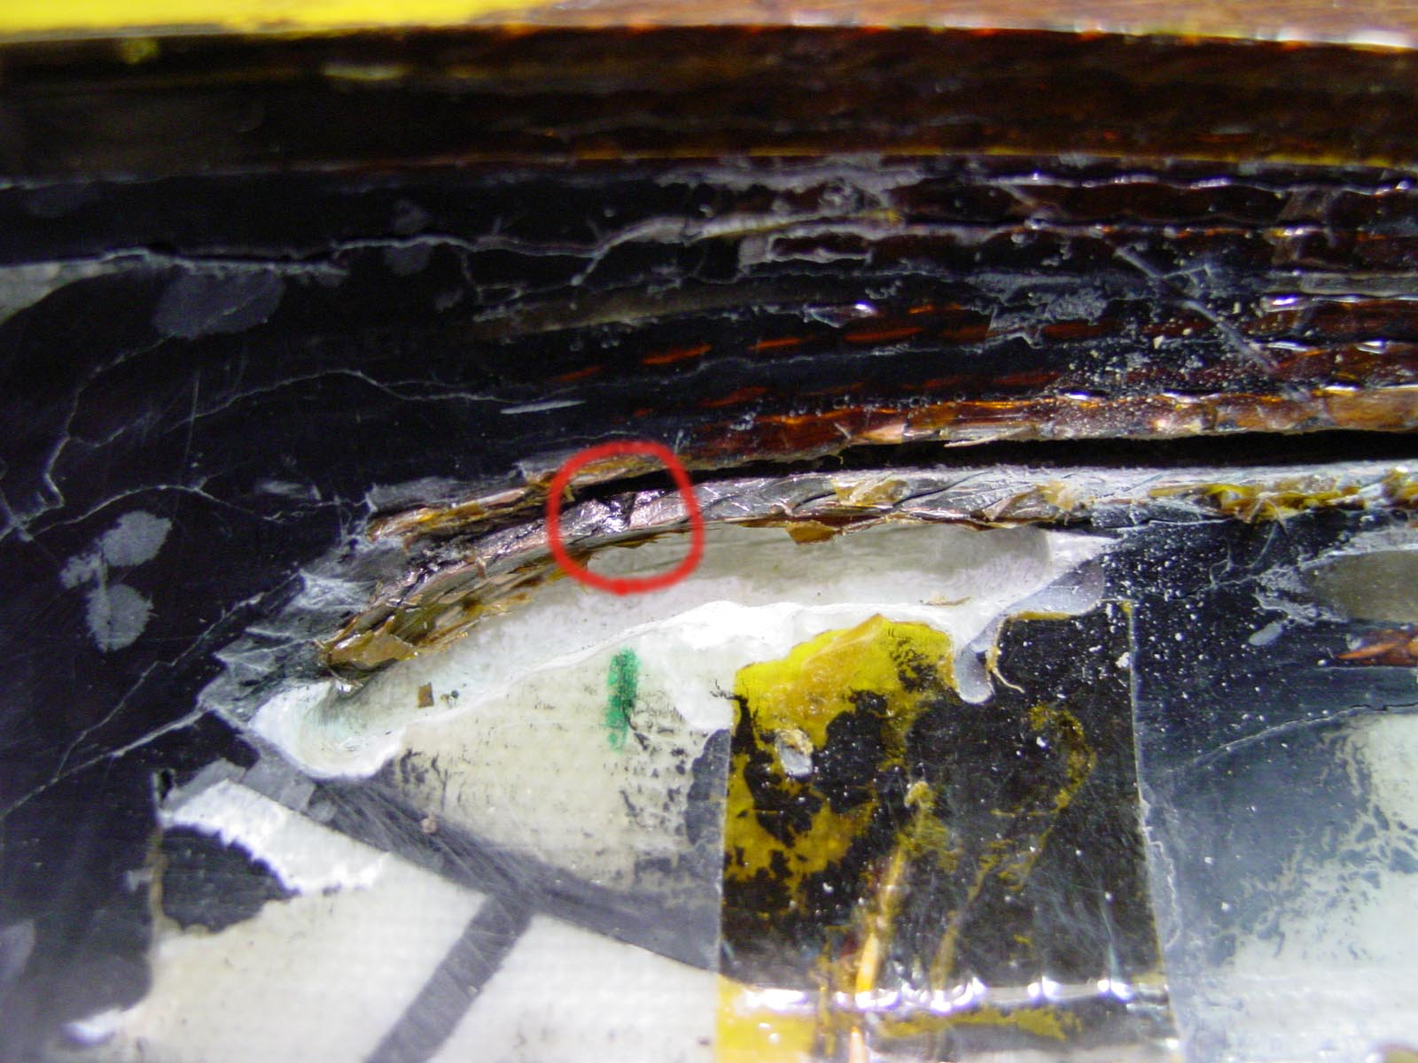Inner layer 02I00262

