–

Non conformity Report
IDENTIFICATION
1. Originator’s Name: F. Terzi | 5. Date: 11/11/2003
2. Contractor/Supplier: Ansaldo Superconduttori S.p.A. | 6. Part description: HCMBA_A001-02000054
3. Contract No: F462/LHC/LHC | 7. Qty: 1
4. Project Engineer: F. Savary | 8. Dwg No: LHCMBB_A0002/F (683RM08451)

9. Found during what activity:
□ Incoming inspection | □ Final inspection
☑ In-process inspection | □ Other:

10. Description of non conformity (use continuation page if necessary)
After welding of end –covers on CM 2054, a visual check showed a swap of wires nr.1 & 2 about auxiliary bus-bars installed on M1-line. This means that wires nr.1 & 2 are in reversed position.
However, the identification of wires nr.1 & 2 is correct.
This problem is related to a manufacturing error of the supplier of the bus-bars and cannot be solved by ASG because the auxiliary bus bars are joined together by resin.
See sketch about the connections on next page.

11. Action taken to prevent misuse (use continuation page if necessary)

IMPORTANCE
12. | ☑ Non critical | □ Critical

DISPOSITION
13. | ☑Use-as-is | □ Repair | □ Reject | □ Rework | □ Return to supplier
Description of proposed action (use continuation page if necessary)
"Use-as-is", disposition acceptable after checking with Mr. J.P.Tock at CERN before delivery of the magnet.
Important to put a clear warning on the magnet to draw the user at CERN during testing, stripping and installation.

CORRECTIVE/PREVENTIVE ACTION
14. Description of proposed action (use continuation page if necessary)

APPROVAL OF NON CRITICAL NON CONFORMITIES
15 | Project Engineer: F. Savary | Date: 20/11/2003

APPROVAL OF CRITICAL NON CONFORMITIES
16 | Project Management: | Date:

CLOSURE OF THE NON CONFORMITY
Planned actions have been completed and corrective/preventive actions have been initiated
 | For non critical non conformities  Quality Manager or Project Engineer | For critical non conformities  Project Engineer
17 | Name: F. Terzi  Date: 20/11/2003 | Name:  Date:

Cold mass 2054

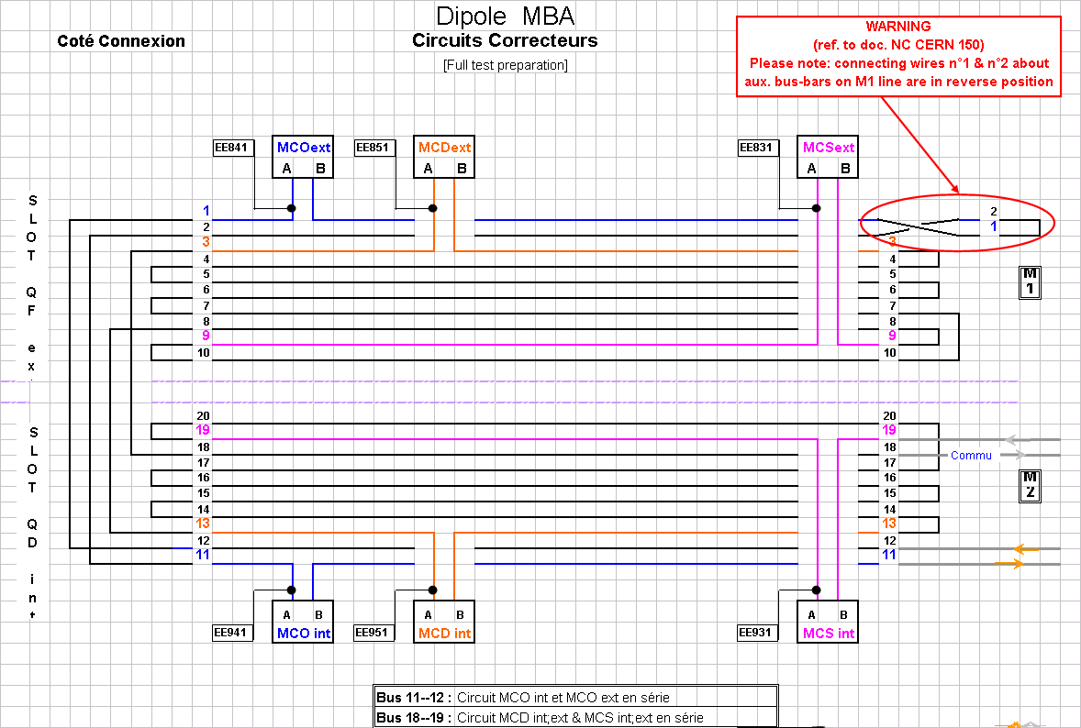

Fig.1 – Sketch of electrical connection of auxiliary bus bar: a reverse position of wires n.1 & 2 is on M1 line

