–

Non conformity Report
IDENTIFICATION
1. Originator’s Name: F. Terzi | 5. Date: 23/01/2004
2. Contractor/Supplier: Ansaldo Superconduttori S.p.A. | 6. Part description: Bus-bar A186
3. Contract No: F462/LHC/LHC | 7. Qty: 1
4. Project Engineer: F. Savary | 8. Dwg No: HCDCBHA055

9. Found during what activity:
□ Incoming inspection | □ Final inspection
☑ In-process inspection | □ Other:

10. Description of non conformity (use continuation page if necessary)
During electrical connection of bus-bars, after longitudinal welding of CM 2066, we found a deformation of the bus-bars nr.A186 for diode connection (bus-bars set nr. HCDCBHA055-BI000186)
Besides this bus-bar is in contact with bus-bar nr.A186/C.
(see next page for detailed photos)

11. Action taken to prevent misuse (use continuation page if necessary)

IMPORTANCE
12. | □ Non critical | □ Critical

DISPOSITION
13. | □ Use-as-is | □ Repair | □ Reject | □ Rework | □ Return to supplier
Description of proposed action (use continuation page if necessary)

CORRECTIVE/PREVENTIVE ACTION
14. Description of proposed action (use continuation page if necessary)

APPROVAL OF NON CRITICAL NON CONFORMITIES
15 | Project Engineer: | Date:

APPROVAL OF CRITICAL NON CONFORMITIES
16 | Project Management: |  | Date:
CLOSURE OF THE NON CONFORMITY
Planned actions have been completed and corrective/preventive actions have been initiated
 | For non critical non conformities  Quality Manager or Project Engineer | For critical non conformities  Project Engineer
17 | Name:  Date: | Name:  Date:

IDENTIFICATION
10. Description of non conformity (continuation page)
Here are some pictures about the deformation of the bus-bar A187 and the wrong positioning of A186 and A186/C.
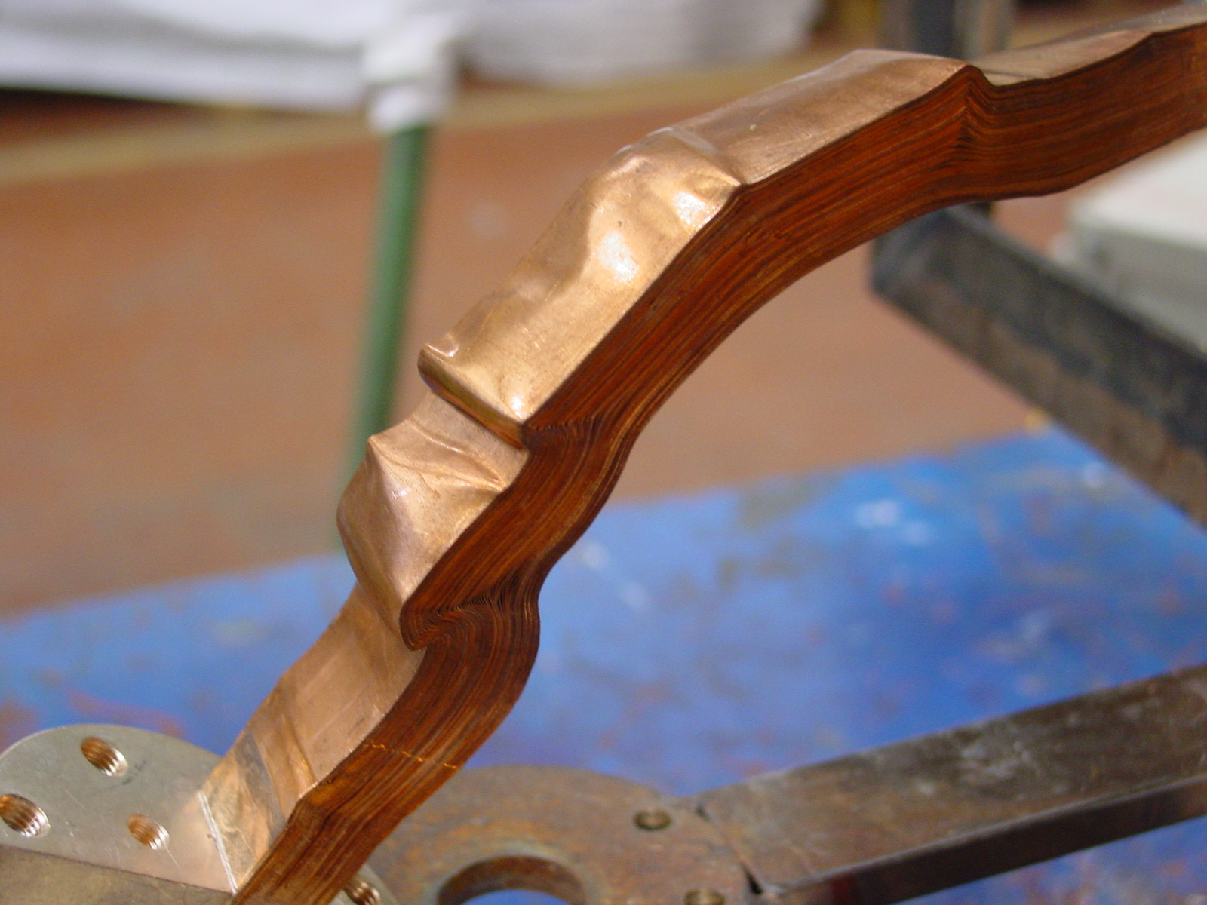
1/3
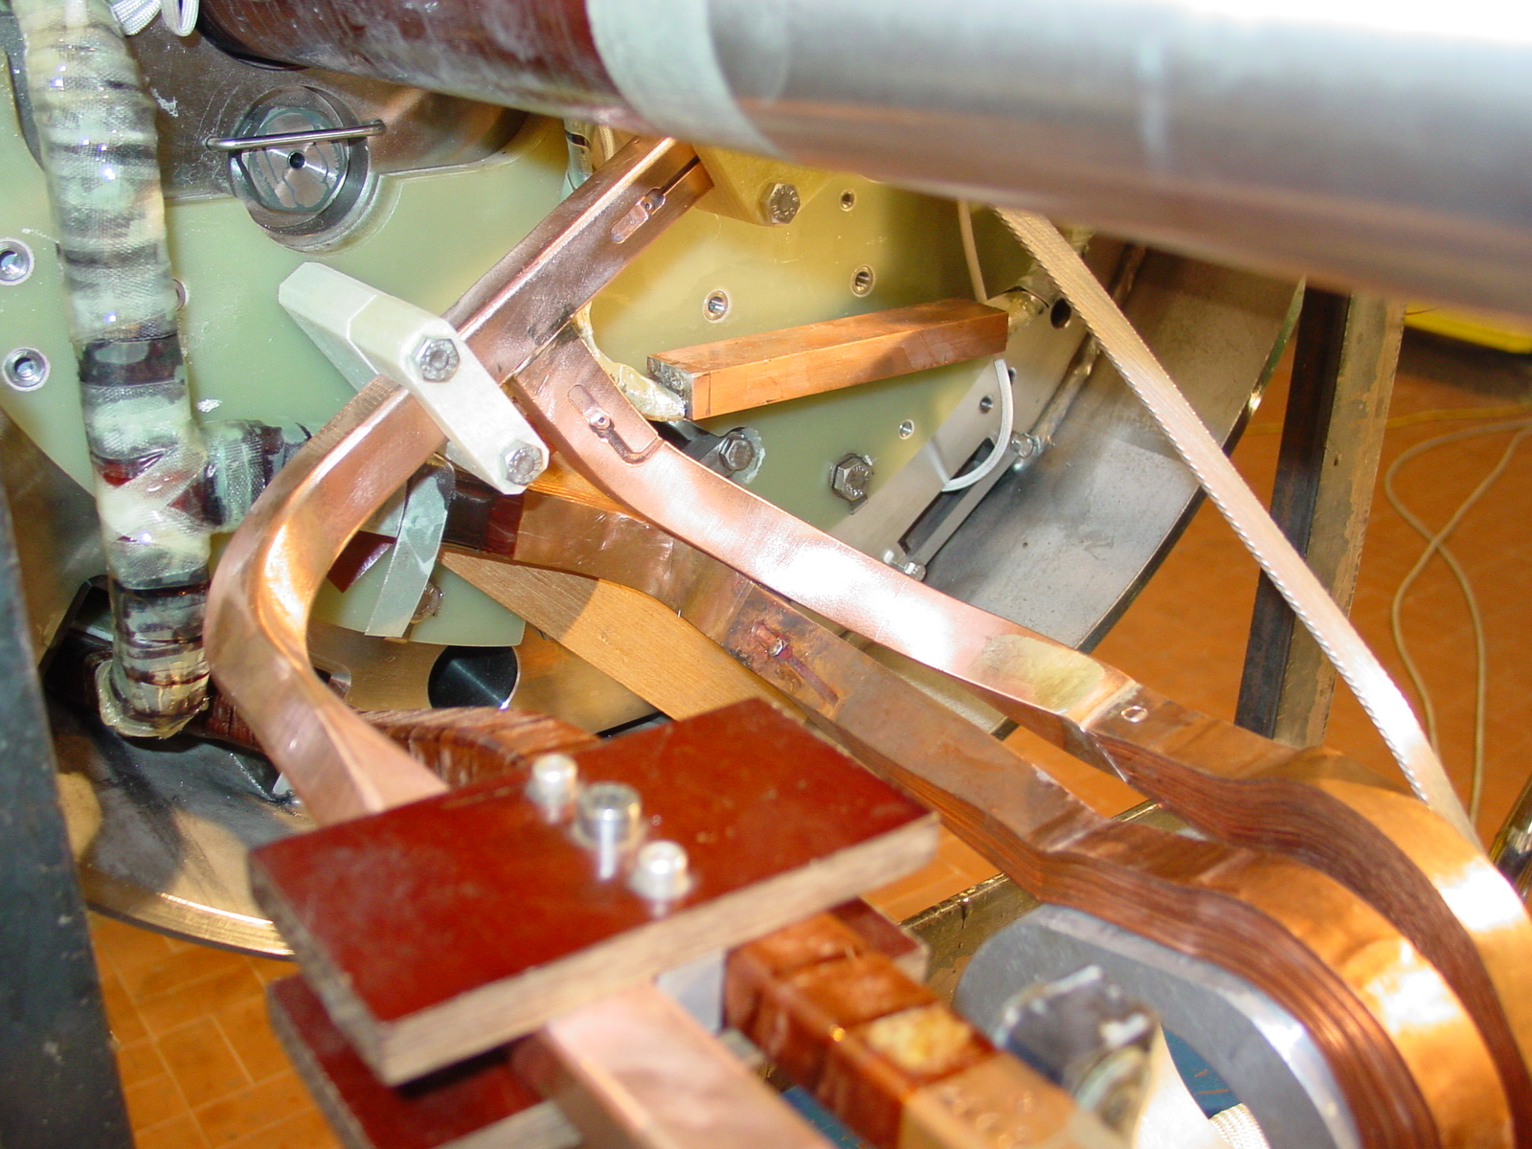
2/3
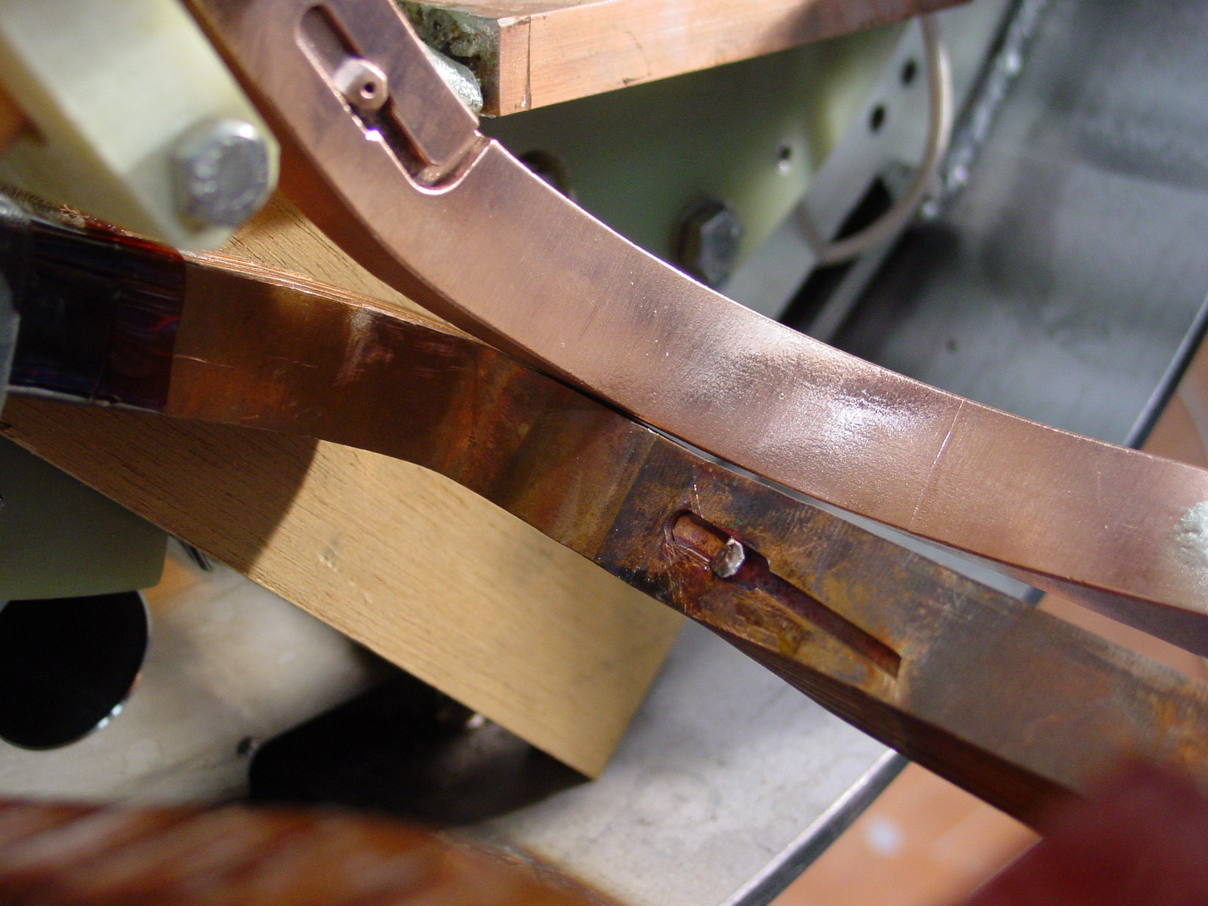
3/3

CLOSURE OF THE NON CONFORMITY
Planned actions have been completed and corrective/preventive actions have been initiated (continuation page)
Here are some pictures about the adjustment of the position of the bus-bars.
F. Terzi
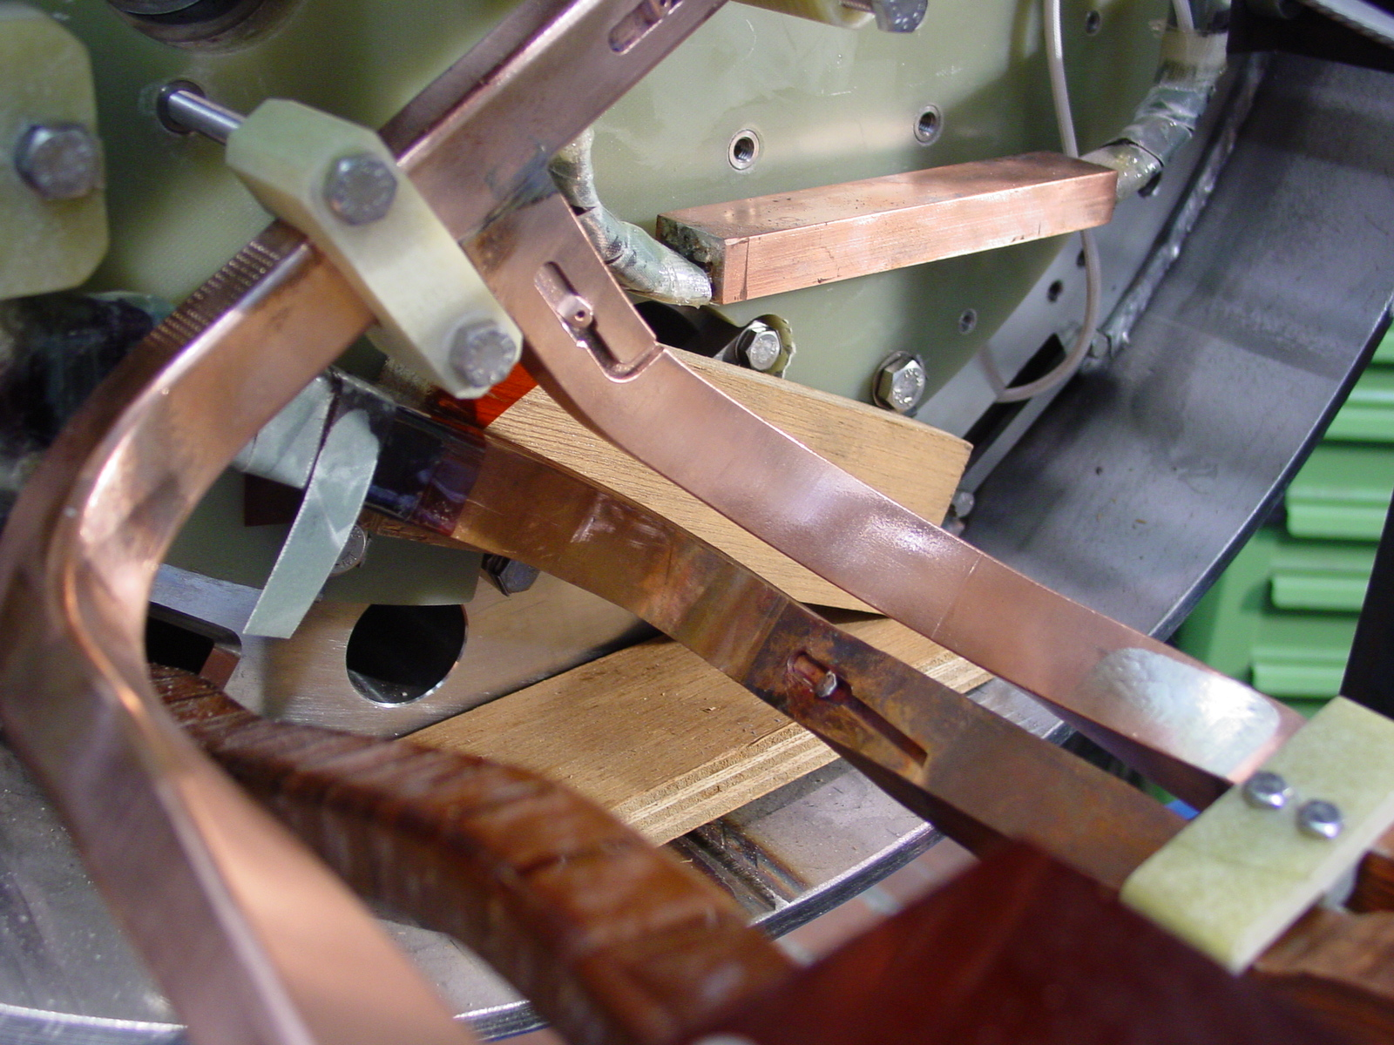
1/2
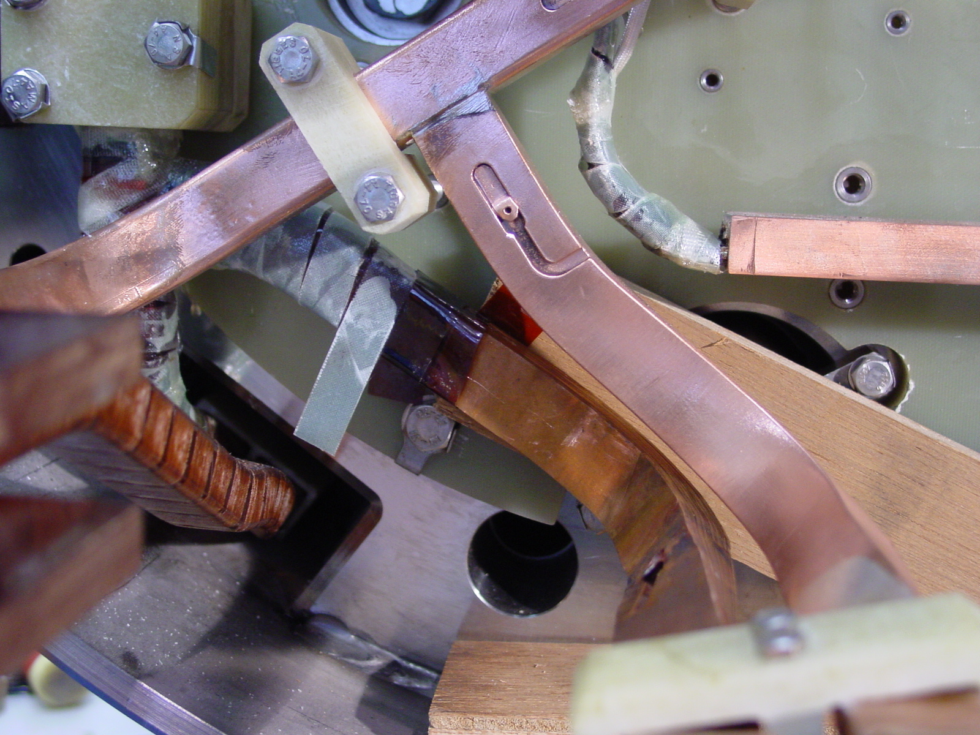
2/2

