–

Non conformity Report
IDENTIFICATION
1. Originator’s Name: F. Terzi | 5. Date: 26/01/2004
2. Contractor/Supplier: Ansaldo Superconduttori S.p.A. | 6. Part description: HCMB__A001-02000063
3. Contract No: F462/LHC/LHC | 7. Qty: 1
4. Project Engineer: F. Savary | 8. Dwg No: LHCMB__A0001/G (620RM08234/L)

9. Found during what activity:
□ Incoming inspection | □Final inspection
☑In-process inspection | □ Other:

10. Description of non conformity (use continuation page if necessary)
Warm magnetic measurements, carried out on the CC 2063, showed anomalies in high order multipoles, in particular about multipole b8 (up to 6 sigma, yellow alarm), in different positions along the magnet axis in Aperture 2, possibly caused by a movement of the conductor of block 6 (ref. test report HCMB__A001-02000063_CC.xls).
Besides, after collaring we had to re-size the inner diameter of the cold bore tubes along the whole length.
Considering these two events, ASG is worried about a possible shift of the inner turns of the coils towards the cold bore tubes, as already occurred on CC 2032 (please ref. to NC CERN 112).
As a consequence, ASG decided, indipendently and without any CERN request, to proceed with de-collaring of CC 2063 at his own costs.

11. Action taken to prevent misuse (use continuation page if necessary)

IMPORTANCE
12. | □ Non critical | □ Critical

DISPOSITION
13. | □ Use-as-is | □ Repair | □ Reject | □ Rework | □ Return to supplier
Description of proposed action (use continuation page if necessary)

CORRECTIVE/PREVENTIVE ACTION
14. Description of proposed action (use continuation page if necessary)

APPROVAL OF NON CRITICAL NON CONFORMITIES
15 | Project Engineer: | Date:

APPROVAL OF CRITICAL NON CONFORMITIES
16 | Project Management: | Date:

CLOSURE OF THE NON CONFORMITY
Planned actions have been completed and corrective/preventive actions have been initiated
 | For non critical non conformities  Quality Manager or Project Engineer | For critical non conformities  Project Engineer
17 | Name:  Date: | Name:  Date:

CLOSURE OF THE NON CONFORMITY
Planned actions have been completed and corrective/preventive actions have been initiated
(continuation page)

After de-collaring of CC 2063, a visual inspection of poles showed:
a) a small shift of the interlayer spacers towards the cold bore tube: maybe this caused a deformation of c.b.t. and it can explain the long process about the re-sizing of inner diameter
b) a not strongly gluing of one turn to the next one, along 150 mm from NCS on the inner layer 02I00253 (details on position: D1-Upper, on the rigth side of the pole, NCS view)
No others defects have been detected both on the straigth part and on the heads.
Poles id nr. 02P00250 – 251 – 252- 253. See pictures here below for details.

26/01/2004
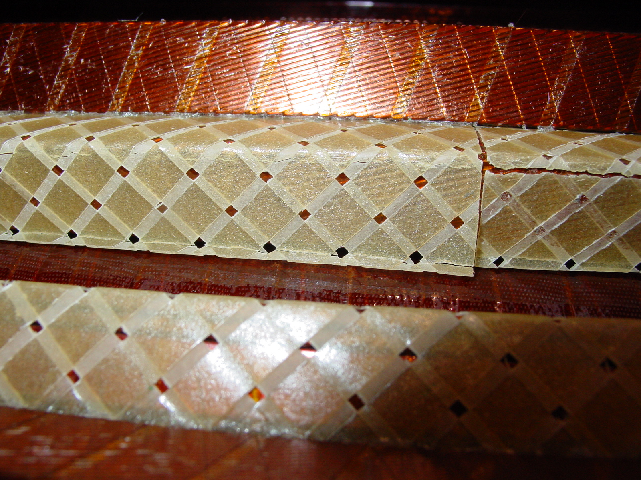
1/4
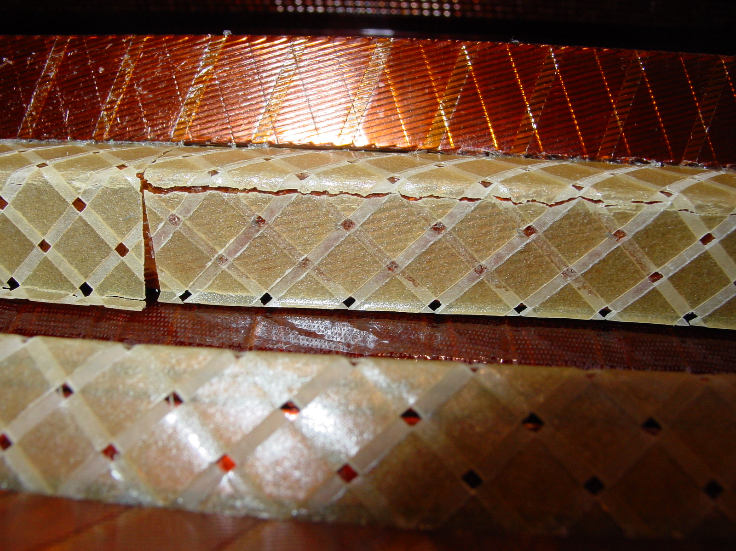
2/4
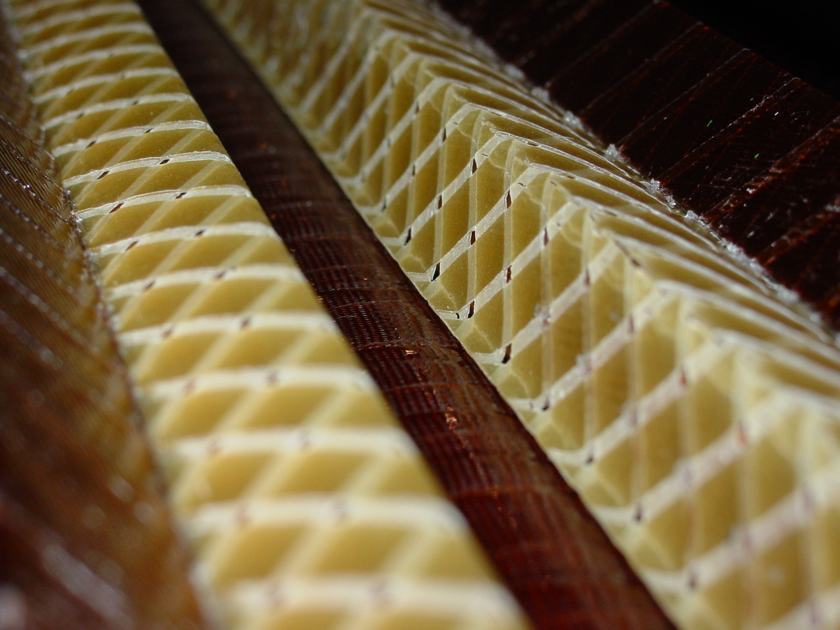
3/4
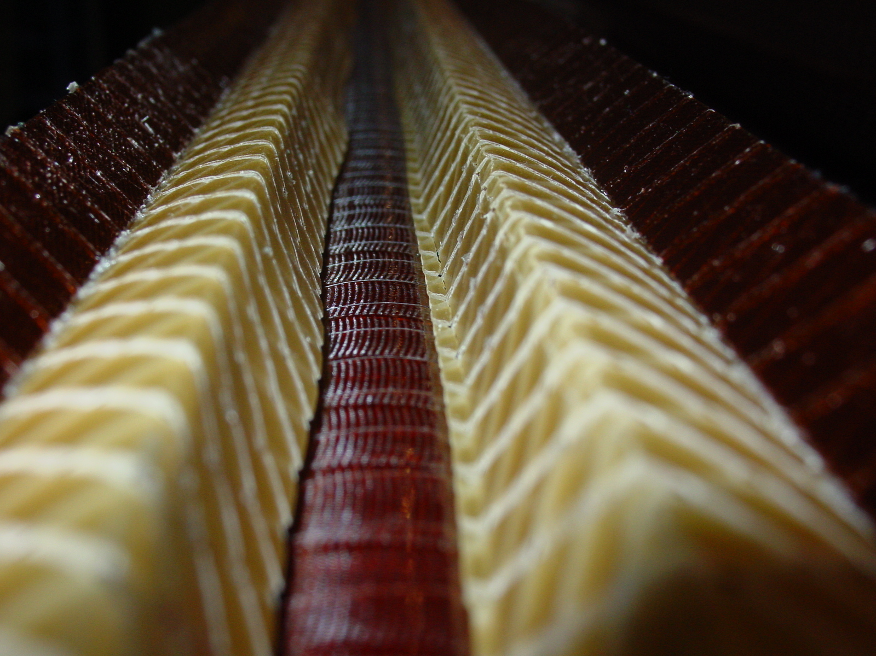
4/4

