–

Non conformity Report
IDENTIFICATION
1. Originator’s Name: F. Terzi | 5. Date: 09/02/2004
2. Contractor/Supplier: Ansaldo Superconduttori S.p.A. | 6. Part description: HCDCBHA055-BI000xxx
3. Contract No: F462/LHC/LHC | 7. Qty: 1
4. Project Engineer: F. Savary, M. Bajko | 8. Dwg No: LHCDCCHA0001-0002-0003-0004

9. Found during what activity:
☑ Incoming inspection | □ Final inspection
□ In-process inspection | □ Other:

10. Description of non conformity (use continuation page if necessary)
With reference to dwg. nr. LHCDCCHA0001-0002-0003-0004 (all rev, index D), the length of the glass cloth of auxiliary bus bars is too short (about 120mm) on both sides.
The end taping is in the position where the clamps (DWG,nr. LHCMB_E0057 & 0058) have to be mounted.
The glass epoxy plate 12x15x2.2mm (dwg. nr. LHCDCCHA0003 pos.6) is missing.
See attached pictures for details.
Bus bar sets id. number: HCDCBHA055-BI000166 to BI000195 (bus bars type A)
HCDCBHA056-BI000181 to BI000210 (bus bars type B)
Total number of non-conforming bus bars: 30 type A + 30 type B

11. Action taken to prevent misuse (use continuation page if necessary)

IMPORTANCE
12. | □ Non critical | □ Critical

DISPOSITION
13. | □Use-as-is | □ Repair | □ Reject | □ Rework | □ Return to supplier
Description of proposed action (use continuation page if necessary)

CORRECTIVE/PREVENTIVE ACTION
14. Description of proposed action (use continuation page if necessary)

APPROVAL OF NON CRITICAL NON CONFORMITIES
15 | Project Engineer: | Date:

APPROVAL OF CRITICAL NON CONFORMITIES
16 | Project Management: | Date:

CLOSURE OF THE NON CONFORMITY
Planned actions have been completed and corrective/preventive actions have been initiated
 | For non critical non conformities  Quality Manager or Project Engineer | For critical non conformities  Project Engineer
17 | Name:  Date: | Name:  Date:

10. Description of non conformity (continuation page)
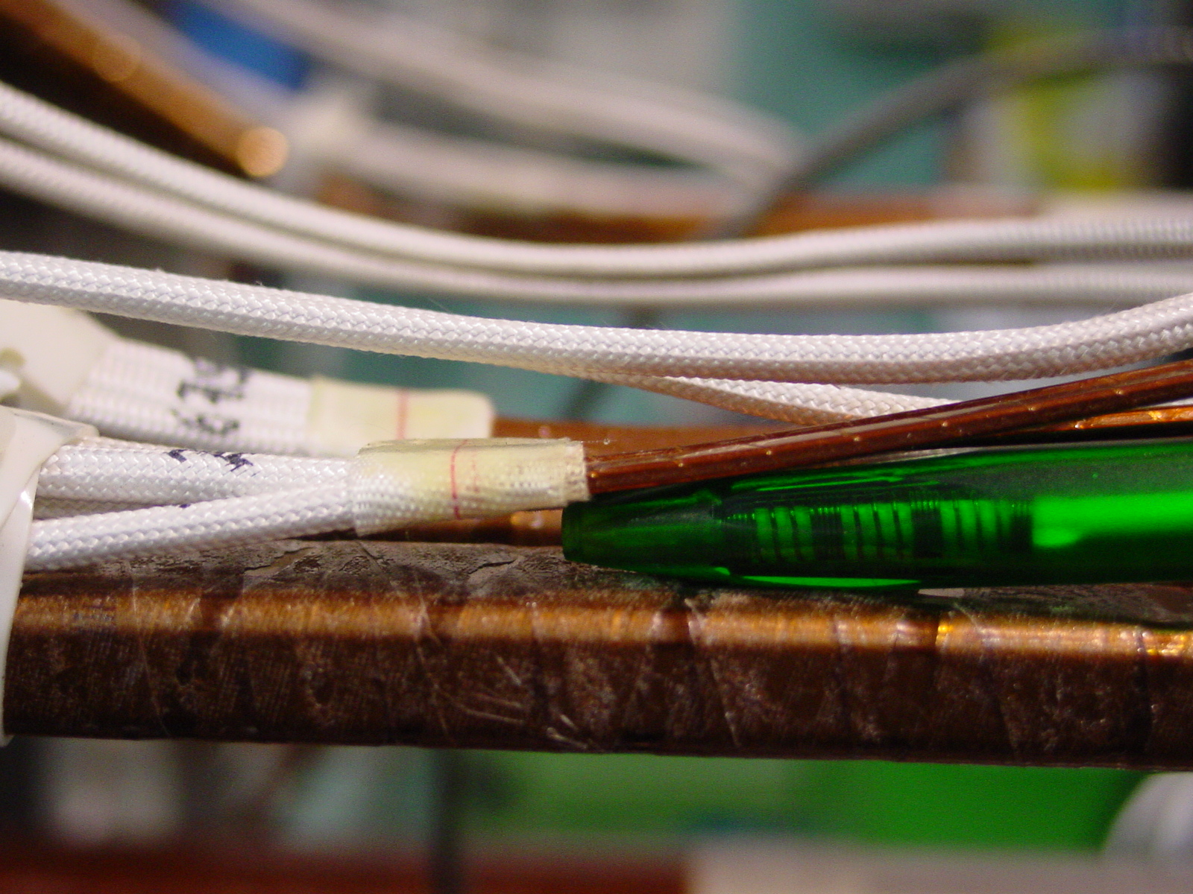
1/3
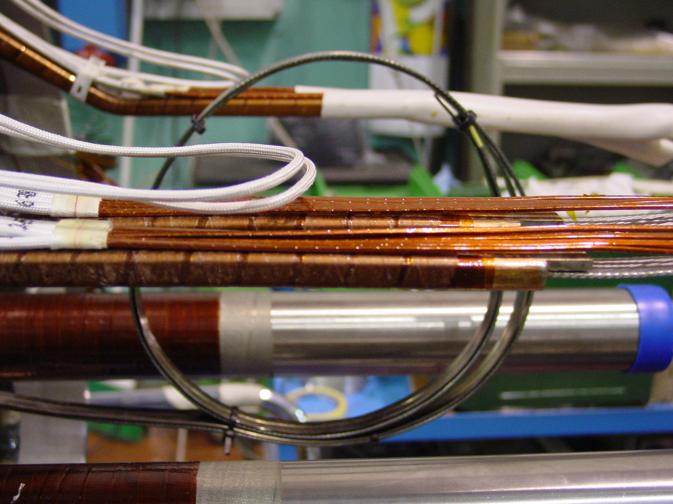
2/3

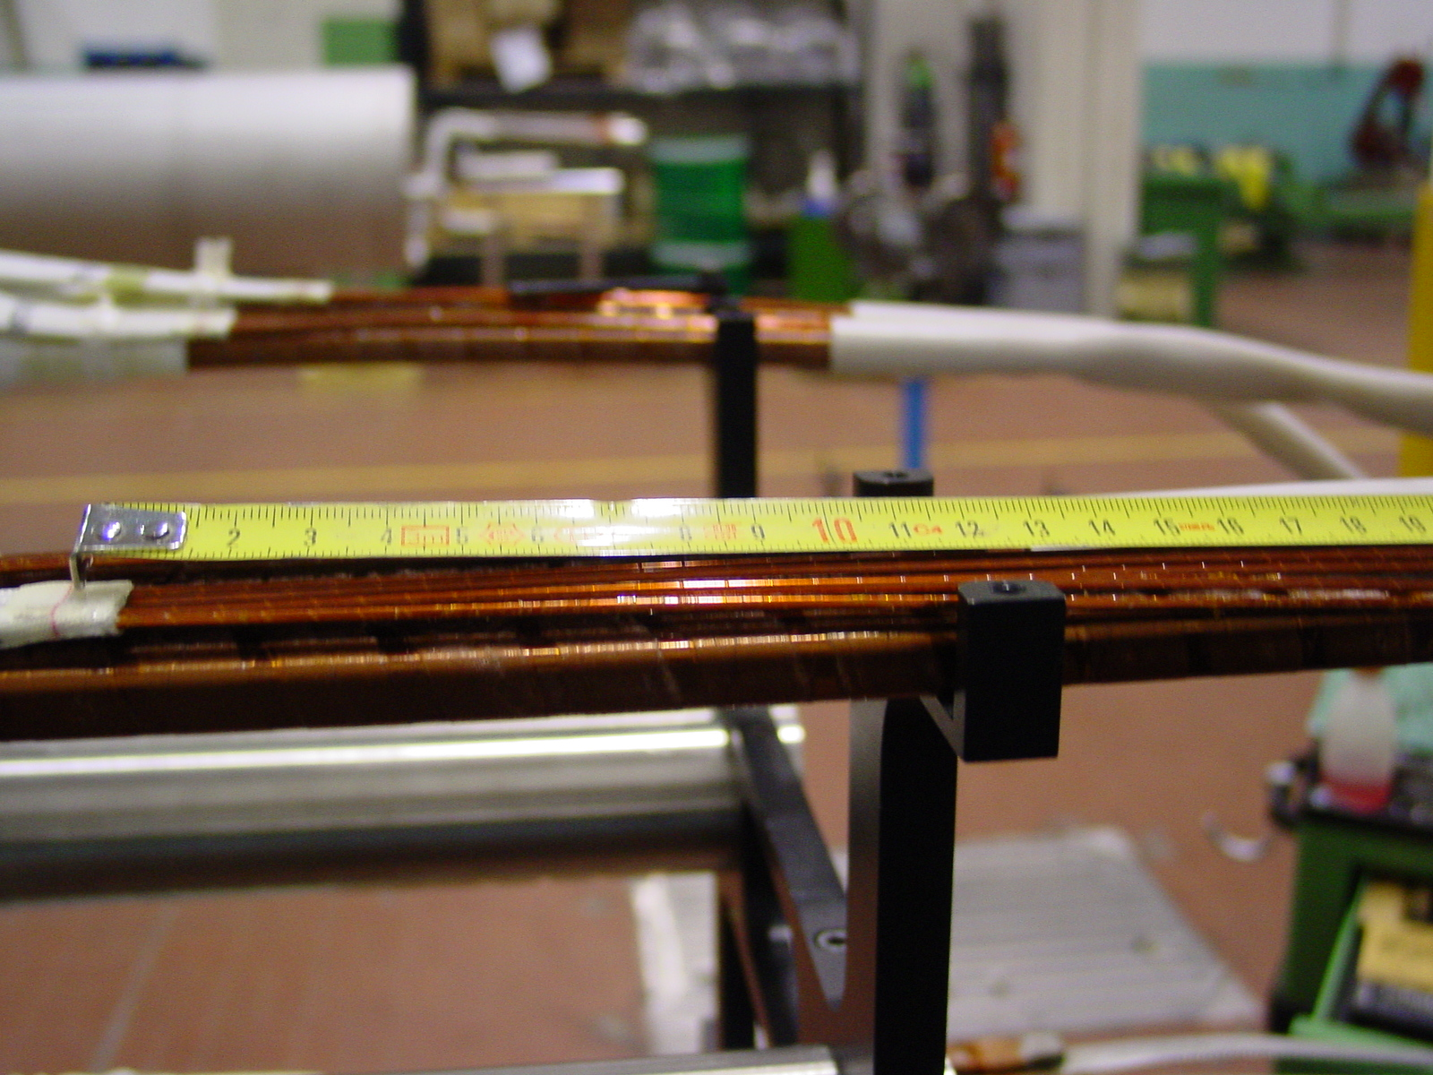
3/3

