–

Non conformity Report
IDENTIFICATION
1. Originator’s Name: B. Caserza, F. Terzi | 5. Date: 17/03/2004
2. Contractor/Supplier: Ansaldo Superconduttori S.p.A. | 6. Part description: 02E00389
3. Contract No: F462/LHC/LHC | 7. Qty: 1
4. Project Engineer: F. Savary, M. Bajko | 8. Dwg No: LHCMB__A0012/E (620RM08202/F)

9. Found during what activity:
□ Incoming inspection | □ Final inspection
☑ In-process inspection | □ Other:

10. Description of non conformity (use continuation page if necessary)
During winding of outer layer 02E00389 regarding CM 2097, the following problems have been detected on sc cable nr.02B50435B:
a) wrong position of some strands in the Rutherford cable (cabling problems)
b) damage of insulation (but no damage of the strands) maybe caused during wrapping process

(see annexed photos on continuation page)

11. Action taken to prevent misuse (use continuation page if necessary)

IMPORTANCE
12. | □ Non critical | □ Critical

DISPOSITION
13. | □ Use-as-is | □ Repair | □ Reject | □ Rework | □ Return to supplier
Description of proposed action (use continuation page if necessary)
Item a): ASG propose to continue the winding operation and check the problem with CERN personell on next visit in ASG workshop
Item b): ASG propose to restore the insulation of the sc cable

CORRECTIVE/PREVENTIVE ACTION
14. Description of proposed action (use continuation page if necessary)

APPROVAL OF NON CRITICAL NON CONFORMITIES
15 | Project Engineer: | Date:

APPROVAL OF CRITICAL NON CONFORMITIES
16 | Project Management: | Date:

CLOSURE OF THE NON CONFORMITY
Planned actions have been completed and corrective/preventive actions have been initiated
 | For non critical non conformities  Quality Manager or Project Engineer | For critical non conformities  Project Engineer
17 | Name:  Date: | Name:  Date:

10. Description of non conformity (continuation page)

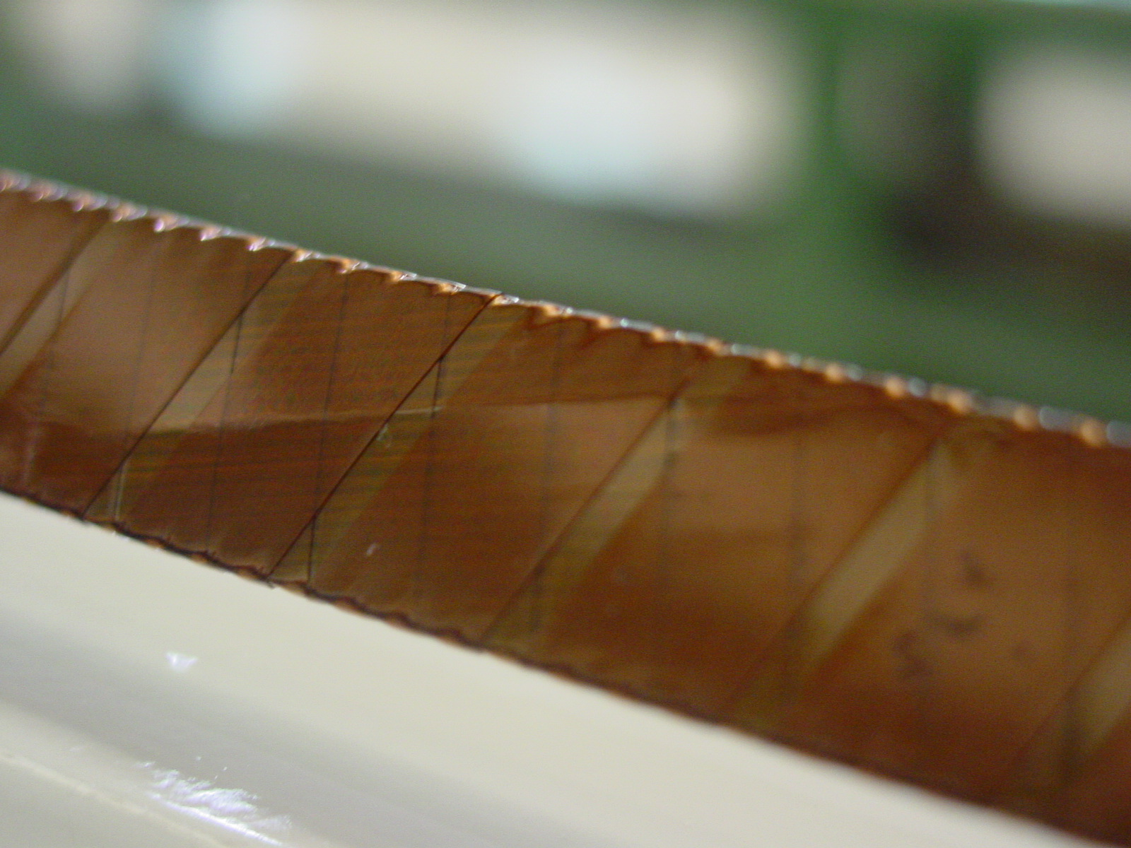
1/4
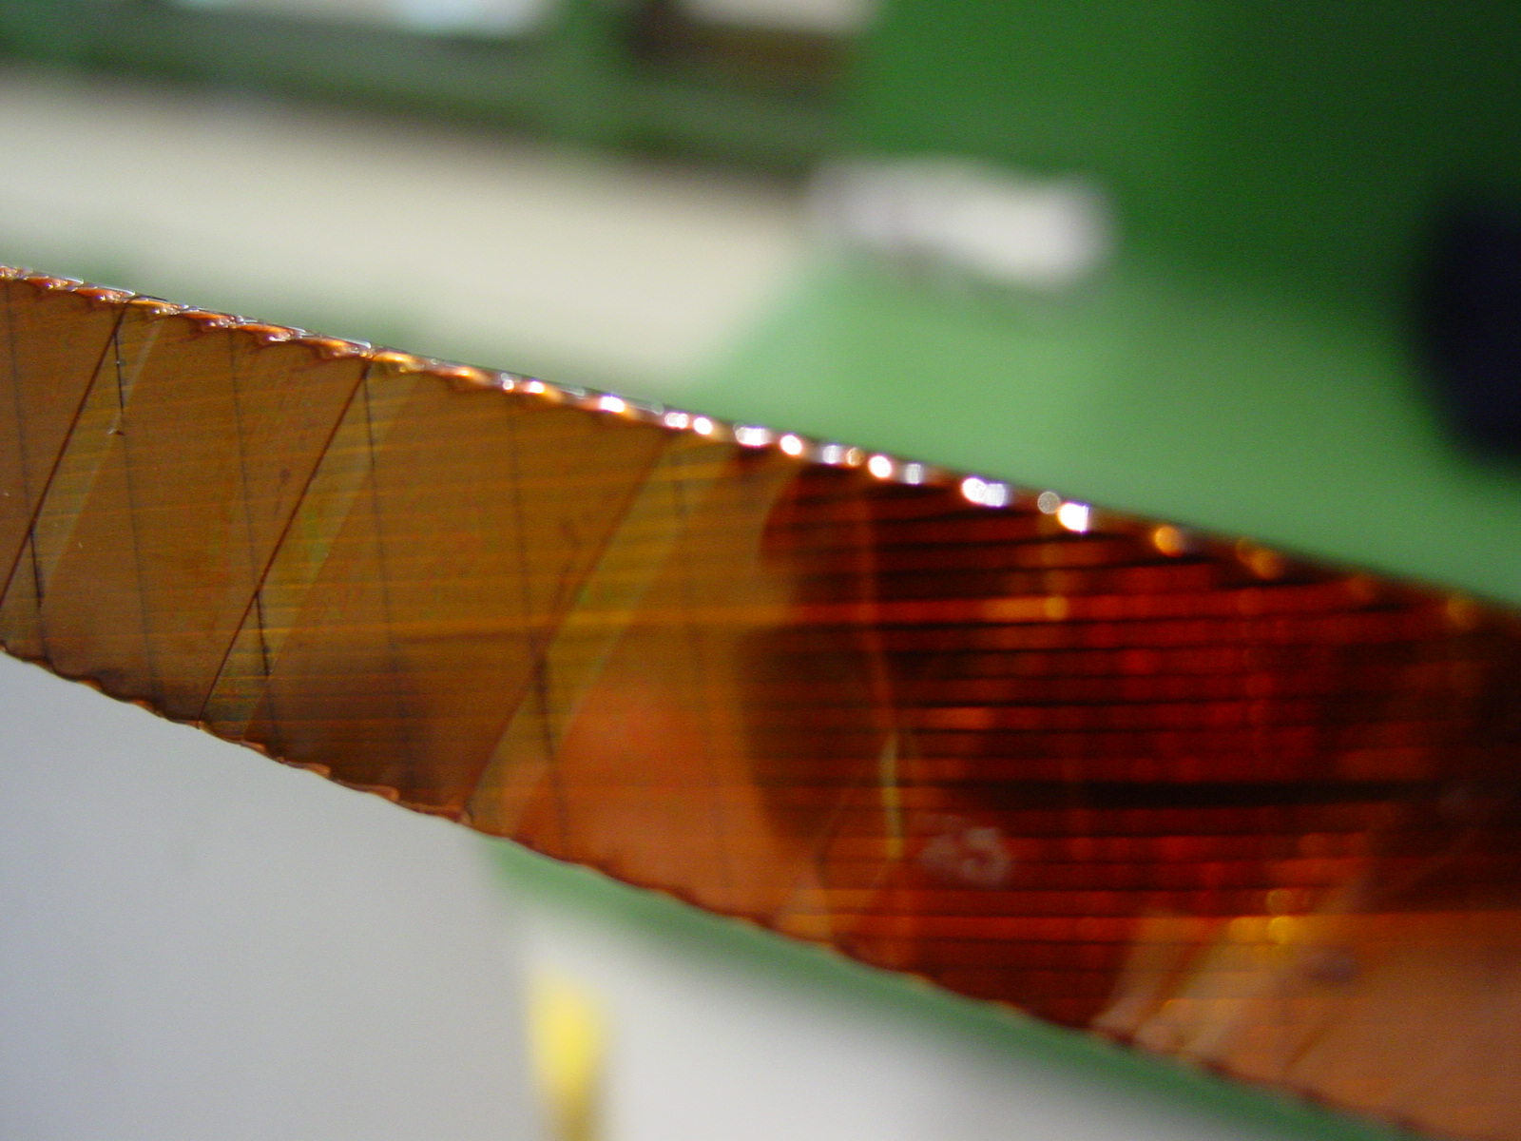
2/4
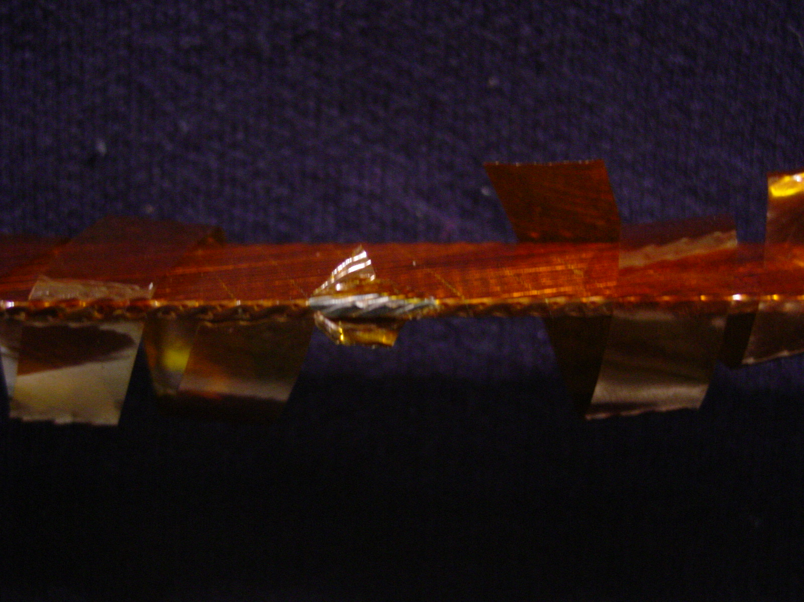
3/4

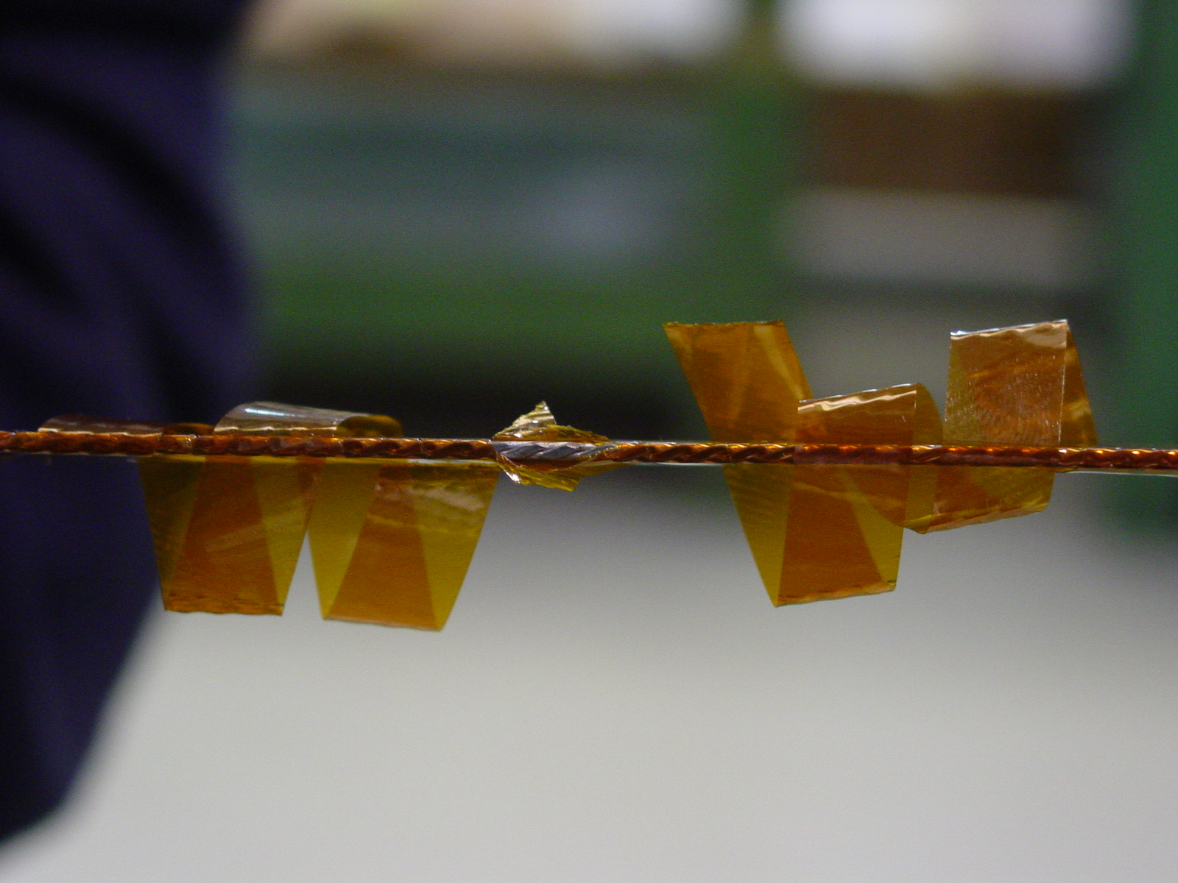
4/4

