–

Non conformity Report
IDENTIFICATION
1. Originator’s Name: B. Caserza, F. Terzi | 5. Date: 17/03/2004
2. Contractor/Supplier: Ansaldo Superconduttori S.p.A. | 6. Part description: 02E00382
3. Contract No: F462/LHC/LHC | 7. Qty: 1
4. Project Engineer: F. Savary, M. Bajko | 8. Dwg No: LHCMB__A0012/E (620RM08202/F)

9. Found during what activity:
□ Incoming inspection | □ Final inspection
☑ In-process inspection | □ Other:

10. Description of non conformity (use continuation page if necessary)
After curing of outer layer 02E00382 regarding CM 2095, the following problems have been detected on sc cable nr.02B50432A:
b) wrong position of some strands in the Rutherford cable (cabling problems)
a) damage of the insulation of the first turn near the first end spacer on CS: this problem could be caused by the wrong position of that strand
(see annexed photo on continuation page)

11. Action taken to prevent misuse (use continuation page if necessary)

IMPORTANCE
12. | □ Non critical | □ Critical

DISPOSITION
13. | □ Use-as-is | □ Repair | □ Reject | □ Rework | □ Return to supplier
Description of proposed action (use continuation page if necessary)
ASG propose to remove the first end spacer, check carefully the condition of the strand, under witness of CERN personnel, try a re-positioning of that strand and restore the insulation

CORRECTIVE/PREVENTIVE ACTION
14. Description of proposed action (use continuation page if necessary)

APPROVAL OF NON CRITICAL NON CONFORMITIES
15 | Project Engineer: | Date:

APPROVAL OF CRITICAL NON CONFORMITIES
16 | Project Management: | Date:

CLOSURE OF THE NON CONFORMITY
Planned actions have been completed and corrective/preventive actions have been initiated
 | For non critical non conformities  Quality Manager or Project Engineer | For critical non conformities  Project Engineer
17 | Name:  Date: | Name:  Date:

10. Description of non conformity (continuation page)

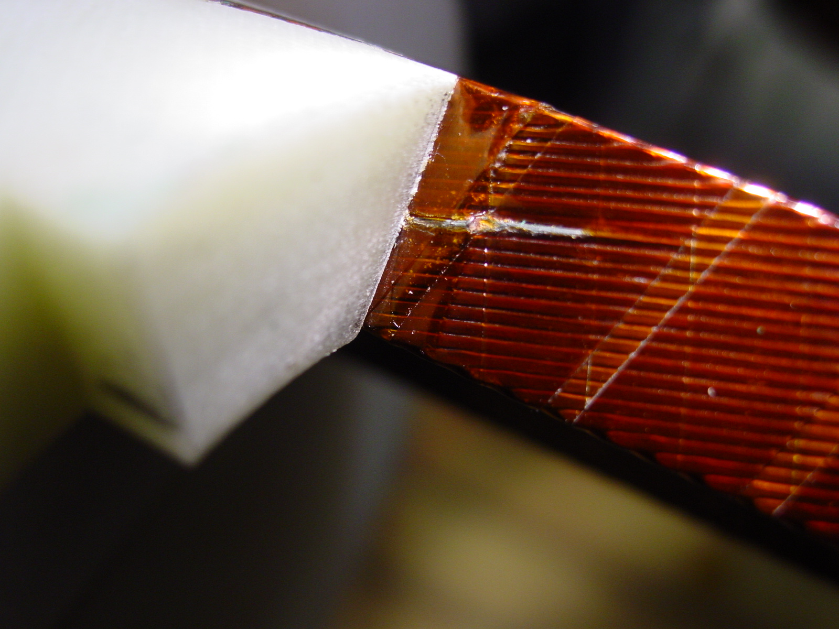
1/1

