–

Non conformity Report
IDENTIFICATION
1. Originator’s Name: B. Caserza, F. Terzi | 5. Date: 17/03/2004
2. Contractor/Supplier: Ansaldo Superconduttori S.p.A. | 6. Part description: 02B50433A- B – C - D
3. Contract No: F462/LHC/LHC | 7. Qty: 4
4. Project Engineer: F. Savary, M. Bajko | 8. Dwg No: LHCMB__A0047/B (620RM08188/B)

9. Found during what activity:
☑ Incoming inspection | □ Final inspection
□ In-process inspection | □ Other:

10. Description of non conformity (use continuation page if necessary)
Just before winding, a visual check of outer layer sc cables for CM 2096, showed cabling problems: some strands are in wrong position in the Rutherford cable.
Sc cables ref. nr. 02B50433A- 02B50433B – 02B50433C - 02B50433D

(see annexed photo on continuation page)

11. Action taken to prevent misuse (use continuation page if necessary)

IMPORTANCE
12. | □ Non critical | □ Critical

DISPOSITION
13. | □ Use-as-is | □ Repair | □ Reject | □ Rework | □ Return to supplier
Description of proposed action (use continuation page if necessary)
ASG didn' start winding of OL for CM 2096 and is asking for a carefull check of that cables by CERN personell.

CORRECTIVE/PREVENTIVE ACTION
14. Description of proposed action (use continuation page if necessary)

APPROVAL OF NON CRITICAL NON CONFORMITIES
15 | Project Engineer: | Date:

APPROVAL OF CRITICAL NON CONFORMITIES
16 | Project Management: | Date:

CLOSURE OF THE NON CONFORMITY
Planned actions have been completed and corrective/preventive actions have been initiated
 | For non critical non conformities  Quality Manager or Project Engineer | For critical non conformities  Project Engineer
17 | Name:  Date: | Name:  Date:

10. Description of non conformity (continuation page)
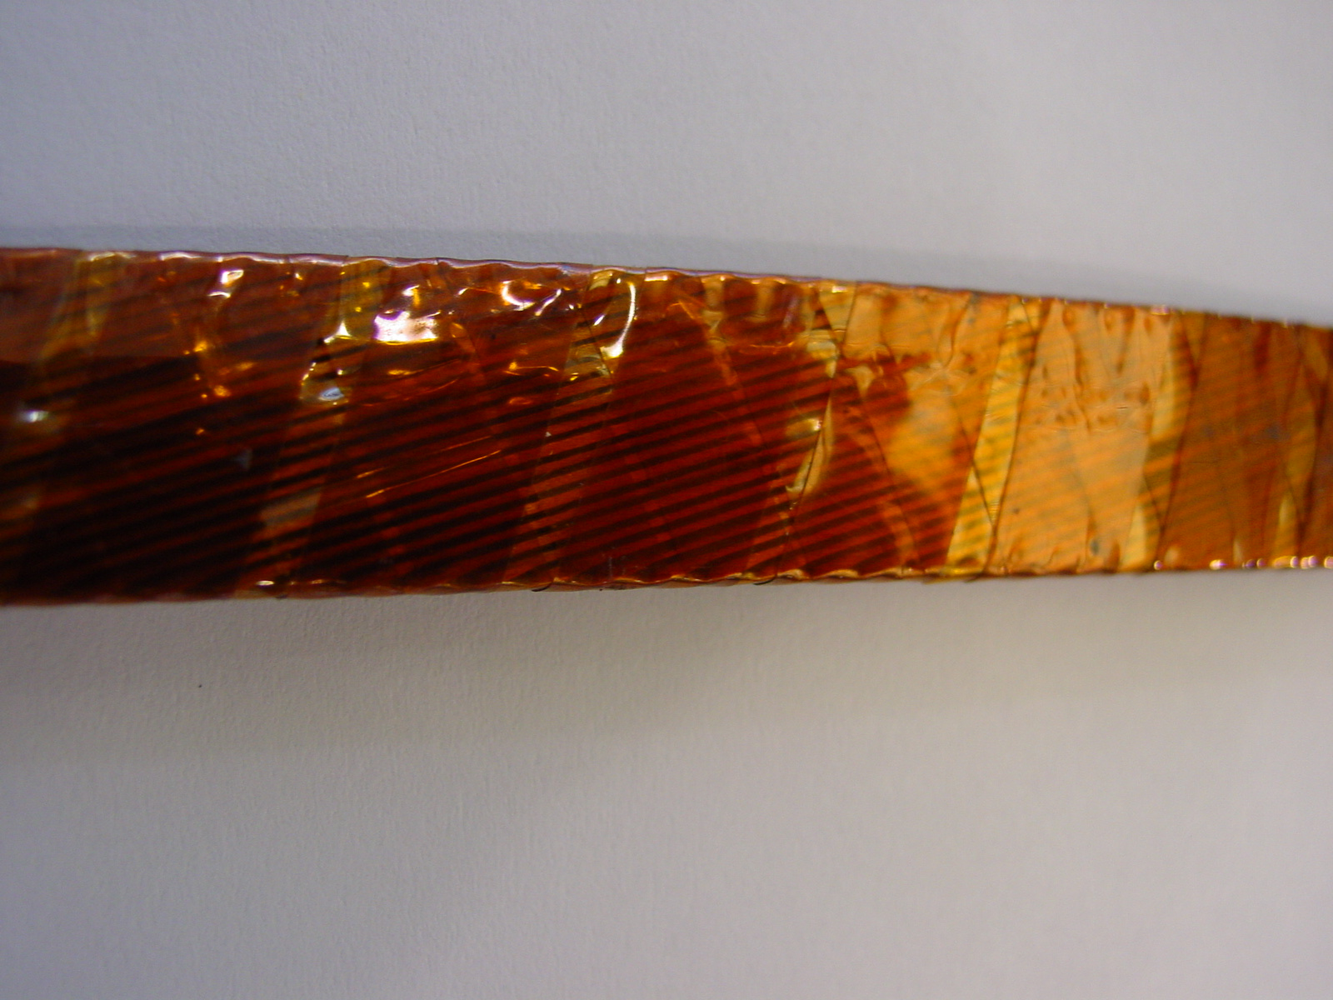
1/4

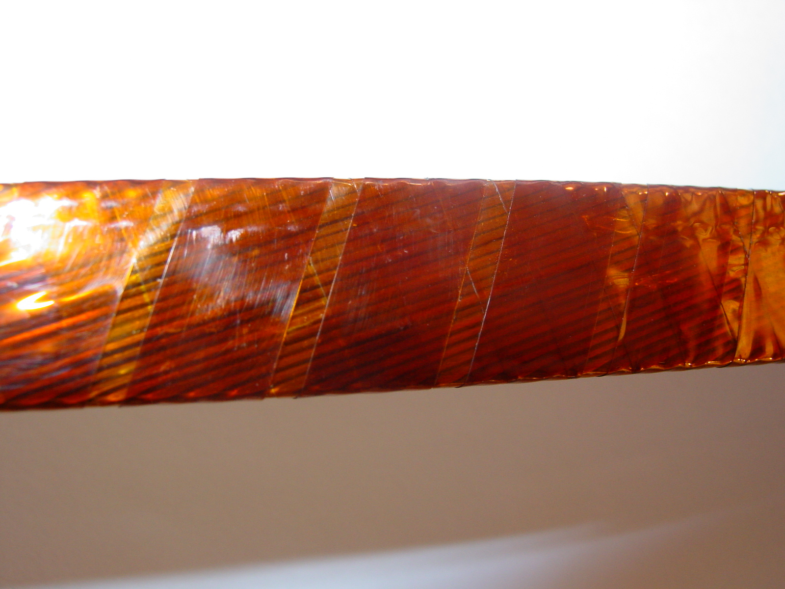
2/4

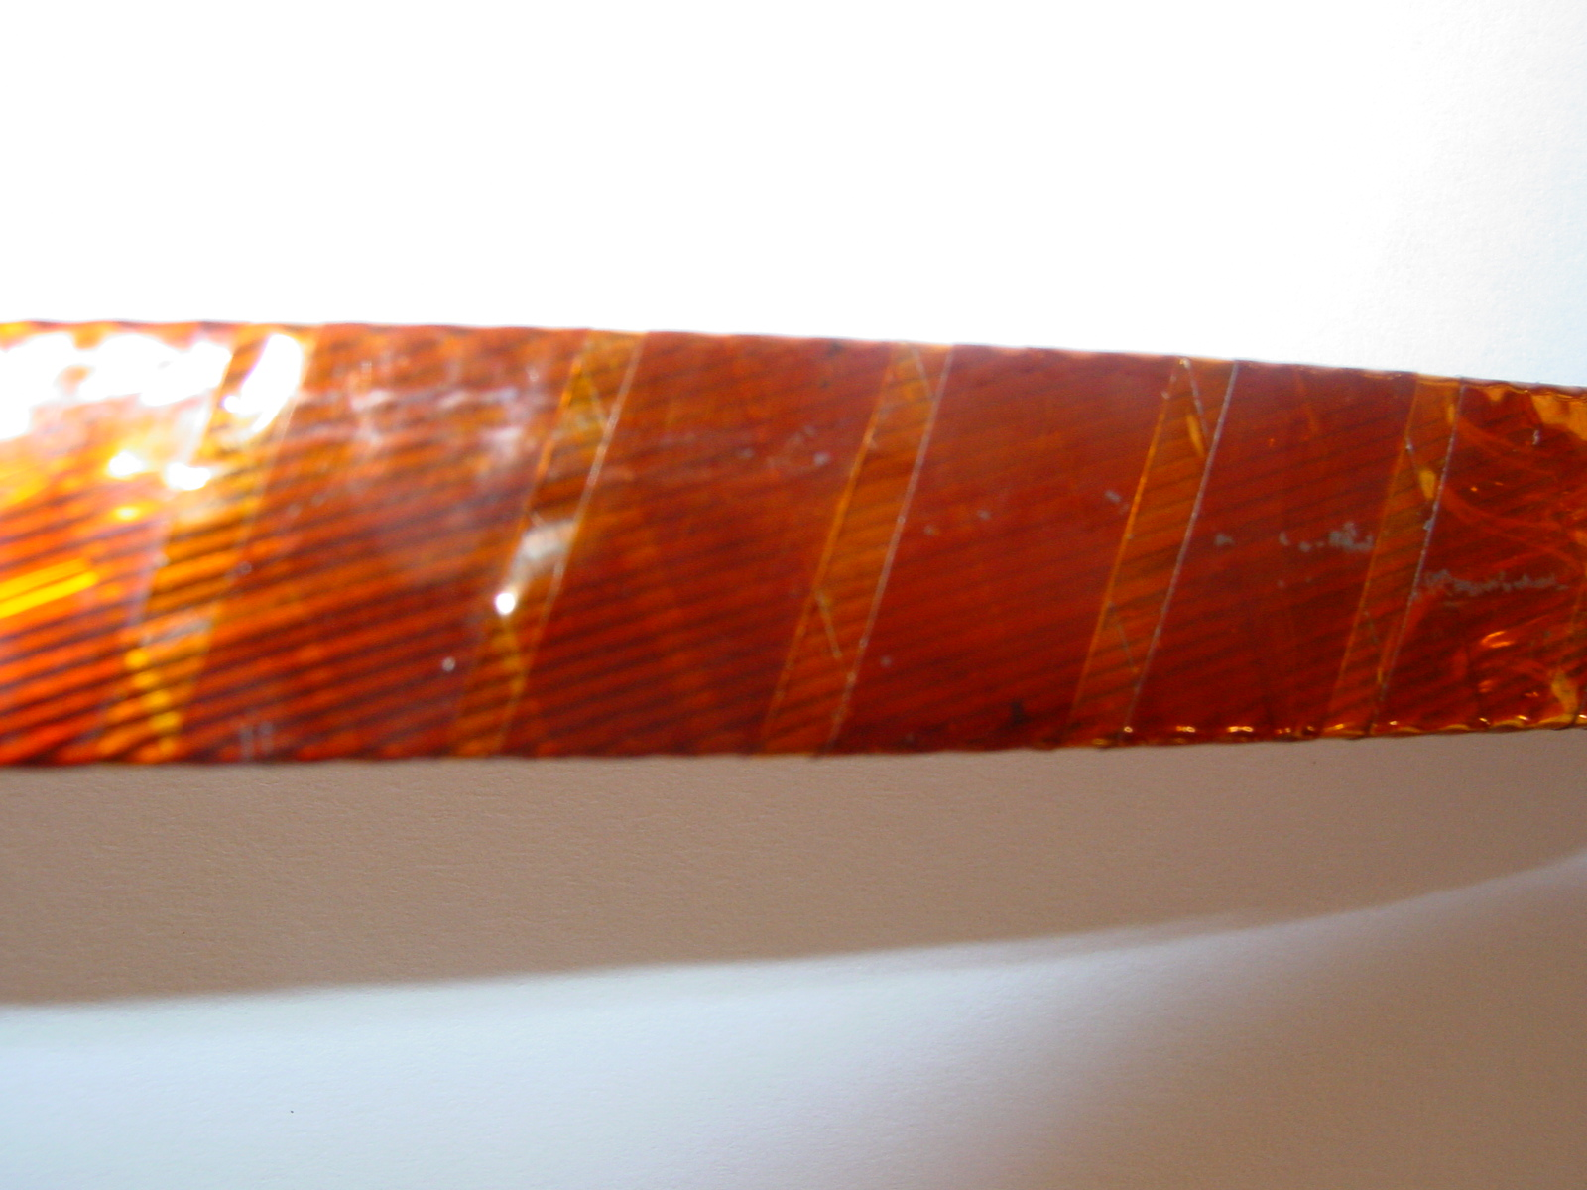
3/4

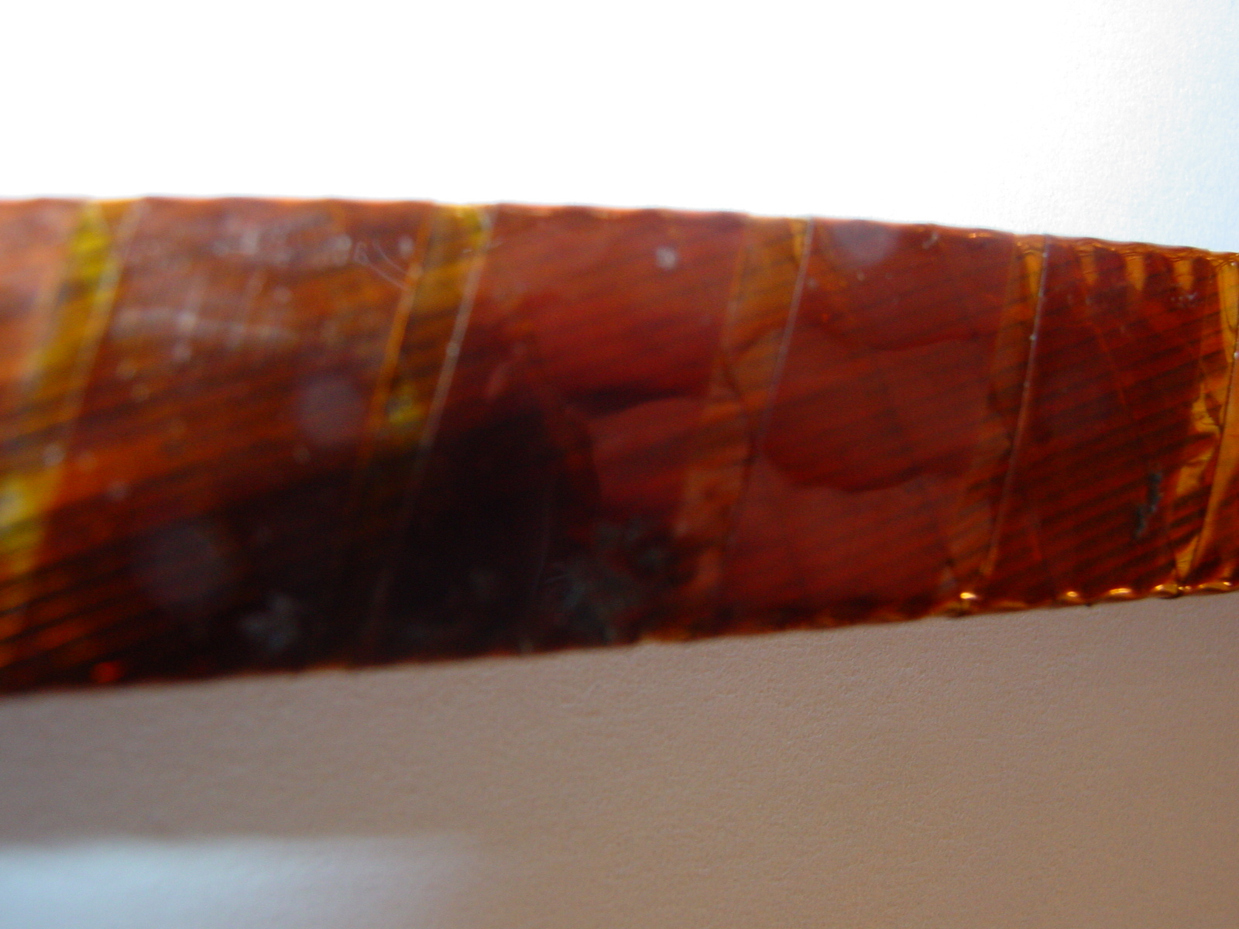
4/4

