–

Non conformity Report
IDENTIFICATION
1. Originator’s Name: B. Caserza, F. Terzi | 5. Date: 31/03/2004
2. Contractor/Supplier: Ansaldo Superconduttori S.p.A. | 6. Part description: HCMB__A099
3. Contract No: F462/LHC/LHC | 7. Qty: 1
4. Project Engineer: F. Savary, M. Bajko | 8. Dwg No: LHCMB__A0099 rev.C

9. Found during what activity:
☑ Incoming inspection | □ Final inspection
□ In-process inspection | □ Other:

10. Description of non conformity (use continuation page if necessary)
A visual check of different collars regarding batches nr. MAL00232 - MAL00235 showed a burr along the inner shape. See annexed photos on next page. ASG Quality Control personnel will perform careful checks on collars regarding others batches stored in Brandi Company.
Following ASG control at Brandi Company, others collars regarding batches nr.
- MAL00233 - MAL00234
- MAL00244-245-246-247
- MAL00252-253-254-255
show the same problems about burr along the inner shape. Total nr. of collar batches: 12

11. Action taken to prevent misuse (use continuation page if necessary)

IMPORTANCE
12. | ☑ Non critical | □ Critical

DISPOSITION
13. | □ Use-as-is | □ Repair | □ Reject | ☑ Rework | □ Return to supplier
Description of proposed action (use continuation page if necessary)
The batches of collars affected by these burrs shall be sent back to Malvestiti for rework.
CERN has given instructions to Malvestiti to de-burr all the collars affected. The collars will be then cleaned again by Malvestiti before delivery.

CORRECTIVE/PREVENTIVE ACTION
14. Description of proposed action (use continuation page if necessary)

APPROVAL OF NON CRITICAL NON CONFORMITIES
15 | Project Engineer: F. Savary | Date: April 8th, 2004

APPROVAL OF CRITICAL NON CONFORMITIES
16 | Project Management: | Date:

CLOSURE OF THE NON CONFORMITY
Planned actions have been completed and corrective/preventive actions have been initiated
 | For non critical non conformities  Quality Manager or Project Engineer | For critical non conformities  Project Engineer
17 | Name: F. Terzi  Date: 09/04/2004 | Name:  Date:

10. Description of non conformity (continuation page)

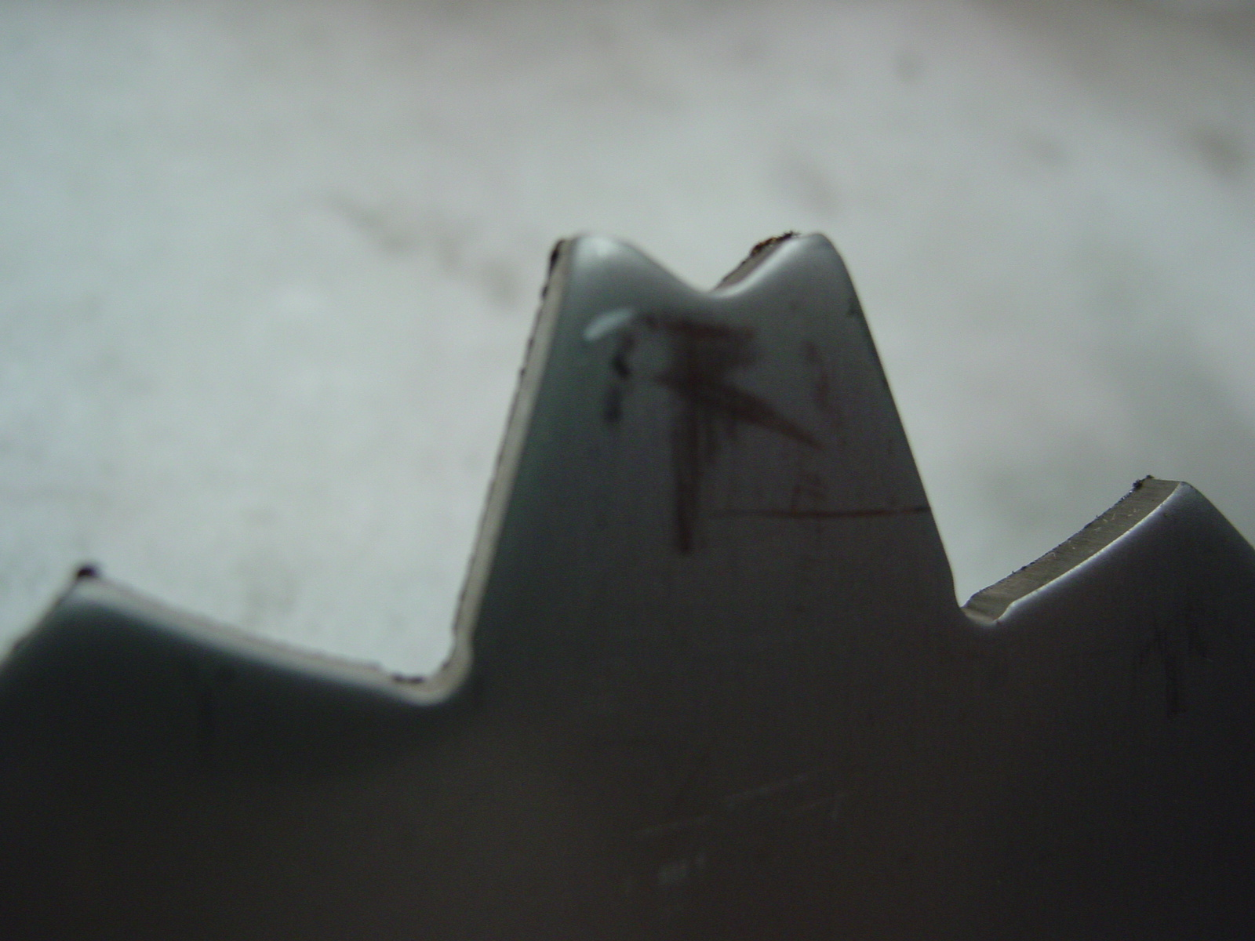
1/2

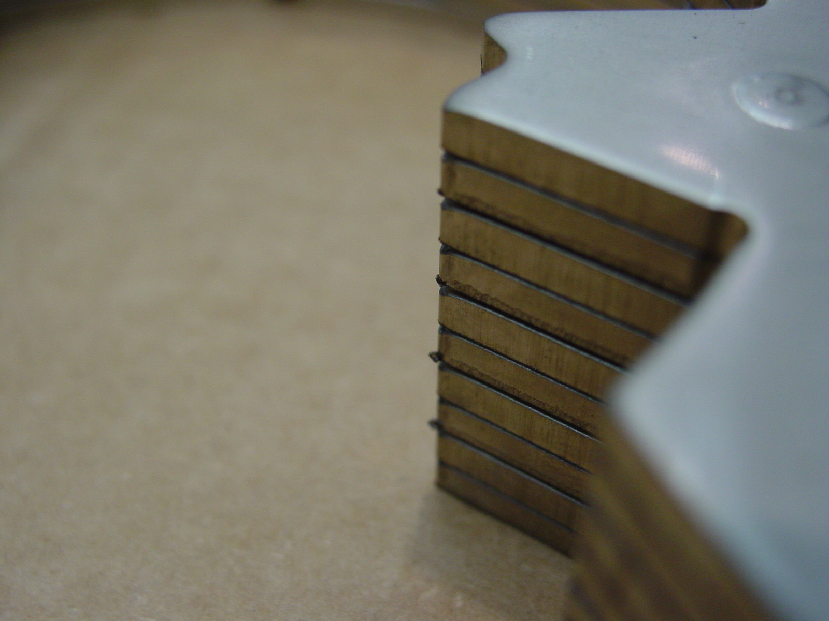
2/2

