–

Non conformity Report
IDENTIFICATION
1. Originator’s Name: F. Terzi | 5. Date: 16/04/2004
2. Contractor/Supplier: Ansaldo Superconduttori S.p.A. | 6. Part description: HCMB__A001-02000112
3. Contract No: F462/LHC/LHC | 7. Qty: 1
4. Project Engineer: F. Savary, M. Bajko | 8. Dwg No: LHCMB__A0047/A (620RM08188/B)

9. Found during what activity:
☑ Incoming inspection | □ Final inspection
□ In-process inspection | □ Other:

10. Description of non conformity (use continuation page if necessary)
During transporation of insulated sc cables from SELVA to ASG, a support of the coils broke: the outer layer cable nr. 02B50250A, for CM 2112, was damaged by an iron nail of the wooden support (see annexed pictures).
The damage is at 18m from the end of the cable (start of winding): usually the tail of others cable is about 16m.
From a visual inspection the depht of the mark is less than 0.1mm and seems to affect only the outer surface of the strands (copper).

11. Action taken to prevent misuse (use continuation page if necessary)
All the old supports will be immediately changed with new ones having better wood quality and different design.

IMPORTANCE
12. | □ Non critical | □ Critical

DISPOSITION
13. | □ Use-as-is | □ Repair | □ Reject | □ Rework | □ Return to supplier
Description of proposed action (use continuation page if necessary)
ASG suggests 3 different solutions:
a) manually restore the insulation of the cable and use the cable;
b) wind the cable on a second spool in order to put the damaged part in the internal part of the coil (end of winding of the layer); if the extra-length of the cable is enough the damaged portion will be cut out.
c) reject the cable asking CERN for replacement

CORRECTIVE/PREVENTIVE ACTION
14. Description of proposed action (use continuation page if necessary)

APPROVAL OF NON CRITICAL NON CONFORMITIES
15 | Project Engineer: | Date:

APPROVAL OF CRITICAL NON CONFORMITIES
16 | Project Management: | Date:

CLOSURE OF THE NON CONFORMITY
Planned actions have been completed and corrective/preventive actions have been initiated
 | For non critical non conformities  Quality Manager or Project Engineer | For critical non conformities  Project Engineer
17 | Name:  Date: | Name:  Date:

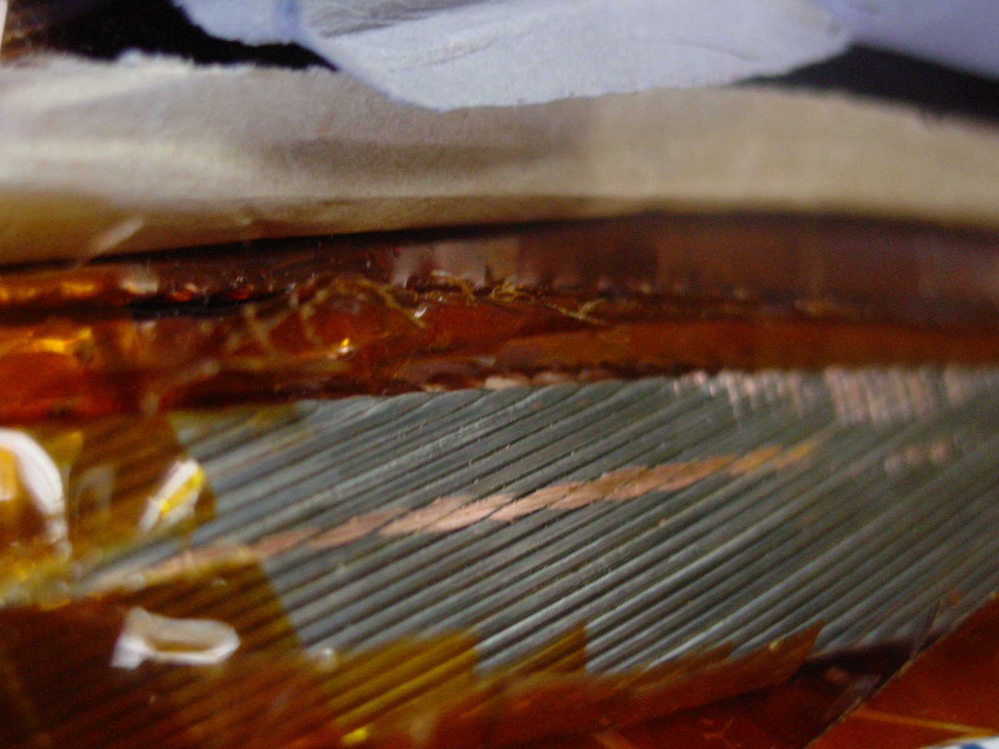
1/4

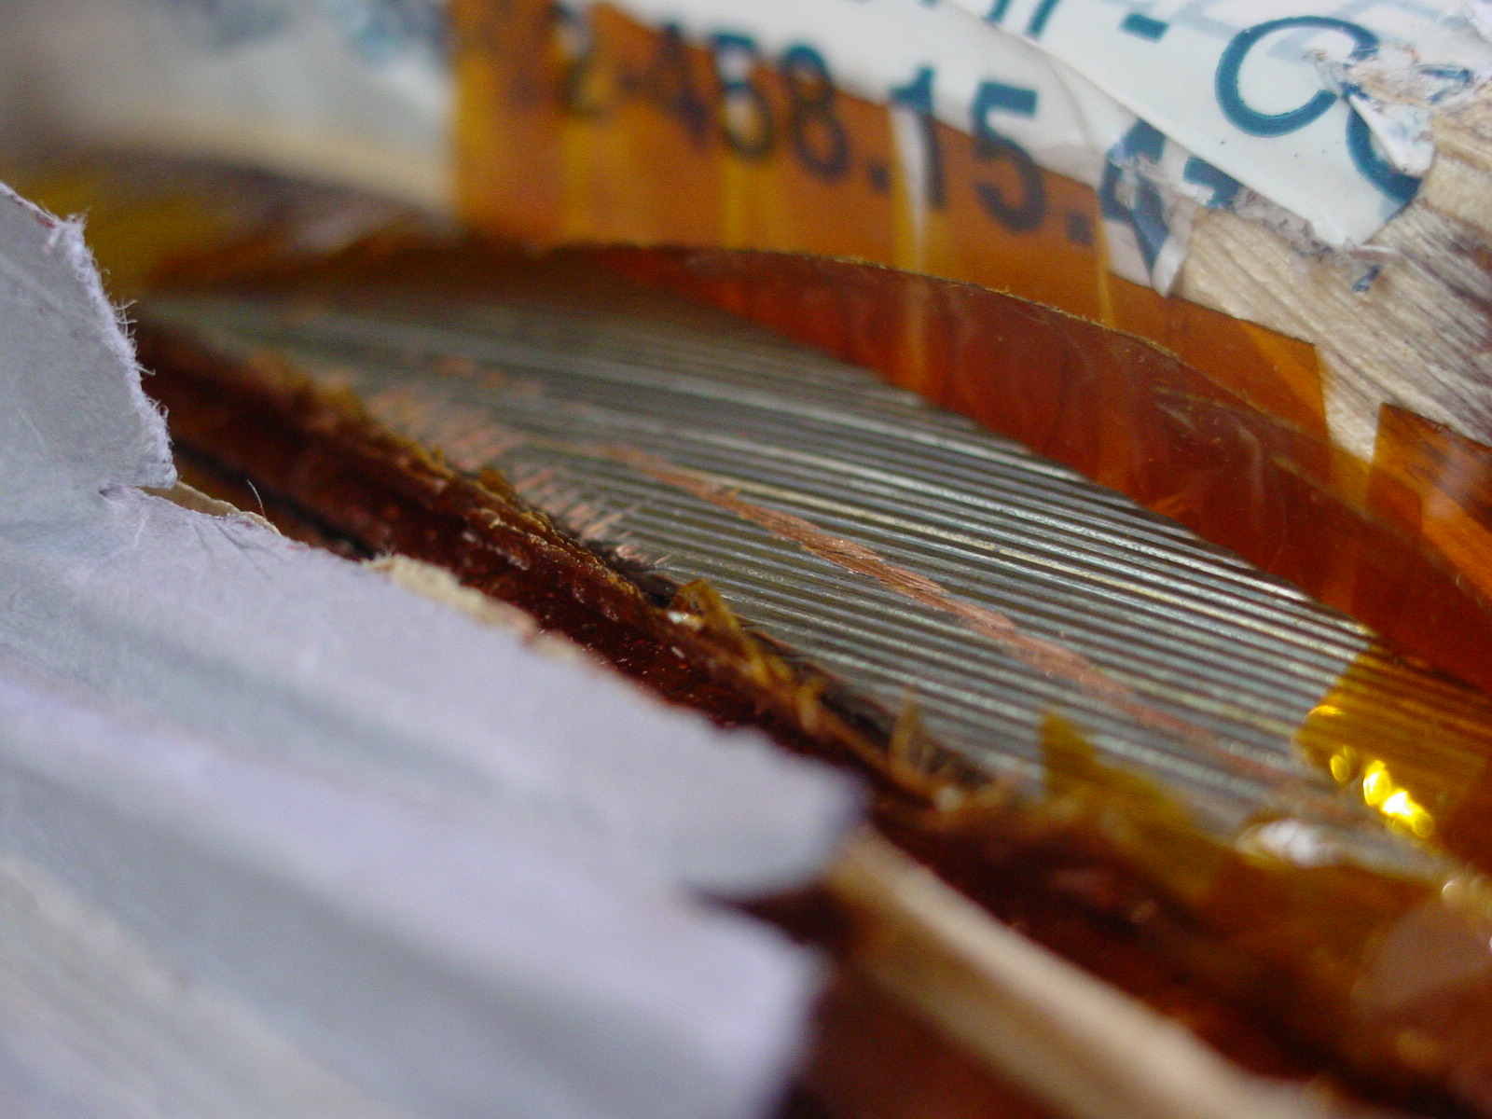
2/4
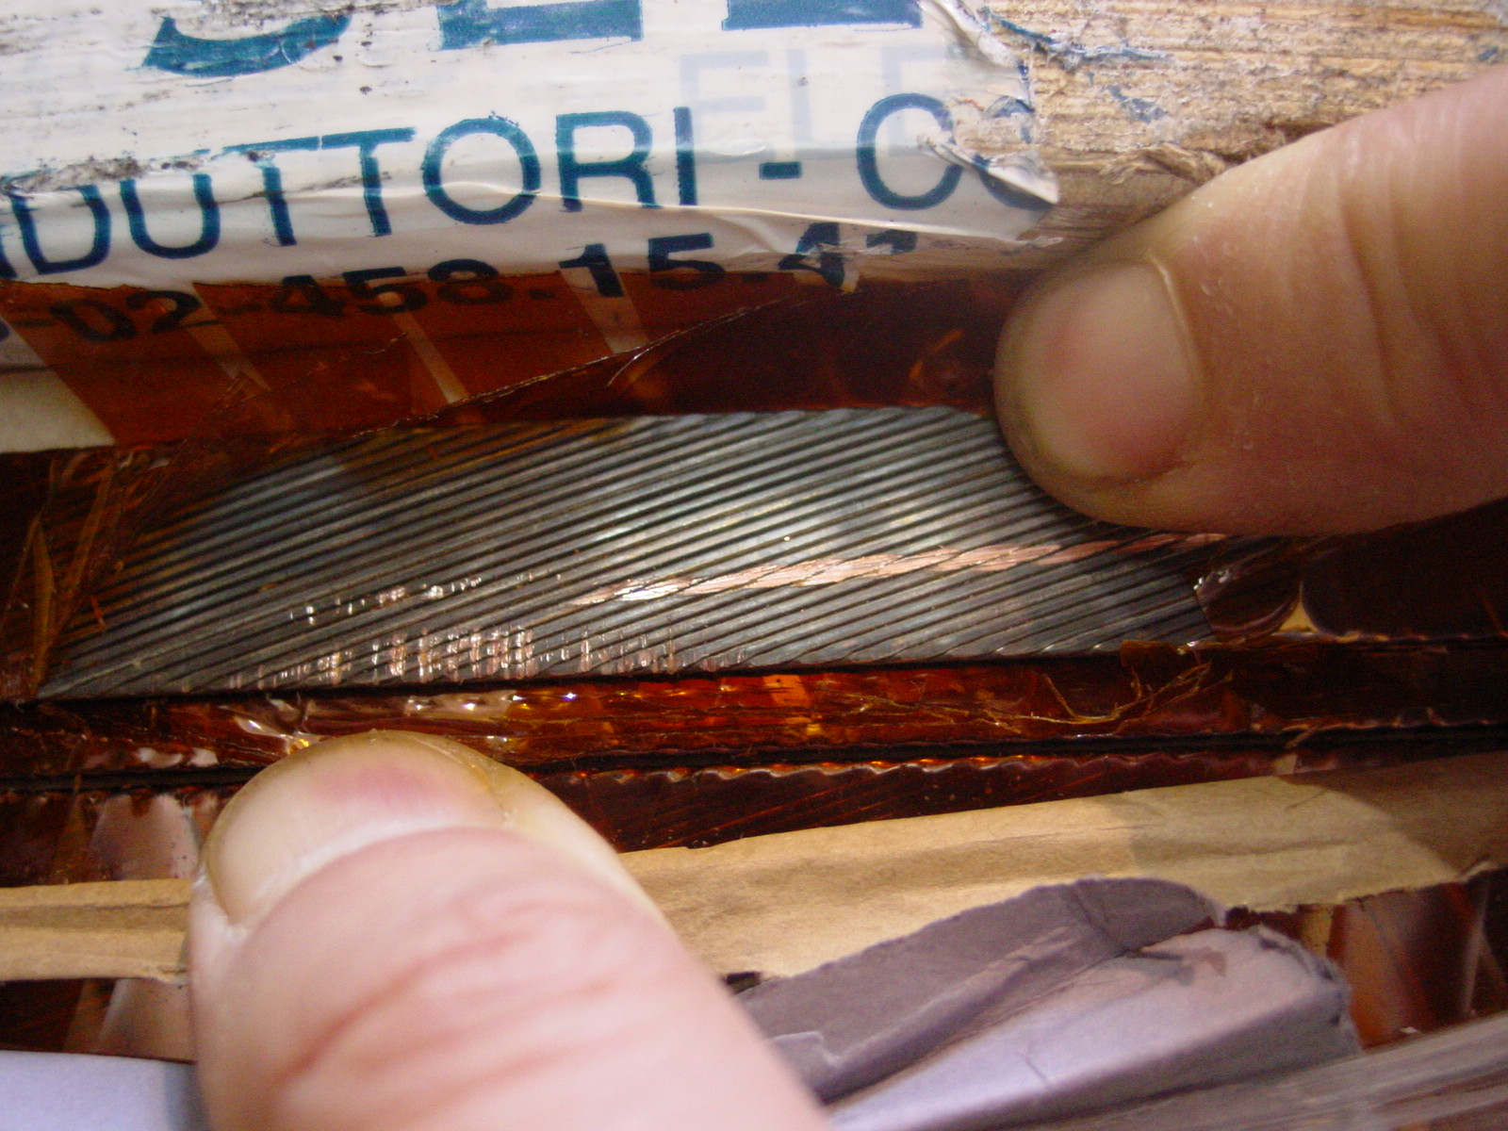
3/4
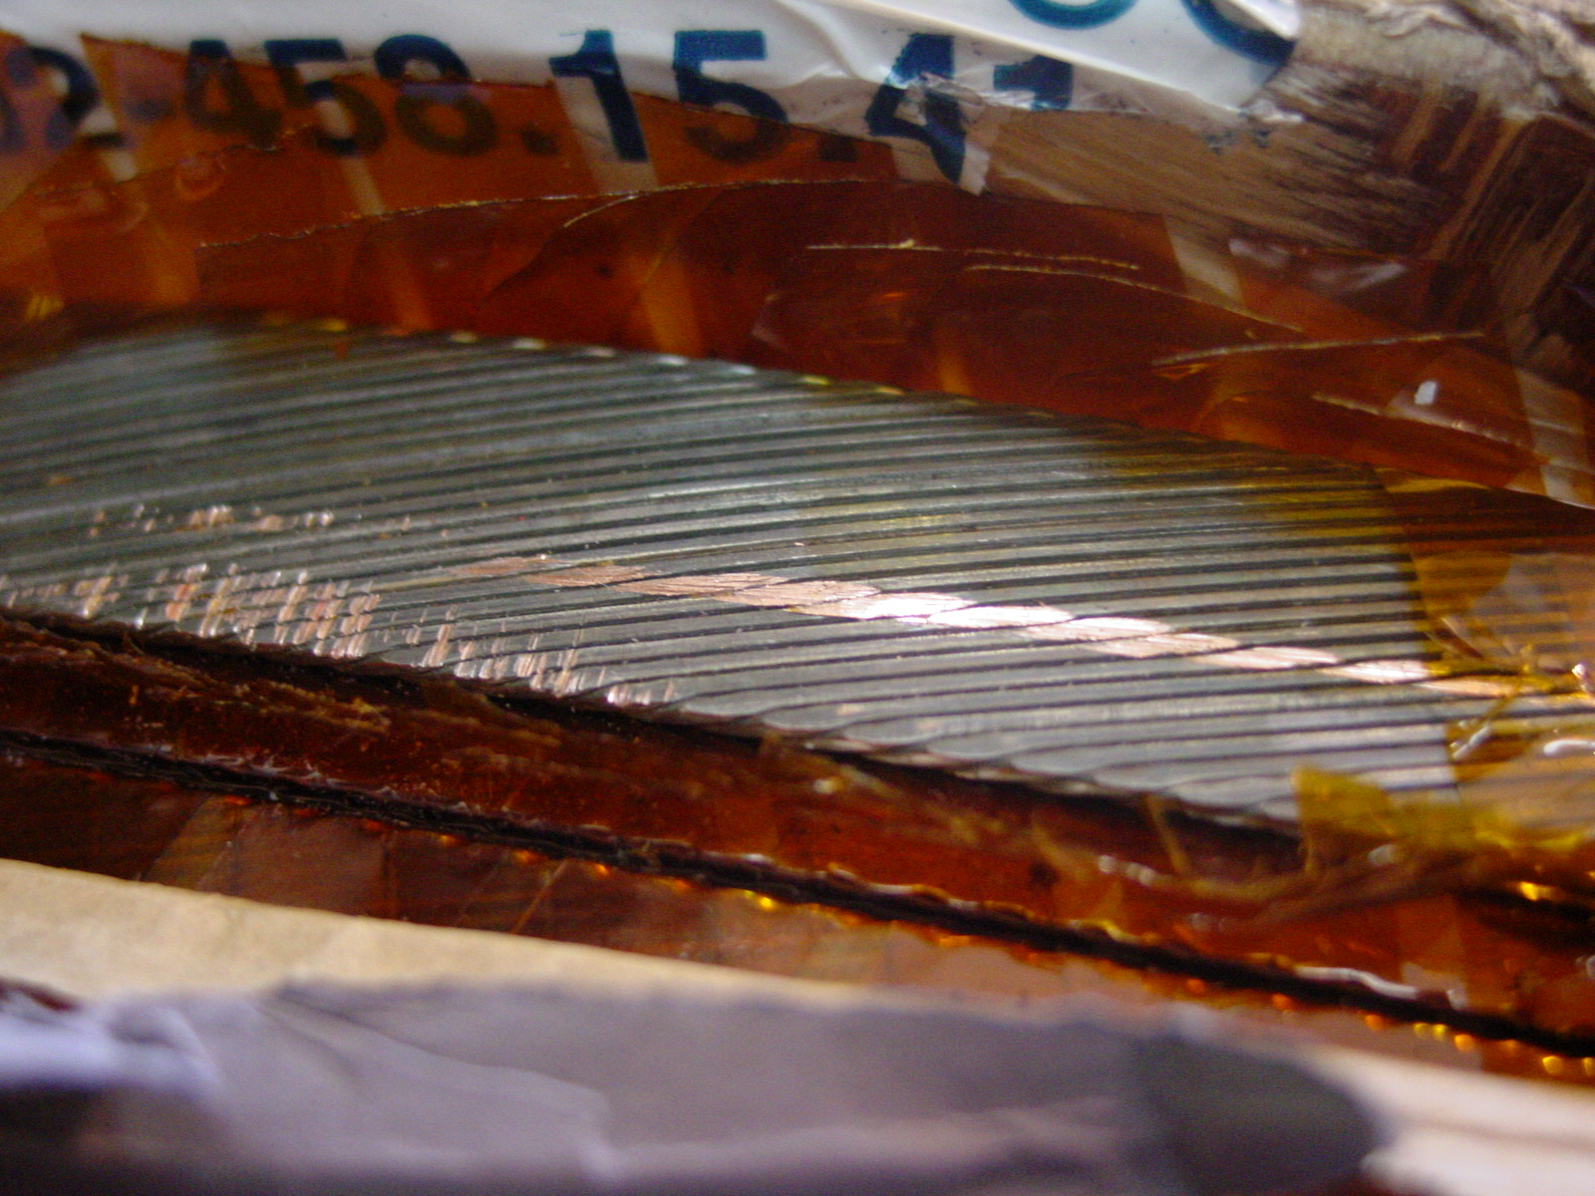
4/4

