–

Non conformity Report
IDENTIFICATION
1. Originator’s Name: F. Terzi | 5. Date: 14/05/2004
2. Contractor/Supplier: Ansaldo Superconduttori S.p.A. | 6. Part description: HCMB__A054
3. Contract No: F462/LHC/LHC | 7. Qty: 160 + 30 pcs.
4. Project Engineer: F. Savary, M. Bajko | 8. Dwg No: LHCMB__A0054

9. Found during what activity:
☑ Incoming inspection | □ Final inspection
□ In-process inspection | □ Other:

10. Description of non conformity (use continuation page if necessary)
Copper wedges type IV/V (PROFILE 2), for inner layer, regarding batch nr.74 (SE000074) & batch nr.75 (SE000075) showed hard oxidations.
Outokumpu production date: 23/01/2004
SELVA tried to remove these oxidations without any results, so, at the moment, the material is in "stand-by". Please find here after some photos.
Total quantity of oxidised copper wedges = 160 pcs. (for batch nr.75) + 30 pcs. (for batch nr.74)
ASG is asking CERN to check the material and take a decisione about it.

11. Action taken to prevent misuse (use continuation page if necessary)

IMPORTANCE
12. | □ Non critical | □ Critical

DISPOSITION
13. | □ Use-as-is | □ Repair | □ Reject | □ Rework | □ Return to supplier
Description of proposed action (use continuation page if necessary)

CORRECTIVE/PREVENTIVE ACTION
14. Description of proposed action (use continuation page if necessary)

APPROVAL OF NON CRITICAL NON CONFORMITIES
15 | Project Engineer: | Date:

APPROVAL OF CRITICAL NON CONFORMITIES
16 | Project Management: | Date:

CLOSURE OF THE NON CONFORMITY
Planned actions have been completed and corrective/preventive actions have been initiated
 | For non critical non conformities  Quality Manager or Project Engineer | For critical non conformities  Project Engineer
17 | Name:  Date: | Name:  Date:

IDENTIFICATION
10. Description of non conformity (continuation page)
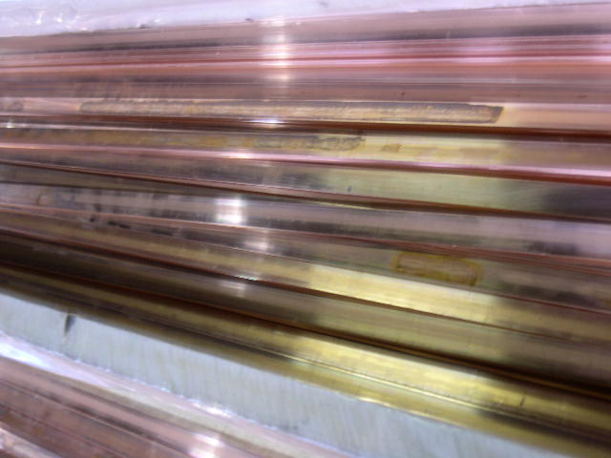
1/3

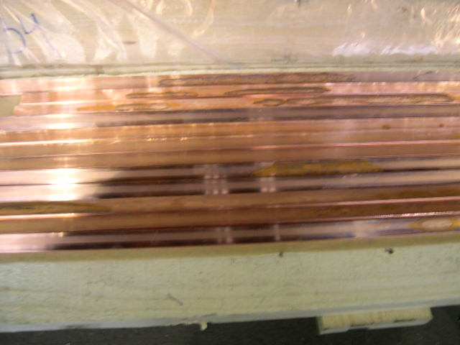
2/3

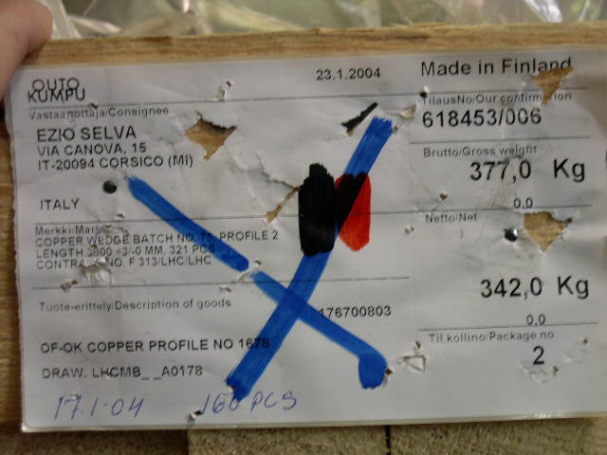
3/3

