–

Non conformity Report
IDENTIFICATION
1. Originator’s Name: F. Terzi | 5. Date: 27/09/2004
2. Contractor/Supplier: Ansaldo Superconduttori S.p.A. | 6. Part description: HCMB__A054
3. Contract No: F462/LHC/LHC | 7. Qty: 510 pcs.
4. Project Engineer: F. Savary, M. Bajko | 8. Dwg No: LHCMB__A0054

9. Found during what activity:
☑ Incoming inspection | □ Final inspection
□ In-process inspection | □ Other:

10. Description of non conformity (use continuation page if necessary)
The following Cu wedges, listed in the next page, showed hard oxidations.
See also annexed photos for details
Outokumpu production date: 23/01/2004 and others. SELVA tried to remove these oxidations without any results, so, at the moment, the material is in "stand-by".
CERN checked the material in ASG on July.

11. Action taken to prevent misuse (use continuation page if necessary)

IMPORTANCE
12. | □ Non critical | □ Critical

DISPOSITION
13. | □ Use-as-is | □ Repair | □ Reject | □ Rework | □ Return to supplier
Description of proposed action (use continuation page if necessary)
ASG, in agreement with CERN, rejected these material.
The material will be sent to CERN for replacement.

CORRECTIVE/PREVENTIVE ACTION
14. Description of proposed action (use continuation page if necessary)

APPROVAL OF NON CRITICAL NON CONFORMITIES
15 | Project Engineer: | Date:

APPROVAL OF CRITICAL NON CONFORMITIES
16 | Project Management: | Date:

CLOSURE OF THE NON CONFORMITY
Planned actions have been completed and corrective/preventive actions have been initiated
 | For non critical non conformities  Quality Manager or Project Engineer | For critical non conformities  Project Engineer
17 | Name:  Date: | Name:  Date:

IDENTIFICATION
a) List of oxidated Cu wedges:

Batch Nr. | Profile type | Pcs.
52 | I | 4
60 | III | 18
67 | III | 24
68 | I | 20
69 | II | 7
74 | I | 160
 | II | 21
 | IV | 27
75 | I | 35
 | II | 168
 | IV | 106

b) summary about the type of Cu-wedges:
Total number:
- type I : 219 pcs.
- type II : 196 pcs.
- type III : 42 pcs.
- type IV : 133 pcs.

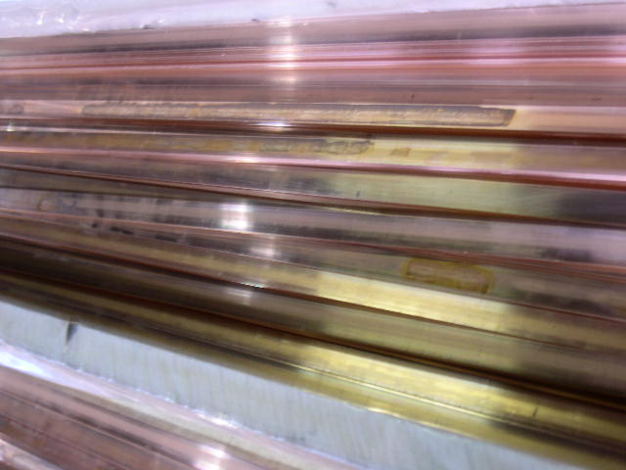
1/3

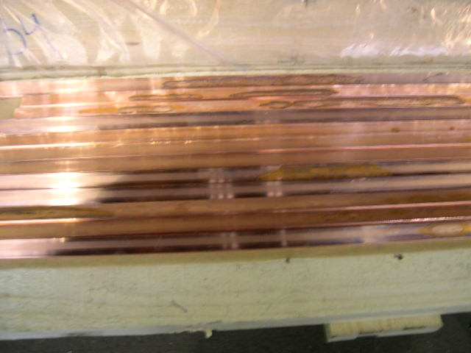
2/3

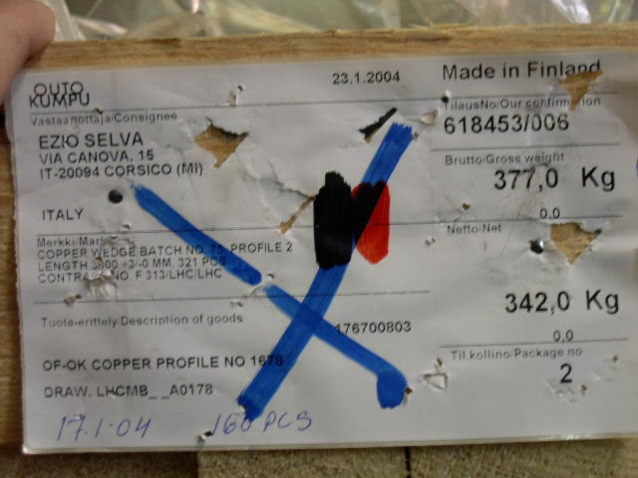
3/3

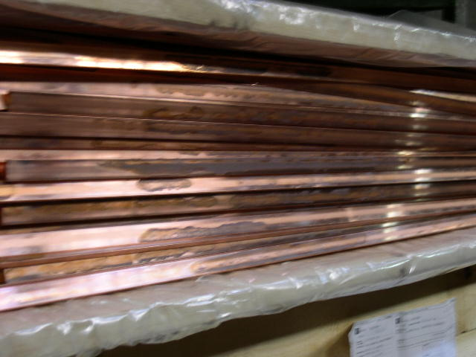1/5 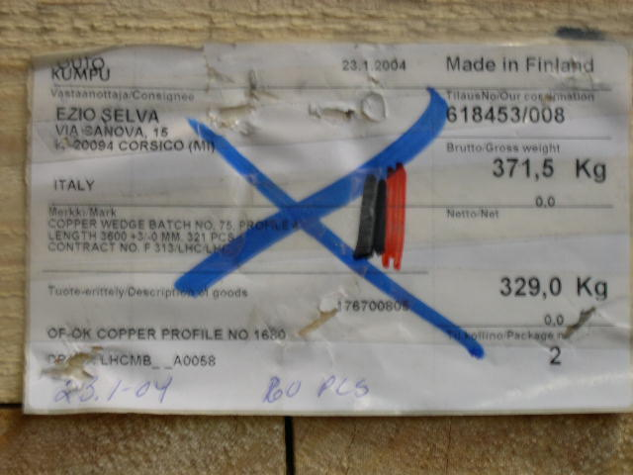2/5

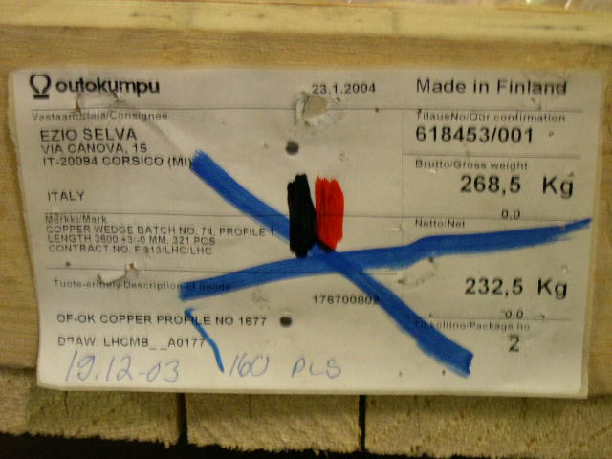 3/5 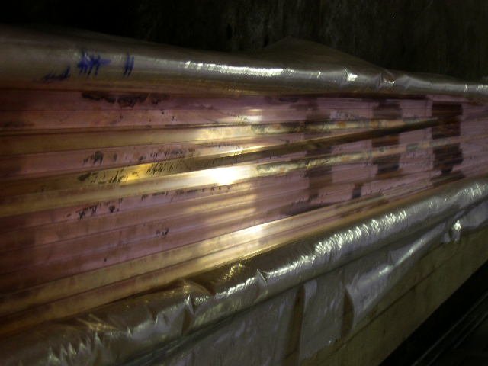4/5


5/5

