–

Non conformity Report
IDENTIFICATION
1. Originator’s Name: F. Terzi | 5. Date: 13/05/2004
2. Contractor/Supplier: Ansaldo Superconduttori S.p.A. | 6. Part description: HCMB__A133
3. Contract No: F462/LHC/LHC | 7. Qty:
4. Project Engineer: F. Savary, M. Bajko | 8. Dwg No:

9. Found during what activity:
☑ Incoming inspection | □ Final inspection
□ In-process inspection | □ Other:

10. Description of non conformity (use continuation page if necessary)
Yoke laminations (batch nr EYA00100 - EYA00101 - EYA00102) received at Ormet, showed dirty surfaces (see annexed photos). At the moment, the material is in "stand-by".
Mr. Musso and Mr. Heer checked the material at Ormet and took away a lamination for visual inspection at CERN.
ASG is asking CERN to check the material and take a decisione about it.

11. Action taken to prevent misuse (use continuation page if necessary)

IMPORTANCE
12. | ☑ Non critical | □ Critical

DISPOSITION
13. | ☑ Use-as-is | □ Repair | □ Reject | □ Rework | □ Return to supplier
Description of proposed action (use continuation page if necessary)
The yoke laminations can be used as is.

CORRECTIVE/PREVENTIVE ACTION
14. Description of proposed action (use continuation page if necessary)
We will complain to CERN supplier so that this does not happen anymore in the future (Action: CERN).

APPROVAL OF NON CRITICAL NON CONFORMITIES
15 | Project Engineer: F. Savary | Date: June 14th, 2004

APPROVAL OF CRITICAL NON CONFORMITIES
16 | Project Management: | Date:

CLOSURE OF THE NON CONFORMITY
Planned actions have been completed and corrective/preventive actions have been initiated
 | For non critical non conformities  Quality Manager or Project Engineer | For critical non conformities  Project Engineer
17 | Name: F. Terzi  Date: 15/06/2004 | Name:  Date:

IDENTIFICATION
10. Description of non conformity (continuation page)
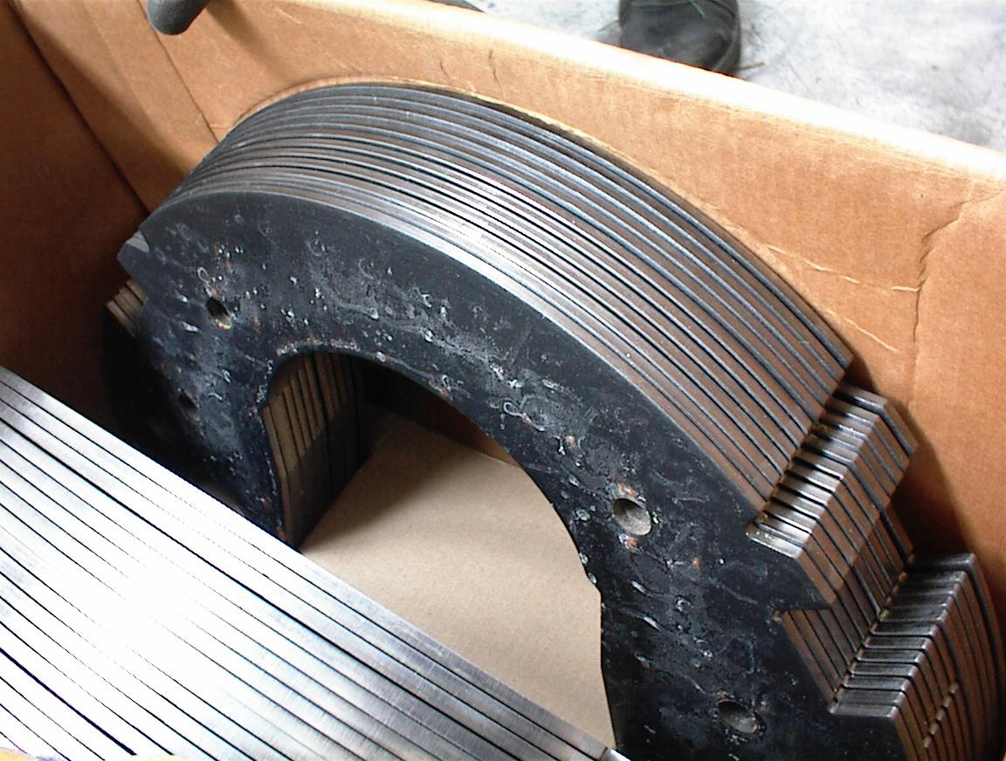
1/2

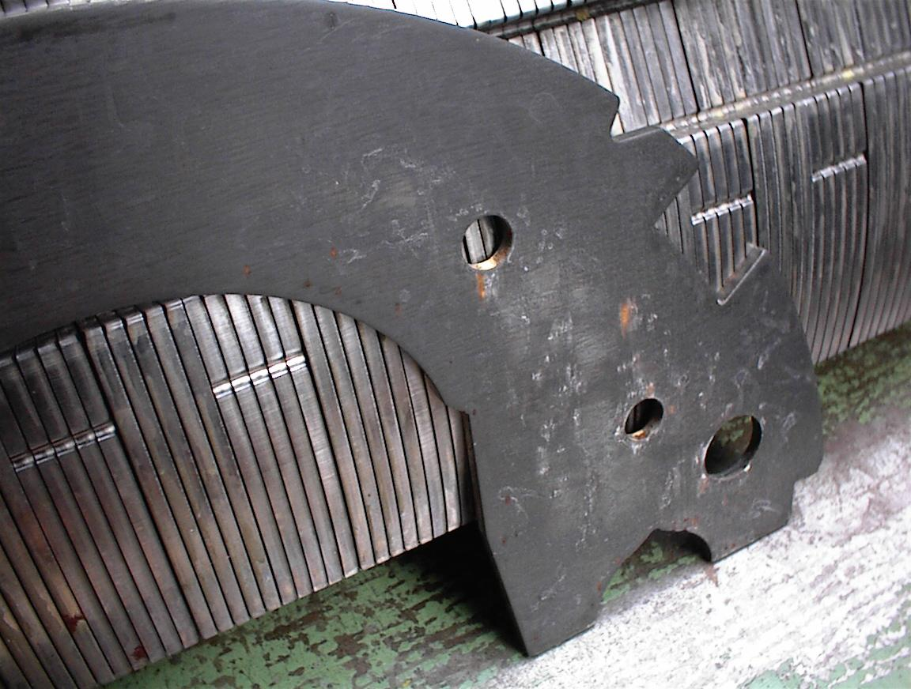
2/2

