–

Non conformity Report
IDENTIFICATION
1. Originator’s Name: F.Terzi | 5. Date: 08/06/2004
2. Contractor/Supplier: Ansaldo Superconduttori S.p.A. | 6. Part description: 02P00403
3. Contract No: F462/LHC/LHC | 7. Qty: 1
4. Project Engineer: F. Savary, M. Bajko | 8. Dwg No: LHCMB__A0001/G (620RM08234/L)

9. Found during what activity:
□ Incoming inspection | □Final inspection
☑In-process inspection | □ Other:

10. Description of non conformity (use continuation page if necessary)
After collaring of CC 2101, electrical test showed a turn to turn short circuit on pole 02P00403 (pos. D1-lower).

11. Action taken to prevent misuse (use continuation page if necessary)

IMPORTANCE
12. | ☑ Non critical | □ Critical

DISPOSITION
13. | □ Use-as-is | ☑ Repair | □ Reject | □ Rework | □ Return to supplier
Description of proposed action (use continuation page if necessary)
The collared coils assembly cannot be used as is.
The pole shall be repaired if possible. If repairing is not possible, then the pole shall be rejected.
CERN suggested repeating the warm magnetic measurements (which, in case of sustained short, give key information for localizing better the short).
These measurements have been carried out on the c.c. assembly being turned upside down and consequently the short has been seen in D2-Upper.

CORRECTIVE/PREVENTIVE ACTION
14. Description of proposed action (use continuation page if necessary)

APPROVAL OF NON CRITICAL NON CONFORMITIES
15 | Project Engineer: F. Savary | Date: June 14th, 2004

APPROVAL OF CRITICAL NON CONFORMITIES
16 | Project Management: | Date:

CLOSURE OF THE NON CONFORMITY
Planned actions have been completed and corrective/preventive actions have been initiated
 | For non critical non conformities  Quality Manager or Project Engineer | For critical non conformities  Project Engineer
17 | Name: F. Terzi  Date: 16/09/2004 | Name:  Date:

CLOSURE OF THE NON CONFORMITY

Collared coils CC 2101 have been dismantled.
Electrical check has been performed on pole 02P00403 in order to find out the position of the short circuit.
An interturn short circuit was found between 6th and 7th turn on I.L. 02I00406.
The layer has been repaired and electrical test performed with good result.
F. Terzi

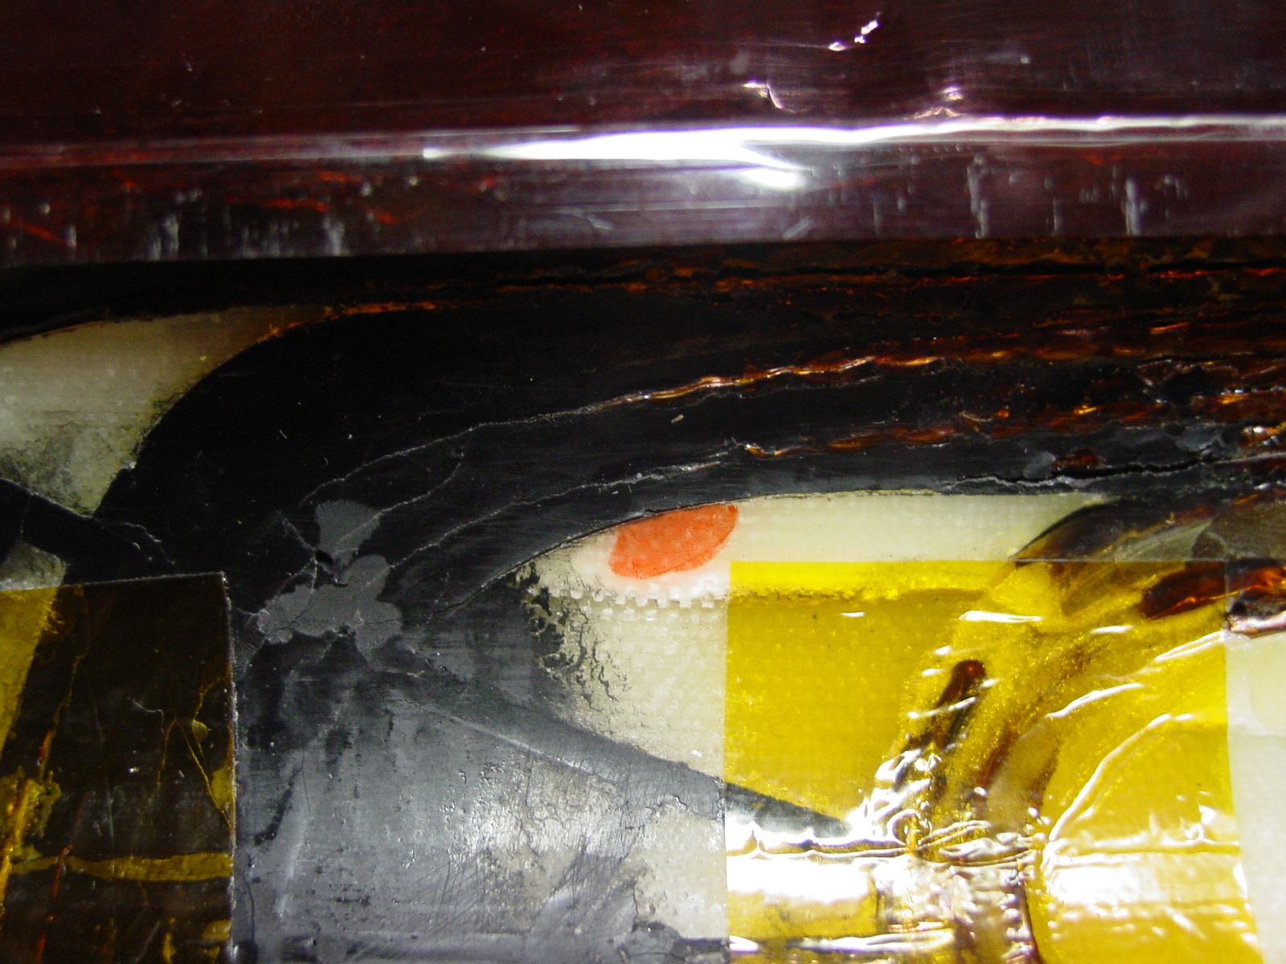
1/2 – Before repairing

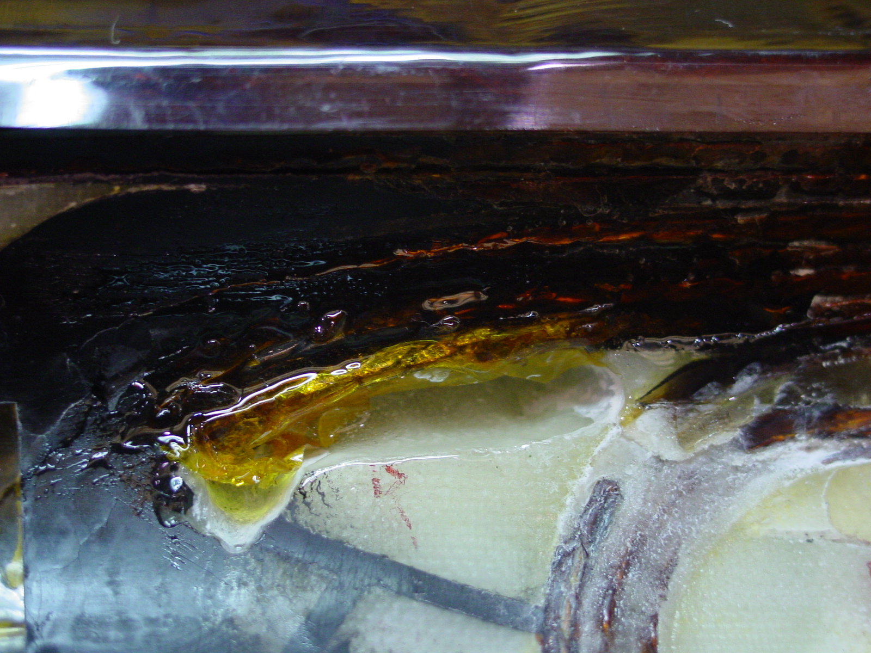
2/2 – After repairing

