–

Non conformity Report
IDENTIFICATION
1. Originator’s Name: B. Caserza, F. Terzi | 5. Date: 09/07/2004
2. Contractor/Supplier: Ansaldo Superconduttori S.p.A. | 6. Part description: HCMBBLA001-02000073
3. Contract No: F462/LHC/LHC | 7. Qty: 1
4. Project Engineer: F. Savary, M. Bajko | 8. Dwg No: LHCMBB_A0002/F (683RM08451)

9. Found during what activity:
□ Incoming inspection | ☑ Final inspection
□ In-process inspection | □ Other:

10. Description of non conformity (use continuation page if necessary)
Final electrical measurements performed on CM 2073 showed a short circuit between QH YT121 and pole (pos. dipole D1).
ASG will proceed to dismantle the cold mass and find out the problem: only after opening of CC, a precise check of the position of the QH and the pole involved will be possible.

11. Action taken to prevent misuse (use continuation page if necessary)

IMPORTANCE
12. |  ☑ Non critical | □ Critical

DISPOSITION
13. | □ Use-as-is | ☑ Repair | □ Reject | □ Rework | □ Return to supplier
Description of proposed action (use continuation page if necessary)
As said above, the assembly shall be dismounted for investigations and repair.
ASG shall then report on the position of the defect and describe the repairing procedure, including pictures if something is visible.

CORRECTIVE/PREVENTIVE ACTION
14. Description of proposed action (use continuation page if necessary)
ASG shall pay more attention during the reception tests of the quench heaters and during their installation in the magnet.

APPROVAL OF NON CRITICAL NON CONFORMITIES
15 | Project Engineer: F. Savary | Date: July 22nd, 2004

APPROVAL OF CRITICAL NON CONFORMITIES
16 | Project Management: | Date:

CLOSURE OF THE NON CONFORMITY
Planned actions have been completed and corrective/preventive actions have been initiated
CC 2073 has been re-collared: QHs, cold bore tubes, coil protection sheets and ground insulation have changed with new ones (See annexed pictures).
 | For non critical non conformities  Quality Manager or Project Engineer | For critical non conformities  Project Engineer
17 | Name: F. Terzi  Date: 29/03/2005 | Name:  Date:

CLOSURE OF THE NON CONFORMITY
(from e-mail to CERN dated 15/03/2005)

The history of the CM 2073 is:
- at the electrical check before the welding of end cover we discovered a short circuit between the quench heater YT211 and the pole D2U (NC CERN 181)
- the CM was demounted and decollared
- then recollared changing all the components (QHs, cold bore tubes, coil protection sheets and ground insulation)
- at the electrical check after collaring, QH nr. YT111 was in short circuit with pole D1-L (NC CERN 202)
- decollaring and recollaring
- extra joint between bus bar and cable (NC CERN 211)
- at the final electrical check after the pressure test, we found a short circuit between the quench heater nr. YT121 and the pole D1 ( NC CERN 225)
- the CM was demounted and decollared
- recollared again changing all the components

Here are some pictures after last decollaring.
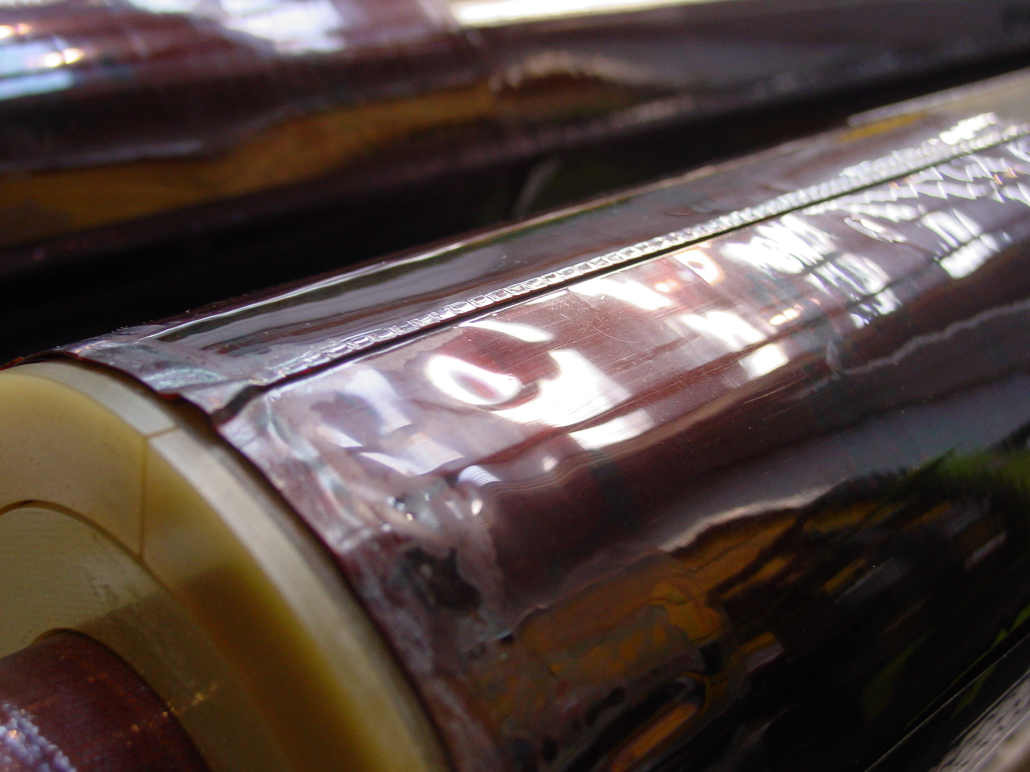
1/3

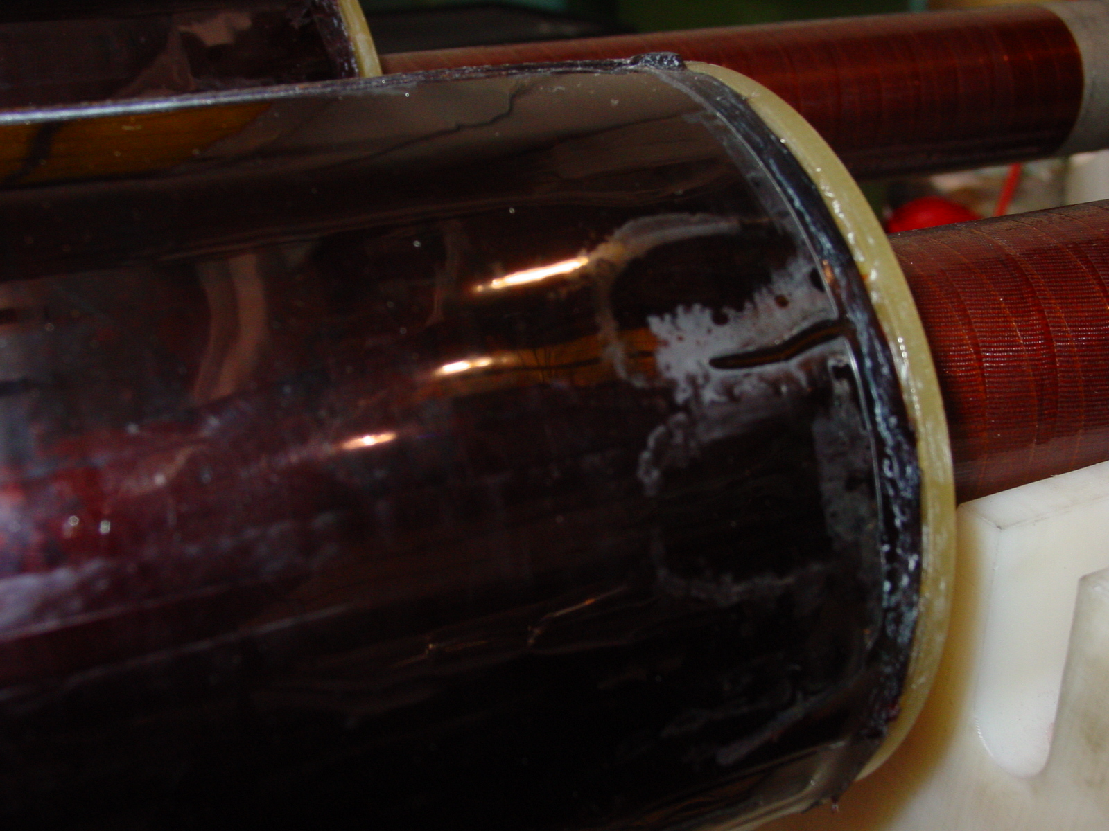
2/3
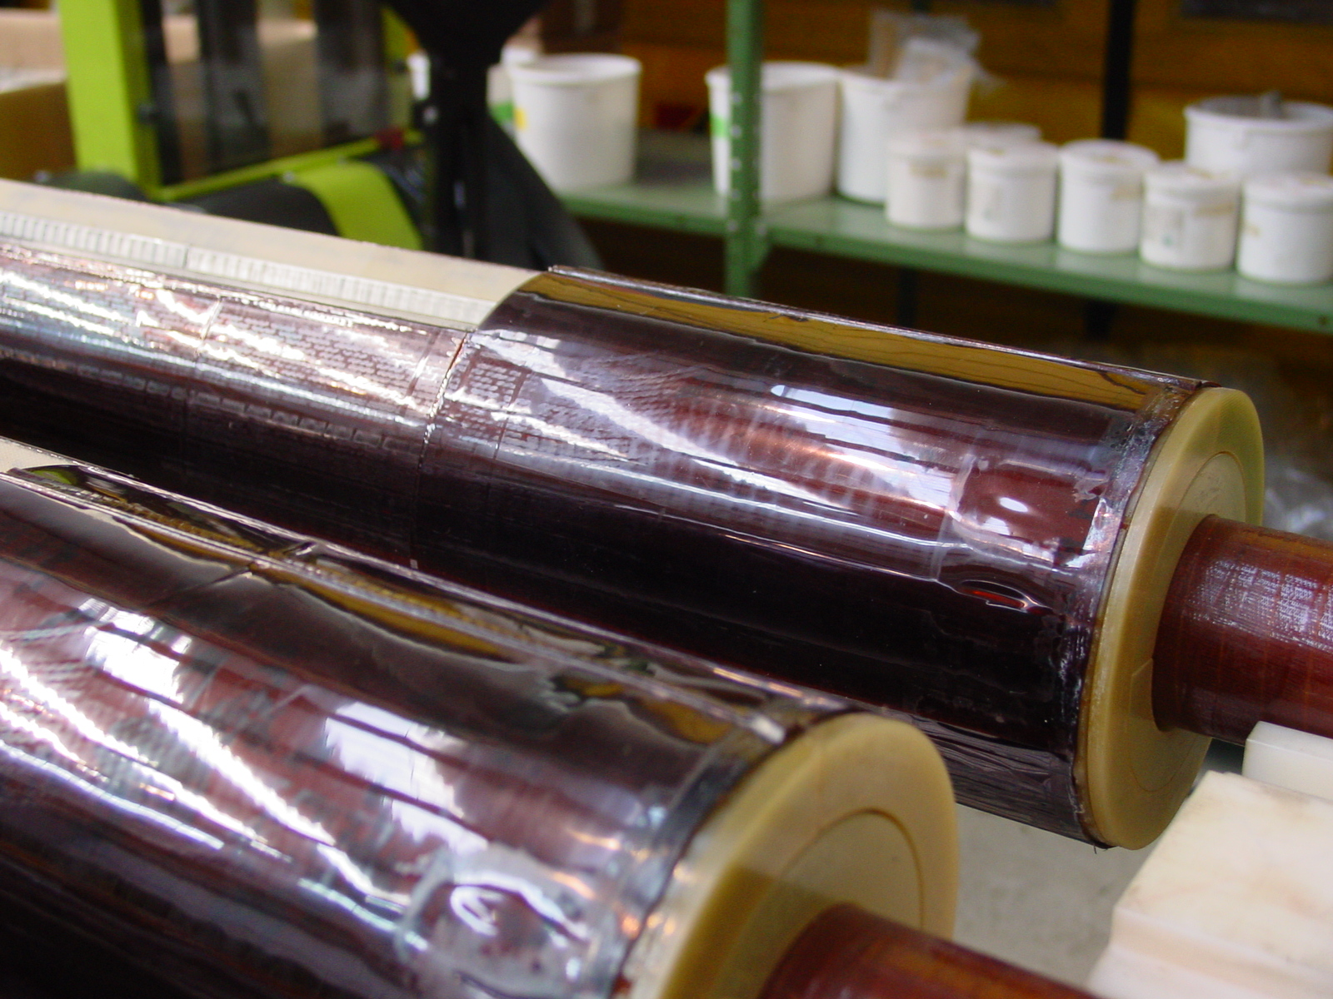
3/3

