–

Non conformity Report
IDENTIFICATION
1. Originator’s Name: F. Terzi | 5. Date: 09/08/2004
2. Contractor/Supplier: Ansaldo Superconduttori S.p.A. | 6. Part description: HCMBALA001-02000094
3. Contract No: F462/LHC/LHC | 7. Qty: 1
4. Project Engineer: F. Savary, M. Bajko | 8. Dwg No: LHCMBB_A0002/F (683RM08451)

9. Found during what activity:
□ Incoming inspection | □ Final inspection
☑ In-process inspection | □ Other:

10. Description of non conformity (use continuation page if necessary)
During preparation of auxiliary bus-bars installed on M2-line, lyre side, of CM 2094, wire n.11 of has been cut at a reduced length of about 100 mm.
See annexed pictures on continuation page.

11. Action taken to prevent misuse (use continuation page if necessary)

IMPORTANCE
12. | □ Non critical | □ Critical

DISPOSITION
13. | □Use-as-is | □ Repair | □ Reject | □ Rework | □ Return to supplier
Description of proposed action (use continuation page if necessary)

CORRECTIVE/PREVENTIVE ACTION
14. Description of proposed action (use continuation page if necessary)

APPROVAL OF NON CRITICAL NON CONFORMITIES
15 | Project Engineer: | Date:

APPROVAL OF CRITICAL NON CONFORMITIES
16 | Project Management: | Date:

CLOSURE OF THE NON CONFORMITY
Planned actions have been completed and corrective/preventive actions have been initiated
 | For non critical non conformities  Quality Manager or Project Engineer | For critical non conformities  Project Engineer
17 | Name:  Date: | Name:  Date:

Cold mass 2094
Auxiliary bus-bars on M2-line, lyre side
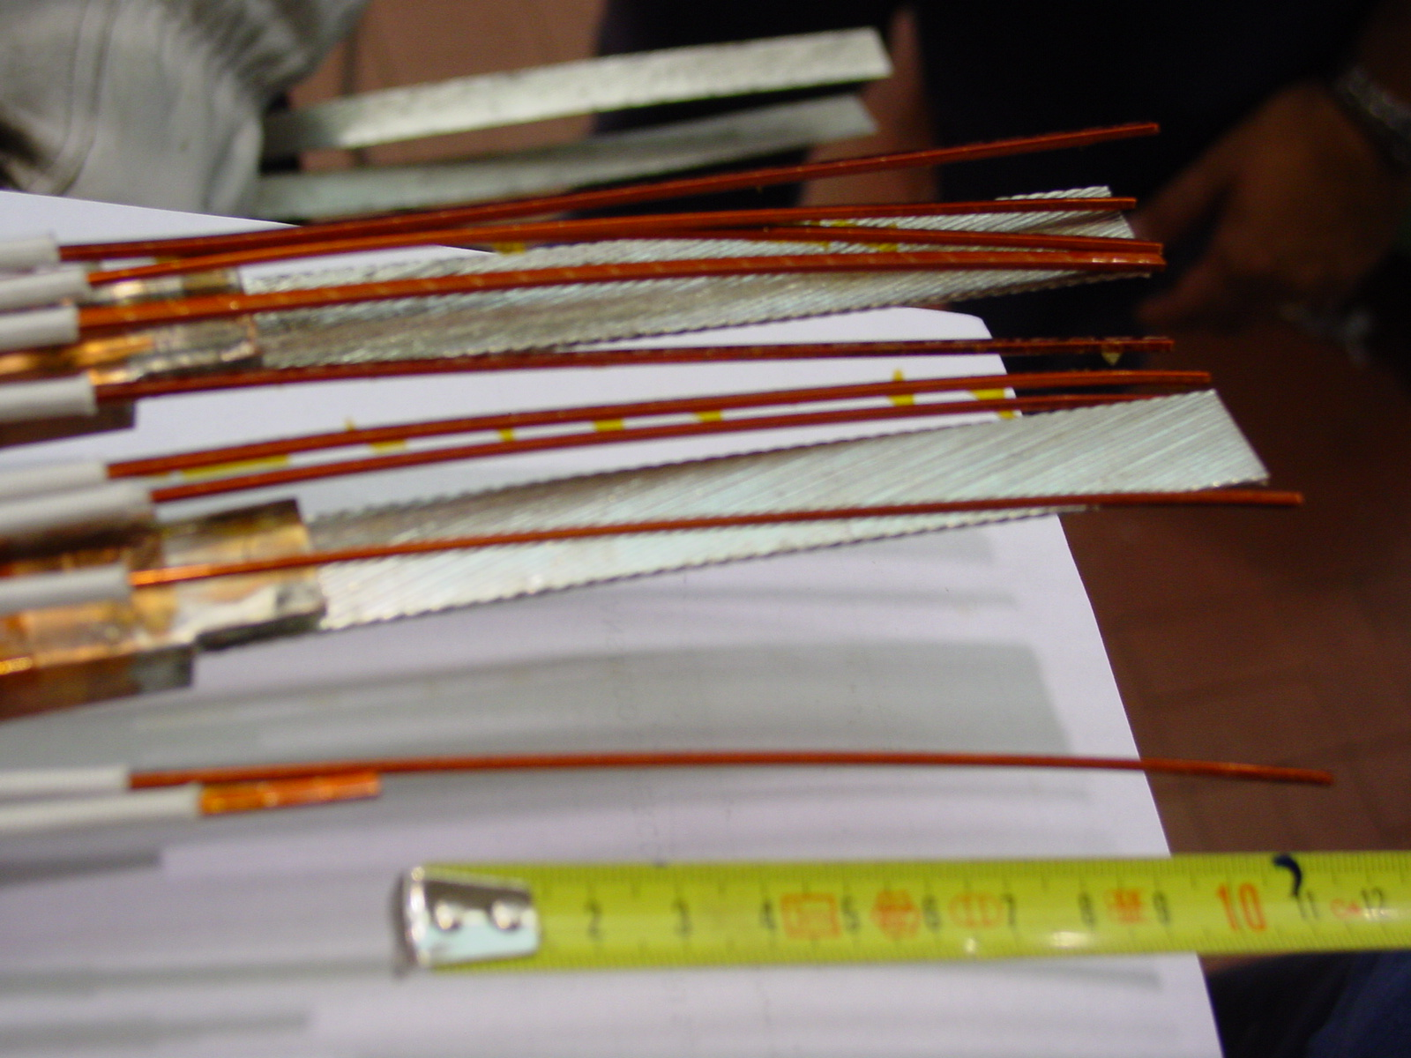
1/2

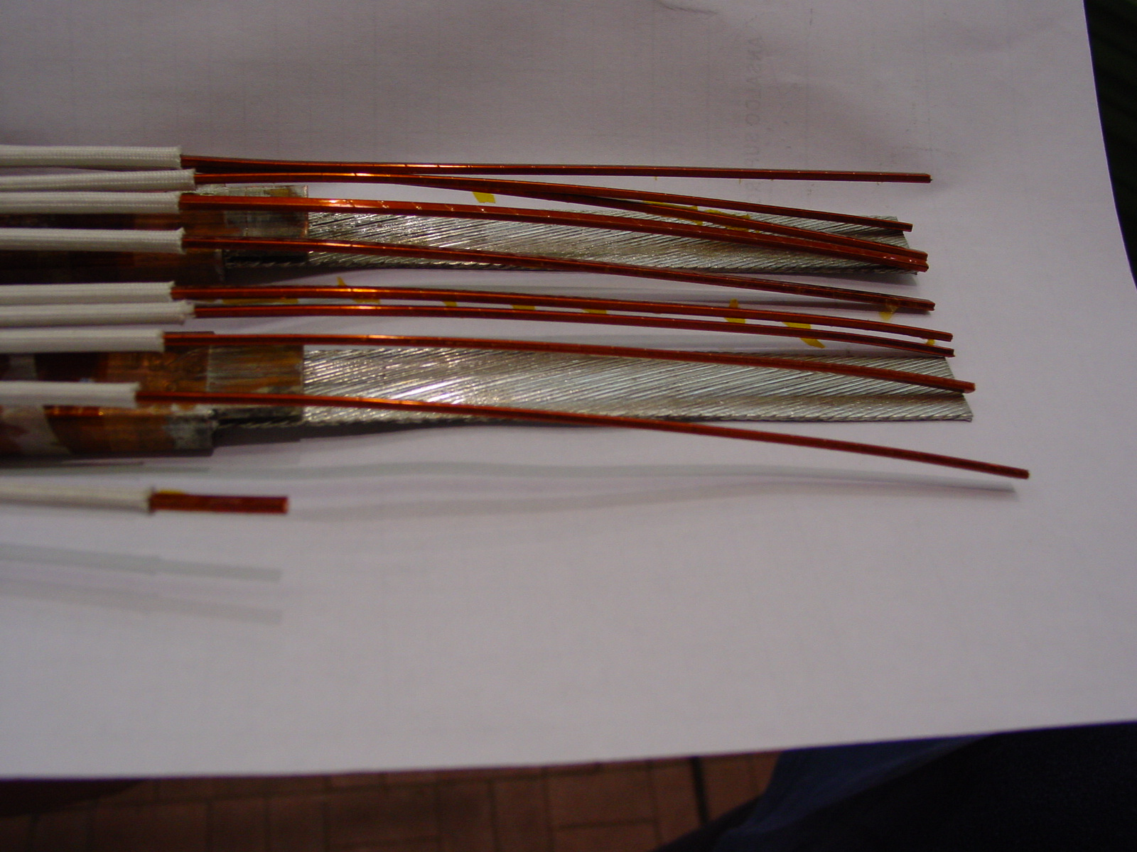
2/2

