–

Non conformity Report
IDENTIFICATION
1. Originator’s Name: B. Caserza, F. Terzi | 5. Date: 16/09/2004
2. Contractor/Supplier: Ansaldo Superconduttori S.p.A. | 6. Part description: HCMB__A001-02000130
3. Contract No: F462/LHC/LHC | 7. Qty: 1
4. Project Engineer: F. Savary, M. Bajko | 8. Dwg No: LHCMB__A0012/E (620RM08202/F)

9. Found during what activity:
☑ Incoming inspection | □ Final inspection
□ In-process inspection | □ Other:

10. Description of non conformity (use continuation page if necessary)
After curing, a visual check of inner layer nr. 02I00524 for CM 2130, showed a piece polyimide foil, coming from protection sheet of winding mandrel, glued between the last turn and the end spacer on NCS.
For details, please look at the annexed pictures on continuation page.

11. Action taken to prevent misuse (use continuation page if necessary)

IMPORTANCE
12. | ☑ Non critical | □ Critical

DISPOSITION
13. | □ Use-as-is | ☑ Repair | □ Reject | □ Rework | □ Return to supplier
Description of proposed action (use continuation page if necessary)
ASG propose to cut the extra material about this small piece of polyimide during finishing operation of coil heads.

CORRECTIVE/PREVENTIVE ACTION
14. Description of proposed action (use continuation page if necessary)

APPROVAL OF NON CRITICAL NON CONFORMITIES
15 | Project Engineer: F. Savary | Date: November 30th, 2004

APPROVAL OF CRITICAL NON CONFORMITIES
16 | Project Management: | Date:

CLOSURE OF THE NON CONFORMITY
Planned actions have been completed and corrective/preventive actions have been initiated
 | For non critical non conformities  Quality Manager or Project Engineer | For critical non conformities  Project Engineer
17 | Name: F. Terzi  Date: 01/12/2004 | Name:  Date:

10. Description of non conformity (continuation page)

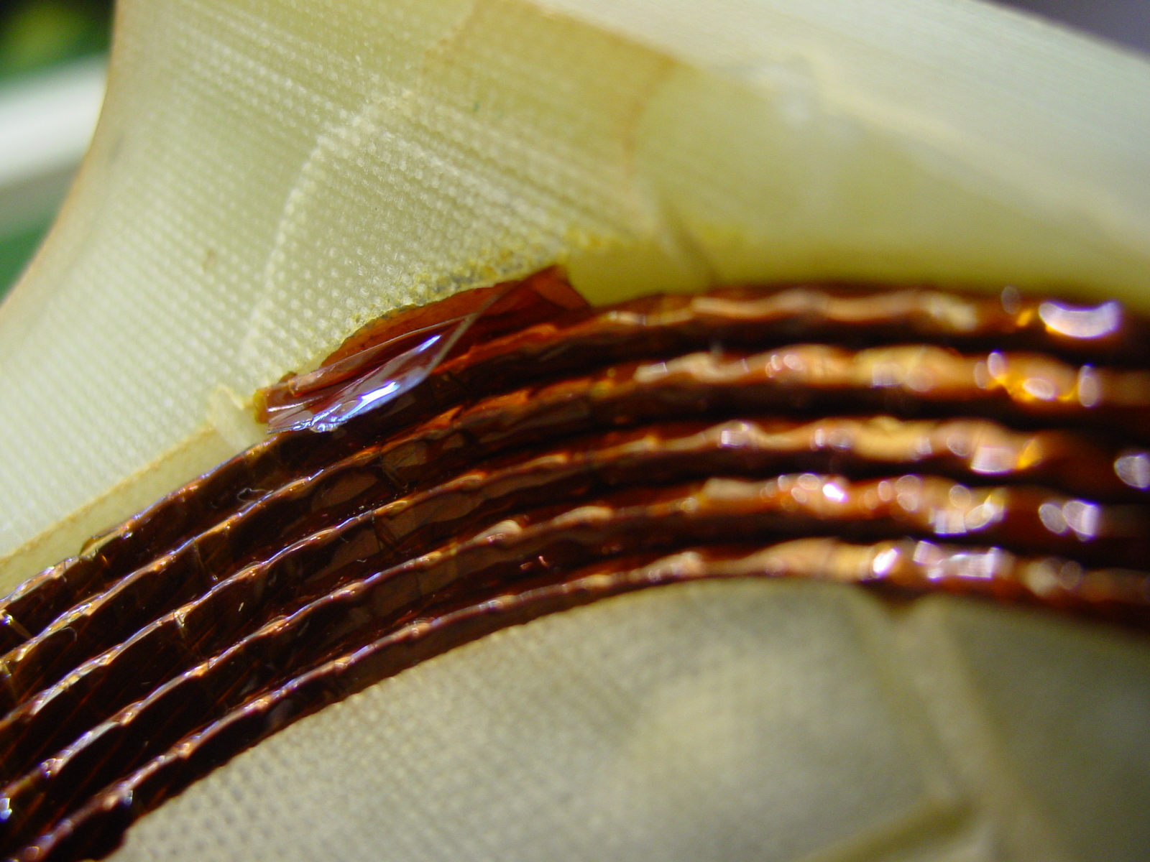
1/2
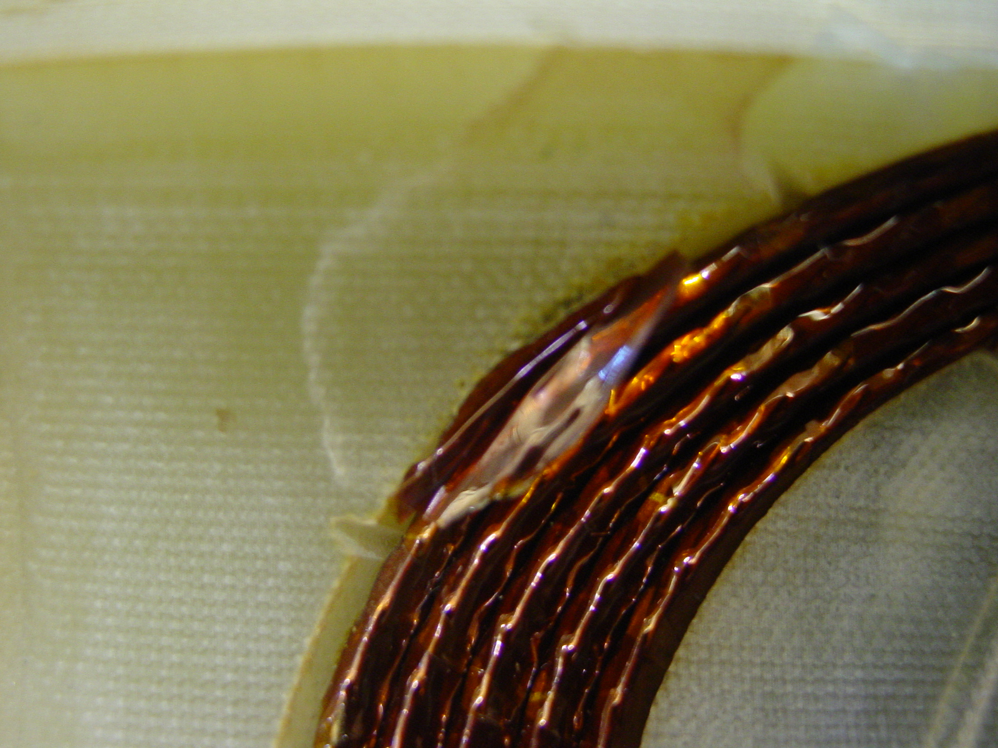
2/2

