–

Non conformity Report
IDENTIFICATION
1. Originator’s Name: F. Terzi, B. Caserza | 5. Date: 17/09/2004
2. Contractor/Supplier: Ansaldo Superconduttori S.p.A. | 6. Part description: CC 2114
3. Contract No: F462/LHC/LHC | 7. Qty: 1
4. Project Engineer: F. Savary, M. Bajko | 8. Dwg No: LHCMB__A0001/G (620RM08234/L)

9. Found during what activity:
□ Incoming inspection | □Final inspection
☑ In-process inspection | □ Other:

10. Description of non conformity (use continuation page if necessary)
During rotation of CC 2114 on rotating bench, the CC felt down from the wheels to the bench plane.
After a visual inspection, no evident damages have been detected.
See annexed pictures.

11. Action taken to prevent misuse (use continuation page if necessary)

IMPORTANCE
12. | □ Non critical | □ Critical

DISPOSITION
13. | ☑ Use-as-is | □ Repair | □ Reject | □ Rework | □ Return to supplier
Description of proposed action (use continuation page if necessary)
ASG propose to perform electrical check, magnetic measurements and dimensional check of inner diameter of cold bore tubes with "go-no-go" gauge. If all measurements proposed by ASG are giving good results ( acceptable within the required tolerance value specified for each test) ASG can go ahead with the assembly on their own responsibility.

CORRECTIVE/PREVENTIVE ACTION
14. Description of proposed action (use continuation page if necessary)

APPROVAL OF NON CRITICAL NON CONFORMITIES
15 | Project Engineer: Marta Bajko | Date: 08.10.2004

APPROVAL OF CRITICAL NON CONFORMITIES
16 | Project Management: | Date:

CLOSURE OF THE NON CONFORMITY
Planned actions have been completed and corrective/preventive actions have been initiated
 | For non critical non conformities  Quality Manager or Project Engineer | For critical non conformities  Project Engineer
17 | Name:  Date: | Name:  Date:

10. Description of non conformity (continuation page)

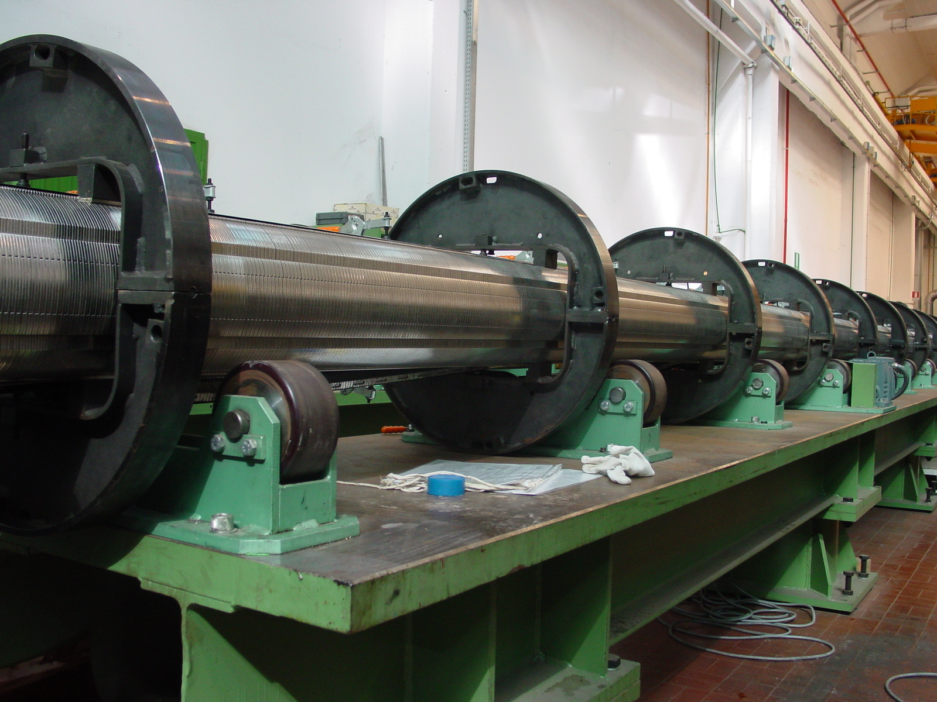
1/2

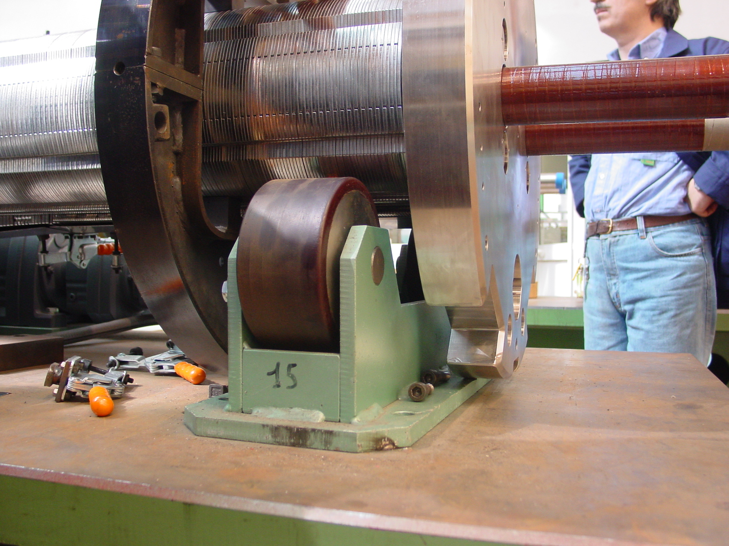
2/2

