–

Non conformity Report
IDENTIFICATION
1. Originator’s Name: B. Caserza, F. Terzi | 5. Date: 08/11/2004
2. Contractor/Supplier: Ansaldo Superconduttori S.p.A. | 6. Part description: HCMB__A001-02000136
3. Contract No: F462/LHC/LHC | 7. Qty: 1
4. Project Engineer: F. Savary, M. Bajko | 8. Dwg No: LHCMB__A0012/E (620RM08202/F)

9. Found during what activity:
☑ Incoming inspection | □ Final inspection
□ In-process inspection | □ Other:

10. Description of non conformity (use continuation page if necessary)
After curing, a visual check of inner layer nr. 02I00548 for CM 2136, showed a strand out of position in the Rutherford cable, near NCS.
Cable id. nr. 01E00140B

11. Action taken to prevent misuse (use continuation page if necessary)

IMPORTANCE
12. | ☑ Non critical | □ Critical

DISPOSITION
13. | □ Use-as-is | ☑ Repair | □ Reject | □ Rework | □ Return to supplier
Description of proposed action (use continuation page if necessary)
ASG proceeded to put the strand in the right position, after removing the G11 filler.

CORRECTIVE/PREVENTIVE ACTION
14. Description of proposed action (use continuation page if necessary)
ASG should document this action and write a repair procedure.

APPROVAL OF NON CRITICAL NON CONFORMITIES
15 | Project Engineer: Marta Bajko | Date: 17.12.2004

APPROVAL OF CRITICAL NON CONFORMITIES
16 | Project Management: | Date:

CLOSURE OF THE NON CONFORMITY
Planned actions have been completed and corrective/preventive actions have been initiated
Repair completed: electrical insulation test performed successfully.
See pictures below for details.
 | For non critical non conformities  Quality Manager or Project Engineer | For critical non conformities  Project Engineer
17 | Name: F. Terzi  Date: 17/12/2004 | Name:  Date:

Before repairing
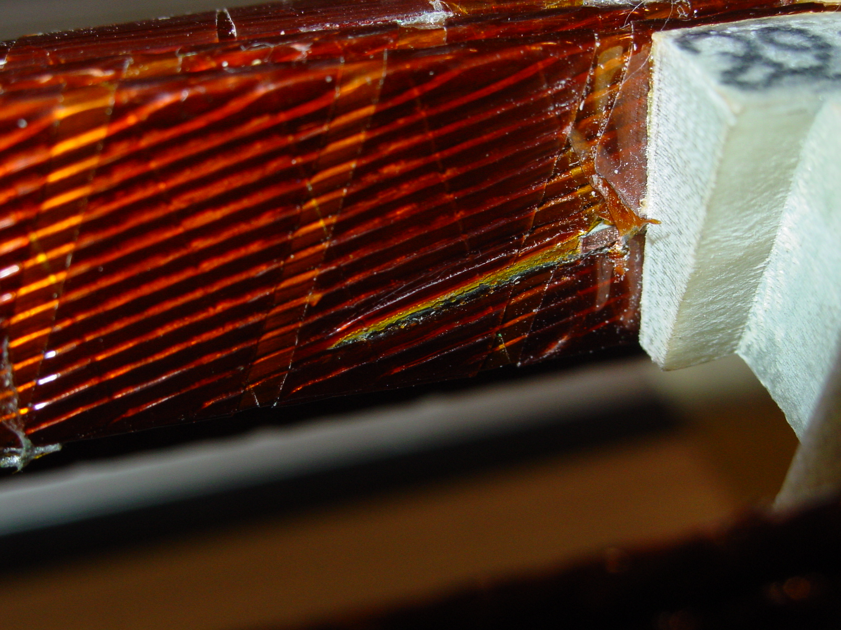
1/5
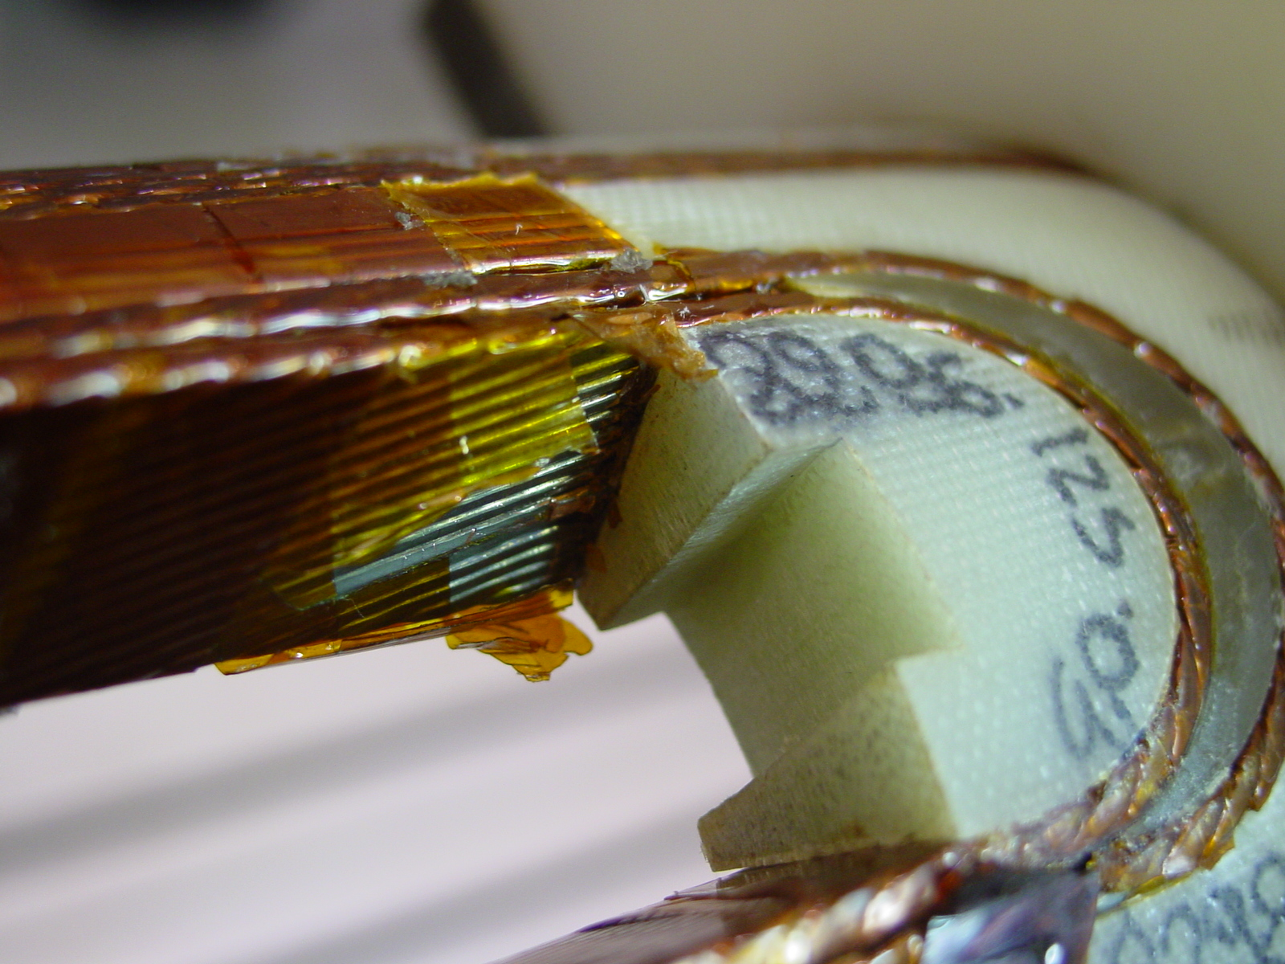
2/5

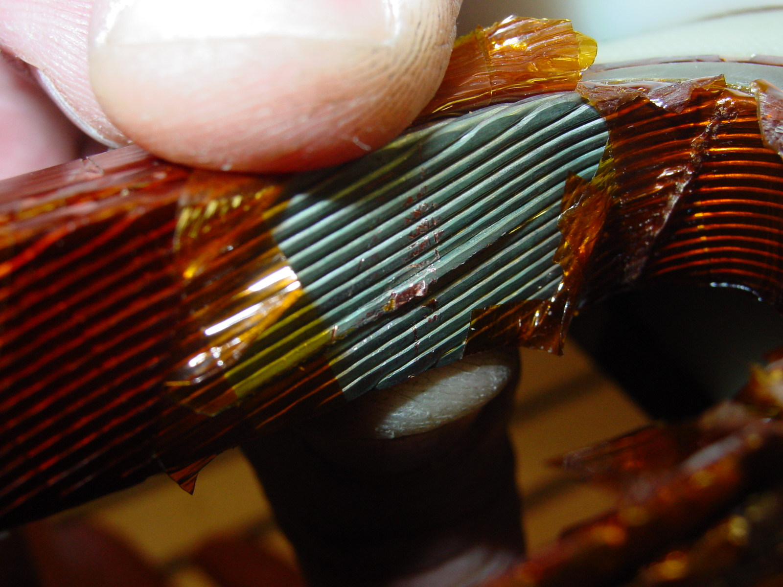
3/4
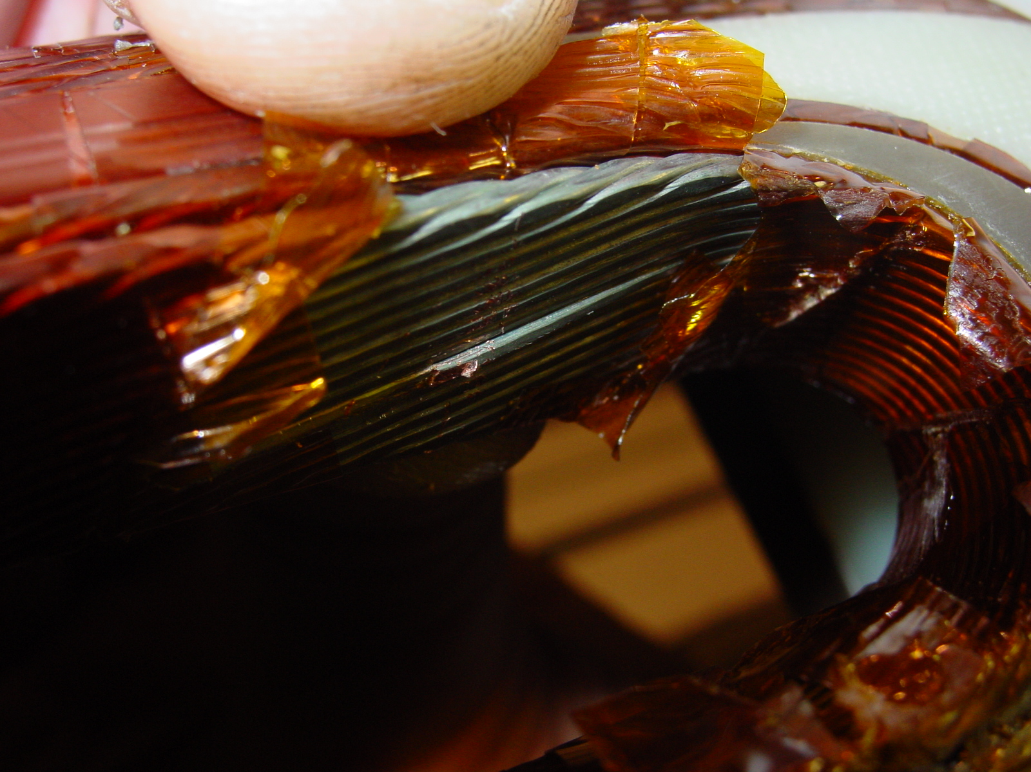
4/4

After re-positioning of the strand inside Rutherford cable
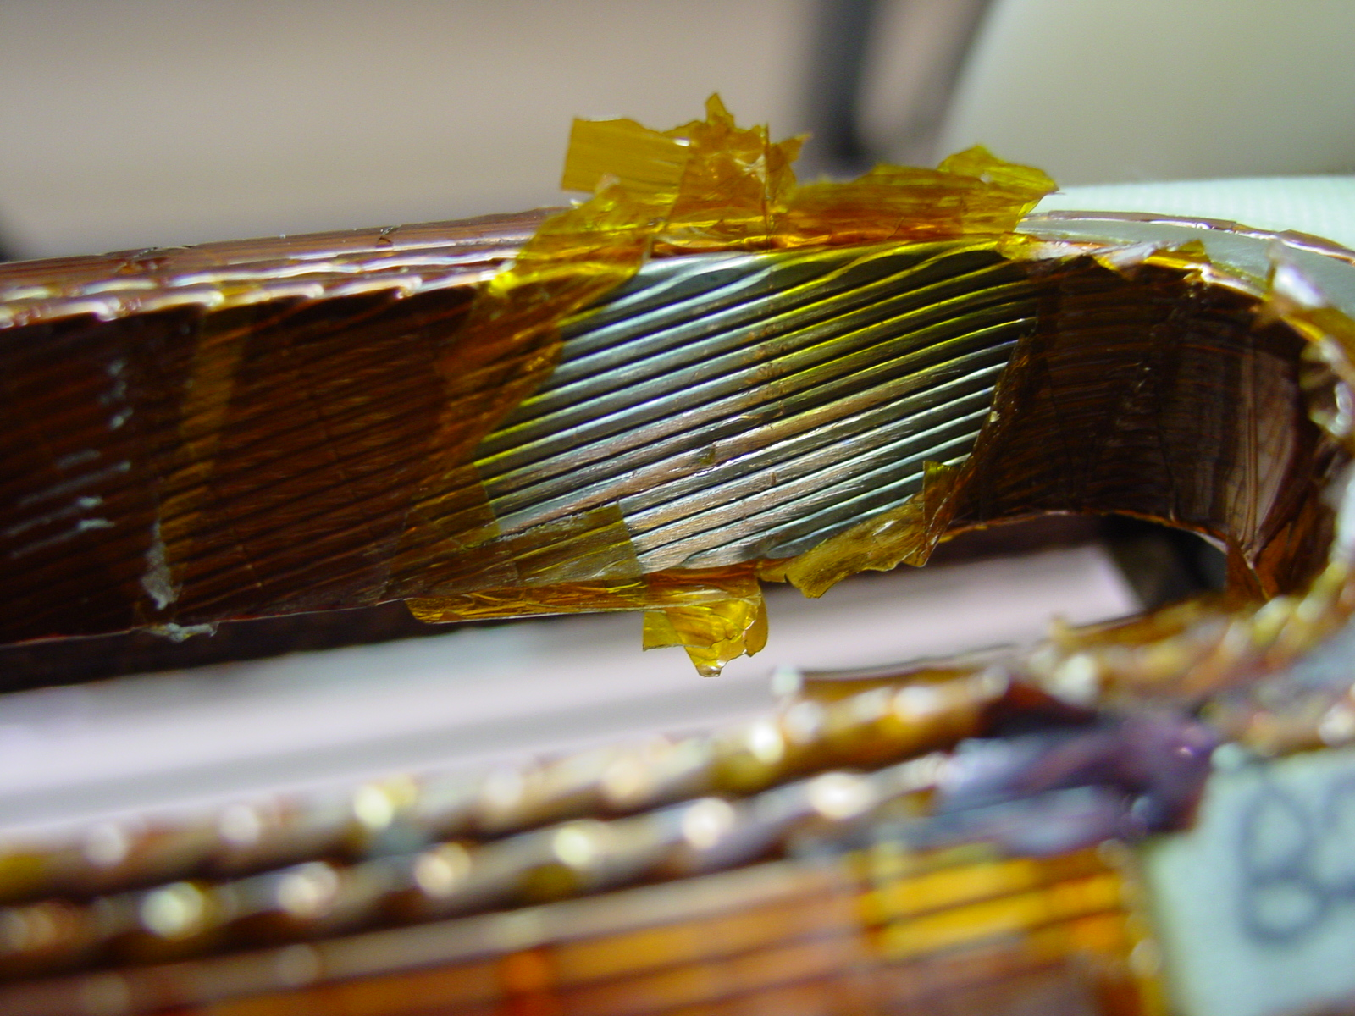
1/1

