–

Non conformity Report
IDENTIFICATION
1. Originator’s Name: B. Caserza, F. Terzi | 5. Date: 02/12/2004
2. Contractor/Supplier: Ansaldo Superconduttori S.p.A. | 6. Part description: HCMB__A001-02000154
3. Contract No: F462/LHC/LHC | 7. Qty: 1
4. Project Engineer: F. Savary, M. Bajko | 8. Dwg No: LHCMB__A0012/E (620RM08202/F)

9. Found during what activity:
☑ Incoming inspection | □ Final inspection
□ In-process inspection | □ Other:

10. Description of non conformity (use continuation page if necessary)
Electrical test after curing, performed on inner layer nr. 02I00617 for CM 2154, showed a short circuit between 1st and 2nd turns on NCS. A visual inspection of these turns showed that the problem was caused by a strand out of its position in the Rutherford cable (cable id. nr. 01E00127A)
Besides the sc cable was found very soft because of a low tension during cabling process.
For details, please look at the annexed pictures on continuation page.
Please note also the mark on the filler demonstrating that the strand wasn't damaged because it's harder that the filler material.

11. Action taken to prevent misuse (use continuation page if necessary)

IMPORTANCE
12. | □ Non critical | □ Critical

DISPOSITION
13. | □ Use-as-is | □ Repair | □ Reject | □ Rework | □ Return to supplier
Description of proposed action (use continuation page if necessary)
ASG is proposing to put the strand in the right position inside the Rutherford cable and restore the insulation.
See annexed picture for details after re-positioning of that strand.

CORRECTIVE/PREVENTIVE ACTION
14. Description of proposed action (use continuation page if necessary)

APPROVAL OF NON CRITICAL NON CONFORMITIES
15 | Project Engineer: | Date:

APPROVAL OF CRITICAL NON CONFORMITIES
16 | Project Management: | Date:

CLOSURE OF THE NON CONFORMITY
Planned actions have been completed and corrective/preventive actions have been initiated
 | For non critical non conformities  Quality Manager or Project Engineer | For critical non conformities  Project Engineer
17 | Name:  Date: | Name:  Date:

10. Description of non conformity (continuation page)

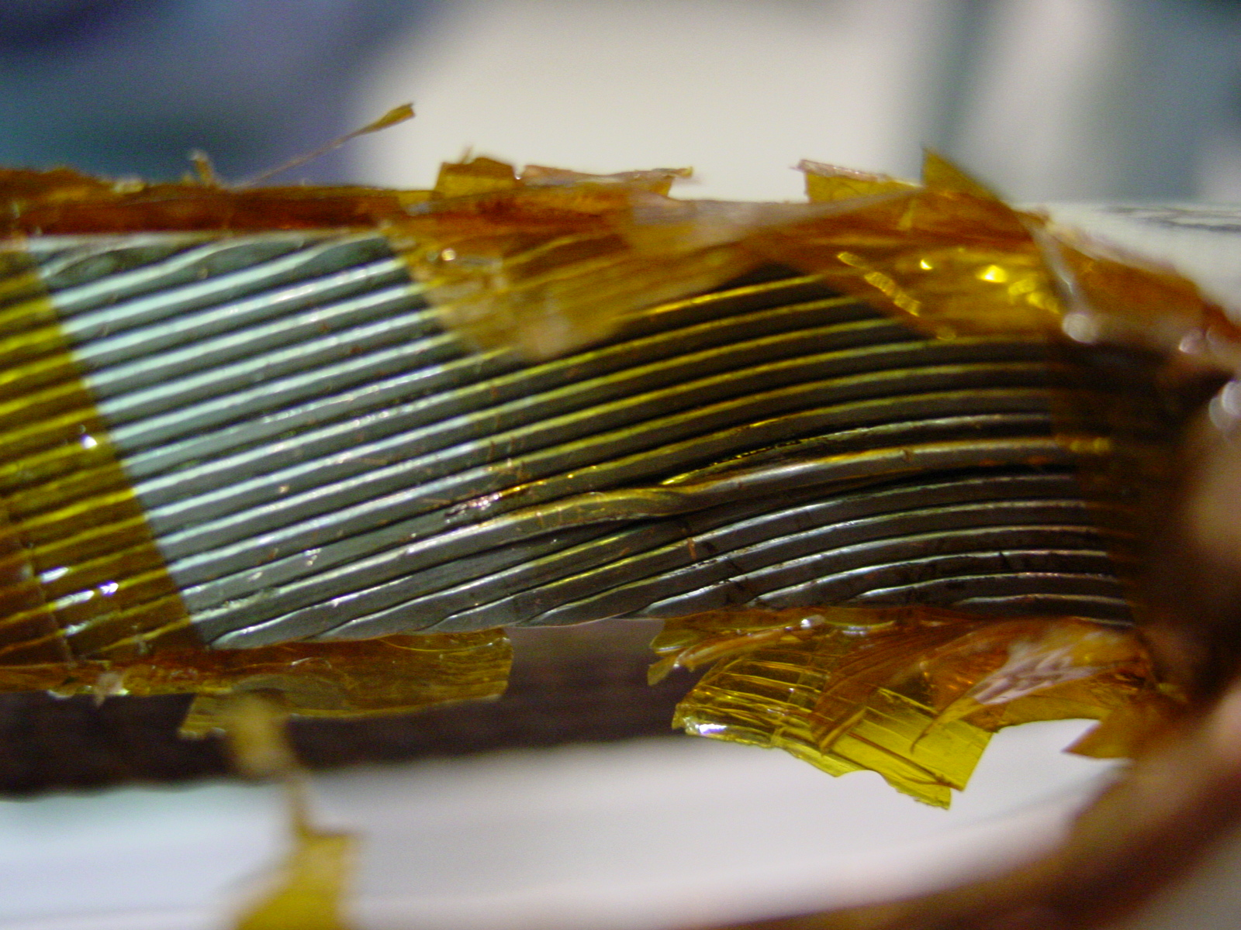
1/3 – Inner Layer 02I00617 before repairing (cable id. nr. 01E00127A)
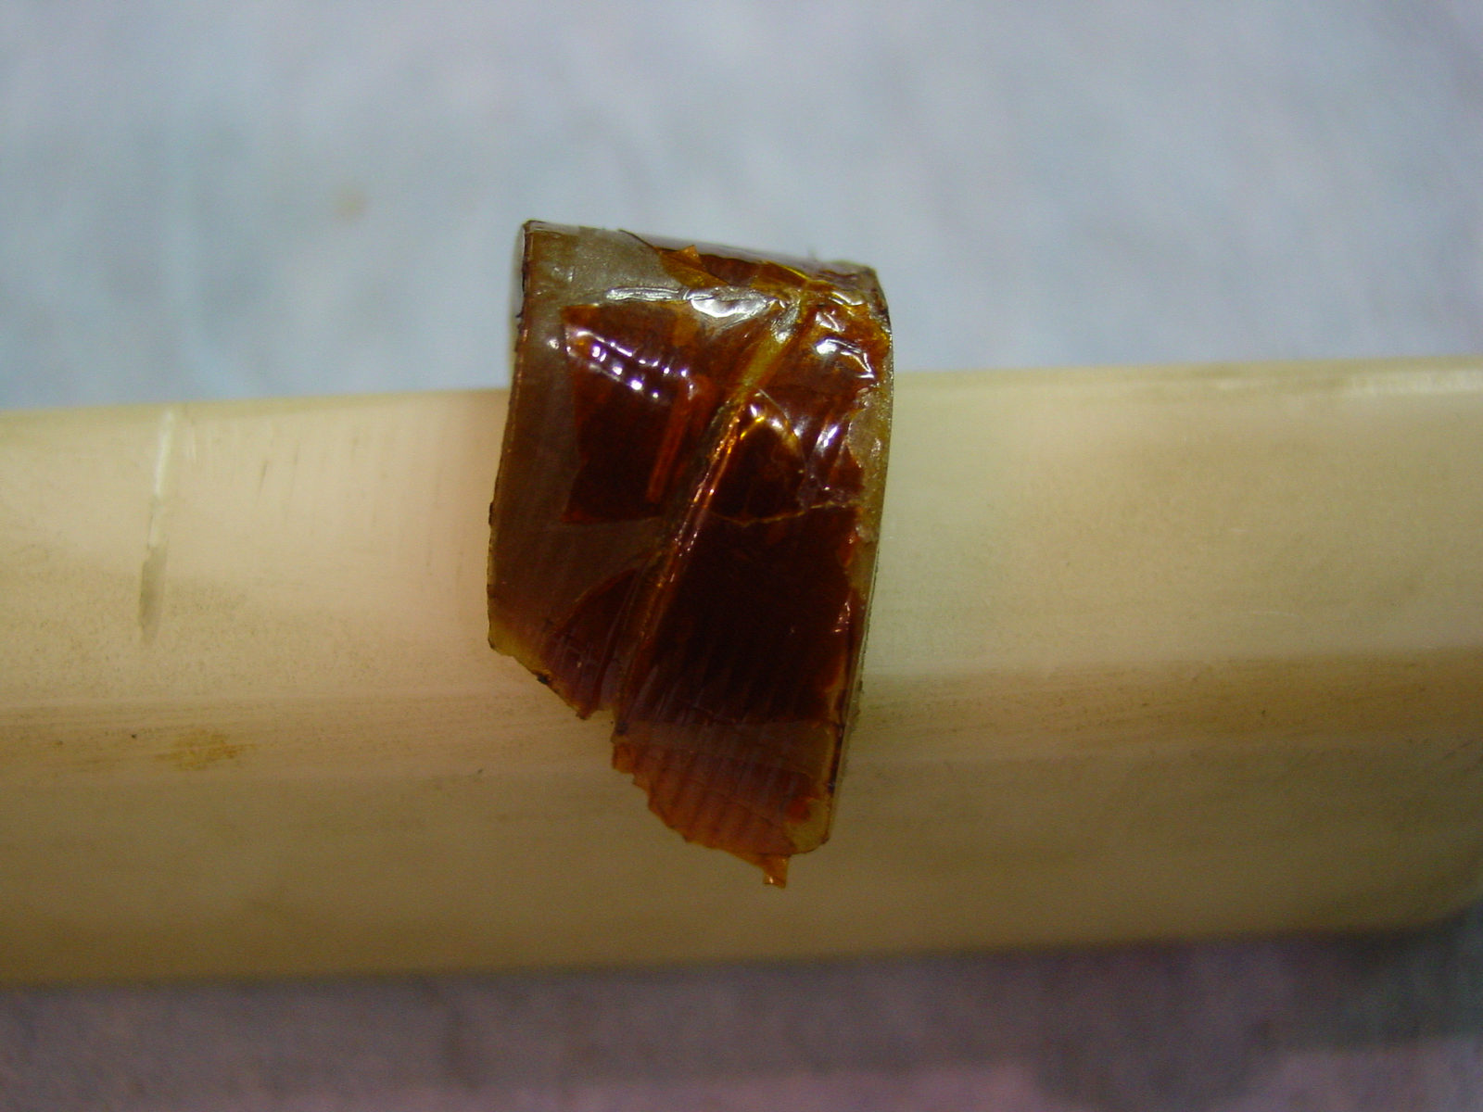
2/3 – Filler between 1st and 2nd turn on NCS
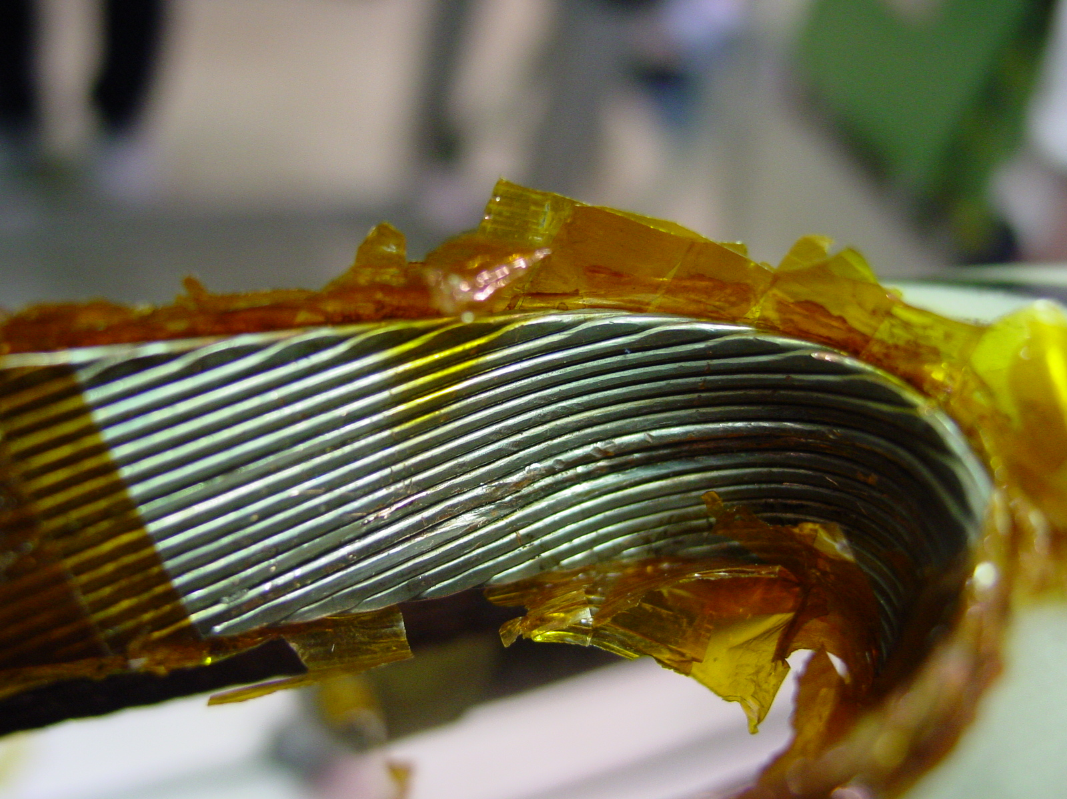
3/3 – After re-positioning of the strand (cable id. nr. 01E00127A)

