–

Non conformity Report
IDENTIFICATION
1. Originator’s Name: B. Caserza, F. Terzi | 5. Date: 10/01/2005
2. Contractor/Supplier: Ansaldo Superconduttori S.p.A. | 6. Part description: HCMB__A001-02000158
3. Contract No: F462/LHC/LHC | 7. Qty: 1
4. Project Engineer: F. Savary, M. Bajko | 8. Dwg No: LHCMB__A0012/E (620RM08202/F)

9. Found during what activity:
☑ Incoming inspection | □ Final inspection
□ In-process inspection | □ Other:

10. Description of non conformity (use continuation page if necessary)
Electrical test on pole nr. 02P00630 with ends under pressure (CM 2158), showed a short circuit between 3rd and 4th turns of inner layer nr. 02I00633 on NCS. A visual inspection of these turns showed that the problem was caused by a strand out of its position in the Rutherford cable (cable id. nr. 01E00163D).

11. Action taken to prevent misuse (use continuation page if necessary)

IMPORTANCE
12. | ☑ Non critical | □ Critical

DISPOSITION
13. | □ Use-as-is | □ Repair | ☑ Reject | □ Rework | □ Return to supplier
Description of proposed action (use continuation page if necessary)
ASG has tried to repair the fault, but a strand was damaged (see annexed picture on continuation page)
Then ASG is proposing to reject the inner layer.
A new layer will be manufactured using a new cable supplied by CERN.

CORRECTIVE/PREVENTIVE ACTION
14. Description of proposed action (use continuation page if necessary)
It is not the first time the problem reported here above is occurring. ASG is requested to reinforce supervision and control during the winding operation.

APPROVAL OF NON CRITICAL NON CONFORMITIES
15 | Project Engineer: F. Savary | Date: March 8th, 2005

APPROVAL OF CRITICAL NON CONFORMITIES
16 | Project Management: | Date:

CLOSURE OF THE NON CONFORMITY
Planned actions have been completed and corrective/preventive actions have been initiated
A new layer id. nr. 02I30633 has been manufactured (sc cable nr. 01E00198K)

 | For non critical non conformities  Quality Manager or Project Engineer | For critical non conformities  Project Engineer
17 | Name: F. Terzi  Date: 16/03/2005 | Name:  Date:

10. Description of non conformity (continuation page)
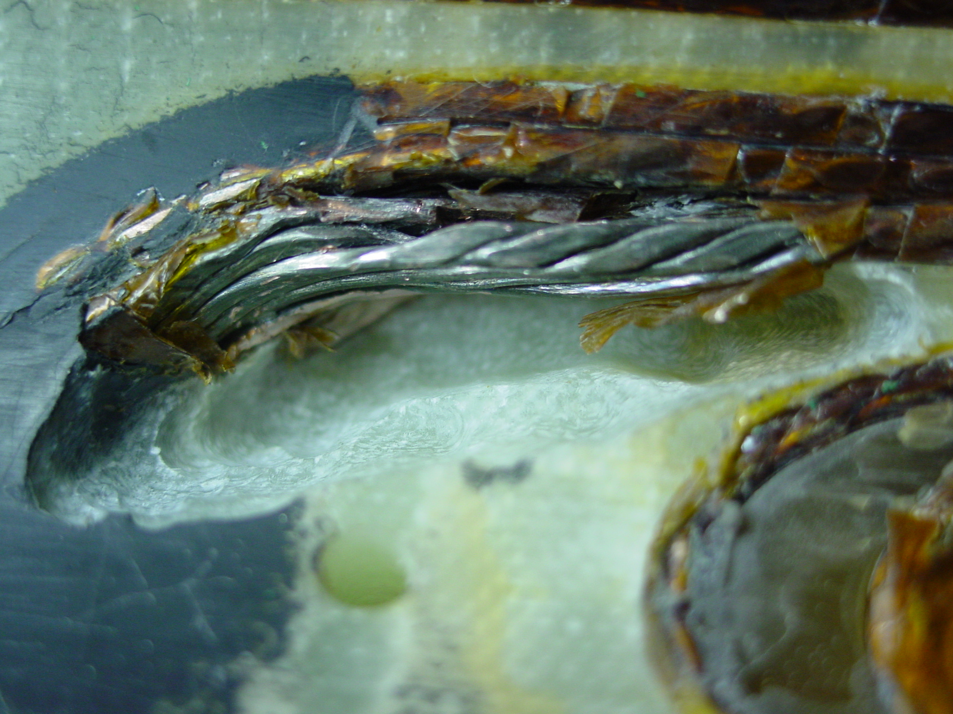

1/1 – Inner Layer 02I00633 (cable id. nr. 01E00163D)

