–

Non conformity Report
IDENTIFICATION
1. Originator’s Name: B. Caserza, F. Terzi | 5. Date: 10/01/2005
2. Contractor/Supplier: Ansaldo Superconduttori S.p.A. | 6. Part description: HCMB__A001-02000158
3. Contract No: F462/LHC/LHC | 7. Qty: 1
4. Project Engineer: F. Savary, M. Bajko | 8. Dwg No: LHCMB__A0012/E (620RM08202/F)

9. Found during what activity:
☑ Incoming inspection | □ Final inspection
□ In-process inspection | □ Other:

10. Description of non conformity (use continuation page if necessary)
Electrical test after curing, performed on inner pole nr. 02P00630 for CM 2158, showed a short circuit between 3rd and 4th turns of inner layer nr. 02I00633 on NCS. A visual inspection of these turns showed that the problem was caused by a strand out of its position in the Rutherford cable (cable id. nr. 01E00163D).

11. Action taken to prevent misuse (use continuation page if necessary)

IMPORTANCE
12. | □ Non critical | □ Critical

DISPOSITION
13. | □ Use-as-is | □ Repair | □ Reject | □ Rework | □ Return to supplier
Description of proposed action (use continuation page if necessary)
ASG tried to repair the fault, but a strand was damaged (see annexed picture on continuation page)
Then ASG is proposing to reject the inner layer.
A new layer will be manufactured using a new cable supplied by CERN.

The new cable id is: 01E00198K

CORRECTIVE/PREVENTIVE ACTION
14. Description of proposed action (use continuation page if necessary)

APPROVAL OF NON CRITICAL NON CONFORMITIES
15 | Project Engineer: Marta Bajko | Date: 25.05.05

APPROVAL OF CRITICAL NON CONFORMITIES
16 | Project Management: | Date:

CLOSURE OF THE NON CONFORMITY
Planned actions have been completed and corrective/preventive actions have been initiated
 | For non critical non conformities  Quality Manager or Project Engineer | For critical non conformities  Project Engineer
17 | Name:  Date: | Name:  Date:

10. Description of non conformity (continuation page)
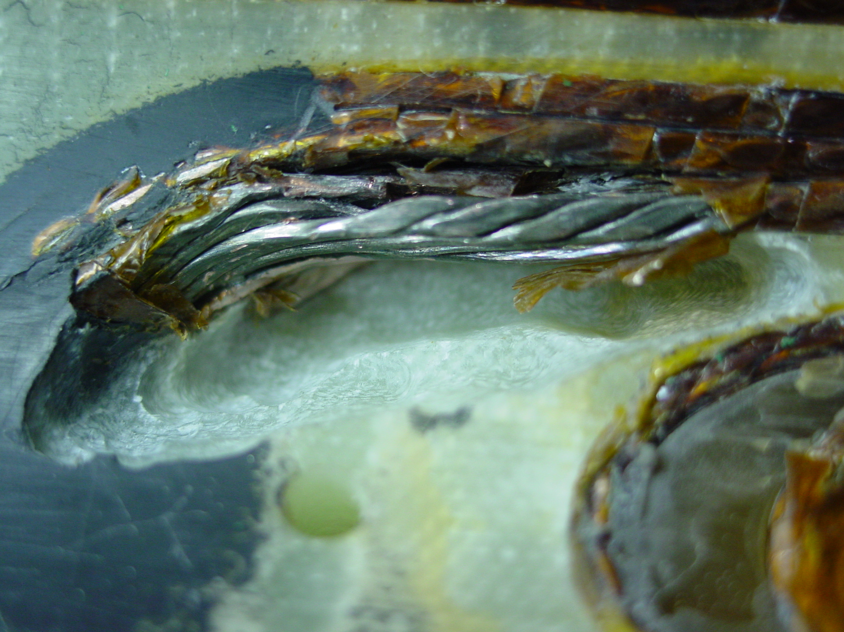

1/1 – Inner Layer 02I00633 (cable id. nr. 01E00163D)

