–

Non conformity Report
IDENTIFICATION
1. Originator’s Name: B. Caserza, F. Terzi | 5. Date: 24/02/2005
2. Contractor/Supplier: Ansaldo Superconduttori S.p.A. | 6. Part description: HCMB__A001-02000182
3. Contract No: F462/LHC/LHC | 7. Qty: 1
4. Project Engineer: F. Savary, M. Bajko | 8. Dwg No: LHCMB__A0012/E (620RM08202/F)

9. Found during what activity:
□ Incoming inspection | □ Final inspection
☑ In-process inspection | □ Other:

10. Description of non conformity (use continuation page if necessary)
Just before winding of outer layer nr. 02E00731 (sc cable nr. 02C00136A) for CM 2182, a visual inspection showed a strand out of its position in the Rutherford cable.
This strand goes out every100mm along the first meter of the Rutherford cable and it shows a different color w.r.t. the others.
See annexed pictures.

11. Action taken to prevent misuse (use continuation page if necessary)

IMPORTANCE
12. | □ Non critical | □ Critical

DISPOSITION
13. | □ Use-as-is | □ Repair | □ Reject | □ Rework | □ Return to supplier
Description of proposed action (use continuation page if necessary)
ASG put the strand in its right position and proceeded with winding operation paying attention in winding, in particular during each turn of the layer.

CORRECTIVE/PREVENTIVE ACTION
14. Description of proposed action (use continuation page if necessary)

APPROVAL OF NON CRITICAL NON CONFORMITIES
15 | Project Engineer: | Date:

APPROVAL OF CRITICAL NON CONFORMITIES
16 | Project Management: | Date:

CLOSURE OF THE NON CONFORMITY
Planned actions have been completed and corrective/preventive actions have been initiated
 | For non critical non conformities  Quality Manager or Project Engineer | For critical non conformities  Project Engineer
17 | Name:  Date: | Name:  Date:

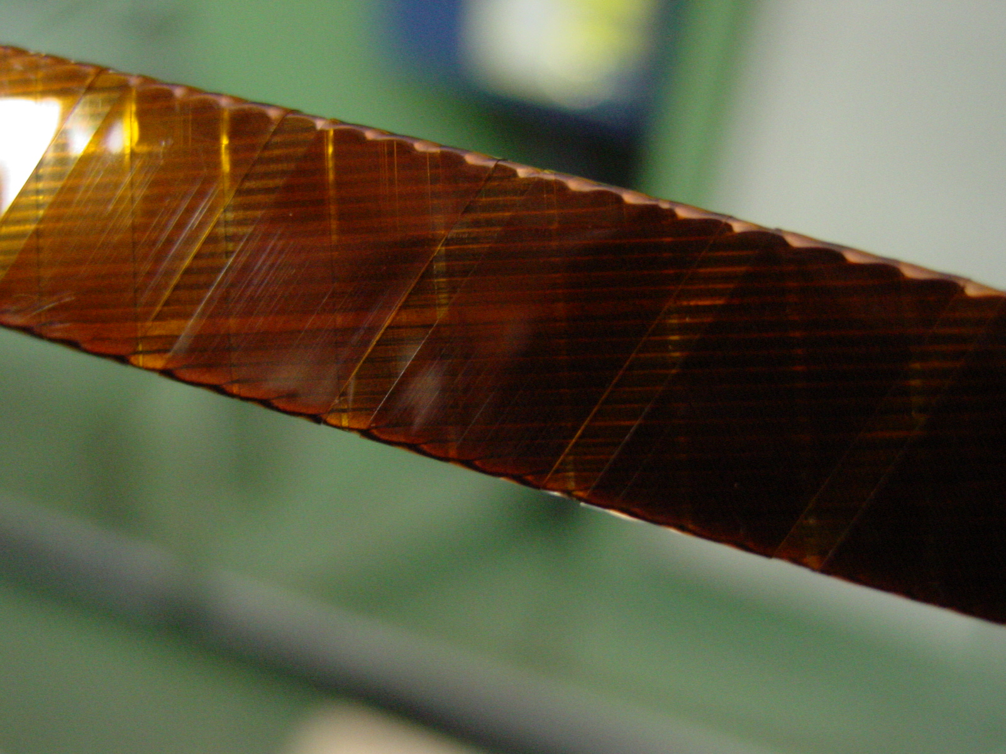
1/2
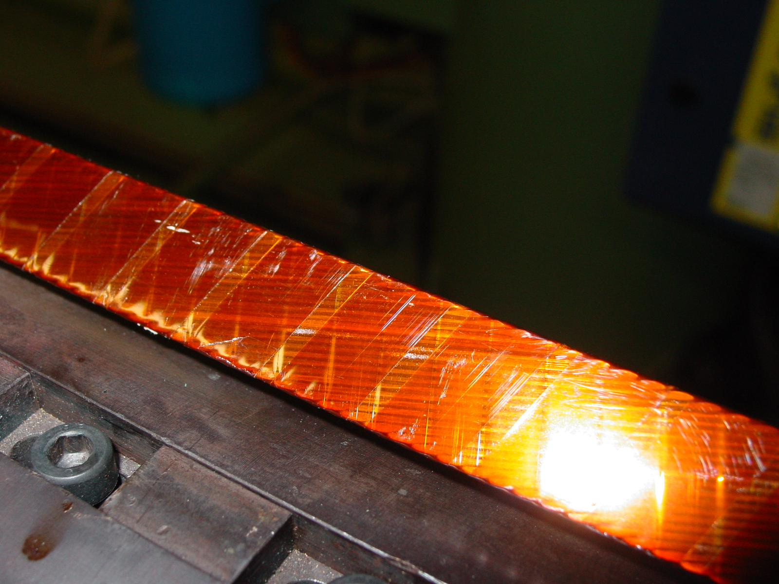
2/2

