–

Non conformity Report
IDENTIFICATION
1. Originator’s Name: B.Caserza – F. Terzi | 5. Date: 21/03/2005
2. Contractor/Supplier: Ansaldo Superconduttori S.p.A. | 6. Part description: HCMB__A001-02000160
3. Contract No: F462/LHC/LHC | 7. Qty: 1
4. Project Engineer: F. Savary | 8. Dwg No: LHCMBB_A0002/F (683RM08451)

9. Found during what activity:
□ Incoming inspection | □ Final inspection
☑ In-process inspection | □ Other:

10. Description of non conformity (use continuation page if necessary)
During leak test on CM 2160, a leak has been detected on a flange of the manifold M2-line.
This was caused by a defect on the weld of the flange (weld id. nr. W38 - dwg. nr. LHCMB__S0268).
Then the weld defect was removed, but the length of the flange was reduced to 6mm (nom. 9mm)
See schematic dwg. on continuation page.

11. Action taken to prevent misuse (use continuation page if necessary)

IMPORTANCE
12. | ☑ Non critical | □ Critical

DISPOSITION
13. | □ Use-as-is | □ Repair | □ Reject | ☑ Rework | □ Return to supplier
Description of proposed action (use continuation page if necessary)
The cold mass cannot be delivered to CERN “as is”. With the 6-mm remaining, the flange will be definitely too short after the cold mass stripping at CERN.
A new flange shall be installed. Then, the cold mass shall be re-checked for pressure and leak tightness and the final electrical checks repeated.
ASG shall communicate to CERN the repairing sequence including all steps of disassembly, reconstruction and testing prior to proceed with the execution of the work.

CORRECTIVE/PREVENTIVE ACTION
14. Description of proposed action (use continuation page if necessary)

APPROVAL OF NON CRITICAL NON CONFORMITIES
15 | Project Engineer: F. Savary | Date: March 21st, 2005

APPROVAL OF CRITICAL NON CONFORMITIES
16 | Project Management: | Date:

CLOSURE OF THE NON CONFORMITY
Planned actions have been completed and corrective/preventive actions have been initiated
See continuation page for details on repairing procedure.
 | For non critical non conformities  Quality Manager or Project Engineer | For critical non conformities  Project Engineer
17 | Name: F. Terzi  Date: 24/03/2005 | Name:  Date:

IDENTIFICATION
11
6
Schematic dwg. of flange (M2-line – manifold)

CLOSURE OF THE NON CONFORMITY
Repairing procedure (see picture for details):
- Cutting of the entire welding of the flange to the end cover on M2-line
- Cutting of the reusable tube in order to be able to disconnect the electrical connections
- Cutting of the welding of the manifold on the other side of the reusable tube
- Dimensional measurements in order to prepare the modified flange to be welded on the end cover
- Disconnection of electrical connections
- Welding of the modified flange, using back gas protection, on the end cover
- Change of the reusable tube with a new one
- Redoing electrical connections and test
- Welding the new tube on the flange of the end cover and, on the other side, to the manifold
- Pressure/leak test of CM
- Final electrical test

All acceptance test performed successfully.

F. Terzi
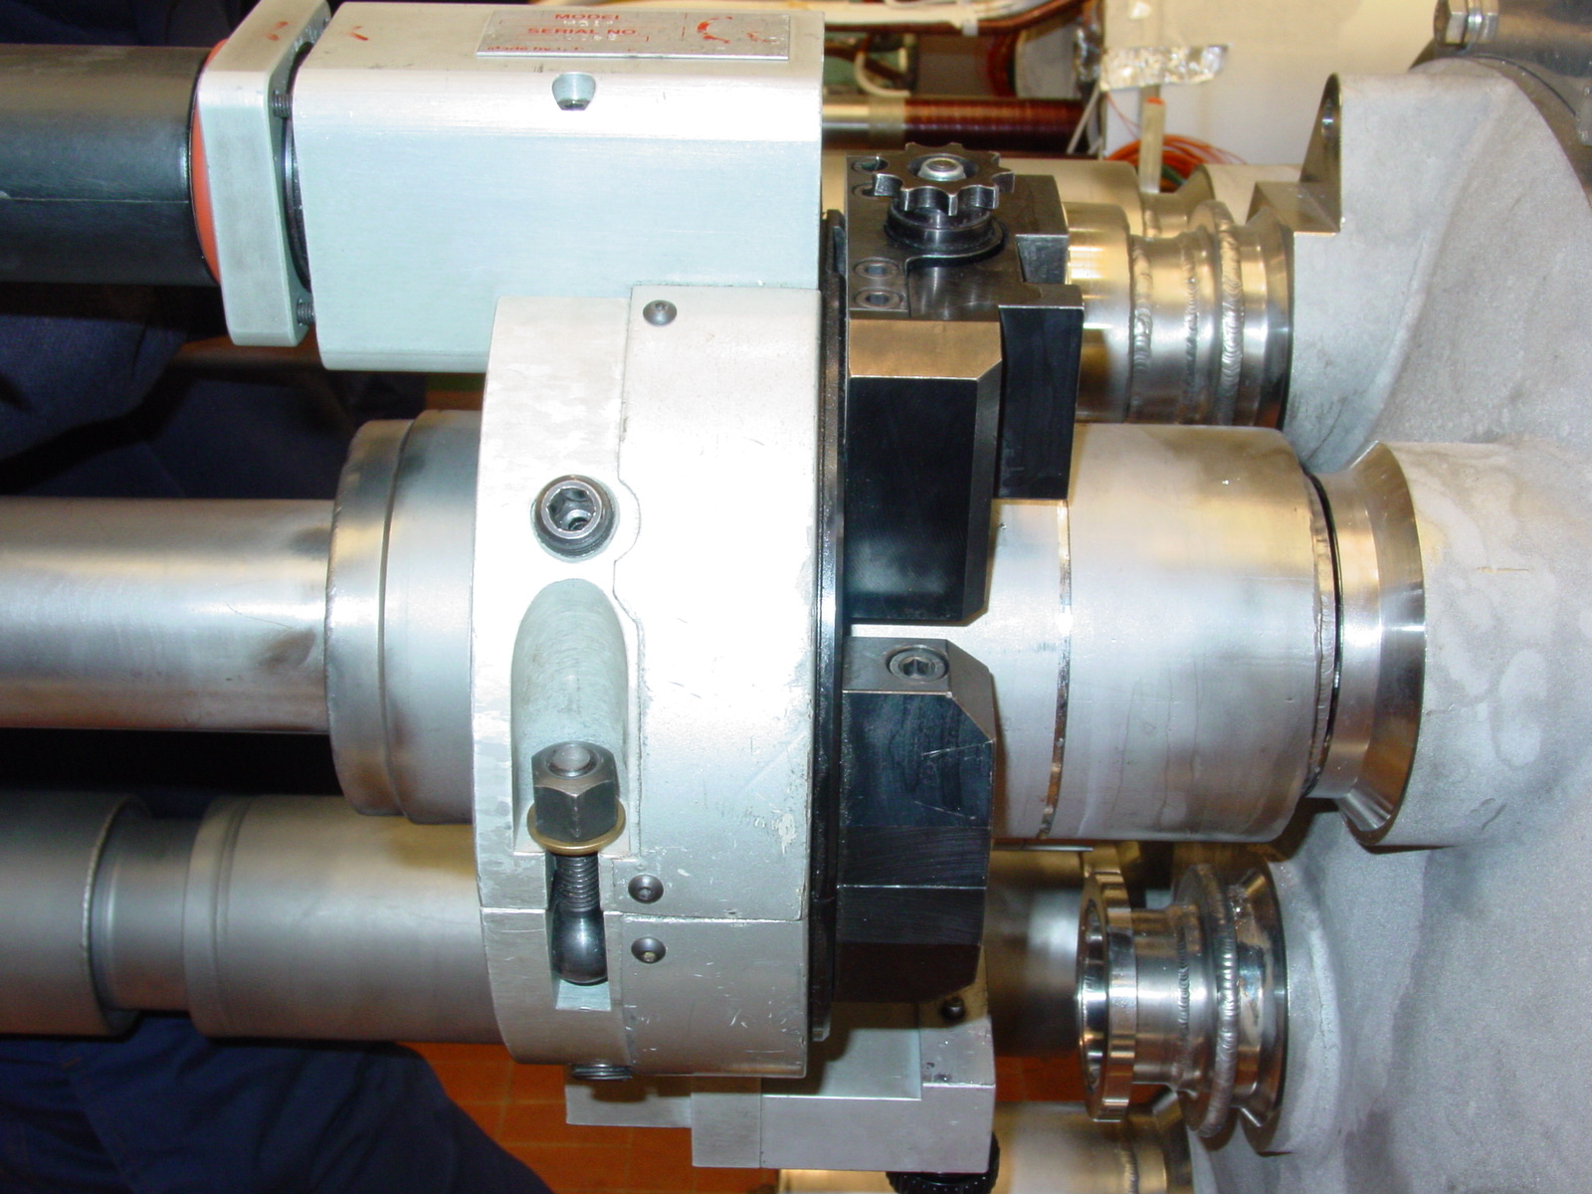
1/1

