–

Non conformity Report
IDENTIFICATION
1. Originator’s Name: B. Caserza, F. Terzi | 5. Date: 25/03/2005
2. Contractor/Supplier: Ansaldo Superconduttori S.p.A. | 6. Part description: HCMB__A001-02000186
3. Contract No: F462/LHC/LHC | 7. Qty: 1
4. Project Engineer: F. Savary, M. Bajko | 8. Dwg No: LHCMB__A0012/E (620RM08202/F)

9. Found during what activity:
☑ Incoming inspection | □ Final inspection
□ In-process inspection | □ Other:

10. Description of non conformity (use continuation page if necessary)
Electrical test on pole nr. 02P00743 with ends under pressure (CM 2186), showed a short circuit between 7th and 8th turn of inner layer nr. 02I00746 on CS.
Cable id. nr. 01B10811A.
See annexed pictures.

11. Action taken to prevent misuse (use continuation page if necessary)

IMPORTANCE
12. | ☑ Non critical | □ Critical

DISPOSITION
13. | □ Use-as-is | □ Repair | ☑ Reject | ☑ Rework | □ Return to supplier
Description of proposed action (use continuation page if necessary)
ASG is proposing to reject the inner layer.
A new layer will be manufactured using a new cable supplied by CERN.

CORRECTIVE/PREVENTIVE ACTION
14. Description of proposed action (use continuation page if necessary)

APPROVAL OF NON CRITICAL NON CONFORMITIES
15 | Project Engineer: F. Savary | Date: May 30th, 2005

APPROVAL OF CRITICAL NON CONFORMITIES
16 | Project Management: | Date:

CLOSURE OF THE NON CONFORMITY
Planned actions have been completed and corrective/preventive actions have been initiated
New layer manufactured: 02I30746 (sc cable id. nr. 01B10893F)
 | For non critical non conformities  Quality Manager or Project Engineer | For critical non conformities  Project Engineer
17 | Name: F. Terzi  Date: 31/05/2005 | Name:  Date:

10. Description of non conformity (continuation page)

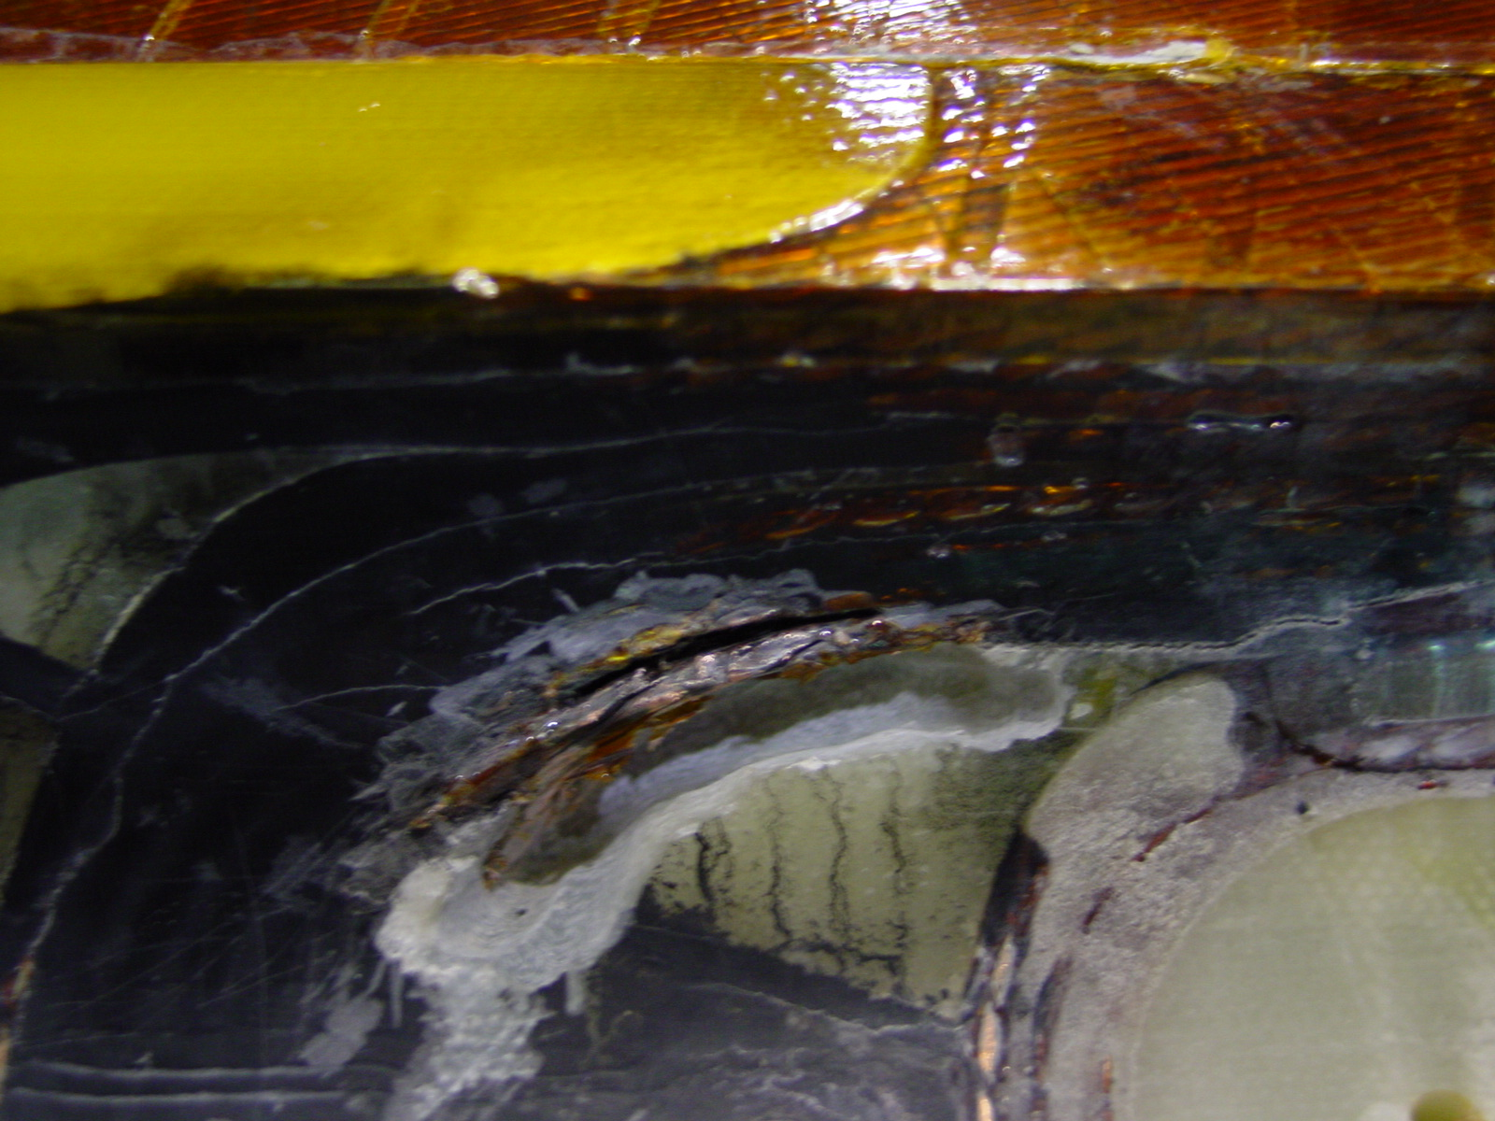
1/1 – Inner Layer 02I00746 (cable id. nr. 01B10811A)

