–

Non conformity Report
IDENTIFICATION
1. Originator’s Name: B. Caserza, F. Terzi | 5. Date: 13/04/2005
2. Contractor/Supplier: Ansaldo Superconduttori S.p.A. | 6. Part description: HCMB__A001-02000198
3. Contract No: F462/LHC/LHC | 7. Qty: 1
4. Project Engineer: F. Savary, M. Bajko | 8. Dwg No: LHCMB__A0012/E (620RM08202/F)

9. Found during what activity:
□ Incoming inspection | □ Final inspection
☑ In-process inspection | □ Other:

10. Description of non conformity (use continuation page if necessary)
At the end of winding of inner layer nr. 02I00794 (sc cable nr. 01B10828A) for CM 2198, a visual inspection showed a strand cut and another one out of its position in the Rutherford cable.
These defects are on CS.
(see annexed pictures)

11. Action taken to prevent misuse (use continuation page if necessary)

IMPORTANCE
12. | ☑ Non critical | □ Critical

DISPOSITION
13. | □ Use-as-is | □ Repair | ☑ Reject | □ Rework | □ Return to supplier
Description of proposed action (use continuation page if necessary)
This layer has to be put aside for the time being.
CERN personel will inspect the cable during a next visit in ASG.
CERN comment: the layer cannot be used as is. It shall be rejected and replaced. Please add the id of the new cable used when closing the non-conformity report.

CORRECTIVE/PREVENTIVE ACTION
14. Description of proposed action (use continuation page if necessary)

APPROVAL OF NON CRITICAL NON CONFORMITIES
15 | Project Engineer: F. Savary | Date: May 27th, 2005

APPROVAL OF CRITICAL NON CONFORMITIES
16 | Project Management: | Date:

CLOSURE OF THE NON CONFORMITY
Planned actions have been completed and corrective/preventive actions have been initiated
New cable id. nr. = 01B10867A. New I.L. id nr. = 02I30794

 | For non critical non conformities  Quality Manager or Project Engineer | For critical non conformities  Project Engineer
17 | Name: F. Terzi  Date: 30/05/2005 | Name:  Date:

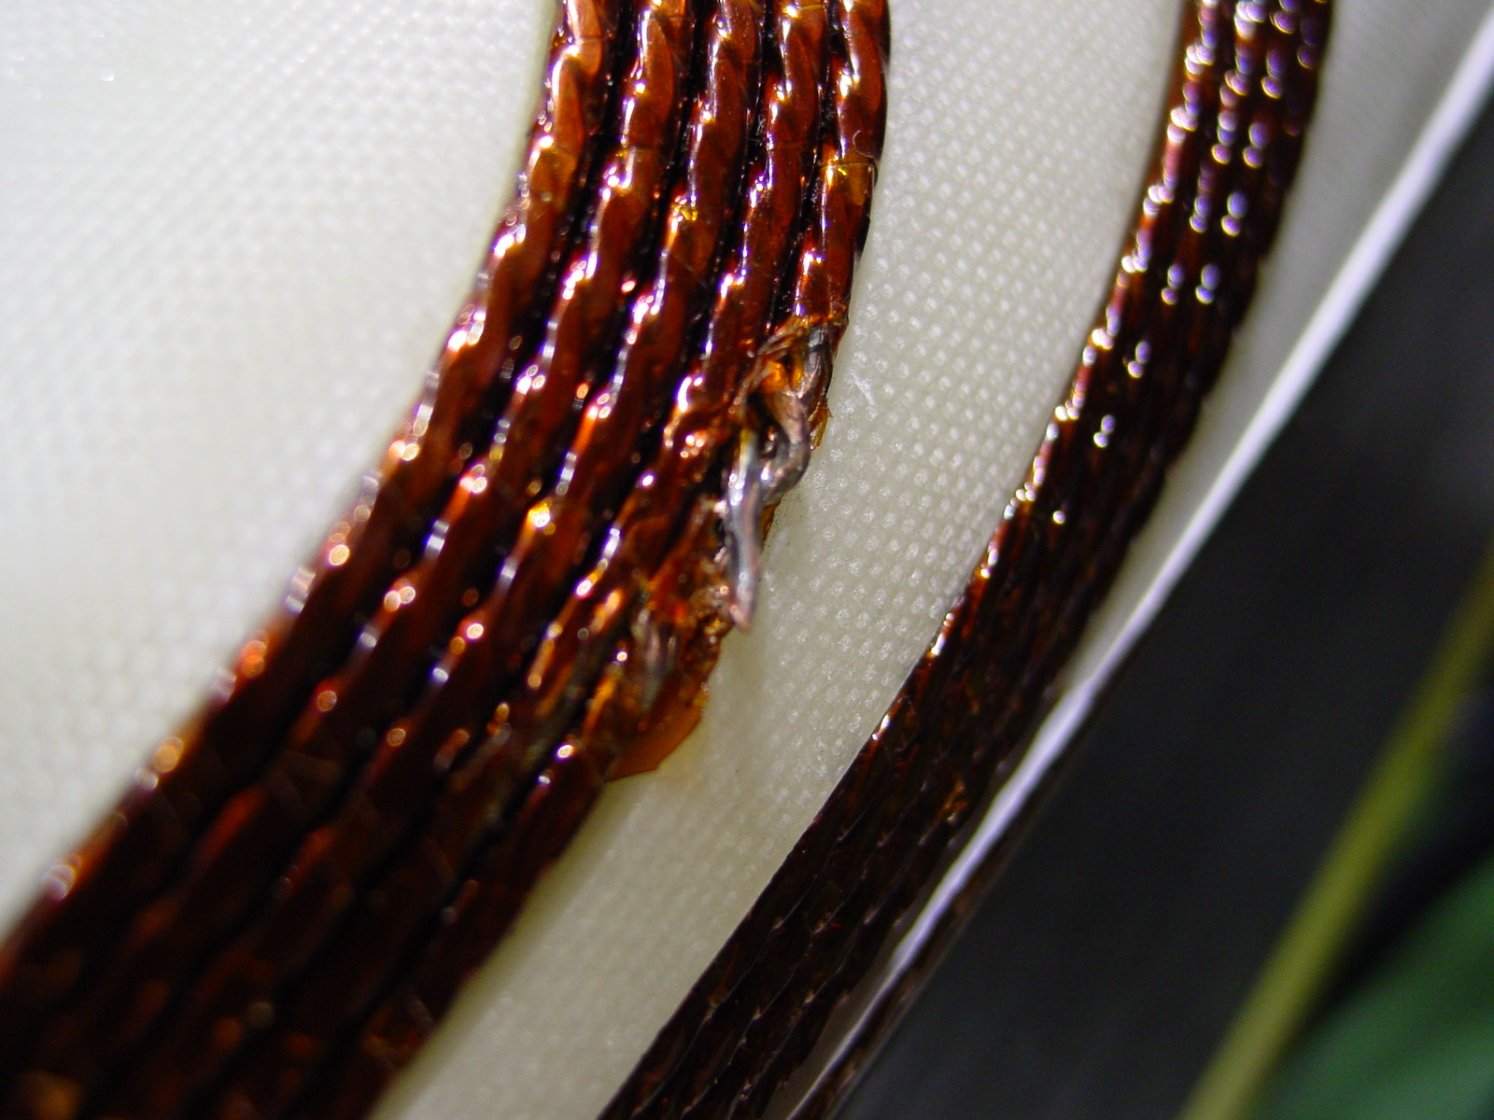
1/5
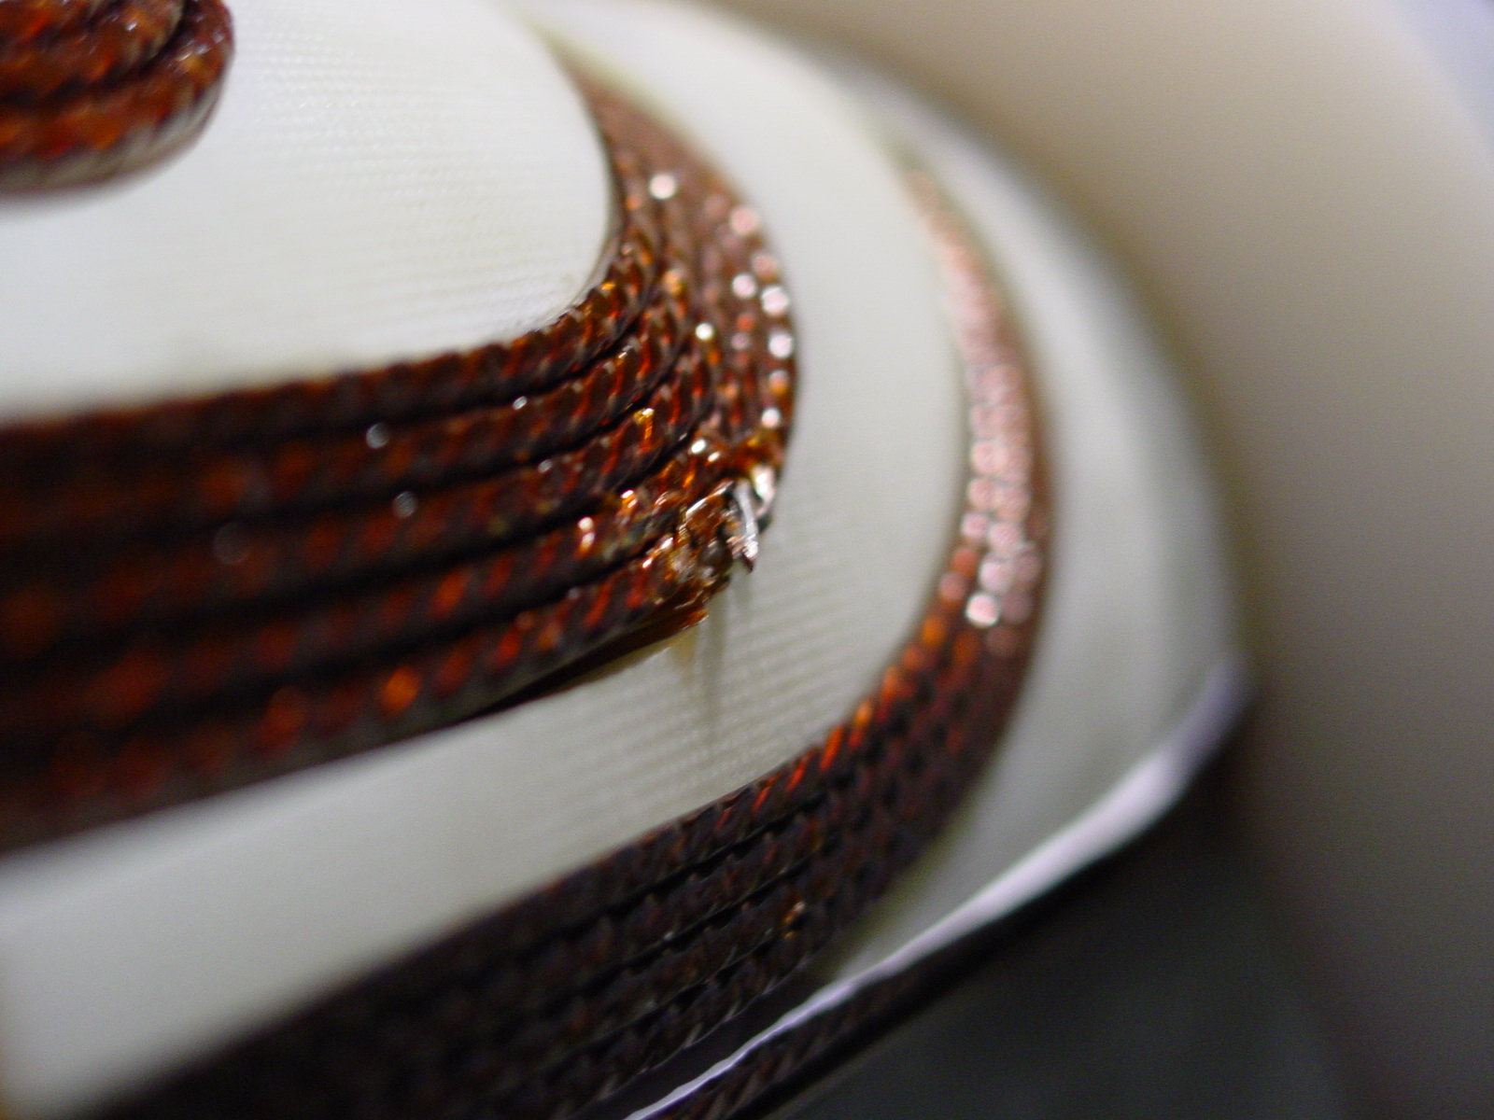
2/5
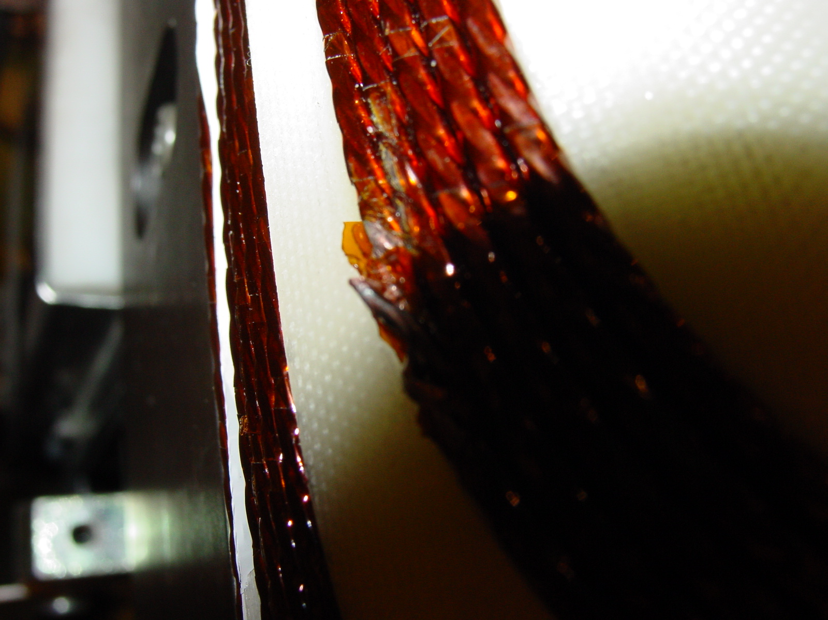
3/5

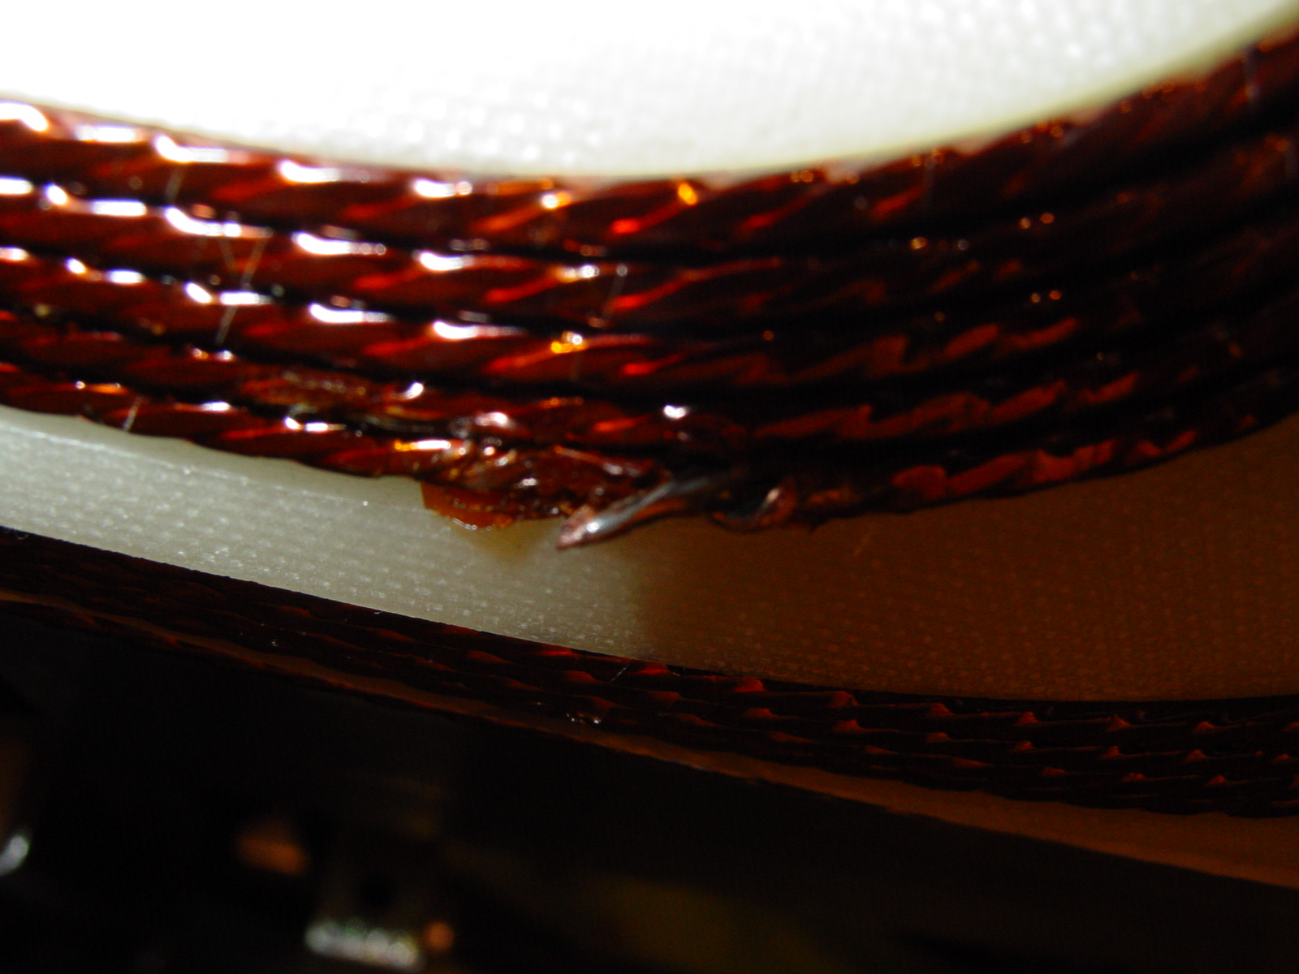
4/5

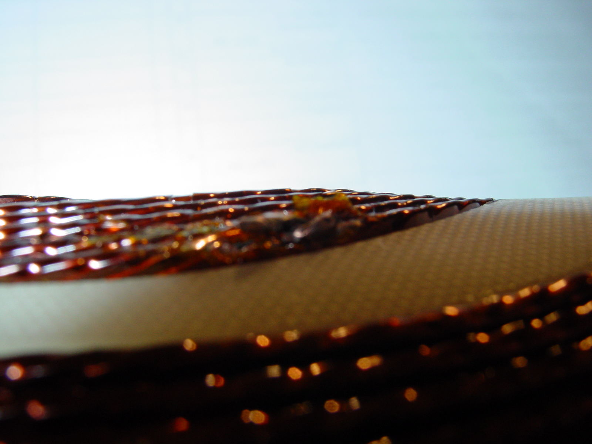
5/5

