–

Non conformity Report
IDENTIFICATION
1. Originator’s Name: B. Caserza, F. Terzi | 5. Date: 26/04/2005
2. Contractor/Supplier: Ansaldo Superconduttori S.p.A. | 6. Part description: HCMB__A001-02000206
3. Contract No: F462/LHC/LHC | 7. Qty: 1
4. Project Engineer: F. Savary, M. Bajko | 8. Dwg No: LHCMB__A0012/E (620RM08202/F)

9. Found during what activity:
□ Incoming inspection | □ Final inspection
☑ In-process inspection | □ Other:

10. Description of non conformity (use continuation page if necessary)
During winding of inner layer nr. 02I00828 (sc cable nr. 01B10868B) for CM 2206, a problem occurred on winding machine and the cable twisted along 12 m about.
(see annexed pictures)

11. Action taken to prevent misuse (use continuation page if necessary)

IMPORTANCE
12. | □ Non critical | □ Critical

DISPOSITION
13. | □ Use-as-is | □ Repair | □ Reject | □ Rework | □ Return to supplier
Description of proposed action (use continuation page if necessary)
ASG personnel removed the very bad first 6.5 meters and tried to adjust the cable. Repair was successfully completed, but ASG was afraid to continue winding.
Then we decided to send the cable back to Selva and to re-wind it so that the twisted cable will be out of the coil (or in the outlet part, depending from the total length of the cable).
CERN comment: Action taken under the full responsibility of ASG. When closing the non-conformity, please indicate how the problem was finally sorted out.

CORRECTIVE/PREVENTIVE ACTION
14. Description of proposed action (use continuation page if necessary)

APPROVAL OF NON CRITICAL NON CONFORMITIES
15 | Project Engineer: F. Savary | Date: May 27th, 2005

APPROVAL OF CRITICAL NON CONFORMITIES
16 | Project Management: | Date:

CLOSURE OF THE NON CONFORMITY
Planned actions have been completed and corrective/preventive actions have been initiated
Selva re-wound the sc cable and sent it back to ASG. Winding operation has been completed successfully.
 | For non critical non conformities  Quality Manager or Project Engineer | For critical non conformities  Project Engineer
17 | Name: F. Terzi  Date: 03/05/2005 | Name:  Date:

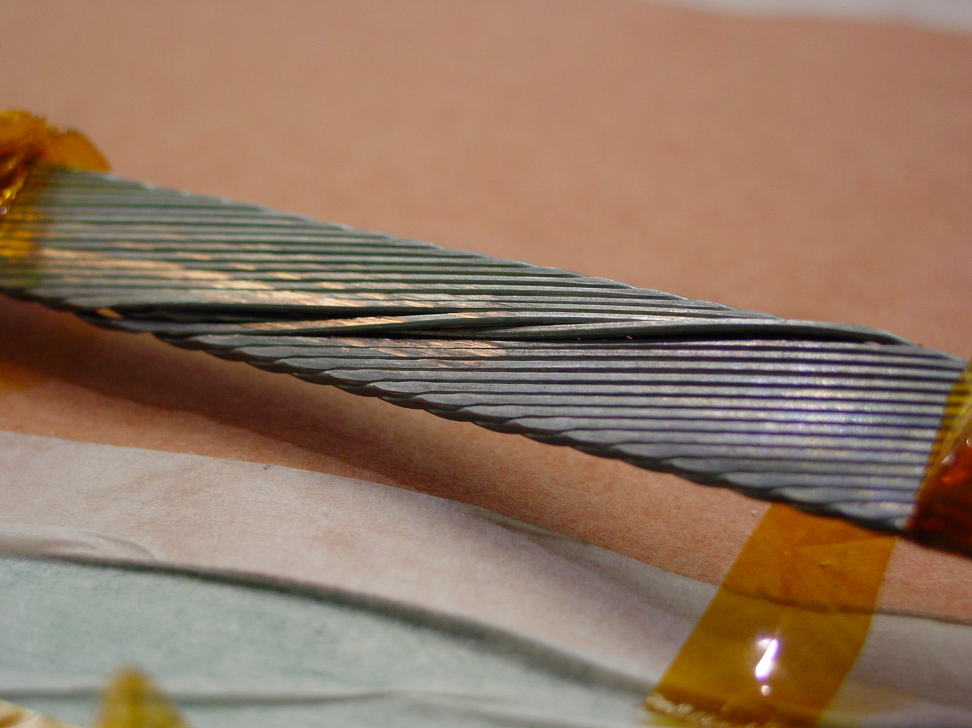
1/3 – Before repairing

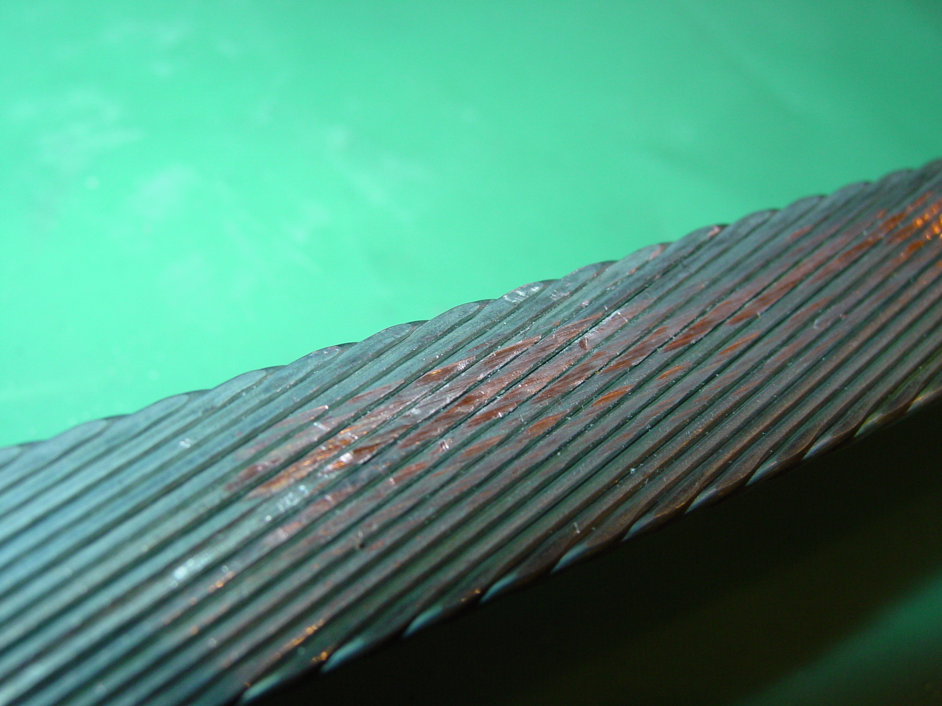
2/3 – After repairing
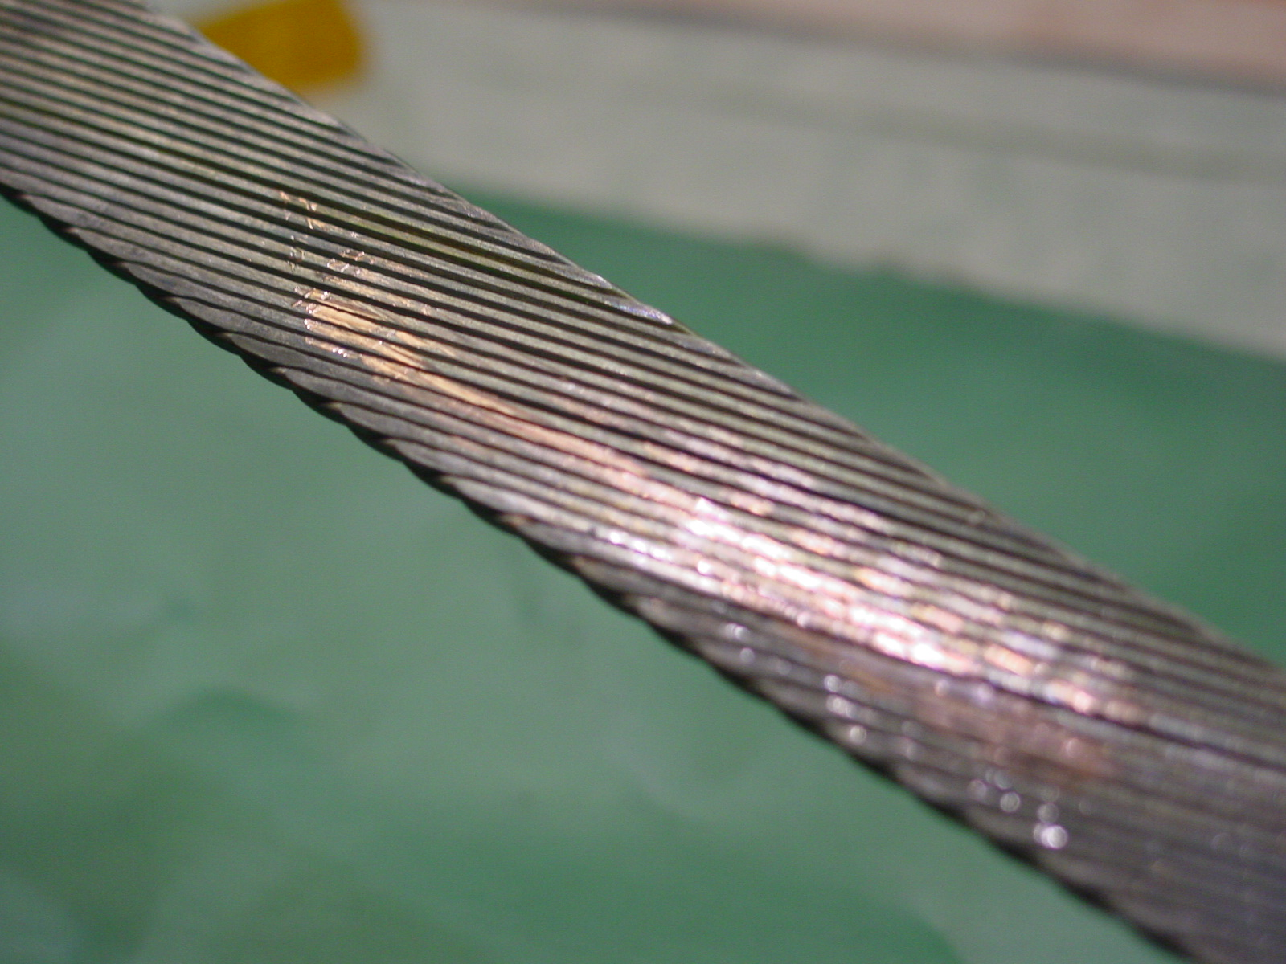
3/3 – After repairing

