–

Non conformity Report
IDENTIFICATION
1. Originator’s Name: B.Caserza – F. Terzi | 5. Date: 23/05/2005
2. Contractor/Supplier: Ansaldo Superconduttori S.p.A. | 6. Part description: HCMBBLA001-02000144
3. Contract No: F302/LHC/LHC | 7. Qty: 1
4. Project Engineer: F. Savary, M. Bajko | 8. Dwg No: LHCMBB_A0002/F (683RM08451)

9. Found during what activity:
□ Incoming inspection | ☑ Final inspection
□ In-process inspection | □ Other:

10. Description of non conformity (use continuation page if necessary)
Final geometrical measurements performed on CM 2144 showed out-of-tolerance of 2mm (N.C.S. direction) about the longitudinal positioning of the heat exchanger tube.

11. Action taken to prevent misuse (use continuation page if necessary)

IMPORTANCE
12. |  ☑ Non critical | □ Critical

DISPOSITION
13. | □ Use-as-is | ☑ Repair | □ Reject | □ Rework | □ Return to supplier
Description of proposed action (use continuation page if necessary)
Cut the weld (do it very carefully in order not to remove base material of the heat exchanger tube), put the tube at the right place and weld again.
Radiograph the new weld (add the results of the radiographic examination when closing the NCR).
See continuation pages for details.

CORRECTIVE/PREVENTIVE ACTION
14. Description of proposed action (use continuation page if necessary)

APPROVAL OF NON CRITICAL NON CONFORMITIES
15 | Project Engineer: F. Savary | Date: May 24th, 2004

APPROVAL OF CRITICAL NON CONFORMITIES
16 | Project Management: | Date:

CLOSURE OF THE NON CONFORMITY
Planned actions have been completed and corrective/preventive actions have been initiated
Repair completed successfully, see annexed results of the radiographic examination.
 | For non critical non conformities  Quality Manager or Project Engineer | For critical non conformities  Project Engineer
17 | Name: F. Terzi  Date: 26/05/2005 | Name:  Date:

Reparation heatexchanger tube CM2144

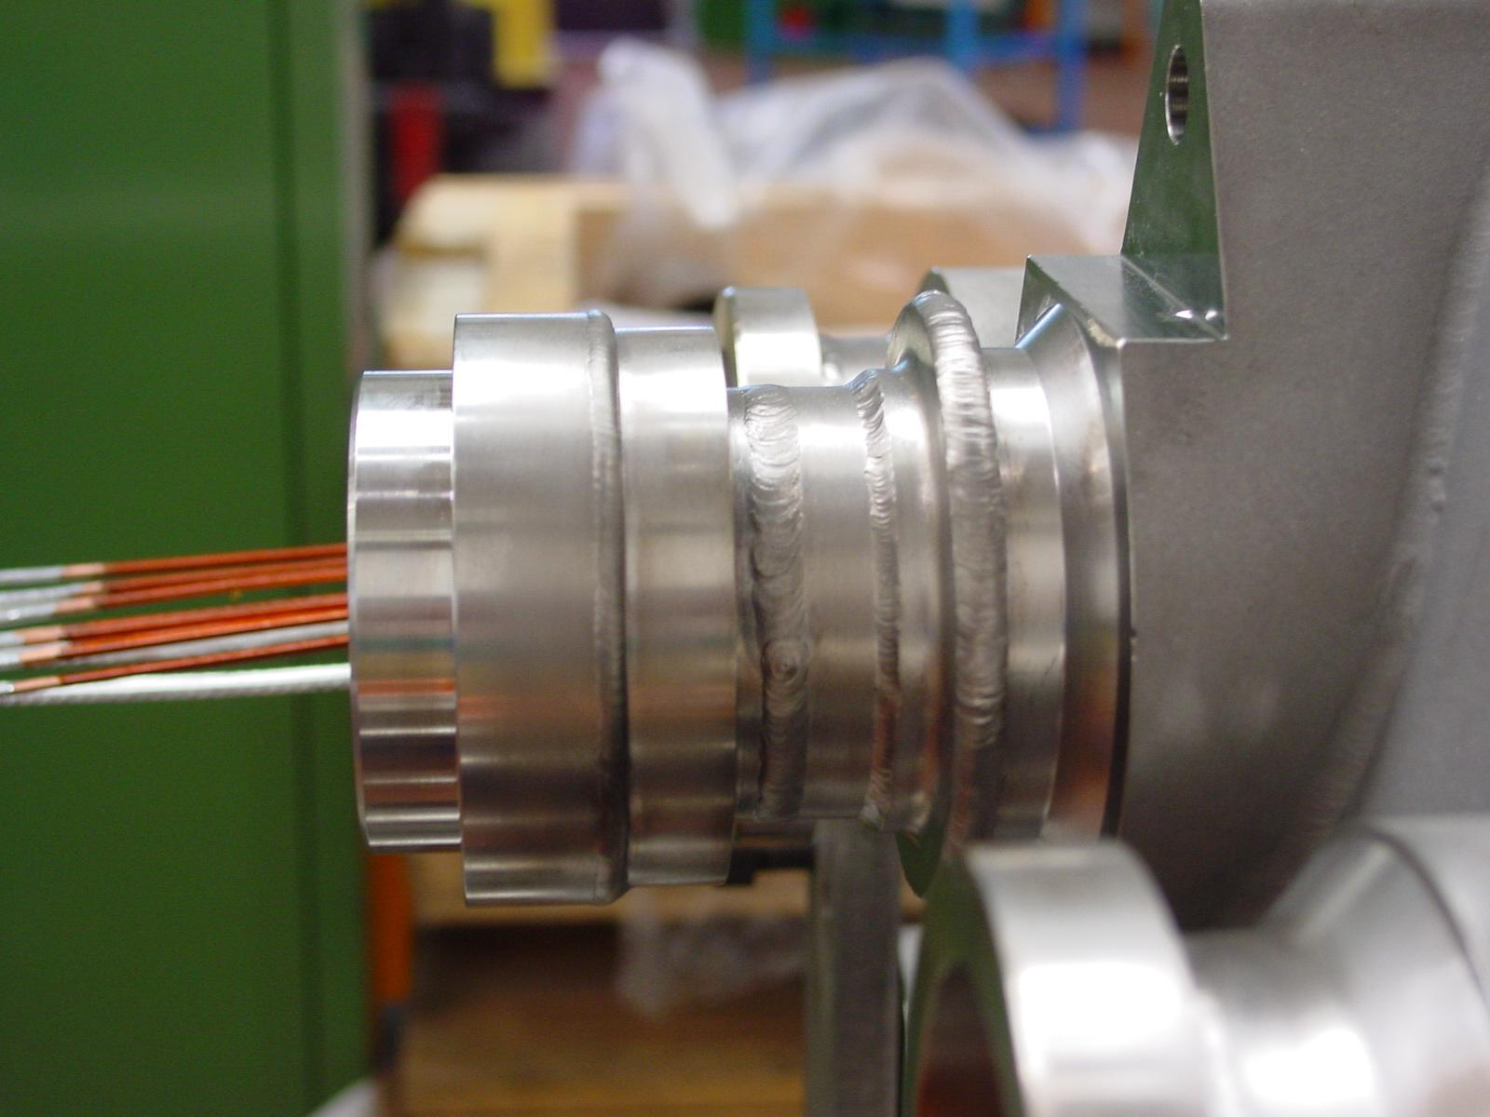

Cut of welding W44

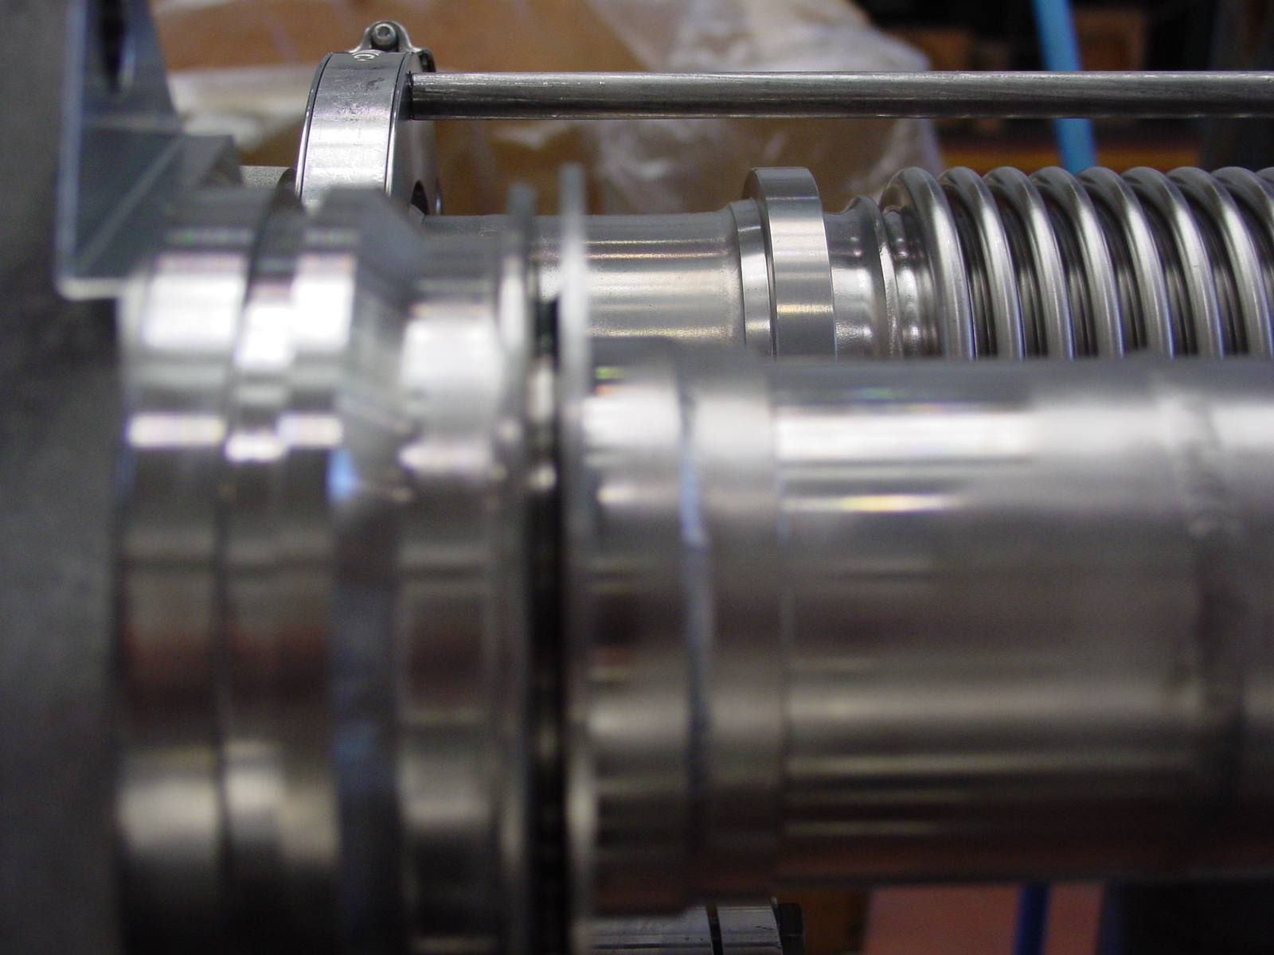

Positioning the tube after cutting and rewelding the W44 .
