–

Non conformity Report
IDENTIFICATION
1. Originator’s Name: B.Caserza – F. Terzi | 5. Date: 23/05/2005
2. Contractor/Supplier: Ansaldo Superconduttori S.p.A. | 6. Part description: HCMBARA001-02000024
3. Contract No: F302/LHC/LHC | 7. Qty: 1
4. Project Engineer: F. Savary, M. Bajko | 8. Dwg No: LHCMBB_A0002/F (683RM08451)

9. Found during what activity:
□ Incoming inspection | ☑ Final inspection
□ In-process inspection | □ Other:

10. Description of non conformity (use continuation page if necessary)
Final visual inspection on CM 2024 showed a deformation of flexible tube installed on N-line (id. nr. NN0107).
See attached pictures.

11. Action taken to prevent misuse (use continuation page if necessary)

IMPORTANCE
12. |  □ Non critical | □ Critical

DISPOSITION
13. | □ Use-as-is | ◻ Repair | □ Reject | □ Rework | □ Return to supplier
Description of proposed action (use continuation page if necessary)
Change the damaged flexible tube with a new one.
Repeat the leak test.

CORRECTIVE/PREVENTIVE ACTION
14. Description of proposed action (use continuation page if necessary)

APPROVAL OF NON CRITICAL NON CONFORMITIES
15 | Project Engineer: | Date:

APPROVAL OF CRITICAL NON CONFORMITIES
16 | Project Management: | Date:

CLOSURE OF THE NON CONFORMITY
Planned actions have been completed and corrective/preventive actions have been initiated
 | For non critical non conformities  Quality Manager or Project Engineer | For critical non conformities  Project Engineer
17 | Name:  Date: | Name:  Date:

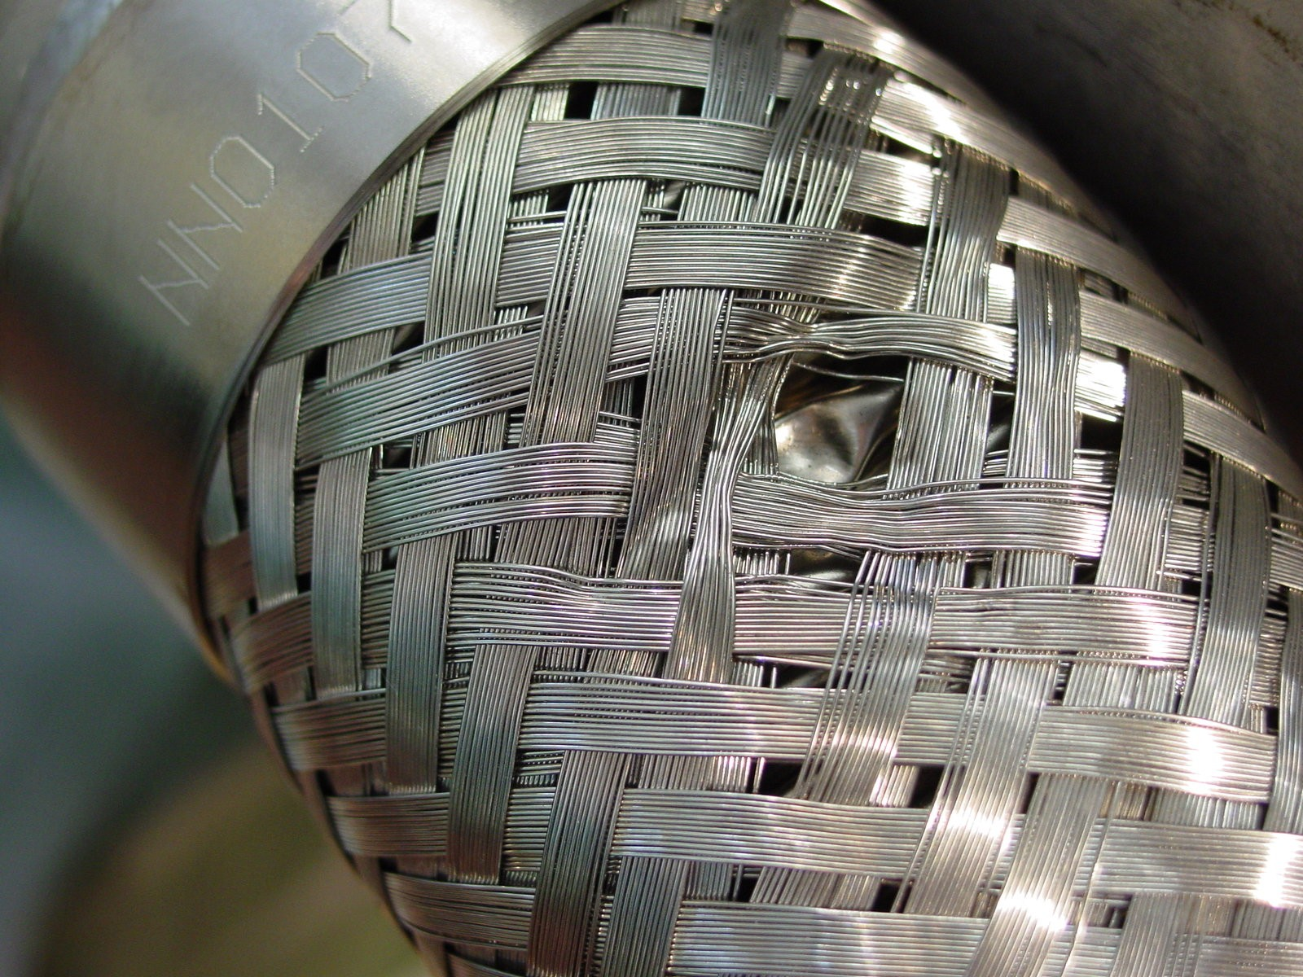
1/1

