–

Non conformity Report
IDENTIFICATION
1. Originator’s Name: B. Caserza, F. Terzi | 5. Date: 23/06/2005
2. Contractor/Supplier: Ansaldo Superconduttori S.p.A. | 6. Part description: HCMBBLA001-02000197
3. Contract No: F462/LHC/LHC | 7. Qty: 1
4. Project Engineer: F. Savary, M. Bajko | 8. Dwg No: LHCMBB_A0002/F (683RM08451)

9. Found during what activity:
□ Incoming inspection | ☑ Final inspection
□ In-process inspection | □ Other:

10. Description of non conformity (use continuation page if necessary)
During final electrical test at 5 kV, performed on CM 2197, a low insulation resistance has been detected between bus-bars QF+QD and ground.
Measured leakage current I > 10 μA (max acceptable value 10 μA)

11. Action taken to prevent misuse (use continuation page if necessary)

IMPORTANCE
12. |  □ Non critical | □ Critical

DISPOSITION
13. | □ Use-as-is | □ Repair | □ Reject | □ Rework | □ Return to supplier
Description of proposed action (use continuation page if necessary)
In order to find the defect, we cut the two reusable pieces on CS and one on NCS.
At the end we found that the defect was due to a dirty reusable vetronite.
Now the vetronite is changed and the defect is disappeared.
We re-welded the reusable pieces and performed again the vacuum/pressure test and the final electrical test.

CORRECTIVE/PREVENTIVE ACTION
14. Description of proposed action (use continuation page if necessary)
It would be more efficient to check the parts before assembly! Don’t you think so? Does it make sense to use parts which are doubtful?

APPROVAL OF NON CRITICAL NON CONFORMITIES
15 | Project Engineer: F. Savary | Date: June 23rd, 2005

APPROVAL OF CRITICAL NON CONFORMITIES
16 | Project Management: | Date:

CLOSURE OF THE NON CONFORMITY
Planned actions have been completed and corrective/preventive actions have been initiated
Leak test and Final electrical test performed successfully.
 | For non critical non conformities  Quality Manager or Project Engineer | For critical non conformities  Project Engineer
17 | Name: F. Terzi  Date: 27/06/2005 | Name:  Date:

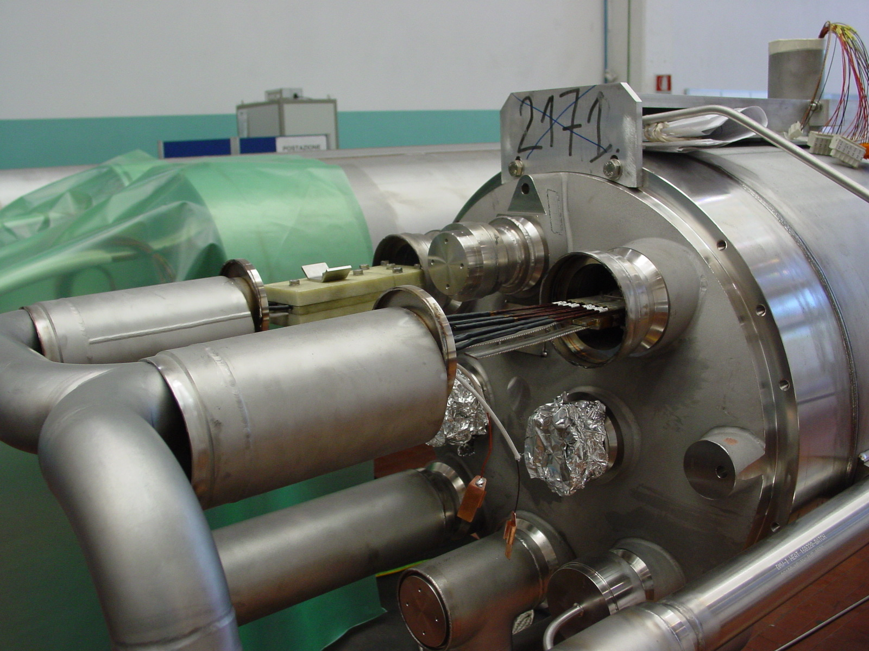
1/3
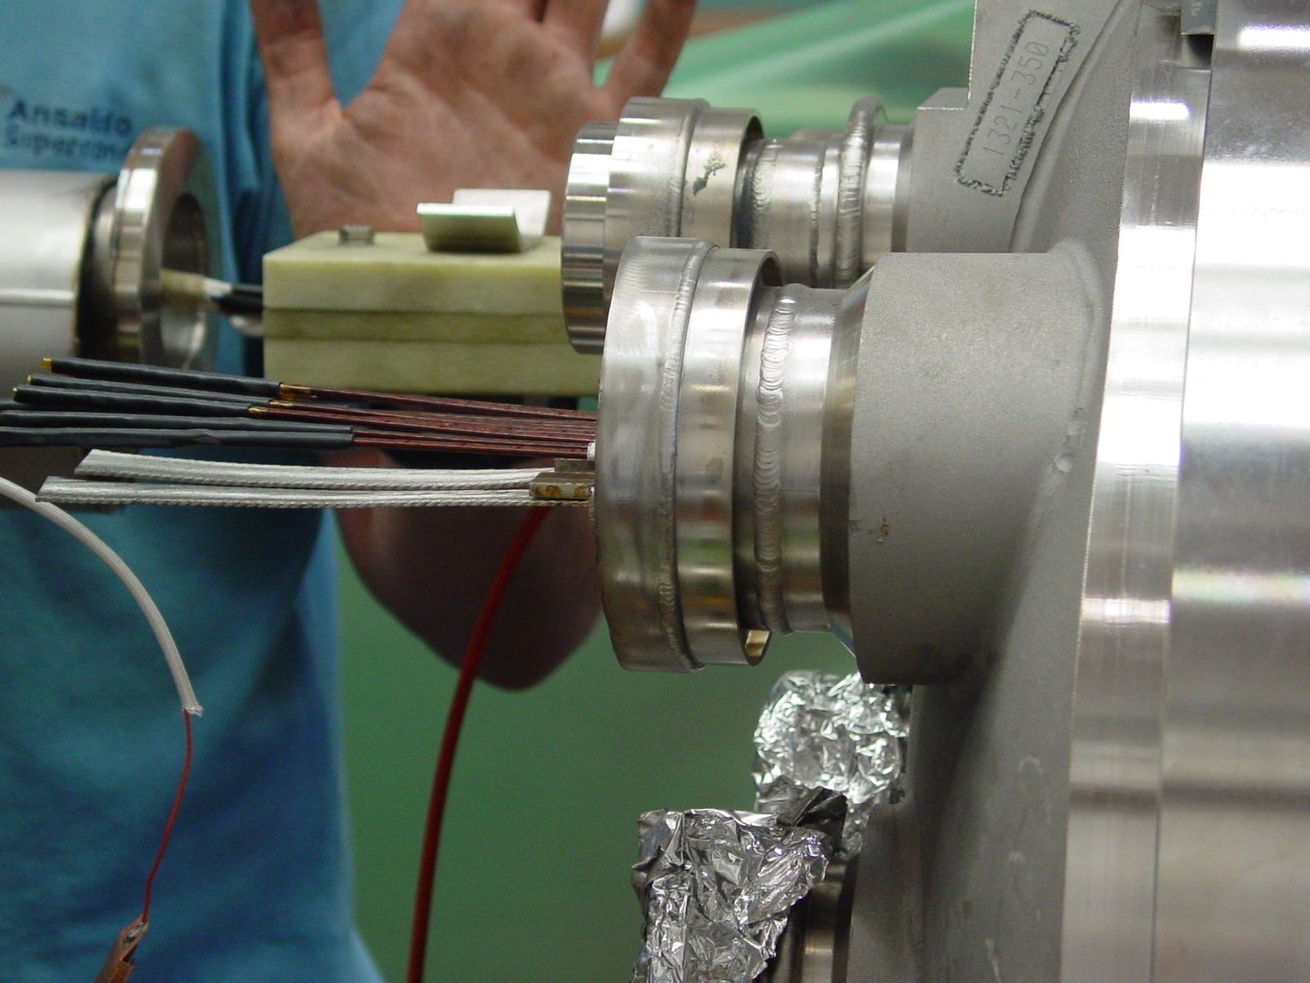
2/3
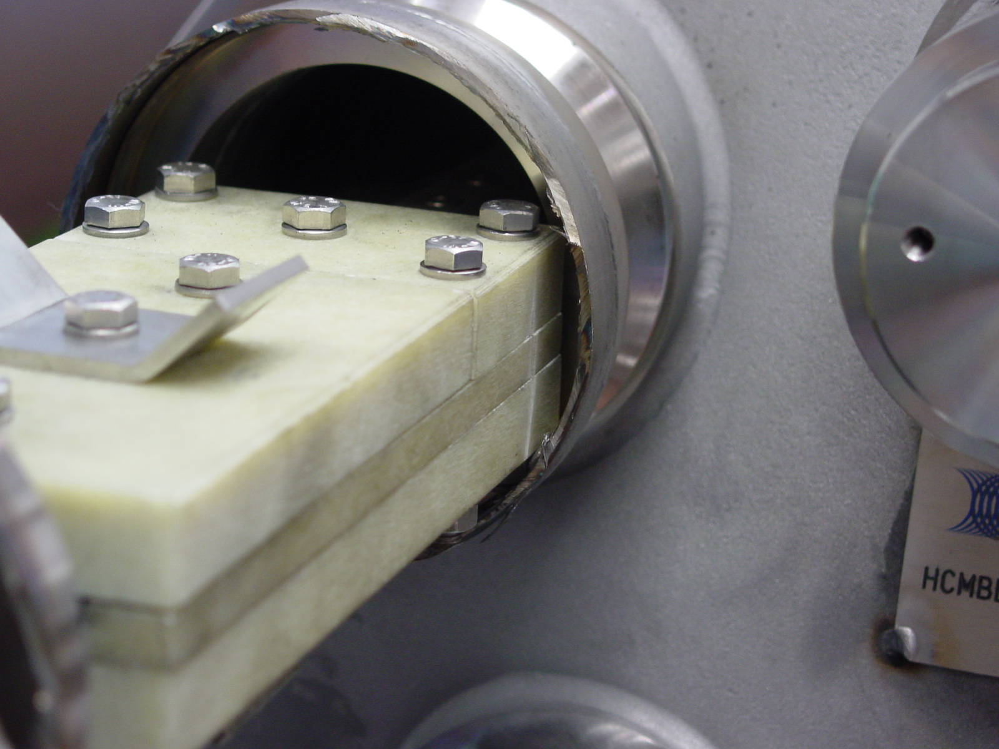
3/3

