–

Non conformity Report
IDENTIFICATION
1. Originator’s Name: B. Caserza, F. Terzi | 5. Date: 30/06/2005
2. Contractor/Supplier: Ansaldo Superconduttori S.p.A. | 6. Part description: HCMB__A001-02000236
3. Contract No: F462/LHC/LHC | 7. Qty: 1
4. Project Engineer: F. Savary, M. Bajko | 8. Dwg No: LHCMB__A0012/E (620RM08202/F)

9. Found during what activity:
□ Incoming inspection | □ Final inspection
☑ In-process inspection | □ Other:

10. Description of non conformity (use continuation page if necessary)
During winding of outer layer nr. 02E00946 (sc cable nr. 02C00222A) for CM 2236, a visual inspection showed the cross-section of the Rutherford cable completely buckled, at about 105 m from the start, on 4th turn.

11. Action taken to prevent misuse (use continuation page if necessary)

IMPORTANCE
12. | □ Non critical | □ Critical

DISPOSITION
13. | □ Use-as-is | □ Repair | □ Reject | □ Rework | □ Return to supplier
Description of proposed action (use continuation page if necessary)
We removed the insulation and tried to repair the cable as shown in the attached pictures.
After restarting the winding the cable collapsed again. In order not to stop the production we propose to rewind the cable on the spool and store for examination.

CORRECTIVE/PREVENTIVE ACTION
14. Description of proposed action (use continuation page if necessary)

APPROVAL OF NON CRITICAL NON CONFORMITIES
15 | Project Engineer: | Date:

APPROVAL OF CRITICAL NON CONFORMITIES
16 | Project Management: | Date:

CLOSURE OF THE NON CONFORMITY
Planned actions have been completed and corrective/preventive actions have been initiated
 | For non critical non conformities  Quality Manager or Project Engineer | For critical non conformities  Project Engineer
17 | Name:  Date: | Name:  Date:

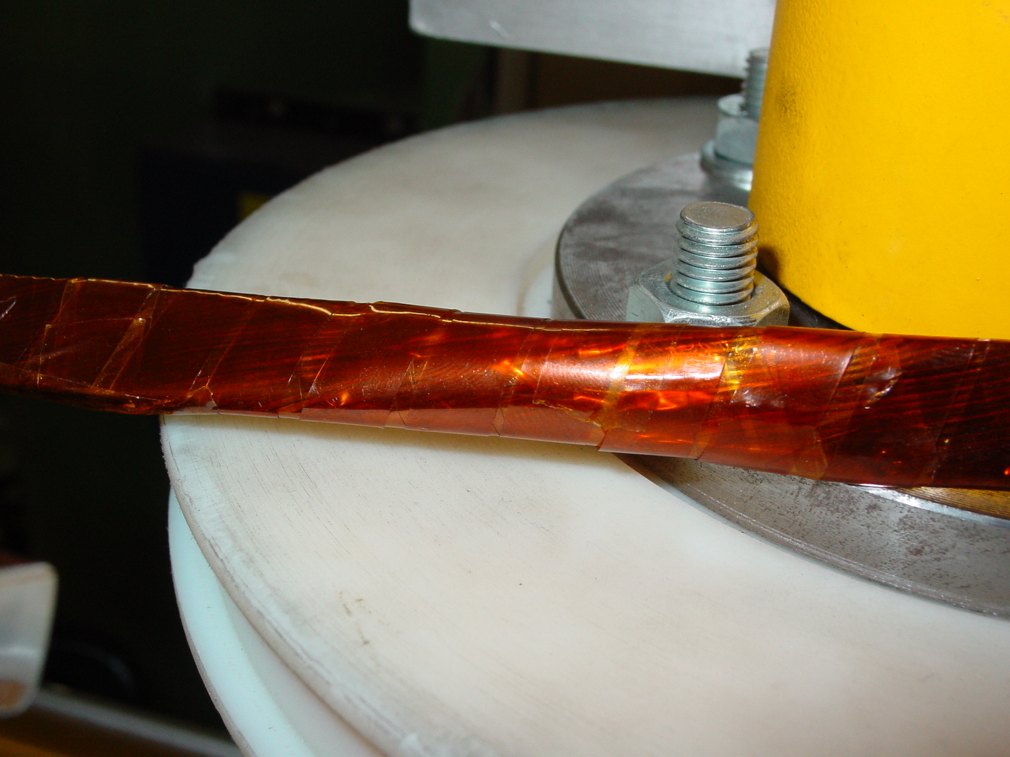
Picture 1: Affected zone before removing the insulation

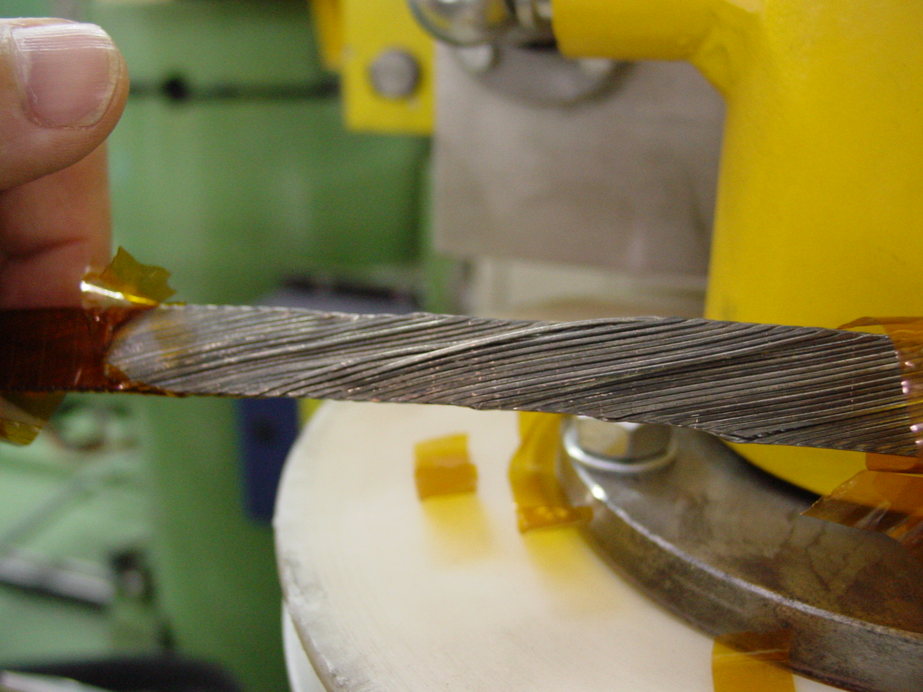

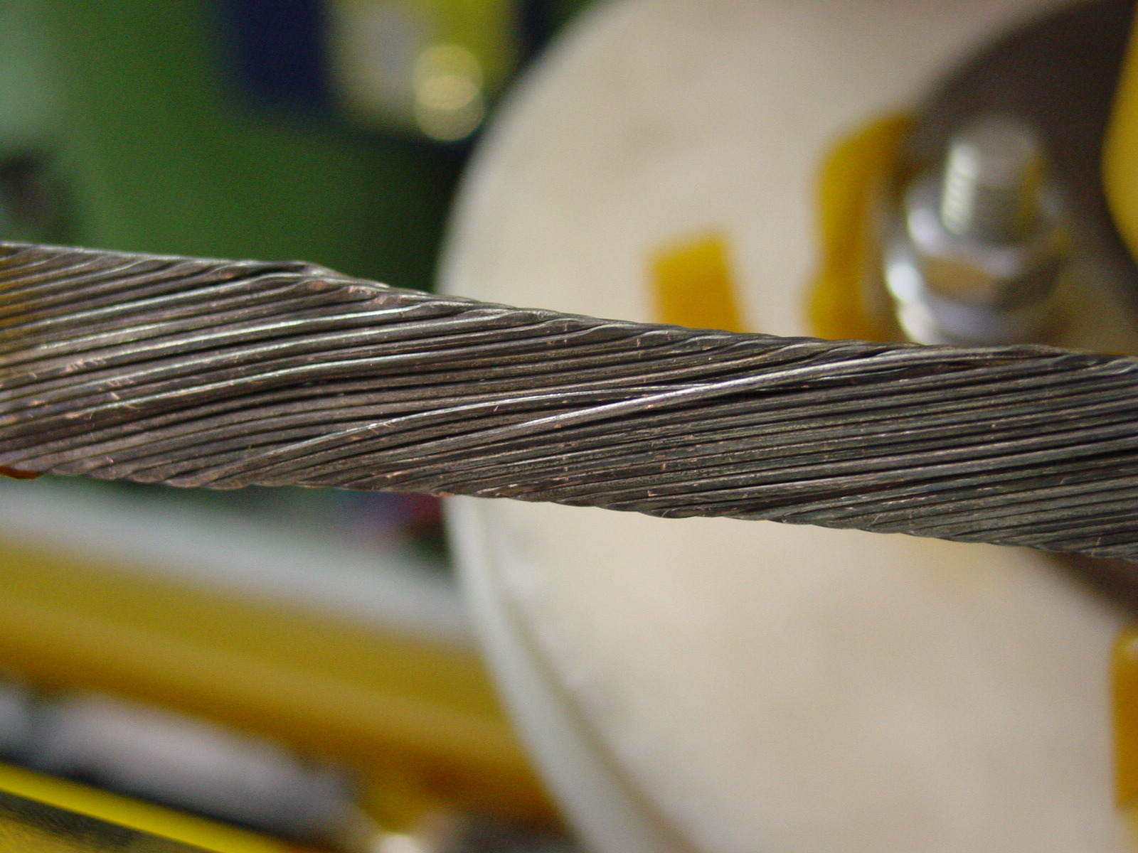
Picture 2-3: Affected zone after removal of the insulation
ù
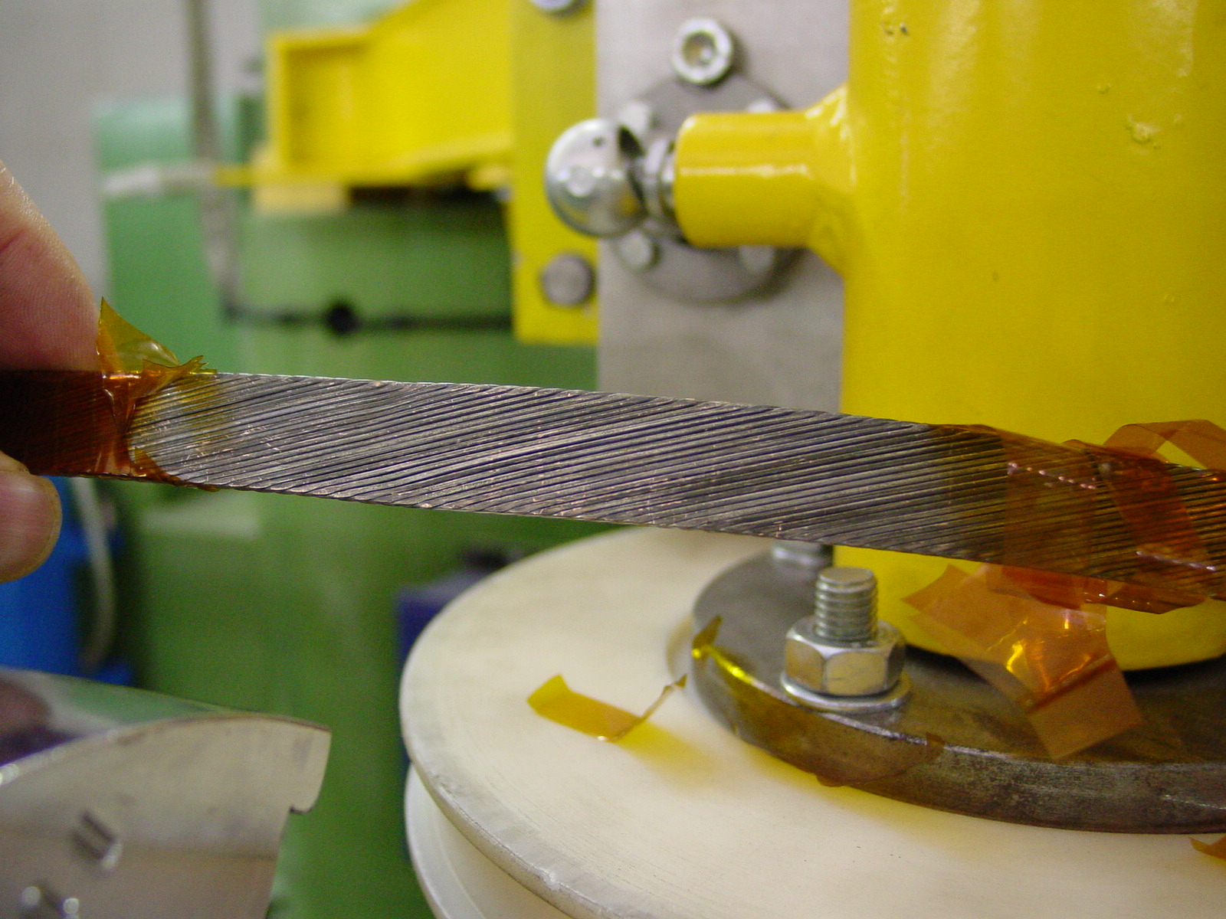

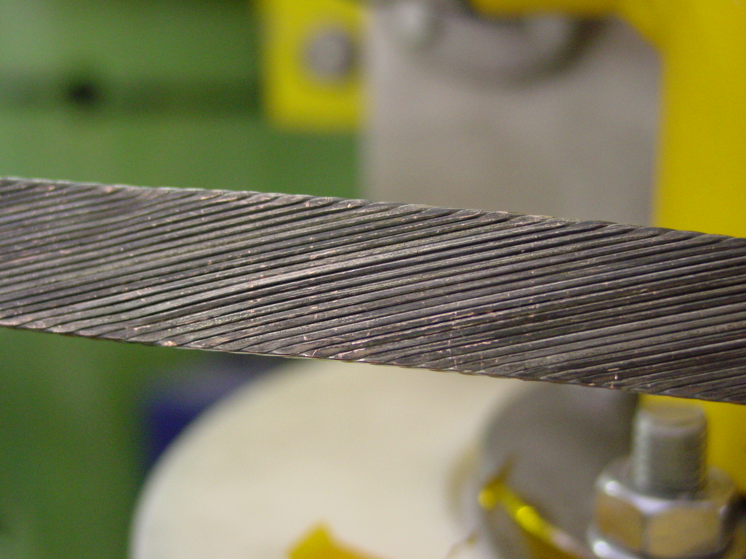
Picture 4-5: Affected zone after repair

