–

Non conformity Report
IDENTIFICATION
1. Originator’s Name: B.Caserza – F. Terzi | 5. Date: 01/07/2005
2. Contractor/Supplier: Ansaldo Superconduttori S.p.A. | 6. Part description: HCMBALA001-02000170
3. Contract No: F462/LHC/LHC | 7. Qty: 1
4. Project Engineer: F. Savary, M. Bajko | 8. Dwg No: LHCMBB_A0002/F (683RM08451)

9. Found during what activity:
□ Incoming inspection | □ Final inspection
☑ In-process inspection | □ Other:

10. Description of non conformity (use continuation page if necessary)
CM 2170: during welding of flare diam.=53 / 82 ("collarette" – dwg. nr. LHBMB__S0121 P.1) on c.b.t of V1-line, Lyre side, (weld id. nr. W50-V1), the weld created an internal defect classified as "scaled surface and temper coloration" (ref. to group D on Test procedure LHC–MB–TP-0011 Rev. 1)

Please find detail pictures on continuation page.

11. Action taken to prevent misuse (use continuation page if necessary)

IMPORTANCE
12. | ☑ Non critical | □ Critical

DISPOSITION
13. | □ Use-as-is | ☑ Repair | □ Reject | □ Rework | □ Return to supplier
Description of proposed action (use continuation page if necessary)
Brush the inside surface of the tube according to the procedure LHC-MB-TP-0011 EDMS doc. N° 591131.
A picture of the tube inside before and after brushing should have been included. Please add them when closing the non-conformity report.

CORRECTIVE/PREVENTIVE ACTION
14. Description of proposed action (use continuation page if necessary)

APPROVAL OF NON CRITICAL NON CONFORMITIES
15 | Project Engineer: O. Crettiez | Date: July 1rst, 2005

APPROVAL OF CRITICAL NON CONFORMITIES
16 | Project Management: | Date:

CLOSURE OF THE NON CONFORMITY
Planned actions have been completed and corrective/preventive actions have been initiated
 | For non critical non conformities  Quality Manager or Project Engineer | For critical non conformities  Project Engineer
17 | Name: F. Terzi  Date: 01/07/2005 | Name:  Date:

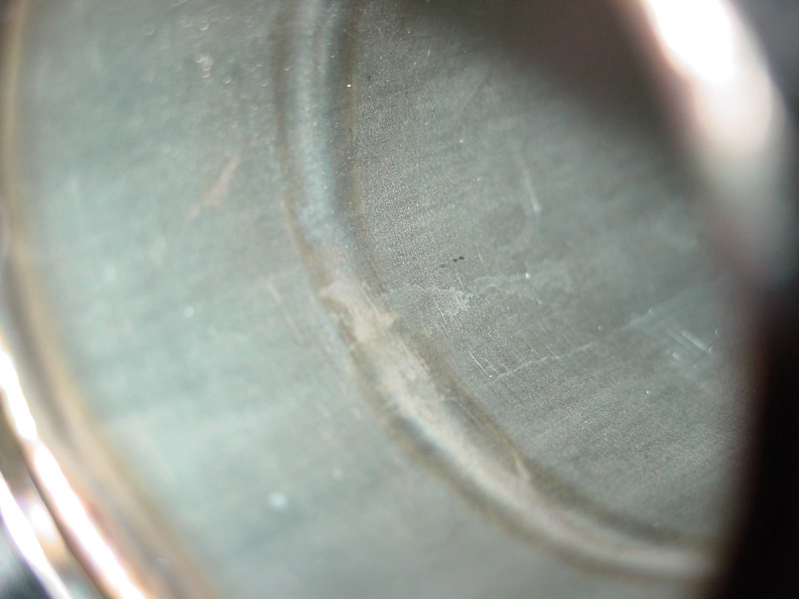
1/5 – BEFORE brushing

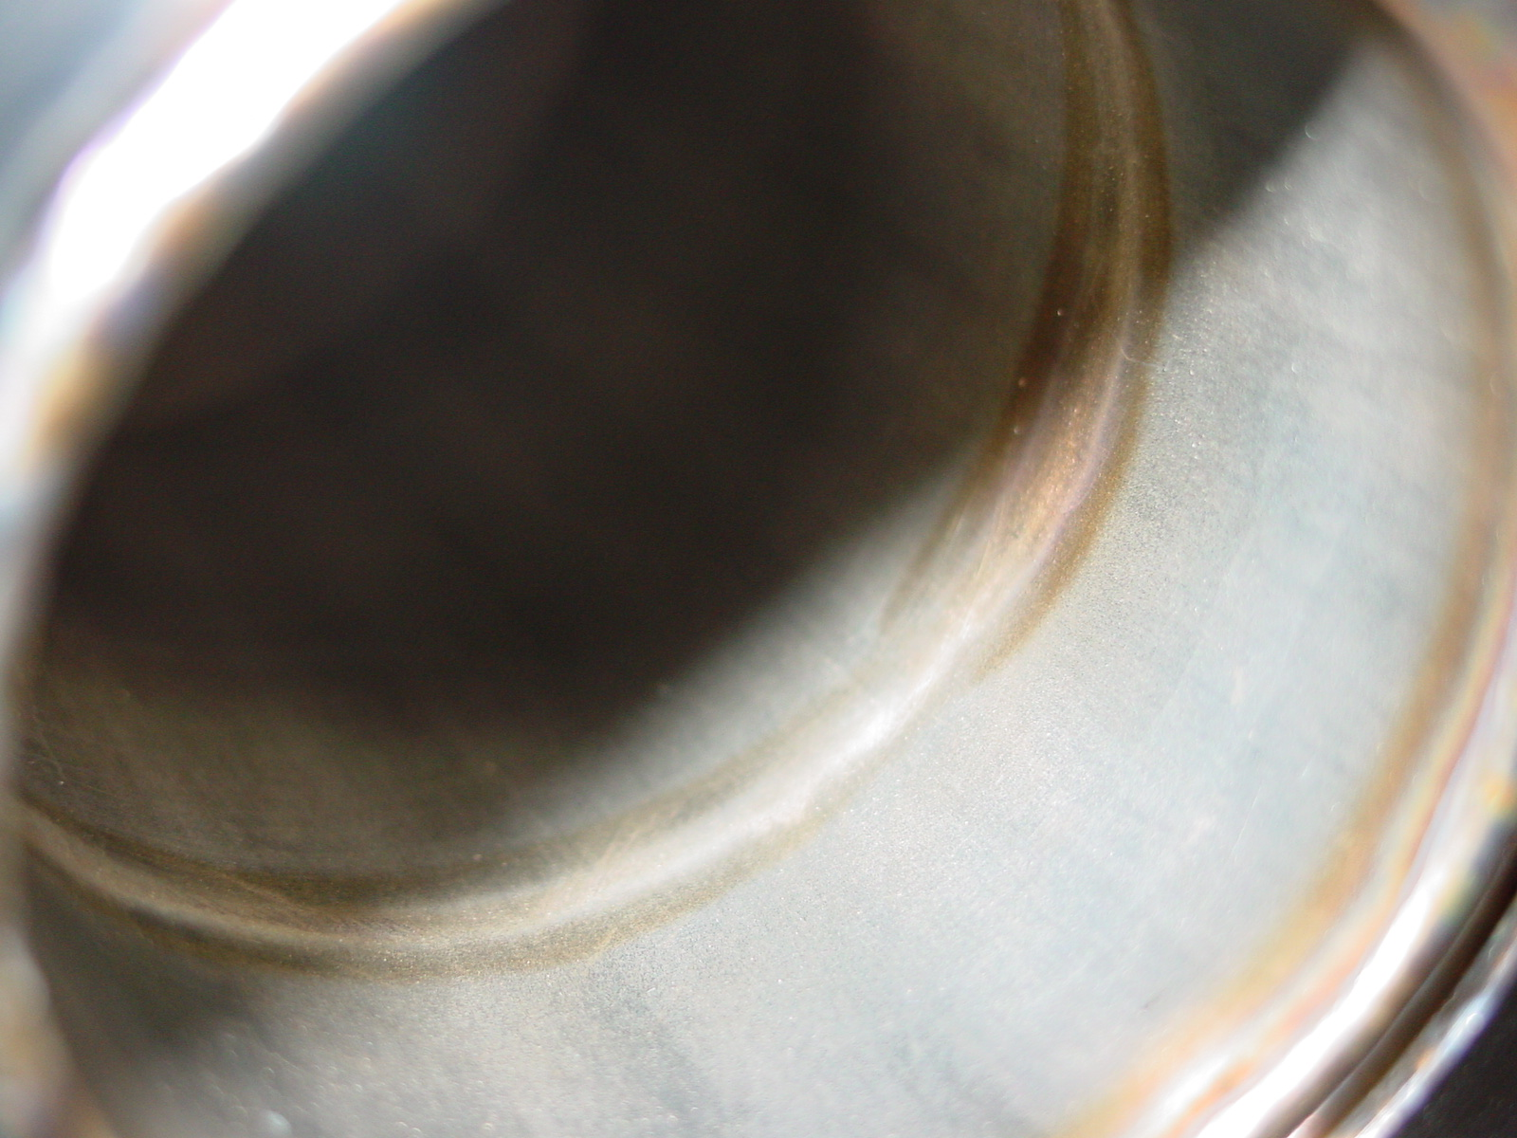
2/5 – BEFORE brushing

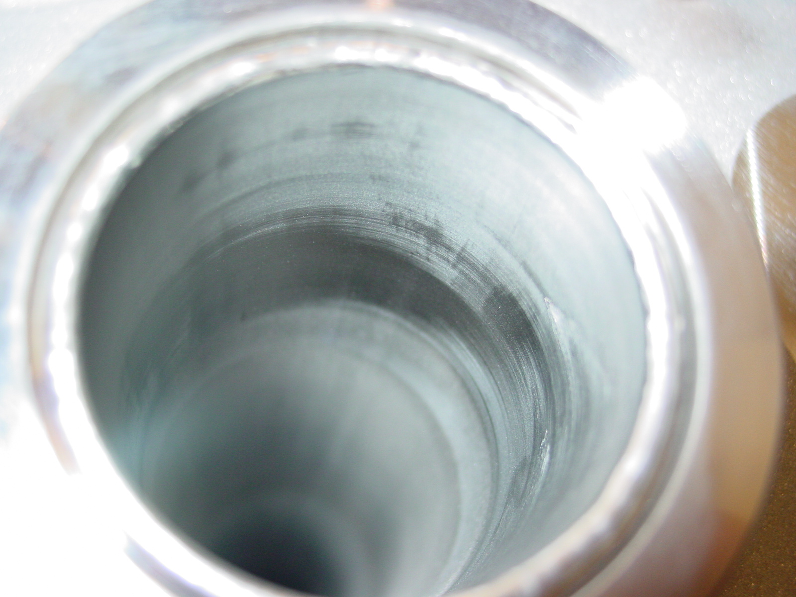
3/5 – AFTER brushing

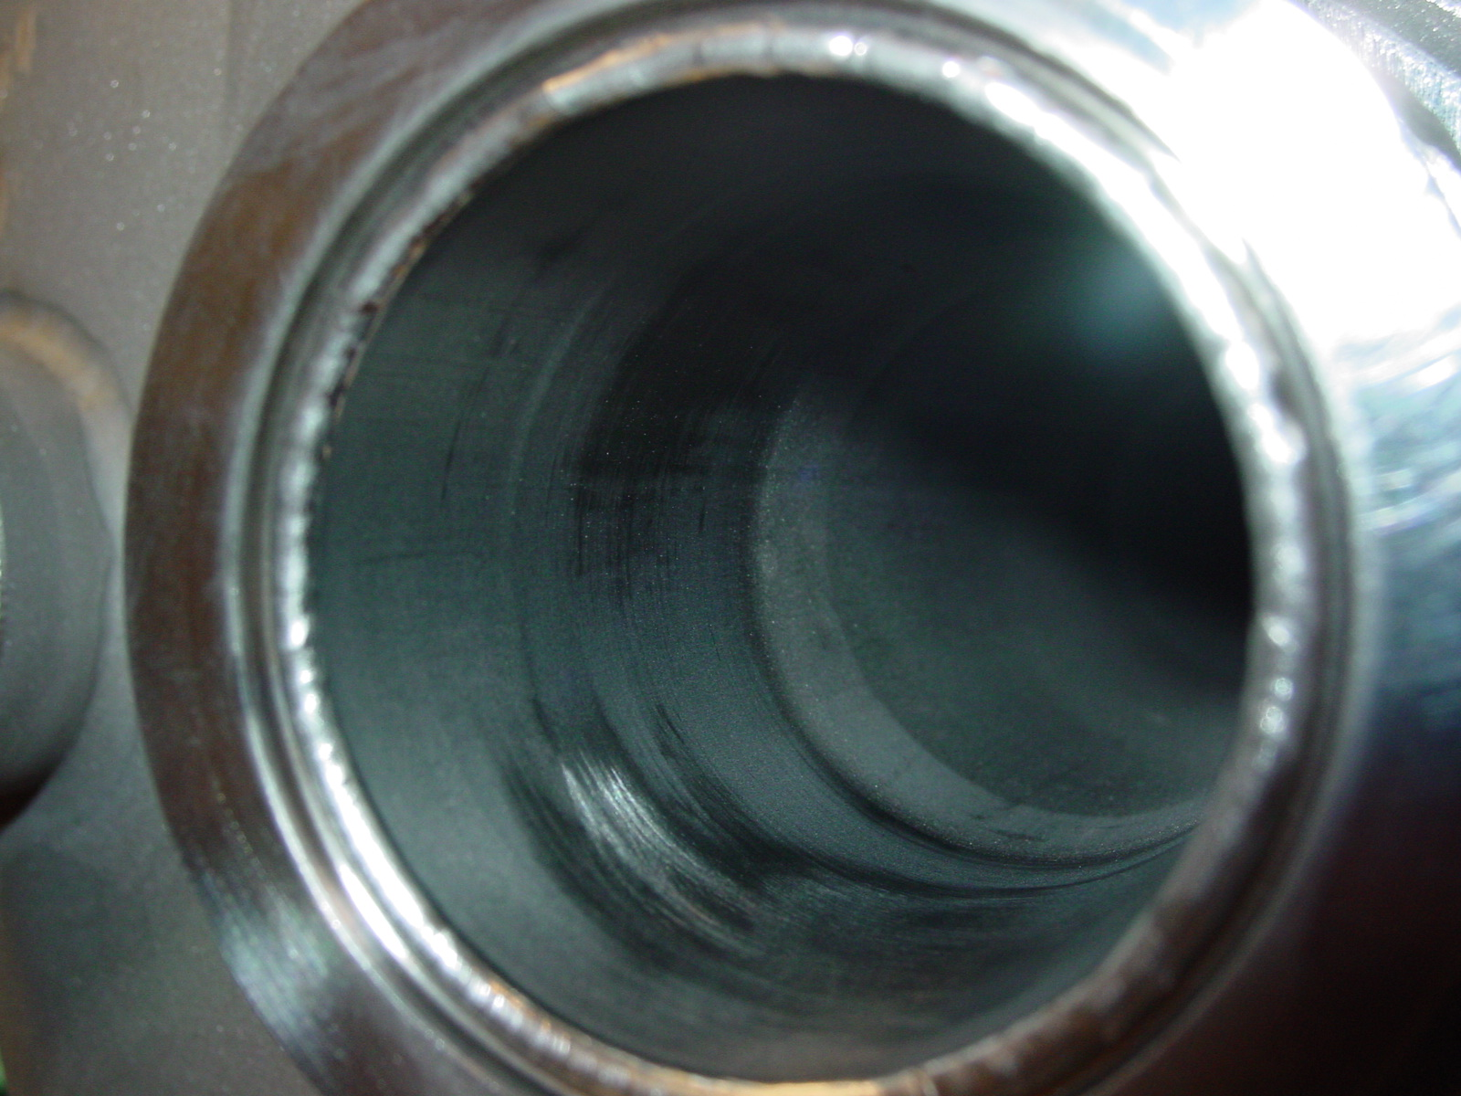
4/5 – AFTER brushing

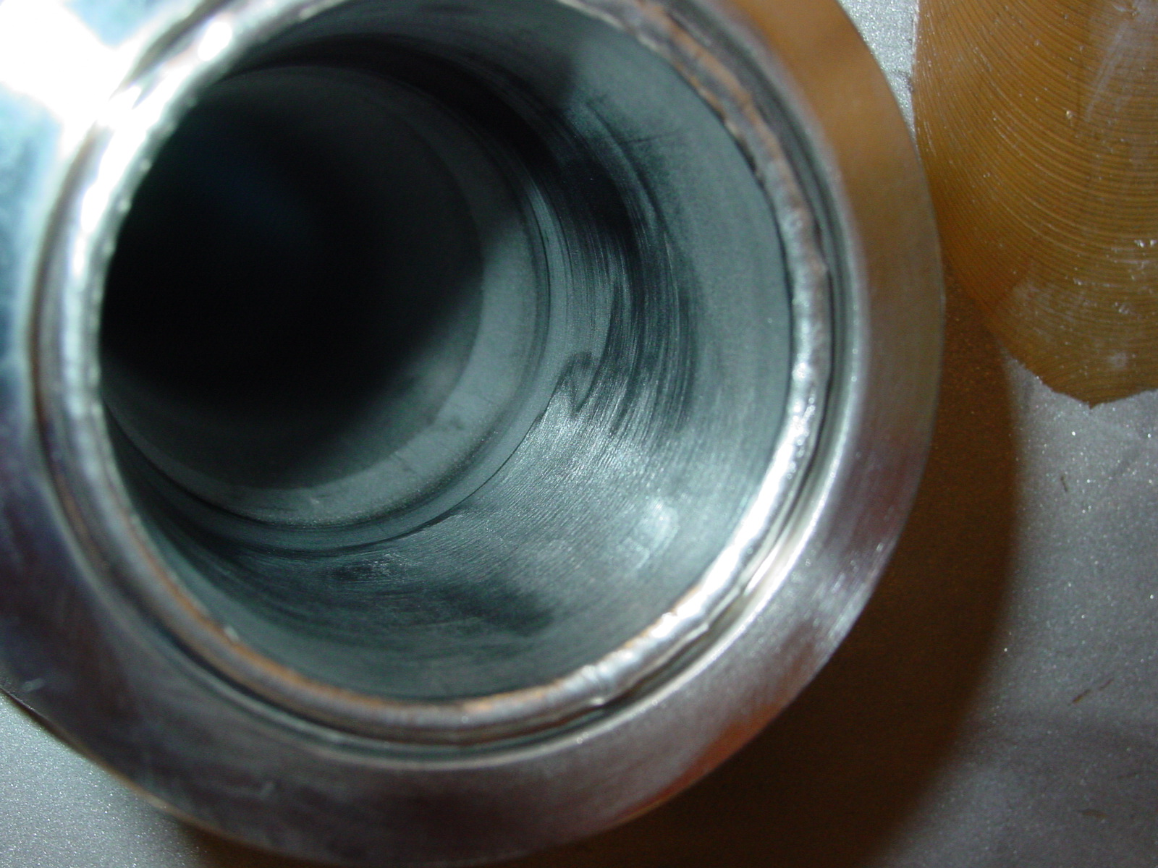
5/5 – AFTER brushing

