–

Non conformity Report
IDENTIFICATION
1. Originator’s Name: B.Caserza, F. Terzi | 5. Date: 03/08/2004
2. Contractor/Supplier: Ansaldo Superconduttori S.p.A. | 6. Part description: HCMBALA001-02000205
3. Contract No: F462/LHC/LHC | 7. Qty: 1
4. Project Engineer: F. Savary, M. Bajko | 8. Dwg No: LHCMBB_A0002/F (683RM08451)

9. Found during what activity:
□ Incoming inspection | □ Final inspection
☑ In-process inspection | □ Other:

10. Description of non conformity (use continuation page if necessary)
Visual and dimensional check of bus bars installed on CM 2205 showed that the bus-bar installed on M3 line (id. nr. 426 type A) has a reduced length of the sc cable of about 10 mm (from 270 to 260 mm).
See attached pictures.

11. Action taken to prevent misuse (use continuation page if necessary)

IMPORTANCE
12. | ☑ Non critical | □ Critical

DISPOSITION
13. | ☑ Use-as-is | □ Repair | □ Reject | □ Rework | □ Return to supplier
Description of proposed action (use continuation page if necessary)
After completion of the approval circuit of NC CERN 227 (that is exactly the same) among the responsible project engineers and users of the cold mass, we can conclude that this magnet can be used as is.
There must be a clear warning/sticker on the cold mass itself to draw the attention of the user at CERN reception and at further steps of the cryo-magnet preparation.

CORRECTIVE/PREVENTIVE ACTION
14. Description of proposed action (use continuation page if necessary)
Inform the manufacturer & supplier of the bus bars to eradicate this kind on non-conformity (action CERN project engineers).

APPROVAL OF NON CRITICAL NON CONFORMITIES
15 | Project Engineer: Marta Bajko | Date: 09.08.2005

APPROVAL OF CRITICAL NON CONFORMITIES
16 | Project Management: | Date:

CLOSURE OF THE NON CONFORMITY
Planned actions have been completed and corrective/preventive actions have been initiated
A clear WARNING STICKER shall be put on the cold mass.
 | For non critical non conformities  Quality Manager or Project Engineer | For critical non conformities  Project Engineer
17 | Name: F. Terzi  Date: 10/08/2005 | Name:  Date:

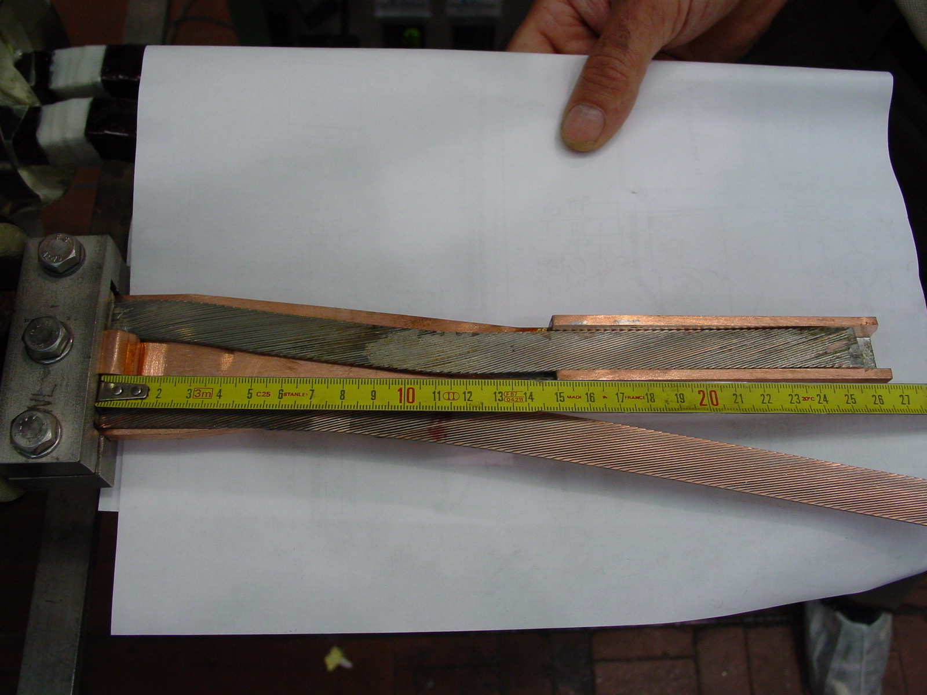
1/2
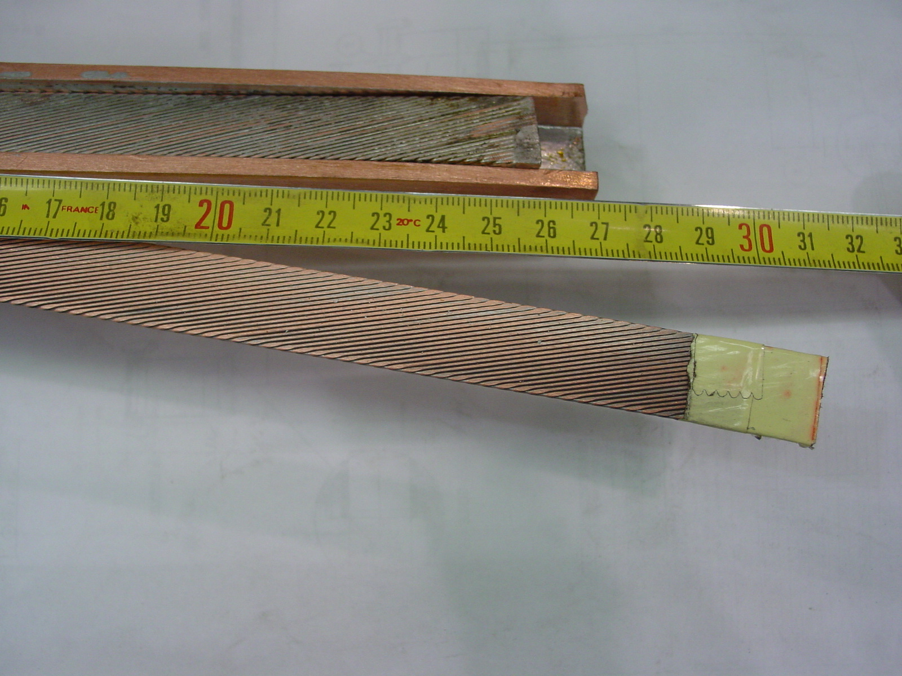
2/2

